Michelin star Chef Tom Parker cooked for over 50 pensioners in Fence on Monday 15th December. This was a heartfelt gesture from Chef Tom, of the Swan in Fence. At £10 per head for a full Christmas dinner in the Refectory at St Anne’s church, tickets sold out within a few hours of going on sale.
Chef Tom said ‘It’s an absolute joy and pleasure to support the village, the White Swan is a big part of the village and it’s always nice to give something back certainly around Christmas time’
Reverend Lesley, Vicar of St Anne’s, said ‘Wow! What church has a Michelin Star chef to cook for their people! We are truly blessed. All enjoyed a fabulous meal followed by Carol singing led by Matt Butler of the Inghamite church in Fence. This has been a wonderful collaboration with the Parish Council and wider community’
The White Swan is open all throughout Christmas apart from Boxing Day. For all information and to book look on the website at https://www.whiteswanatfence.co.uk/
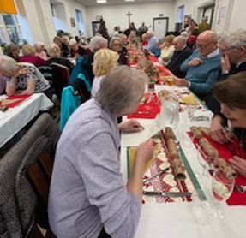
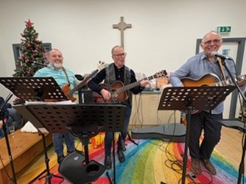

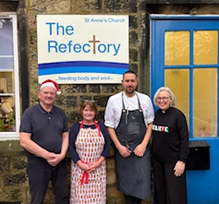
Reverend Lesley is pictured with Howard Hartley, Parish Councillor, Jill Hartley, Chair of Fence Parish Council and Chef Tom Parker.

