Friday Faith and Fun met on Friday 12th December for their Christmas party. After a short Act of Worship, the games began followed by food. Great to see adults and children join in the fun.
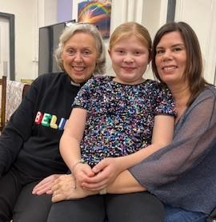
Next session Friday 9th January 2026. Do join us ●•^-
