Into his Courts
with Praise...



A Service of the Word

Thursday 25 December 2025
Christmas Day.

A Service of the Word for Sunday morning

This service is taken from A Service of the Word,
Morning and Evening Prayer, Night Prayer,
which is copyright (c) The Archbishops' Council, 2000,
with permitted variations.

Christmas Day

Today is the day for which we have all been waiting.
Our Advent wreath will now be completed
by the lighting of our Christ candle.
“For unto us a child is given, unto us a Saviour is born
and the order of the world will be upon his shoulders.”
With the birth of Jesus, our lives will be changed.
We will be transformed by his model and message.
We light this candle to represent
that Christ is truly the centre of our lives.
We light the central white candle;

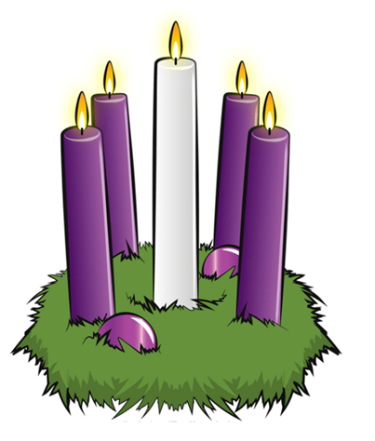

We welcome Jesus Christ, come Lord, change our lives!

INTRODUCTION

“In the beginning was the Word, and the Word was with God, and the Word was God.”
John 1:1.

THE CONFESSION
The grace of God has dawned upon the world with healing for all. Though we have grieved him, yet he will heal us if we confess our sins in penitence and faith.

Almighty God,
I confess that I have sinned against you
in thought, word and deed;
I have not loved you with all my heart;
I have not loved my neighbours as myself.
Have mercy upon me,
cleanse me from my sins,
and help me to overcome my faults,
through Jesus Christ our Lord. Amen.

Receive God’s forgiveness
May the Father forgive us
By the death of His Son
And strengthen us
To live in the power of the Spirit
All our days. Amen.

PRAISE
O Lord, open my lips...
and my mouth shall proclaim your praise.
Give me the joy of your saving help...
and sustain me with your life-giving Spirit.

THE COLLECT
Lord Jesus Christ, your birth at Bethlehem draws us to kneel in wonder at heaven touching earth:
accept our heartfelt praise as we worship you, our Saviour and our eternal God.
Amen.
Suggested hymn to sing or read It came upon the midnight clear.

THE WORD OF GOD.
Psalm 98

Sing to the Lord a new song, ♦︎
for he has done marvellous things.
His own right hand and his holy arm ♦︎
have won for him the victory.
The Lord has made known his salvation; ♦︎
his deliverance has he openly shown in the sight of the nations.

He has remembered his mercy and faithfulness
towards the house of Israel, ♦︎
and all the ends of the earth have seen the salvation of our God.
Sound praises to the Lord, all the earth; ♦︎
break into singing and make music.
Make music to the Lord with the lyre, ♦︎
with the lyre and the voice of melody.
With trumpets and the sound of the horn ♦︎
sound praises before the Lord, the King.
Let the sea thunder and all that fills it, ♦︎
the world and all that dwell upon it.

Let the rivers clap their hands ♦︎
and let the hills ring out together before the Lord,
for he comes to judge the earth.
In righteousness shall he judge the world ♦︎
and the peoples with equity.

Isaiah 52:7-10

How beautiful upon the mountains
are the feet of the messenger who announces peace,
who brings good news,
who announces salvation,
who says to Zion, ‘Your God reigns.’

Listen! Your sentinels lift up their voices,
together they sing for joy;
for in plain sight they see
the return of the Lord to Zion.

Break forth together into singing,
you ruins of Jerusalem;
for the Lord has comforted his people,
he has redeemed Jerusalem.
The Lord has bared his holy arm
before the eyes of all the nations;
and all the ends of the earth shall see
the salvation of our God.

Hebrews 1:1-4

Long ago God spoke to our ancestors in many and various ways by the prophets, but in these last days he has spoken to us by a Son, whom he appointed heir of all things, through whom he also created the worlds. He is the reflection of God’s glory and the exact imprint of God’s very being, and he sustains all things by his powerful word.

When he had made purification for sins, he sat down at the right hand of the Majesty on high, having become as much superior to angels as the name he has inherited is more excellent than theirs.

Suggested hymn to sing or read O come all ye faithful.

GOSPEL
John 1:1-14

In the beginning was the Word, and the Word was with God, and the Word was God. He was in the beginning with God. All things came into being through him, and without him not one thing came into being. What has come into being in him was life, and the life was the light of all people.

The light shines in the darkness, and the darkness did not overcome it.

There was a man sent from God, whose name was John. He came as a witness to testify to the light, so that all might believe through him. He himself was not the light, but he came to testify to the light. The true light, which enlightens everyone, was coming into the world.

He was in the world, and the world came into being through him; yet the world did not know him. He came to what was his own, and his own people did not accept him. But to all who received him, who believed in his name, he gave power to become children of God, who were born, not of blood or of the will of the flesh or of the will of man, but of God.

And the Word became flesh and lived among us, and we have seen his glory, the glory as of a father’s only son, full of grace and truth.

REFLECTION – Start at the very beginning, a good place to start.

REFLECTION –.
Christmas Day is here again, a time for praise, thanksgiving and joy in the birth of Jesus Christ.

At first glance the readings used today don’t exactly sound very “Christmassy”. After all, there is no mention of the journey to Bethlehem, no shepherds or flocks.

Instead we have Isaiah telling us about the redemption of Jerusalem and the salvation of God. Things become a little clearer with the letter to the Hebrews. Here we read of God speaking first through the prophets and now through his Son.

In the opening words of John’s Gospel there is no direct mention of Jesus but a poetically beautiful explanation of the nature of God.

In the beginning was the Word, and the Word was with God, and the Word was God.

John begins his gospel with a completely different emphasis from the three “synoptic” gospels. He doesn’t begin with the birth of Jesus (Matthew), Jesus’ baptism by John the Baptist (Mark) or the birth of John the Baptist – the preparer of the way (Luke). No, John begins from the very beginning, perhaps even before the beginning;

He was in the beginning with God. All things came into being through him, and without him not one thing came into being. What has come into being in him was life, and the life was the light of all people. The light shines in the darkness, and the darkness did not overcome it.

To John’s audience there was only one God, and they knew therefore who the “He” was. This was the one who was here on Earth, part of the lives of real humans, with all their faults and failings. There were disagreements in the Early Church (yes, of course there were – it wouldn’t be “church” otherwise).

One group were the Docetics (from the Greek, docein, meaning to seem or appear to be) who doubted the humanity of Jesus. Many believed that he only “seemed” to be human and that the idea that Jesus Christ, the Son of God could be present in our imperfect, messy world as sinful human flesh was an outrageous idea.

This was prevalent in John’s church and what we have today is John’s validation of Jesus as the Son of God, the only Son of God, present on earth, both human and divine.

One of the main themes in John’s Gospel is the nature of Jesus as both human and divine. His emphasis on this is far stronger than the other three Gospels. So John’s Christmas story begins at the beginning to tell us why Jesus was born on Christmas day two millennia ago, so that he could become flesh and live among us.

And the Word became flesh and lived among us.

Not only that;

We have seen his glory, the glory as of a father’s only son, full of grace and truth.

This is very significant, as the description includes all the Jewish ideas of the presence, glory and grace of God. All of these are present in his only Son, Jesus Christ. In this one sentence John overturns the Docetic Heresy and identifies Jesus.

Lord Jesus, shine your life light into our darkness so that we may be witnesses to you.
Amen.

Brian Pateman.

Suggested hymn to sing or read Love came down at Christmas.

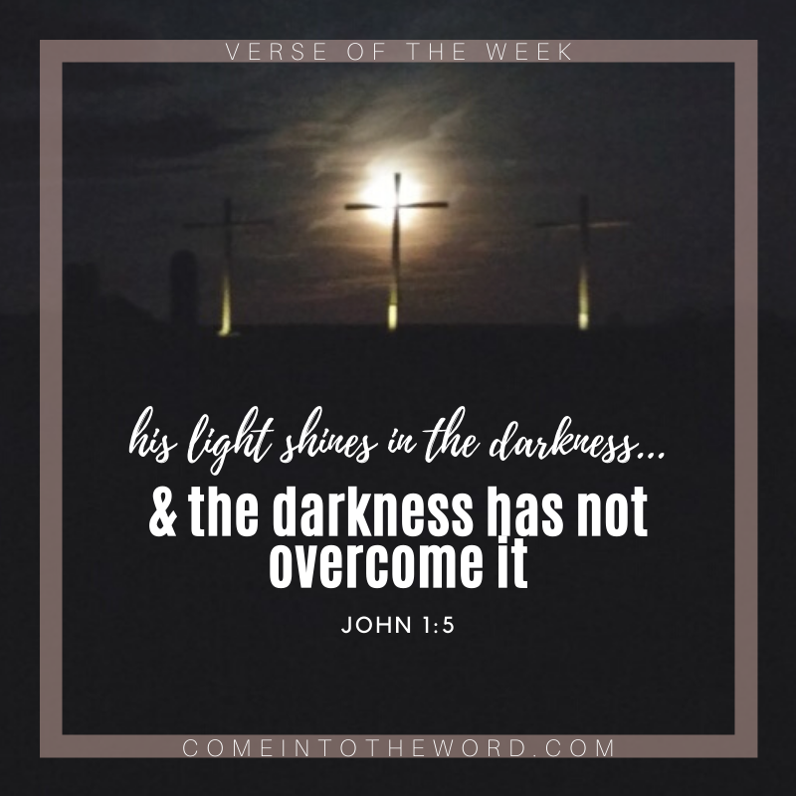

THE CREED

All I believe in God the Father,
whose loving care is the pattern for family life.
I believe in Jesus, the Son of God,
who lives in my heart through faith,
and fills me with his love.
I believe in God the Holy Spirit,
who strengthens me with power from on high.
I believe in one God;
Father, Son and Holy Spirit. Amen.

A time of quiet prayer for
• The universal Church - Bishops, synods and all leaders church
• The leaders of the nations
• The natural world and the resources of the earth

Loving God I see the news and I am afraid. Violence is spiralling out of control. I don’t know what to think or feel. The temptation to fall into hatred, or despair feels very close at hand.
Help me to remember that nothing in all creation can separate me from your love that I know in Jesus. May your perfect love for me cast out my fear and free me to discern what is mine to do amidst the chaos of this suffering world.
Amen.

Finishing with the South Calder Mission Community prayer...
Heavenly Father we thank you for the life of your Church
in this place, and in all the villages of the South Calder Mission Community;
for all who have served and worshipped you in years gone by,
for all who make up your family in our churches today, for the faith we have in common, and for the people and traditions which make each church unique.
By your Spirit, guide and equip us, that together we might find new ways to reach out to our local community, to show your love to our neighbours, and to encourage them to follow the Lord Jesus in their lives. Father, we offer ourselves to your service. In the unity of the Holy Spirit, And in the name of Jesus Christ our Lord. Amen.

and the Lord’s prayer...
Our Father, who art in heaven,
hallowed be thy name; thy kingdom come;
thy will be done; on earth as it is in heaven.
Give us this day our daily bread.
And forgive us our trespasses,
as we forgive those who trespass against us.
And lead us not into temptation;
but deliver us from evil.
For thine is the kingdom,
the power and the glory,
for ever and ever. Amen.

THE CONCLUSION

Suggested hymn to sing or read Hark the herald angels sing.

The following prayer is said
Be with me, Lord, as I finish my prayer today.
May my lips always speak the truth;
may my eyes which have read your word
see only what is good;
and may my life as well as my worship
be always pleasing in your sight,
for the glory of your name. Amen.

And now may the Lord who brought us to birth by his Spirit,
strengthen us for the Christian life.
May the Lord who provides for all our needs
sustain us day by day.
May the Lord whose steadfast love is constant as a mother's care,
send us out to live and work for others.
And the blessing of God Almighty.
the Father, the Son, and the Holy Spirit,
be with us and remain with us always.
Amen.
So now may I go in peace to love and serve the Lord.
In the name of Christ. Amen.

Links for the hymns

It came upon the midnight clear.

https://youtu.be/_U_Dzovu1XA

O come all ye faithful.

https://youtu.be/zw-FAqx9kpw

Love came down at Christmas.

https://youtu.be/HLws2WvdXdM

Hark the herald angels sing.

https://youtu.be/1IGP68i3JvU

