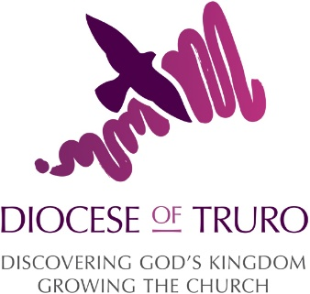

Bishop David’s concluding prayer in his first Christmas Message 2025, as Bishop of Truro:

Bishop David says how “Christmas reminds us again and again that hope does triumph over despair, that love does win over evil. That light shines in the darkness, and darkness will never put it out”
He concludes his message to us all with:
“I wonder if I could pray for you this Christmas.
May the joy of the Angels
May the worship of the Shepherds
May the gladness of the Wise Men
May the obedience of Mary and Joseph
May the Peace of the Christ Child
Be yours this Christmas.
And the Blessing of God, Father, Son and Holy Spirit
Be yours this day and the days to come,
Amen
