Sunday 28th December 2025 St Paul’s, Woodhouse Eaves
WE WELCOME YOU, for we are all one in Christ Jesus

MISSION  Our Mission Statement  Our Mission is to make known the Gospel and love of Jesus Christ. We hope that you experience us as a safe, sacramental, welcoming, loving and inclusive Kingdom people who seek to make Christ present in the hearts of all.  Safeguarding  The parishes of St Paul’s, Woodhouse Eaves & St Mary’s, Woodhouse, are committed to the safeguarding of children, young people and adults. We follow the House of Bishops’ guidance and policies, and have our own Parish Safeguarding Officers. If you are concerned that a child or adult has been harmed or may be at risk of harm please contact –  ST PAUL’S - Safeguarding  Co-ordinator: Tony Lane  07977 924 677  ST MARY’S - Safeguarding  Co-ordinator: Andrea Farnsworth 07958 376 963  As a Benefice, we affirm that it is about not just a set of policies and procedures, but about all of us as the body of Christ sharing the responsibility for making God’s Church as safe as we can  Please take this pew sheet  home and recycle it when you’ve read it. Thank you |  | PRAYER  Let us use our time  before the service  to talk to God,  during the service  may God talk to us, and  after the service  let us talk to one another  If you would like someone to listen or to pray with you, please contact your Parish Priest:  Rev’d Lisa Temperley-Barnes - 01509 890 972  If you would like us to pray for someone by name in our Sunday services and through the week, please email Rev’d Lisa or Stephen  A Christmas prayer  Lord Jesus Christ,  your birth at Bethlehem  draws us to kneel in wonder  at heaven touching earth:  accept our heartfelt praise  as we worship you,  our Saviour and our eternal God. Amen |  | We pray for all who are ill  for Dennis, Gill Kelly,  Judy Riley, Tom Hobbs,  Sue and John Thorne,  June Shilton, Joseph Breed  We remember before God  the faithful departed,  and from St Mary’s  Book of Remembrance  Ellen Elizabeth ‘Nellie’ Wood, Derek Royston Smith  and from St Paul’s  Book of Remembrance  Simon Burt, Andrew ‘Andy’ Gravil, John Charles Chapman, Nicholas Chapman, Sidney Charles Henry Preston, Lauryn Paige Ann Bradley, Patrick Joseph Tobin, Margaret Maude Leslie  Rest eternal grant unto them, O Lord, and let light perpetual shine upon them. May the souls of the faithful departed through the mercy of God, rest in peace and rise in glory. Amen  A prayer for peace  God in Trinity,  eternal unity of perfect love:  gather the nations  to be one family,  and draw us into your holy life through the birth of Emmanuel, our Lord Jesus Christ. Amen  
Christmas 1 Sung Eucharist
COLLECT  Almighty God, who wonderfully created us in your own image and yet more wonderfully restored us through your Son Jesus Christ: grant that, as he came to share in our humanity, so we may share the life of his divinity; who is alive and reigns with you, in the unity of the Holy Spirit, one God, now and for ever. Amen  FIRST READING  A reading from the prophet Isaiah  I will tell of the Lord's unfailing love;  I praise him for all he has done for us.  He has richly blessed the people of Israel  because of his mercy and constant love.  ⁸ The Lord said, “They are my people; they will not deceive me.” And so he saved them ⁹ from all their suffering. It was not an angel, but the Lord himself who saved them. In his love and compassion he rescued them. He had always taken care of them in the past,  Isaiah 63:7-9  This is the word of the Lord  Thanks be to God |  | PSALM 148:7-end  Refrain: O praise the name of the Lord  - Praise the Lord from the earth ♦  you sea monsters and all deeps;  - Mountains and all hills ♦  fruit trees and all cedars. R  - Kings of the earth and all peoples ♦  princes and all rulers of the world;  - Young men and women, old and young together; ♦  let them praise the name of the Lord. R  - For his name only is exalted, ♦  his splendour above earth and heaven. R  Glory be to the Father, and to the Son, and to the Holy Spirit: as it was in the beginning, is now, and ever shall be, world without end. Amen  GOSPEL  Alleluia, alleluia  “Speak, Lord, your servant is listening. You have the words to eternal life.”  Alleluia  Hear the holy Gospel of our Lord Jesus Christ according to St Matthew  -  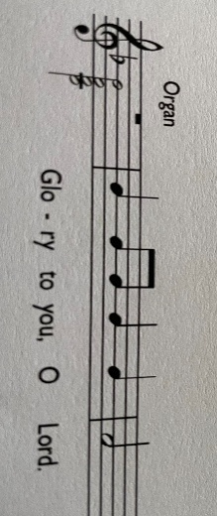  Now after they had left, an angel of the Lord appeared to Joseph in a dream and said, ‘Get up, take the child and his mother, and flee to Egypt, and remain there until I tell you; for Herod is about to search for the child, to destroy him.’ ¹⁴ Then Joseph got up, took the child and his mother by night, and went to Egypt, ¹⁵ and remained there until the death of Herod. This was to fulfil what had been spoken by the Lord through the prophet, ‘Out of Egypt I have called my son.’ |  | ¹⁶ When Herod saw that he had been tricked by the wise men, he was infuriated, and he sent and killed all the children in and around Bethlehem who were two years old or under, according to the time that he had learned from the wise men. ¹⁷ Then was fulfilled what had been spoken through the prophet Jeremiah:  ¹⁸ ‘A voice was heard in Ramah,  wailing and loud lamentation,  Rachel weeping for her children;  she refused to be consoled, because they are no more.’  ¹⁹ When Herod died, an angel of the Lord suddenly appeared in a dream to Joseph in Egypt and said, ²⁰ ‘Get up, take the child and his mother, and go to the land of Israel, for those who were seeking the child’s life are dead.’ ²¹ Then Joseph got up, took the child and his mother, and went to the land of Israel. ²² But when he heard that Archelaus was ruling over Judea in place of his father Herod, he was afraid to go there. And after being warned in a dream, he went away to the district of Galilee. ²³ There he made his home in a town called Nazareth, so that what had been spoken through the prophets might be fulfilled, ‘He will be called a Nazorean.’  Matthew 2:13-end  This is the Gospel of the Lord  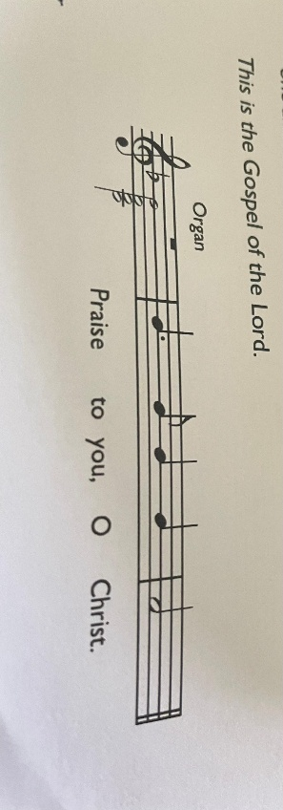  POST COMMUNION  Heavenly Father, whose blessed Son shared at Nazareth the life of an earthly home: help your Church to live as one family, united in love and obedience, and bring us all at last to our home in heaven; through Jesus Christ our Lord. Amen

