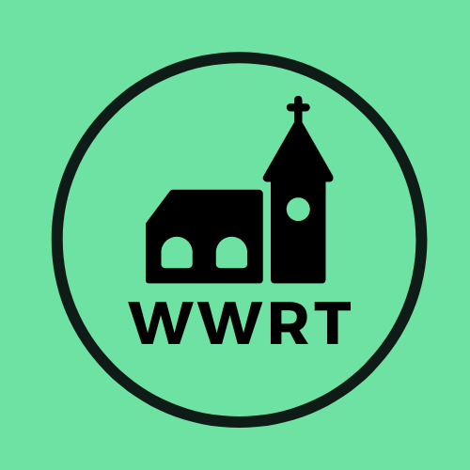
CHURCH SERVICES IN MARTLEY AND WICHENFORD
DECEMBER 2025

Sunday 7th December
2nd Sunday of Advent
10.30am CW Holy Communion and Advent Car., St Peter, Martley
10.30am All Age Advent Service, St Mary Magdalene, Broadwas

Sunday 14th December
3rd Sunday of Advent
4.00pm Carol Service, St Laurence, Wichenford

Sunday 21st December
4th Sunday of Advent
5.00pm Carols and Christingle, St Peter, Martley

Wednesday 24th December
Christmas Eve
10.00pm Holy Communion, St Laurence, Wichenford
11.00pm Holy Communion, St Peter, Martley

Thursday 25th December
Christmas Day
11.00am Family Worship, St Peter, Martley

Sunday 28th December
Christmas 1
10.30am Benefice CW HC, St Thomas, Crown East

In December there will be Holy Communion at Heaton House, Martley on the 2nd and 4th Wednesday at 10.15am and on the 1st and 3rd Wednesday via our YouTube channel -wwrtlive1.

All services and timings are subject to review and amendment – please check the website for updates: www.achurchnearyou.com

