A service of celebration & thanksgiving for the ministry of retired clergy.
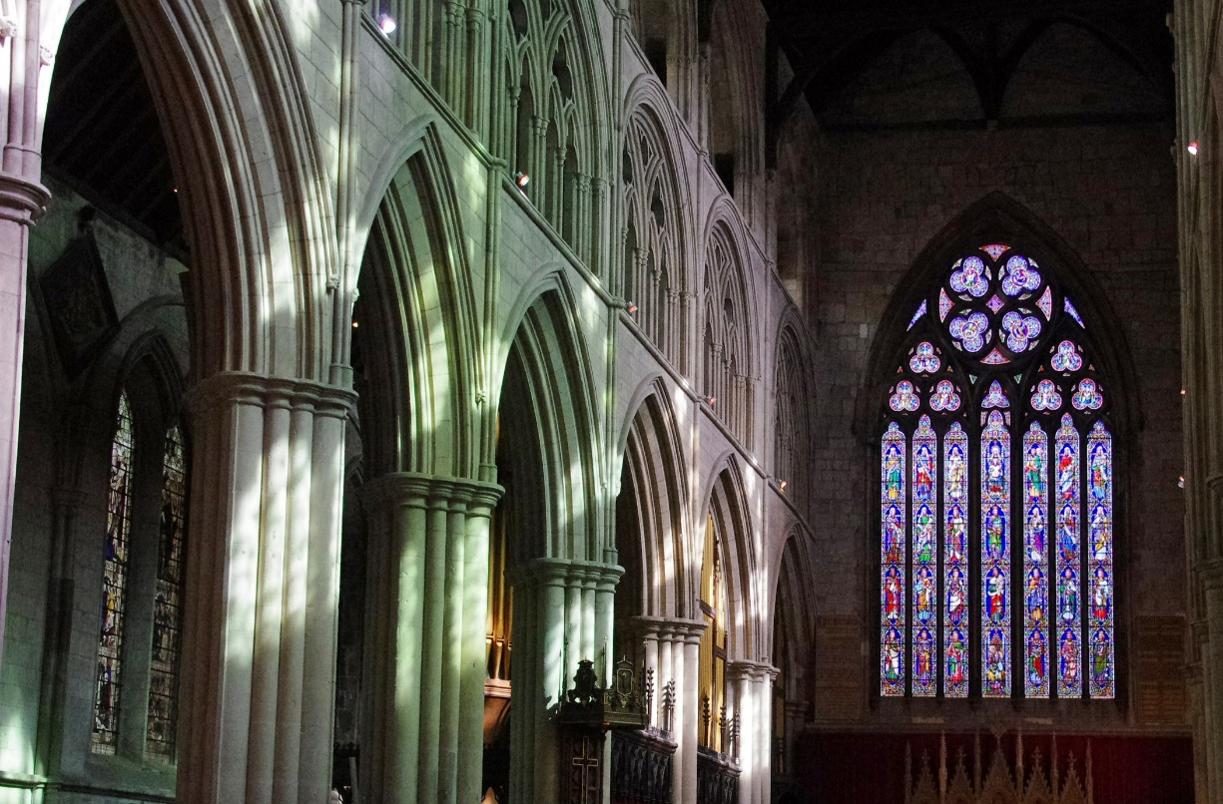
Saturday 15th November 3pm
Bridlington Priory
with Bishop Eleanor Sanderson, Bishop of Hull.
All are welcome.

