Yorkshire Dales 2 bedroom cottage situated in the hamlet of CB Yard in Arkengarthdale

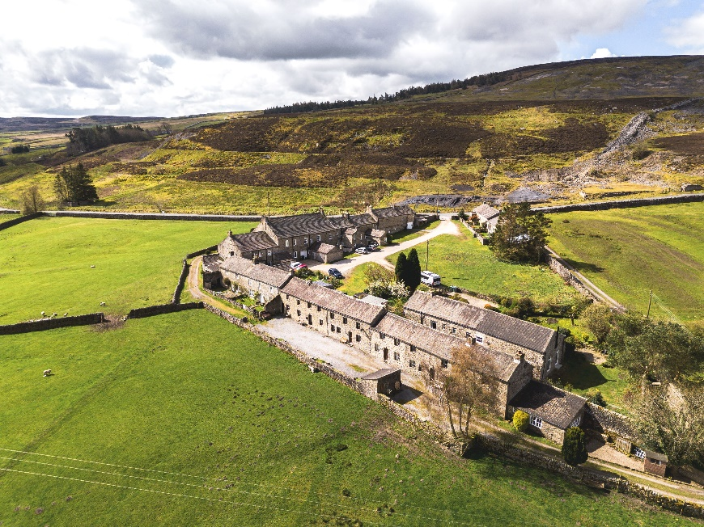

2 night stay in low season 2026 (subject to availability).
12 January – 27 March or 2 November – 19 December
For full details see website - https://www.cottages.com/cottages/swallowholm-inj

