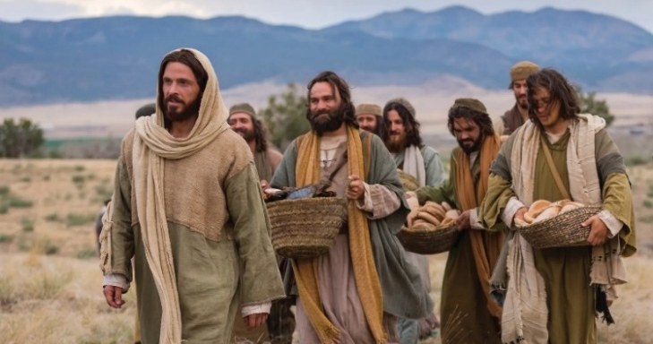
But seek ye first the Kingdom of God….

You are invited to a
Celtic Encounter
The Kingdom
Our path and our destination
A short time of Celtic style Christian worship
Tuesday, 11th November at 3pm
at Porchfield Village Hall
Refreshments afterwards. All welcome.

Your kingdom come; Thy will be done on earth as it is in heaven

Further information text or ring Alison on 07870 509153.

