Advent Reflections 2025

Advent means "coming" or "arrival".
The focus of the entire season is preparation to celebrate the birth of Jesus. It is celebrating a truth about God, the revelation of God in Christ whereby all of creation might be reconciled to God. It has a focus in the past: ‘Christ was born’, in the here and now: ‘Christ is with us’, and in the future: ‘Christ will come again’. Advent is marked by a spirit of waiting, of expectation, of anticipation, of preparation, of longing, and of reflection.
This year for our Advent journey we will be looking at women who are part of the story of the incarnation of Jesus.

Women of the Incarnation
(based on the Women of the Nativity, by Paula Gooder)

Elizabeth, and Mary, who are very much central to the incarnation story, and Anna and Phoebe, who form part of the revelation of the incarnate Christ to the world.
We will look at the stories of these women through the lenses of scripture, tradition, reason, and experience, which are the foundational elements in Christian theology and have shaped faith and practice in our faith over the millennia.
Read the first paragraph, which offers a short introduction, and then read the passage. You might like to reflect on the passage for a while before reading the background and then the ponderings. Finally end with prayer: either the one written or one of your own.
How you choose to use this material is up to you, but hopefully you will be able spend time during this ‘waiting time’ of Advent to draw closer to God and find something new in these stories of the incarnation and revelation of Christ.
Anne Brown, Judie Horrocks, October 2025



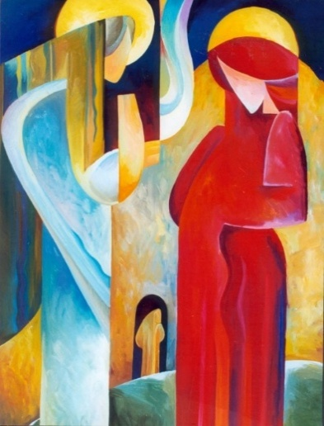
Week 1 Mary
(Annunciation, Painting on glass by Andriy Khomyk)
We learn about Mary, the mother of Jesus, from the gospel accounts of Matthew, Mark, Luke and John, and from the beginning of the Acts of the Apostles. Not only was her presence woven throughout the life of her son but after his death she continued as part of the community of faith.
Read Luke 1 26-38
From that moment on, Mary’s life, her marriage to Joseph, the birth of her firstborn son, and her relationship with him down the years were unconventional, to say the least.
In Mary’s time, marriage involved two stages: the betrothal, which could take place once a girl was 12 years and 1 day old. Then, after an interval of up to a year, she would have been taken from her parental home to the house of her husband-to-be and at that moment they would have been considered properly married.
A girl who became pregnant outside marriage would have been terrified because the whole social structure was set up for children to be born within it. Girls like Mary would most likely have had to leave their homes and their families and might have been sold into slavery or prostitution or even stoned to death.
It is against this backdrop that we read these words from the first chapter of Luke’s gospel. How remarkable it is that her first reaction to the news conveyed to her is to say: ‘Here am I, the servant of the Lord; let it be with me according to your word.’ It is for this reason, among others, that Mary is revered by many for the way that she responded to the unexpected challenges that life presented her.

Ponderings
- How much do you think Mary (and Joseph) understood about who Jesus was?
- The biblical account doesn’t tell us much about Mary. When you think about her, what do you ‘add’ to her story to help you understand her?
- What inspires you most about the character of Mary?

Prayer
Dear Lord, grant to us, like Mary, faithfulness and a heart full of worship so that we might give you thanks even when life is challenging.
Amen. xx

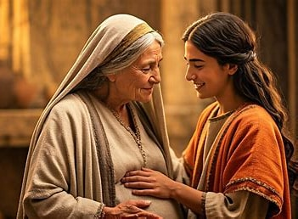
Week 2 Elizabeth
(Image – The Visitation as portrayed in the film ‘The Story of Jesus’, 1979)
We first meet Elizabeth at the beginning of Luke’s gospel account of the life of Jesus, although almost as a character offstage away from the main action, which involves her husband Zechariah. Until she proclaims that the impending birth of her son John the Baptist is a sign of God’s blessing on her life. Then, a few months later, she is visited by Mary, now pregnant herself.
Read Luke 1 39-45, 57-66
We know nothing of the details of Elizabeth’s life other than what we learn about her as the wife of a priest in the temple and the mother of the one whom Luke described as: “Among those born of women, there is not a greater prophet than John the Baptist.” (Luke 7.28)
In her response to her own unexpected pregnancy, in her reactions during her encounter with Mary, and in her support for Zechariah in naming their child unconventionally we can discover hints of the woman that she was.
When he first introduces them, Luke describes both Zechariah and Elizabeth as ‘righteous’ – as honourable and upright followers of God. And from what she says and does, we learn that Elizabeth had indeed learned to trust in God, even in the face of society’s judgment and insurmountable odds. Perhaps her openness to God at work in her own life was part of what helped her recognize God at work in Mary and rejoice with her about the coming birth of Christ.
Together, they stood as sisters in faith, ready to prepare the way of the Lord.

Ponderings
- What do you think Mary and Elizabeth talked about when they met?
- Attitudes to motherhood and childbirth and the place of women in society have changed dramatically since the first century. How can we tell Elizabeth’s story today, in a way that doesn’t come across as judgmental and inappropriate in our context?
- Do you know what your name means? Why do you think names are so important in the bible?

Prayer
Dear God, grant to us open and accepting hearts towards those whose lives are different to our own, so that we may recognize you at work even in unexpected places.
Amen.

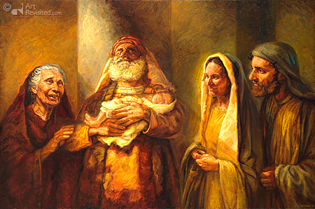
Week 3 Anna
(Image Simeon and Anna by Jan van 't Hoff)
Anna is one of the few women mentioned in the whole bible as a prophet, moreover she is one handful of people in the New Testament specifically called a prophet.
Read Luke 2 22-38
From three verses in Luke, the following is known of Anna:
She was a prophetess. She was a daughter of Phanuel. She was a member of the tribe of Asher. She was widowed after seven years of marriage (her husband is not named). She was a devout Asherite Hebrew who regularly practiced prayer and fasting.
The Tribe of Asher is descended from Asher, the eighth son of Jacob and Zilpah, (Genesis 30:12-13). The name "Asher" means "happy" or "blessed."
Luke describes Anna as "very old". Many Bibles and older commentaries interpret the New Testament text to say that she was 84 years old. The passage is generally translated as "she was a widow of eighty-four years”; however the Greek is ambiguous. It could mean that she was 84 years old, or that she had been a widow for 84 years. Orthodox tradition considers that Christ met his people, Israel, in the persons of Anna and Simeon.
In the short passage about Anna, we come to understand that she is an old woman who shows courage and vision; patience and persistence; love and joy.

Ponderings
- What do you think made Anna (and Simion) recognise Jesus?
- Consider Simeon who was at the temple because he was ‘guided by the Spirit’ and Anna who was always there because she was a prophet. How do these contrast with each other, and what can we learn from these perspectives?
- What signs of God in the world do you notice and what makes you think they are signs of God?

Prayer
Dear Lord, grant to us, like Anna, patience and the wisdom of age to see you at work and joy at being part of your revelation to the world.
Amen.xx

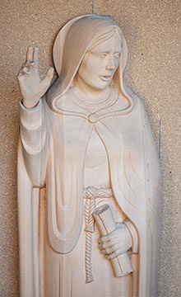
Week 4 Phoebe
(Image sculpture St Phoebe, Mark Carroll)
Phoebe is mentioned at the end of Paul's letter to the followers of Christ in Rome. This is not an afterthought by him but highlights her importance in the early Christian community. Her name means ‘shining’ and it is likely she was a Greek, having been named after a Greek god.
Read Romans 16:1-2.
What we know from these two verses is that Paul commends her to the Roman followers of Christ, describing her as a deacon (Greek: diakonos) of the church in Cenchreae, a port city near Corinth. This designation indicates that she held some form of official position within the church, serving in a leadership capacity similar to other male leaders mentioned in the New Testament. Paul emphasizes her role as a benefactor or patron, suggesting that she was a woman of means who supported many, including Paul himself.
Phoebe's mention in Paul's letter highlights her importance in the early Christian community. She is believed to have been responsible for delivering Paul's letter to the Romans, a task that underscores her trustworthiness and leadership and willingness to undertake the dangerous journey.
Paul’s commendation indicates that she was not only a respected member of the church but also played a crucial role in the growth and support of the early Church.
Phoebe's contributions reflect the active involvement of women in the early church, challenging traditional views about gender roles in ministry. Her example illustrates that women were integral to the church's mission, serving in various capacities and providing support to the community. The Greek term ‘diakonos’ used to describe her role is significant, as it is the same term applied to male leaders, suggesting that Phoebe's leadership was recognized and valued.

Ponderings
- Phoebe stands as a model of faith, service, courage and leadership in the early church. How can we embody that today?
- Phoebe travelled a long way to take Paul’s message to the church in Rome. What dangers was she willing to face and are we willing to face similar challenges?
- Consider how we can today, share the message of Jesus with others.

Prayer
Dear God, give me the courage, faithfulness and grace of Phoebe, to share your Good News, wherever I am called.
Amen.

