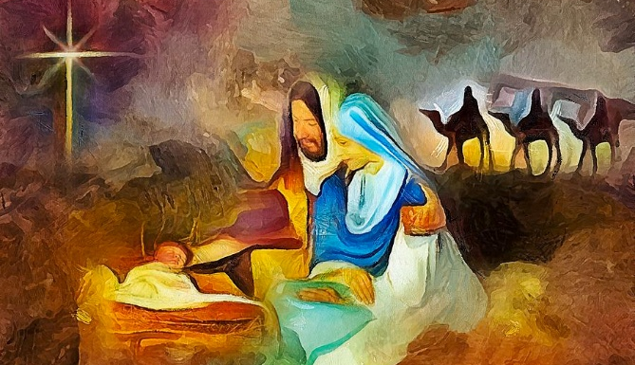

You are invited to a
Celtic Encounter
The Joy of Christmas
at the Brighstone Christmas Tree Festival
Thursday, 4th December at 3pm
Olive Garden, St Mary’s Churchyard, Brighstone
or in the church depending on the weather!
Refreshments afterwards. All welcome.


Further information text or ring Alison on 07870 509153.

