St Mary Magdalene Church Medomsley
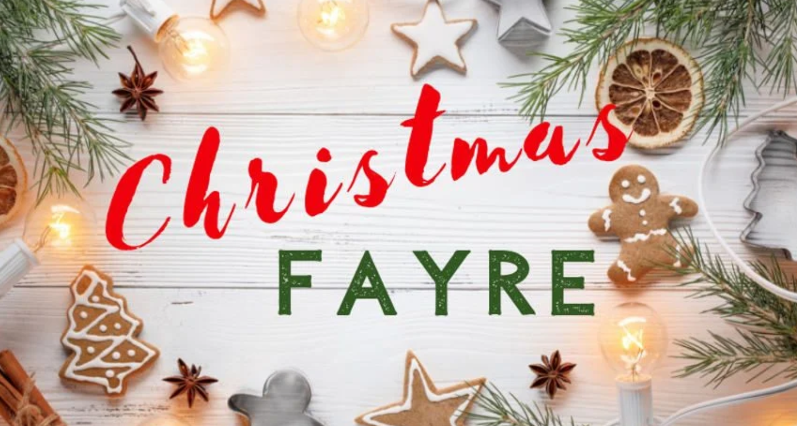

Christmas Fayre
Saturday 22nd November
11am – 1pm
Lunch, refreshments, home baked food stall, raffle, tombola, bottle stall, gifts & Christmas fun, books
All Welcome

