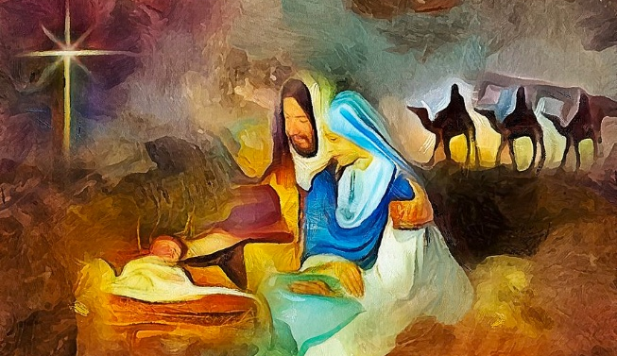

You are invited to a
Celtic Encounter
The Joy of Christmas
A short time of Celtic style Christian worship
Tuesday, 9th December at 3pm
At Porchfield Village Hall
Refreshments afterwards. All welcome.


Further information text or ring Alison on 07870 509153.

