CHURCH SERVICES IN CLIFTON, THE SHELSLEYS AND LOWER SAPEY (HARPLEY)
November 2025
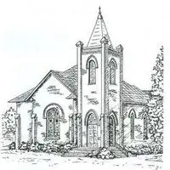

Sunday 2nd November
10.30am: Holy Communion, St Kenelm’s, Clifton
3.00pm: ‘Remembering a Loved One’ All Soul’s Service, St Kenelm’s, Clifton

Sunday 9th November
10.45am: Harpley Outdoor Act of Remembrance,
St Bartholomew, Harpley
10.45am: Service of Remembrance, All Saints,
Shelsley Beauchamp
10.45am: Clifton Parade and Service of Remembrance,
St Kenelm’s, Clifton

Tuesday 11th November
10.45am: Observance of Armistice Day, Village Green, Clifton

Sunday 16th November
10.00am: Praise 4 All, St Kenelm’s, Clifton
6.30pm: Evensong, St Kenelm’s, Clifton

Wednesday 19th November
10.30am: Holy Communion, St Andrews, Shelsley Walsh

Sunday 23rd November
10.30am: Circle Service, St Bartholomew, Harpley

Sunday 30th November
6.30pm: Advent Praise with guest musicians, St. Kenelm’s

