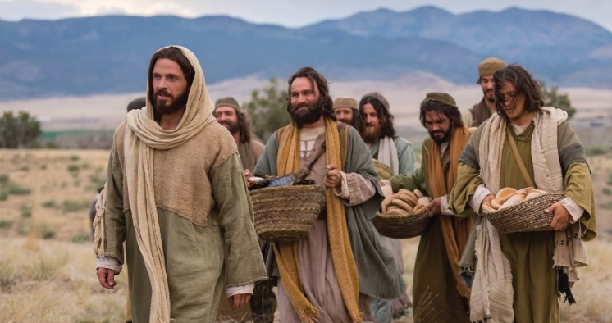
But seek ye first the Kingdom of God….

You are invited to a
Celtic Encounter
The Kingdom
Our path and our destination
Thursday, 6th November at 3pm
Olive Garden, St Mary’s Churchyard, Brighstone
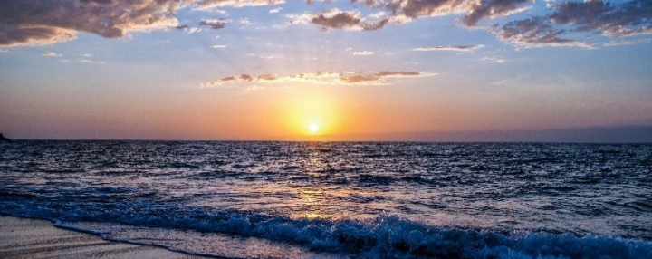
Refreshments afterwards. All welcome.
Your kingdom come; Thy will be done on earth as it is in heaven

Further information text or ring Alison on 07870 509153.
If wet the Celtic Encounter will be held in the church.

