
St Augustine of Hippo
Grimsby

A Forward in Faith Parish

Parish Magazine



December 2025
Our Giving

Bank details for standing orders or donations are:
TSB Bank
St Augustine of Hippo PCC
Sort Code: 30-93-72 Account Number: 00159954

You may have seen that many charity bank accounts have started
charging fees for every day transactions. It costs us money to bank cheques and cash, which devalues the amount of the donation/payment. We are therefore asking that, wherever possible, people donate money using online banking, even for small amounts. This doesn't cost us a penny. Please indicate in the reference field who it's from, and what for, then we can Gift Aid your donation wherever possible. Gift aid forms should be completed for regular giving by standing order if applicable. Thank you.


Donating by card or phone

We have a card machine positioned at the back of church near the south door as an alternative way of giving. Please bear in mind that a percentage of all giving using this method (between 1% and 2%) is taken by the provider.

Regular Sunday giving by oﬀertory collection plate


It is no longer necessary to use gift aid envelopes for cash donations of £30 or less. This again keeps administration down. However, should you wish to make a higher donation, please use gift aid envelopes as usual.
Anniversary of Deaths / Year’s Mind Parish Records for December
2 2019 Robert Graham Shearlaw 83
3 2002 Arthur Geo. Johnson Cole 84
4 2002 Stanley Smith 79
5 2002 Jack Beales 85
9 1989 Wilfred Windley 90
10 2017 Margaret Jean Warmsley 75
12 1987 Marion Windley 90
12 2024 Doris Goldberg 91
15 1986 Barbara May Beckett 61
15 2011 David Goldberg 81
15 2020 Jim Cullum
17 2017 Kathlen May Coates
25 1979 Charles Chapman
28 1981 Percy Robinson 82
30 1989 Joan Martyn LBE 90

If you have any additional information to complete any gaps for those
listed, or information relating to anyone you know of who should be
included please let me know on: mrs.maria.mason@gmail.com

Thank you
Maria

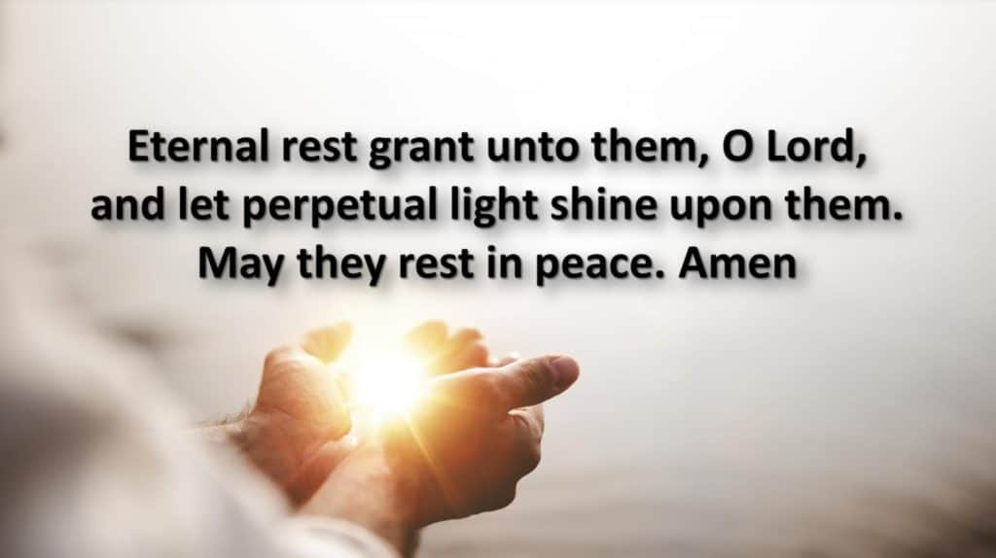

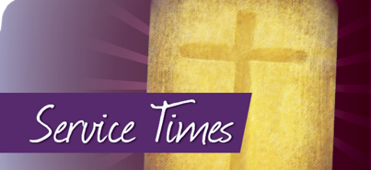
December Worship Times

First Week of Advent
Monday 1 December 10am Said Mass
Tuesday 2 December 6.30pm Said Mass
Wednesday 5 November 10am Said Mass followed by Coffee Morning

Second Week of Advent
Sunday 7 December 10am Sung Parish Mass
Monday 8 December 10am Said Mass
Tuesday 9 December 6.30pm Said Mass
Wednesday 10 December 10am Said Mass followed by Coffee Morning

Third Week of Advent
Sunday 14 December 10am Sung Parish Mass
Monday 15 December 10am Said Mass
Tuesday 16 December 6pm Oasis Academy Christmas Concert
Wednesday 19 December 10am Said Mass followed by Coffee Morning

Fourth Week of Advent
Sunday 21 December 10am Sung Parish Mass
3.30pm Evensong and Benediction
Monday 22 December 10am Said Mass
Tuesday 23 December 6.30pm Said Mass
Wednesday 24 December 4pm Christingle Family Service
11.30pm Sung Parish Mass
Thursday 25 December 10am Said Mass
Friday 26 December 10am Said Mass
Saturday 27 December 10am Said Mass

First Week of Christmas
Sunday 28 December 10am Sung Parish Mass
Monday 29 December 10am Said Mass
Tuesday 30 December 6.30pm Said Mass
Wednesday 31 December 10am Said Mass followed by Coffee Morning

December 2025 Calendar
Dates, Observances and Prayer Intentions
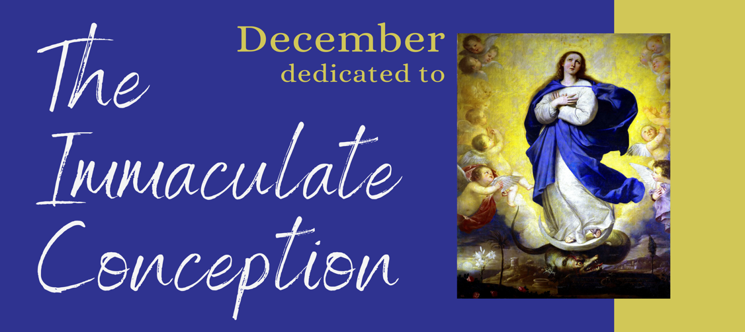
Month of Devotion to the Immaculate Conception
Date Feast Intentions
1 Advent Feria Primary School Teachers
2 Advent Feria Lisle Mardsen Academy
3 St Francis Xavier Missionaries
4 Advent Feria Monastics
5 Advent Feria Persecuted Christians
6 St Nicholas Commerce
7 Second Sunday of Advent The Parish
8 Immaculate Conception of the BVM The Parish
9 Advent Feria Mexican Christians
10 Advent Feria Pilgrims
11 Advent Feria Bishop Luke
12 Advent Feria Bishop Stephen
13 St Lucy Great Women of Faith
14 Third Sunday of Advent
(Refreshment or Gaudete) The Parish
15 Advent Feria Benedictines
16 Advent Feria Carmelites
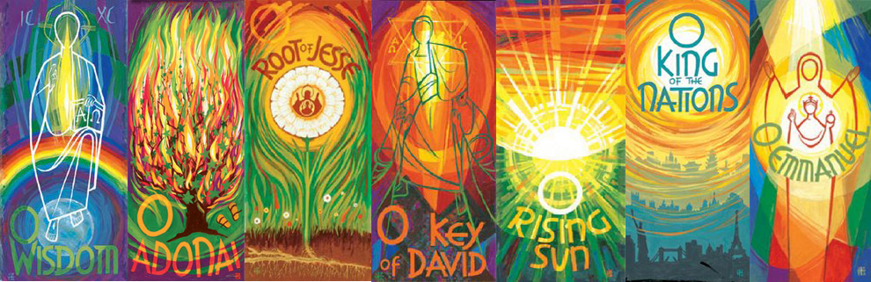

17 O Sapientia Our PCC
18 O Adonai Our Servers
19 O Radix Jesse Our Organist and Choir
20 O Clavis David Our Welcomers
21 Fourth Sunday of Advent (O Oriens) The Parish
22 O Rex Gentium Earthly Rulers
23 O Emmanuel Polish Christians
24 Christmas Eve Those Expecting Children
25 Christmas Day The Parish
26 St Stephen The Parish
27 St John Evangelist The Parish
28 The Holy Family The Parish
29 St Thomas Becket The Parish
30 Christmas Feria Eleanor Archdeacon Elect of
Stowe and Lindsey
31 Christmas Feria Pope Leo

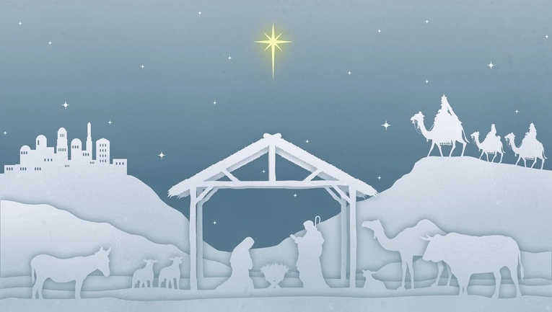
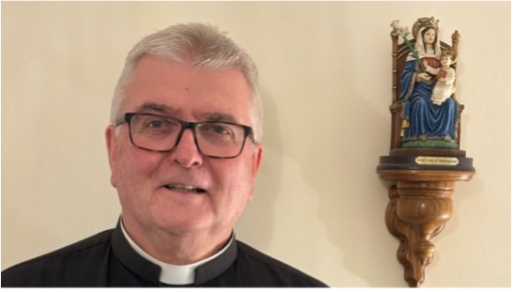

Fr Adrain Writes . . . . . . . . .

Advent for me focuses on two things, both to do with movement.
The word Advent finds its root in the Latin word Advenio, meaning "to arrive," "to come to," or "to reach". Literally translated, ad- ("toward") and veniō ("to come"). The Latin noun form, adventus, means "arrival". I knew scraping an O-level in Latin would come in handy at some stage!
The two things for me are exactly that. We move towards Christmas and we ponder the Second Coming in Glory of Our Lord Jesus Christ.

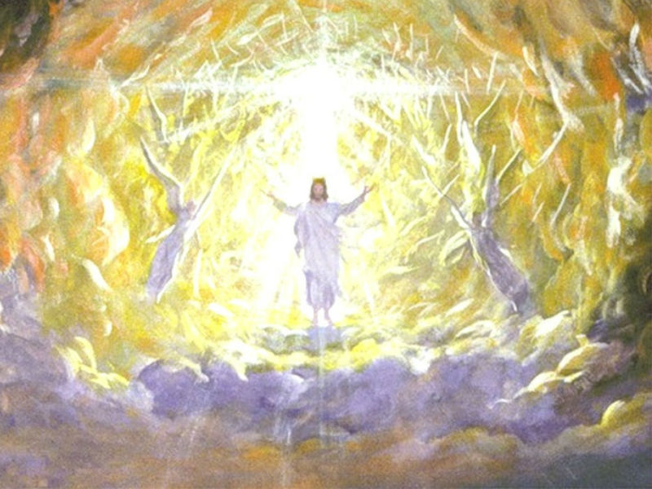
After a little consultation with our Standing Committee, I have arranged for us to try a revised liturgy for our masses during Advent. Hopefully this will help us all to feel that Advent is a different season. It has a different feel, different flavour. Sometimes we miss that difference. There are slight differences on some of the wording and the Peace occurs in a different place. We omit the Gloria and we have our Advent Wreath/Crown. The change in liturgy will also bring us in line with other churches in the Society of Ss. Wilfred and Hilda, within our Diocese and the other churches of the Society LMP.
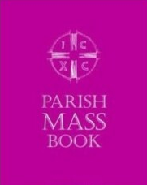
Hopefully, this will prompt us to ponder the two aspects of Advent; the preparation for Christmas so that we arrive fully ready; and the preparation to meet our Lord face to face at His Second Coming.
So, as we enter Advent, let us pause and reflect on the coming of Christ—both in history and in our hearts today. This season is a time of hope, anticipation, and gentle preparation. Amid the busyness of December, Advent calls us to make space for prayer, kindness, and quiet moments with God.

Let us use these weeks to open our hearts to the blessings around us, to reach out to those in need, and to prepare ourselves spiritually for the joy of Christmas and meeting Our Lord face to face. May each day of Advent bring us closer to the light of Christ, filling our lives with peace and love.

With every blessing

Fr Adrian

The Immaculate Conception
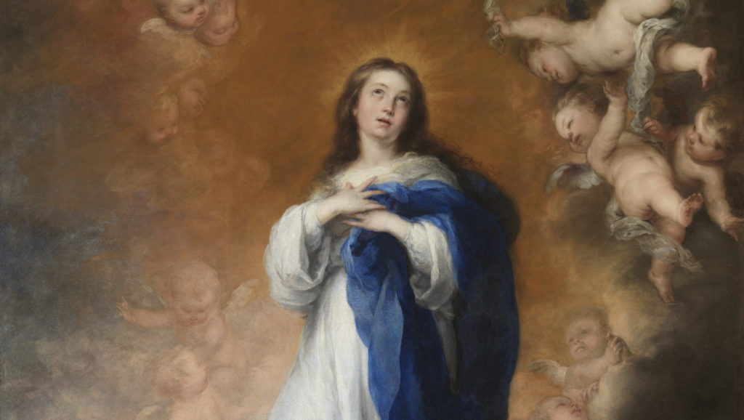

The Immaculate Conception was declared a dogma in the year 1854. But the belief has been with the Church since the beginning.

In the fourth century, St. Athanasius said, “The Lord, who knows his entire creation well, saw in it nothing like Mary. In the entire creation, everything else was subject to the curse of the Fall of Adam and Eve.” So what was that curse?

It was original sin, with all its horrible effects (see Genesis 3:16–19). Instead of paradise, our first parents faced a life of pain and futility that must end in death.

Adam was a “type.” That’s what St. Paul called him (Romans 5:14), and that means that Adam foreshadowed an eventual fulfilment. St. Paul also tells us that the New Adam is Jesus (1 Corinthians 15:22, 45, 47).

Paul said explicitly that Jesus is the New Adam. The Church Fathers said overwhelmingly that the Virgin Mary is the New Eve.

The earliest Christians insisted that Mary did not suffer labour pains in giving birth. We see this already in the first century — in documents known as the Ascension of Isaiah, the Odes of Solomon, and the Infancy Gospel of James.

It mattered because they believed that the New Creation was a fulfilment of the Old. They believed that God had made the conditions of the New Creation to be recognizably like the conditions of the original creation.

That’s why the story of Jesus, as it appears in the Book of Revelation, turns on the interaction of a man, a woman, and a serpent.

The difference in the story of the New Adam and Eve is that their story ends well.

It’s reasonable for us to expect that the New Man and New Woman should enjoy the privileges of their first forebears. So, as the early Christians told the story, Mary’s pregnancy and birth proceeded without pain, as if God had never pronounced the punishing curse of Genesis 3:16.

This, in turn, led the Fathers to the conclusion that Mary was without sin. Listen to Ephrem of Syria as he sang a song to Jesus in the fourth century: “You alone and your mother are more beautiful than any others, for there is no blemish in you nor any stains upon your mother.”

In the same century, St. Ambrose called Mary “a virgin not only undefiled, but a virgin whom grace had made inviolate, free of every stain of sin.” In a second-century epitaph in Rome, the virgin is hailed as “spotless,” “immaculate.”

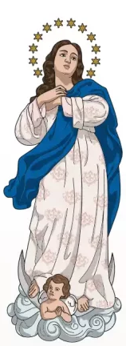
And St. Augustine would not even allow himself to speak of the virgin Mary in the context of his discussion of sin. He acknowledges that all have sinned, but he goes on to say, “We must make an exception of the holy virgin Mary, concerning whom I wish to raise no question when it touches the subject of sins, out of honour to the Lord.”

Other voices sing in this choir. I’ve mentioned only a few. Add your own voice as the Church celebrates the Immaculate Conception on December 8. Make sure to go to Mass.
Saint Francis Xavier’s Story
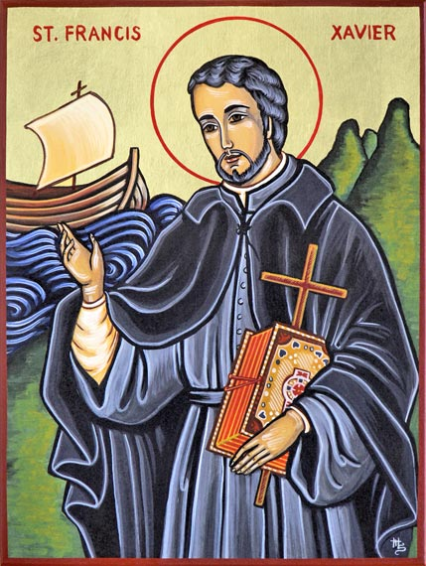
Jesus asked, “What profit would there be for one to gain the whole world and forfeit his life?” (Matthew 16:26a). The words were repeated to a young teacher of philosophy who had a highly promising career in academics, with success and a life of prestige and honour before him.
Francis Xavier, 24 at the time, and living and teaching in Paris, did not heed these words at once. They came from a good friend, Ignatius of Loyola, whose tireless persuasion finally won the young man to Christ. Francis then made the spiritual exercises under the direction of Ignatius, and in 1534, joined his little community, the infant Society of Jesus. Together at Montmartre they vowed poverty, chastity, obedience, and apostolic service according to the directions of the pope.
From Venice, where he was ordained a priest in 1537, Xavier went on to Lisbon and from there sailed to the East Indies, landing at Goa, on the west coast of India. For the next 10 years he labored to bring the faith to such widely scattered peoples as the Hindus, the Malayans, and the Japanese. He spent much of that time in India, and served as provincial of the newly established Jesuit province of India.
Wherever he went, Xavier lived with the poorest people, sharing their food and rough accommodations. He spent countless hours ministering to the sick and the poor, particularly to lepers. Very often he had no time to sleep or even to say his breviary but, as we know from his letters, he was filled always with joy.
Xavier went through the islands of Malaysia, then up to Japan. He learned enough Japanese to preach to simple folk, to instruct, and to baptize, and to establish missions for those who were to follow him. From Japan he had dreams of going to China, but this plan was never realized. Before reaching the mainland, he died. His remains are enshrined in the Church of Good Jesus in Goa. He and Saint Thérèse of Lisieux were declared co-patrons of the missions in 1925.


Reflection
All of us are called to “go and preach to all nations—see Matthew 28:19. Our preaching is not necessarily on distant shores but to our families, our children, our husband or wife, our coworkers. And we are called to preach not with words, but by our everyday lives. Only by sacrifice, the giving up of all selfish gain, could Francis Xavier be free to bear the Good News to the world. Sacrifice is leaving yourself behind at times for a greater good, the good of prayer, the good of helping someone in need, the good of just listening to another. The greatest gift we have is our time. Francis Xavier gave his to others.

Saint Francis Xavier is a Patron Saint of:
Japan
Jewellers
Missions
Sailors
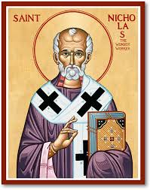
Who is St Nicholas?
As Christmas approaches each year, something changes. People become more cheerful and light hearted, thoughtful and generous. In a word, as Christmas nears each year, people become more human. There is something about the spirit of Christmas that brings out the best in people. Christmas today is a fascinating amalgamation of the birth of Jesus and the legend of a fourth-century bishop. There is something about Christmas that draws people, even non-Christians, to celebration.
Then of course there is Santa Claus and the question most parents dread: Is Santa real? The answer? Yes. Santa Claus is real and he lived an incredible life, hundreds of years ago. But he didn’t go by the name Santa Claus. He was known as Nicholas.
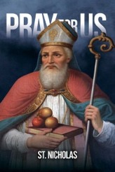
Saint Nicholas was an early Christian bishop of the ancient Greek city of Myra (modern-day Demre, Turkey). During his life he gained the reputation of uncommon concern for the needs of his people, and after his death he became renowned as a great miracle worker.
Nicholas had a profound understanding of the method Jesus used throughout his ministry. When you read the four Gospels, you discover that Jesus almost never preached before he attended to some human need. He would heal someone—make the lame walk or the blind see. He would feed the hungry, often thousands of people at a time.
Jesus’ concern for people’s physical and material needs is one of the things that set him apart from the spiritual leaders of his time. He wasn’t just interested in the spiritual well-being of people; he was interested in the whole person. Nicholas understood that. He understood that it is hard to listen to the Word of God if you are hungry and thirsty. He realized that it is even difficult to believe in God if your children are dying of hunger.
Poverty has been an obstacle to flourishing for billions of people throughout history—and it is still an obstacle today. The saints realized that we each have the power to help some people overcome this obstacle. The haunting truth comes by reflecting on two simple questions: (1) Is there really any good reason why a billion people alive today are starving to death? (2) How is it possible or acceptable that we allow one in five children 3.8 million children in the UK to go to bed hungry each night? As Christians we are called to serve the hungry, the lonely, the poor, the uneducated. They are our brothers and sisters. They are Jesus in disguise; they are Jesus in our midst. There are many stories about Saint Nicholas. They are stories of love and compassion. They are stories of self-sacrifice and great generosity. It’s impossible to know if they are true, but if they are not, we should make them true with our own lives.
One of these stories tells about a widowed man with three daughters. He was old and poor. Having no money for dowries, upon his death, his daughters would most likely be sold into slavery or prostitution. One night while everybody was sleeping, Nicholas rode past the family’s home and flung a red velvet bag filled with gold coins in through the window of the old man’s home. The father heard the noise and saw Nicholas riding off, and he spent the rest of his life praising God for sending Nicholas to them.
This is just one of many ways he generously interceded for his people, providing for their needs or giving special gifts on significant occasions in their lives. Intercede is a beautiful word. I love seeing someone intercede to solve a problem or improve a situation. Religious leaders throughout history have a reputation for being disconnected from the daily realities of the people they claim to serve. This is why Jesus and the prophets were repulsed by so many so-called spiritual leaders. But Nicholas had the heart of a servant and was deeply in touch with the needs of his people.
Santa Claus comes once a year to our shopping centres; Saint Nicholas did something every day to demonstrate the generosity of God to the people of his time. Fifteen hundred years before Dickens wrote his play, Nicholas of Myra was already living out the central lesson of A Christmas Carol: to honour Christmas in your heart each and every day of the year.
St Lucy - Martyr
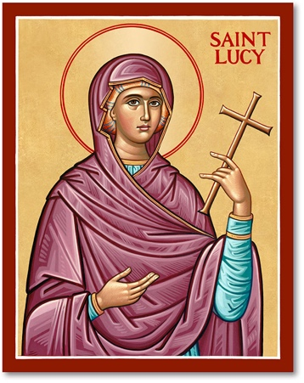
Lucy’s story is told in the Acts of Martyrdom: a collection of traditions, popular tales and legends. Lucy was born at the end of the third century in Syracuse, into a wealthy, high-ranking family. Reared as a Christian, she was still a child when she was orphaned of her father. Her mother, Eutychia, brought her up with love and dedication. While still a girl, Lucy meditated on her dedication to God, but kept her wish in her heart. Not knowing her daughter’s intentions, Eutychia promised her in marriage to a young man, who was not a Christian. Lucy did not reveal her desire to offer her virginity to Christ and, with various pretexts, puts off the wedding, trusting in prayer and divine rescue.
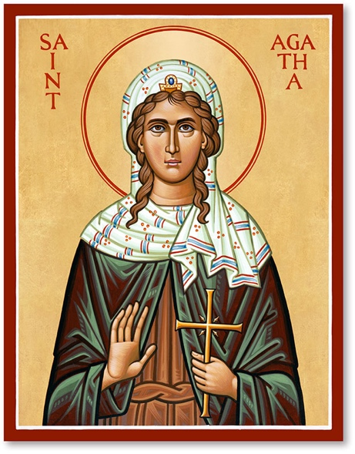

The journey to Catania and the intercession of Sant Agatha
It was in the year 301 that Lucy and her mother went on a pilgrimage to Catania, to the tomb of Saint Agatha. Eutychia suffered from bleeding, and despite various and expensive treatments, nothing had helped her. At the cathedral dedicated to the young martyr, mother and daughter desired to ask for the grace of healing. It was February 5th when they reach the foot of Mount Etna, Agatha’s feast day. They assisted the Eucharistic celebration at the tomb of the saint and “it happened ... that ... in hearing the evangelical episode of the hemorrhagic woman, who had achieved healing by the simple touch of the flap of the Lord’s robe, Lucy turned to her mother, and said: ‘Mother, if you are faithful to the things that have been read, you will also believe that Agatha, who has suffered for Christ, has free and confident access to His tribunal. So trust her tomb, if you wish, and you will be resurrected’ (Passion of Saint Lucy). Eutychia and Lucy then approached the burial place of Agatha. Lucy prayed for her mother and begged for herself to be allowed devote her life to God. Taken as if in a gentle sleep, as she was caught up in ecstasy, and saw Agatha among the angels, proclaiming to her: “Lucy, my sister and Virgin of the Lord, why ask what can you grant me for yourself? Your faith has been of great benefit to your mother, who has already been healed. And as for me, the city of Catania is filled with thanksgiving, so the city of Syracuse will be preserved for you, because our Lord Jesus Christ is pleased that you should keep your virginity intact.” Returned to herself, Lucy referred her vision to her mother, and told her of her desire give up an earthly spouse, asking to be allowed to sell her dowry to make charity to the poor.

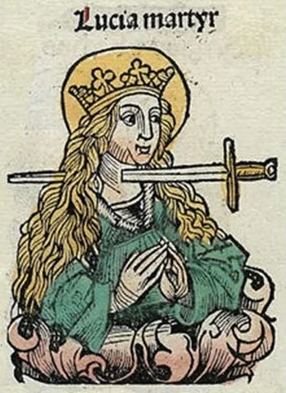
Martyrdom
Disappointed and unsatisfied, Lucy’s young suitor denounced Lucy as a Christian to the Prefect, Pascasius, accusing her of worshiping Christ and of disobeying Emperor Diocletian's edict. Arrested by the Prefect, Lucy was interrogated, and refused to sacrifice to the gods. She professed her faith: “I am a servant of the Eternal God and He said: ‘When you are led to the kings and princes do not give thought how or what you have to say because you will not be talking yourself but the Holy Spirit is speaking in you.’” Pascasius pressed her: “Oh, then, do you think you have the Holy Spirit?” Lucy answered: “The Apostle said, ‘The chaste are the temple of God, and the Holy Spirit dwells in them.’” Pascasius, in order to discredit her, then commands that she be brought to the brothel; Lucy declared then that she would not give herself over to the lust of the flesh, and that, despite any violence that would come to be done to her body against her will, she would remain chaste, pure and uncontaminated in mind and spirit. Prodigiously immovable, soldiers fail to dislodge her from her place. Tied hands and feet, not even with oxen were they able to drag her away. Exasperated by the extraordinary event, Pascasius disposed that the young virgin be burnt. The fire did not harm her in the least. Furious, Pascasius decided to make her perish by the sword. She was decapitated on 13 December, 304.
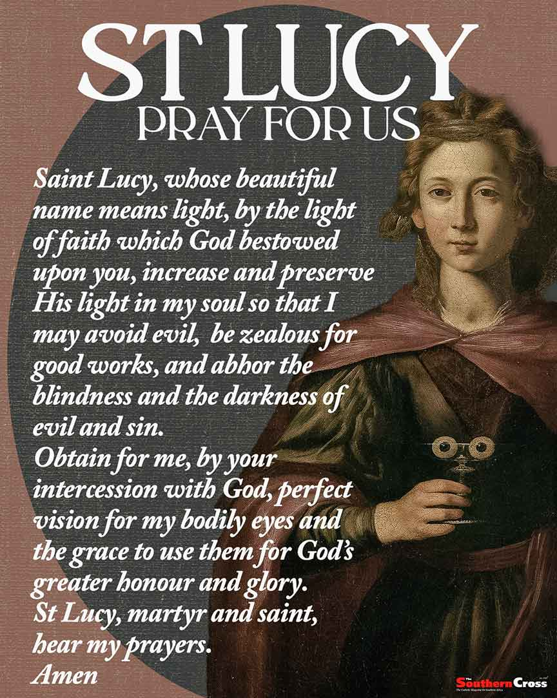

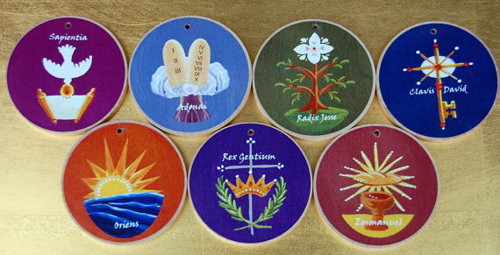
The O Antiphons
On the First Sunday of Advent, Christians everywhere make a collective and noticeable turn toward Christmas, toward the coming birth of Jesus.
Throughout the next four weeks our day-to-day routines give way to divine preparation and joyful anticipation; the world is bathed in lights, complete strangers exchange “Merry Christmas” and mankind eagerly awaits the Christ Child.

The ageless Gospels that are read during Mass reflect on John the Baptist, the Annunciation, the Visitation, the Nativity. The clergy don purple vestments and we are inspired by the seasonal hymns reminding us that a great event is about to happen. Past the halfway point of Advent the beautiful O Antiphons are introduced into the daily prayer life of the Church. These mostly ancient and thought-provoking verses fit the season perfectly, but why are they called O Antiphons?

The Special Antiphons
Beginning 17 December of each Advent season, and for the next seven days, a special antiphon known as an O Antiphon is read before the Magnificat during evening prayer or before the gospel at Mass. Sometimes called the Greater Antiphons, or the O’s of Advent (because they begin with that exclamation), the O Antiphons differ from the daily antiphons because they herald the coming birth of Christ. Originally written in Latin around the seventh or eighth centuries, these special antiphons are verses extracted from the Old Testament prophets — especially, Isaiah — and express the longing for the coming of the Christ. In fact, the word “come” is used in every O Antiphon.

Each of the seven antiphons begins by addressing Jesus using an Old Testament title for the Messiah. These seven names or titles, all from the Book of Isaiah, are:


Dec. 17, O’ Sapientia (meaning O Wisdom), from Isaiah 11:2-3.
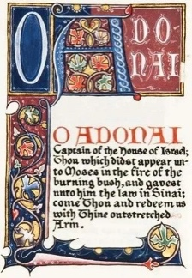
O Wisdom, who proceeds from the mouth of the Most High, reaching out mightily from end to end, and sweetly arranging all things: Come to teach us the way of prudence.

Dec. 18, O’ Adonai (O Lord or Ruler), 11:4-5 and 33:22.
O Mighty Lord and leader of the house of Israel, who appeared to Moses in the burning bush, and on Sinai gave him the law: Come to redeem us with outstretched arm.
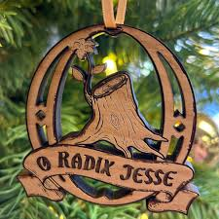
Dec. 19, O’ Radix (O Root of Jesse), 11:1.
O Root of Jesse, who stands as a sign for the people, kings stand silent in your presence, whom the nations will worship: Come to set us free, put it off no longer.

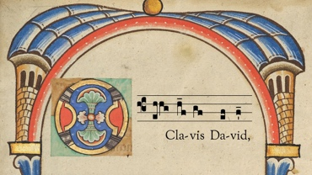
Dec. 20, O’ Clavis (O Key of David), 22:22.
O Key of David, and sceptre of the house of Israel, you open, and no one shuts, you shut, and no one opens: Come, and lead the prisoner from jail, seated in darkness and in the shadow of death.
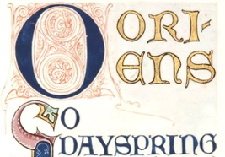
Dec. 21, O’ Oriens (O Radiant Dawn), 9:1.
O Dawn, splendour of eternal light and sun of justice, come, and shine on those seated in darkness and in the shadow of death.
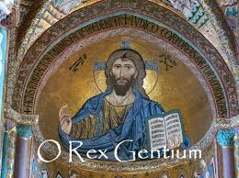
Dec. 22, O’ Rex Gentium (O King of the Nations), 2:4.
O King of the Nations, and the one they desired, Keystone, who makes both peoples one: Come and save mankind, whom you shaped from the mud.

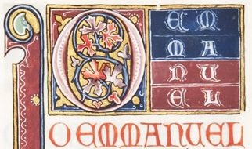
Dec. 23, O’ Emmanuel (O God with Us), 7:14.
O Emmanuel, our King and lawgiver, the One awaited by the Gentiles and their Savior: Come to save us, Lord our God.

It is widely pointed out that if you take the first letter of each Latin name and reverse the order — that is, begin with E from Emmanuel, then Rex Gentium and so on you will spell the word EROCRAS, which in Latin means “I shall come tomorrow.”

Many people add the Greater Antiphons to their prayers during Advent. These beautiful antiphons are like a drum roll growing to a crescendo as the seven days bring us closer to the Christmas miracle of God made flesh, born as a babe and, with few exceptions, mostly unnoticed by mankind. Each of the seven Greater Antiphons are also sung or recited as the Alleluia verse (or antiphon) before the Gospel at daily Mass 17 – 23 December.

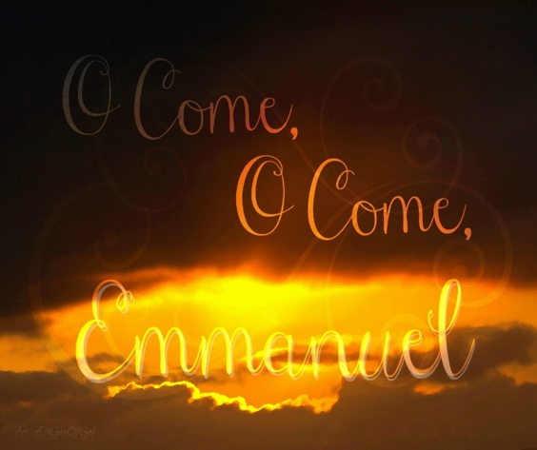
Sometime before the 12th century, the exact date and author being unknown, selected verses from the seven antiphons were compiled into the hymn we today call “O Come, O Come, Emmanuel.” During the Middle Ages this hymn was an important teaching and worship aid to a society that was largely illiterate and had few Bibles. In the 19th century, the Latin version of the hymn was translated into English by an Anglican priest named John Neale. He called his original translation “Draw Nigh, Draw Nigh, Emmanuel,” but in 1854 he renamed the song, “O Come, O Come, Emmanuel,” which, given its history, is believed to be among the oldest of all the Christmas hymns.

Magazine Sponsorship for December

December’s magazine has been sponsored by Diana Berrett in memory of her parents.

This sponsorship enables us to offer our monthly magazine free of charge. Thank you!

Moving forward as a way of covering some of the ongoing costs of the
the church and wider ministry I would like to trial the introduction of
sponsorship.


The easiest example of what I am thinking is the sponsorship of the
printing costs of our new magazine. Another example is covering the cost of the sanctuary light which is always alight (except following the
Good Friday Liturgy until it is lit again to celebrate the risen Lord at the Easter Vigil) and the candles in the Lady Chapel and St Monica’s Chapel.
Sponsorship would be on a weekly or monthly basis, although monthly sponsorship would make administering the process an easier task, and could be in memory of a loved one who has died or something else such as a birthday that is close to your heart. Sponsors and their special intention will be published in this magazine each month.

Sponsorship money should be paid at the beginning of the month
preferably by bank transfer using the reference box to indicate that it is
sponsorship money or you could give your sponsorship money in cash
to our treasurer, Tracy Poole.

If you would like to participate in this, please email Maria
the month, what you are sponsoring and your intention to:

mrs.maria.mason@gmail.com

It is of course possible to have more than one sponsor for any category in
any month and all sponsors with their intention will be published.

Item | Duration | Suggested Donation
Parish Magazine | Monthly | £50
Sanctury Lamp | Monthly | £15
St Monica’s Chapel Lamp | Monthly | £10


Fr Adrian and. Maria have sponsored the Sanctuary Lamp and the St Monica Chapel Lamp for December in memory of the death of their mothers.
Could you sponsor the magazine, or any of the above items, for a month moving forward?

It would be helpful moving forward into 2026 to have the year’s sponsorships laid down. Payment wouldn’t be asked for until the beginning of the month sponsored. Please email Maria to let her know which month you would like to sponsor and she will then be in contact with you nearer the time to ask you why you are sponsoring that particular month’s magazine or sanctuary lamp etc . . . . . .
Your Favourite Hymn

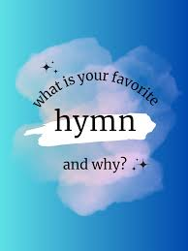
Would you like to share with us details of your favourite Hymn? We will be introducing a new feature each month encouraging you all to share your favourite hymn and why it is so special to you. We will feature one each month beginning in the January 2026 magazine.

Please email details of your favourite hymn to the usual email address:
mrs.maria.mason@gmail.com .

If you would rather just talk about your favourite hymn with Maria, she will do her best to do it justice when writing it up. If this is your preferred way of sharing details about your favourite hymn, please arrange a time to sit down with Maria. A quick conversation after Mass on a Sunday won’t work.
You can contact Maria on 07463 303112.

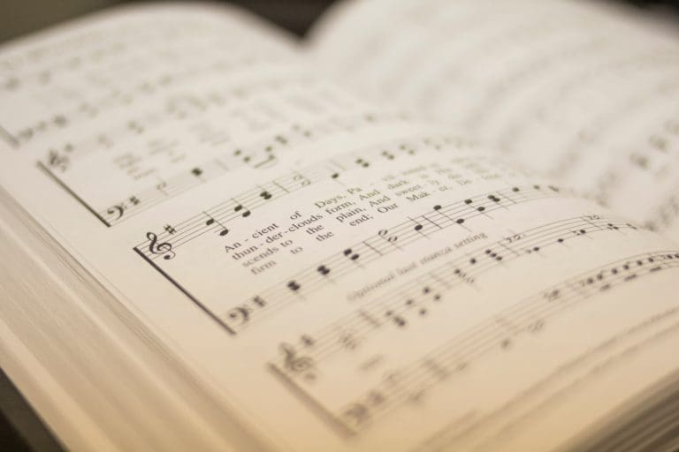

My Favourite Hymn – Maria Mason

My favourite hymn is Lord Of All Hopefulness. I can remember singing this as a young child in our school assemblies and in church. We sang this hymn so often, that even though many children were not yet able to read, we all knew the words.

Looking back, I am sure it was the catchy tune that I first enjoyed. Hymns were taken at quite a pace in my primary school, and I recognised the rhythm as one that my dad used to waltz me around the kitchen to. As a teenager and young adult, I still sang the words and enjoyed the music without any real understanding of the depth of meaning.

From www.crosswalk.com . . . . . . . . . .

The hymn reminds us of God’s presence throughout our lives, from early childhood through the trials of mid-life, and on to the blessings of the end of life. The guiding presence of the Lord gives us hope in every phase of life. The hymn mentions “cares” in the first stanza, when young people need God’s guidance to meet new challenges. In the second stanza, it asks for “Your strength in our hearts” to meet the rigors of mid-life. Richest of all blessings is found in the last stanza: the hope for “Your love in our hearts, Lord, At the eve of the day.” The last stanza brings fulfilment to a life lived with the Lord at our side.”

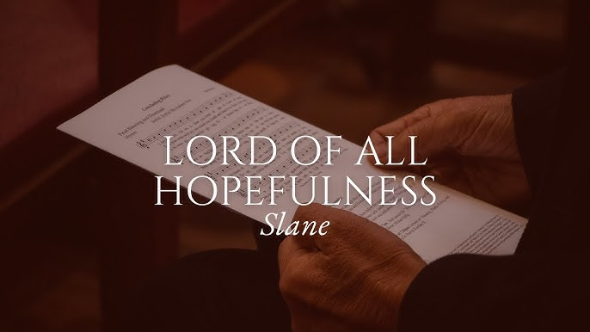
The hymn’s popularity in Christian worship is due to its heartfelt lyrics and lively folk tune. The Slane melody is credited to Patrick W. Joyce and appears in his collection of ballads, Old Irish Folk Music and Songs (1909). David Evans arranged the Slane tune as a hymn and published it with the lyrics to “Be Thou My Vision” in the Church Hymnary of 1927. A few years later, Struther’s lyrics to “Lord of All Hopefulness” were set to the same Slane tune.

Having now sung this hymn at various key events in my life I have come to embrace the sentiment behind the words while still appreciating the tune that is routed in my Irish heritage.
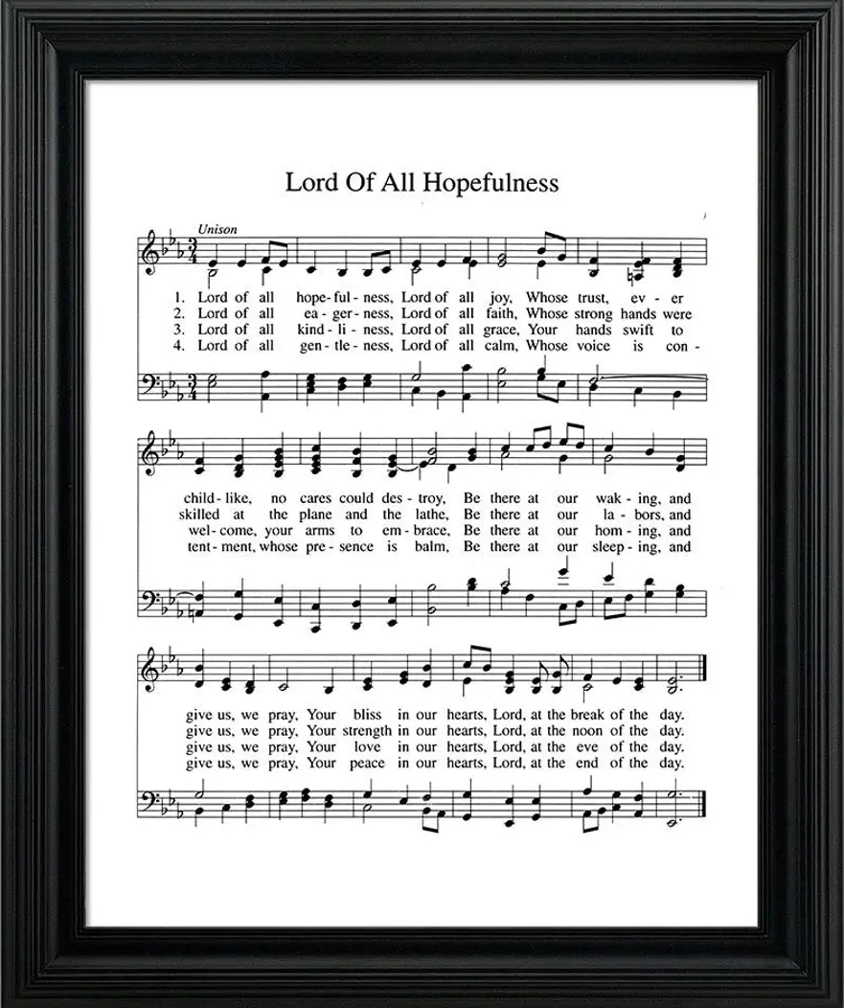
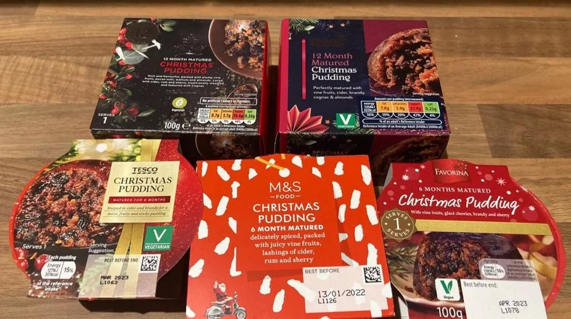
Food Bank Donations for Christmas

Throughout the year donations of essential foods and healthcare products are donated to the Rock Foodbank through St Augustine’s donations box.

It has been decided by the Wednesday Coffee Morning folk that we should focus on something a bit special for the Christmas packages. Christmas Puddings were identified as a good product due to the generous use by dates which are usually at least a year in the future.

For the first few weeks of Advent, you are invited to contribute either family size or individual sized Christmas Puddings. These will be taken to the Rock Foundation on Monday 15 December to ensure they can be included in the Christmas week food parcels and boxes.

You can of course choose to donate anything you are able to and the Rock Foundation will make good use of it.

Thank you in advance for your generosity.

Church Maintenance Update


The trimming of the church yard trees has been awarded to Wold Tree Works. The quote was £1200 + 240 Vat. The work is due to start after Christmas, once the 8 week period to check out all the Protected Trees and trees within the conservation area is completed.


We are also waiting on a quote to clean, unblock both the north and south side drain pipes, (top of pipe to the bottom), plus removal of any tree roots that have found their way into the drain pipes underground. More on this project in a future issue.


We are also waiting to hear from the architect, Peter Rogan, who conducted the Church Quinquennial Report in July, regarding preparing a bid for a national lottery award to help with the church roof repair work and also the church south side wall work.

Paul Nixon
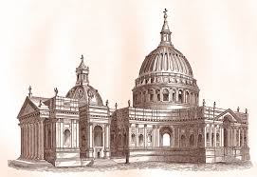
Historic December
1 | 1135 | England’s King Henry I died. He had fallen ill seven days earlier after eating too many lampreys. He was 66, and had ruled for 35 years.
2 | 1697 | Sir Christopher Wren’s St Paul’s Cathedral is opened in London.
3 | 1989 | The Cold War ended after 52 years of superpower rivalry. Soviet leader Mikhail Gorbachev and US President George Bush ended their shipboard summit meeting off Malta.
4 | 1872 | Crew from the British brigantine Die Gratia boarded a deserted ship drifting mid Atlantic. The captain’s table was set for a meal aboard the US ship Marie Celeste but the Captain, crew and passengers were all missing.
5 | 1905 | The roof of Charing Cross Railway Station in London collapsed, killing five people .
6 | 1921 | Ireland’s 26 southern states were granted independence from Britain, becoming the Irish Free State. Ulster in the north remains part of the UK.
7 | 1783 | William Pitt became British Prime Minister and Chancellor of the Exchequer at the tender age of 24.
8 | 1980 | Forty-year-old ex-Beatle John Lennon was murdered in New York.
9 | 1608 | Birthday of John Milton, English poet whose works included Paradise Lost, Paradise Regained and Samson Agonistes.
10 | 1901 | The first Nobel Peace Prizes were awarded worth $30,000 each. Nobel, a Swedish chemist, had died five years earlier leaving the fortune he had amassed from his invention dynamite, to the awarding foundation.
11 | 1936 | Britain’s King Edward VIII renounces the throne in a radio broadcast to the nation. After the broadcast he boards a ship to join the twice-divorced Mrs Wallis Simpson in France.
12 | 1955 |   British engineer Christopher Cockerell patented a new kind of vehicle. Half-ship and half-aircraft, his “hovercraft” floats on an air cushion.
13 | 1989 | In South Africa, ANC leader Nelson Mandela meets President F. W. de Klerk for the first time.
14 | 1895 | Birthday of King George VI, who succeeded to the throne when his brother, Edward VIII, abdicated.
15 | 1791 | The Bill of Rights becomes part of the United States Constitution providing protection for the basic rights of the individual to free expression and justice.
16 | 1773 | Unruly American colonists boarded three ships in Boston harbour and emptied 342 chests of tea into the sea.
17 | 1778 | Birthday of Sir Humphrey Davy, English inventor of the safety lamp for miners, who also discovered sodium, magnesium, calcium, barium and strontium
18 | 1946 | Clement Atlee’s Labour government won the vote on state ownership which lead to the nationalizing of the railways, ports, mines, etc.
19 | 1848 | Emily Bronte, English author of Wuthering Heights, dies of tuberculosis at the tender age of 30.
20 | 1803 | The United States doubles in size when it acquires 88,831,321 square miles of land from France for $15 million – The Louisiana Purchase.
21 | 1988 | A Pan American jumbo jet bound for New York is blown out of the sky by a terrorist bomb and crashes onto the Scottish town of Lockerbie killing all 259 passengers and 11 people on the ground.
22 | 1715 | James Edward Stuart, son of James II, the deposed Catholic King of England, lands in north-east Scotland to lead a Jacobite rebellion.
23 | 1922 | The world’s first regular entertainment radio broadcasts are transmitted by the British Broadcasting Corporation (BBC).
24 | 1508 | London houses receive piped water again, for the first time in over a thousand years, since the Romans left town!
25 | 440 | Church leaders agree to fix the date of the birth of Christ. Previously some people had celebrated it in May, others in January.
26 | 1943 | In World War II, a Royal Navy convoy including the battleship Duke of York and cruiser Jamaica attack and sink the mighty German battlecruiser Scharnhorst.
27 | 1831 | The Royal Navy vessel HMS Beagle sets sail from Devonport, the official naturalist onboard is recent BA graduate Charles Darwin.
28 | 1918 | The results of the first General Election in Britain in which women have been allowed to vote, confirmed David Lloyd George as Prime Minister.
29 | 1170 | Four of King Henry II’s knights murdered the Archbishop of Canterbury, Thomas a Becket, in Canterbury Cathedral.
30 | 1879 | First performance of the Gilbert and Sullivan comic opera The Pirates of Penzance, at the Royal Bijou Theatre, Paignton, Devon.
31 | 1720 | Birthday of Charles Edward Stuart, Scottish royal better known as Bonnie Prince Charlie or the Young Pretender, son of James, the Old Pretender.
Historic-uk.com


Have you thought about becoming a Friend of
St Augustine’s Church for 2026?

Membership per annum is single £15 Joint £25. When you see and hear the wealth of musical talent that rings out in our building during a musical season it is quite mind blowing.

The ‘Friends of St. Augustine’ was established to promote concerts to raise funds to assist with the maintenance of the church. Regular concerts and recitals are held in the church. The building itself possesses an outstanding acoustic and is regularly used for rehearsals and recordings. A variety of musical events feature every year with the 2025 season ending with:

Fri 19 Dec 7.30pm Adele Dixon and Barry Whitfield
Christmas Tree Finale Concert with Octangle ` (octet from Louth Male Voice Choir)
Ticket prices . . . . . . .

Adults: £12 Friends: £10 Students: £5 Under 12: Free

Evening concerts are café style. A complimentary glass of wine or fruit juice is available with each ticket. You can bring your own drinks and nibbles for further refreshment.

Watch this space for details of the 2026 season.

Any queries? Please contact:

staugustinesfriends@gmail.com or phone 07398 567677


Christmas Parish Lunch

Sunday 14 December at 12.30pm

Cheryl has kindly offered to arrange a Parish Christmas Lunch at the Pear Tree in Cleethorpes. The date she is suggesting is Sunday 14 December meeting at the Pear Tree at 12.30pm.

A list is available at the back of church. Please sign up and join in if you are able to make this parish event a success.

Details of prices and menus can be found at:

www.peartreepub.co.uk/menus
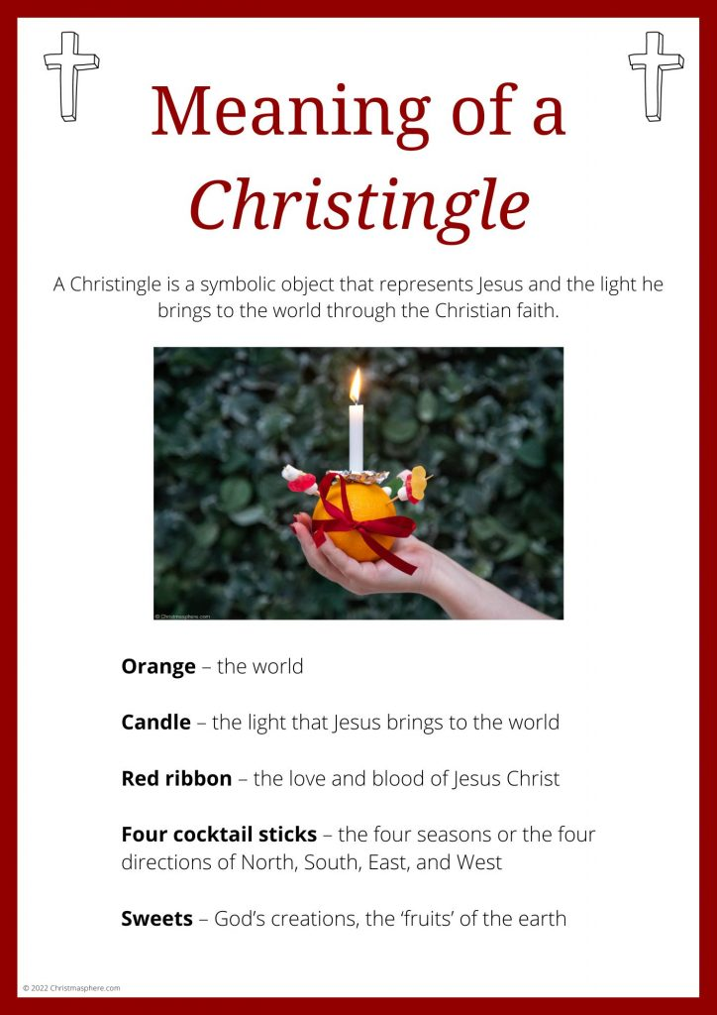 Christmas Services

Wednesday 24 December 4pm Christingle Family Service
11.30pm Sung Parish Mass

Thursday 25 December 10am Said Mass

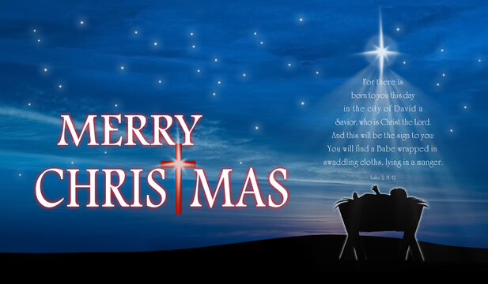

Friday 26 December 10am Said Mass
Saturday 27 December 10am Said Mass

First Week of Christmas
Sunday 28 December 10am Sung Parish Mass
Monday 29 December 10am Said Mass
Tuesday 30 December 6.30pm Said Mass
Wednesday 31 December 10am Said Mass followed by Coffee Morning

There is Mass each day between Christmas and New Year to celebrate the great feasts of St Stephen, St John Evangelist, the Holy Family and St Thomas Beckett. Please join us when you can.

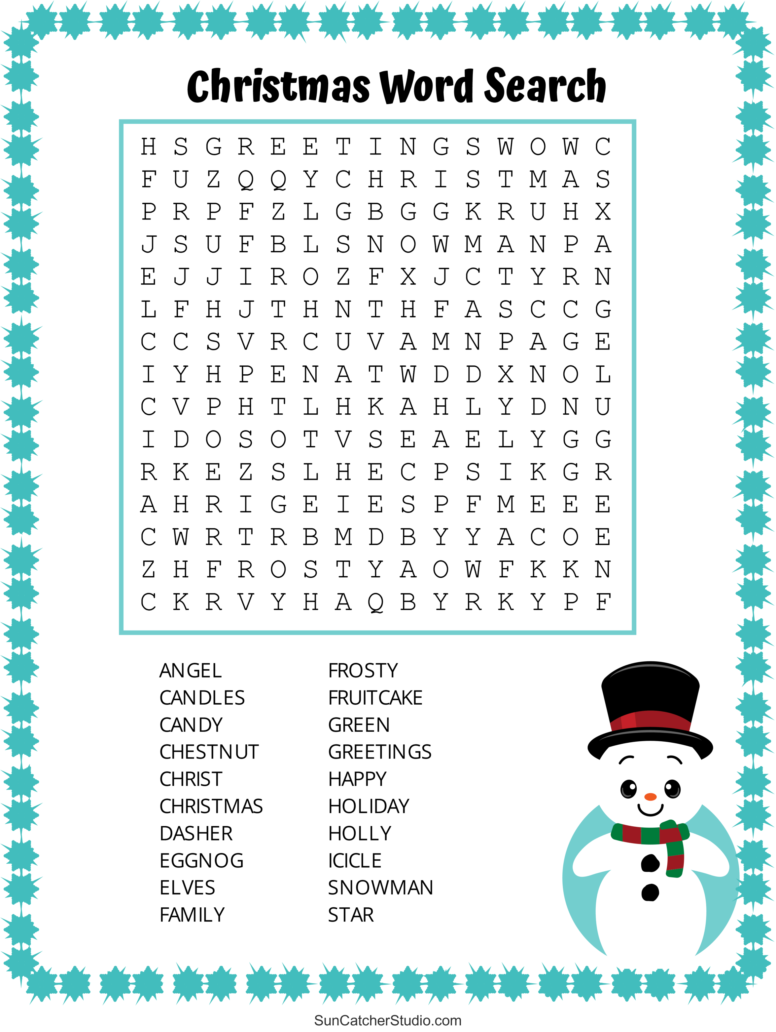

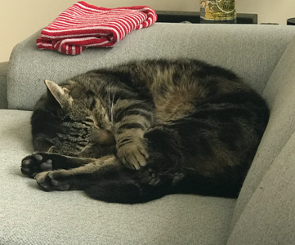
The Life and Times of Thomas Augustus,
The Vicarage Cat

As the winter weather takes hold, I find that I just want to sleep all the time. I am not as young as I once was, even though nobody actually knows how old I am. However, it was nine years ago that I decided that Fr Adrian and Maria would make excellent parents as I had found myself homeless. I must admit that the resident cats were not too keen on my arrival, but we all became friends in the end. Now, there is only me and my little friend Miss Catherine, and she really isn’t very sociable.
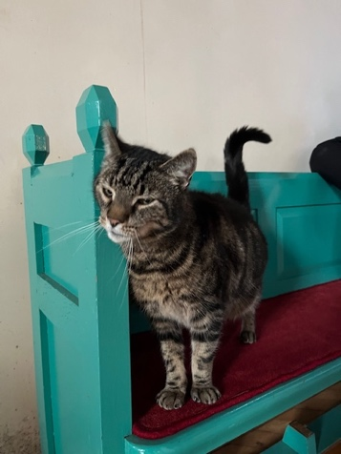
I have been in church as few times over the month not least because I had to carry out my annual check of the church woodwork. I am glad that Paul (Nixon) was there to witness my sudden burst of activity.

There has been an awful lot of activity in the church this last week what with Christmas trees arriving and being decorated. I understand that there were children from Lisle Marden Academy, Edward Heneage Primary Academy and Welholme Academy in church decorating and admiring the trees. I decided to give these sessions a miss as children do seem to love me and sometimes it is too much for me.
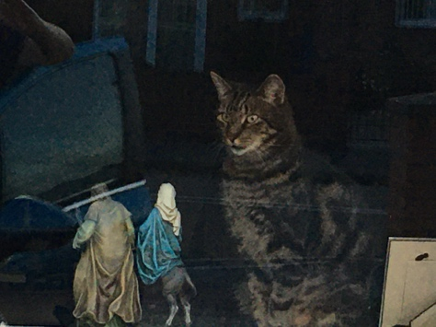
I have had the honour of spending time with Mary and Joseph and their donkey before they set off on the symbolic journey around our parish. I look forward to welcoming them back to celebrate the birth of their baby at midnight Mass on 24 December at 11.30pm


Priest-in-Charge | Fr Adrian Mason | fr.adrian.mason@gmail.com 07824 467333
Church Wardens | Adele Dixon Janet Nixon | adele.dixon90@gmail.com  janet.nixon59@gmail.com
Lay Chair of PCC | Adele Dixon | adele.dixon90@gmail.com
PCC Secretary | Barry Whitfield | barrywwhitfield@gmail.com
PCC Treasurer | Tracy Poole
Safeguarding Officer | Adele Dixon | staugustineofhippo safeguarding@gmail.com
Electoral Roll Officer | Cheryl James | cheryljames1@live.co.uk
Director of Music | Barry Whitfield | barrywwhitfield@gmail.com
Magazine Editor | Maria Mason | mrs.maria.mason@gmail.com


Items for inclusion in the January 2026 edition of this magazine should be sent to the editor via email by Sunday 21 December. There is no guarantee of inclusion after this date.

(mrs.maria.mason@gmail.com).

Could you write an article for our Parish Magazine? The editor would be pleased to receive articles of a religious nature or otherwise that would be of interest to our readers.
Again, the email address to send articles to is: mrs.maria.mason@gmail.com

Cheryl’s Name Cards
As many of you are aware, Cheryl always has some name cards on the go. There are always great prizes including bottles, candles and chocolate, with boxes costing 20p - £1.
To quote Cheryl,
“you have to be in it to win it!”
Prizes are given out as soon as the name card is complete.


As in previous years, Cheryl and Neil have organised a magnificent Christmas Raffle to raise funds for our church. There are spirits and wine, boxes of Christmas chocolates, candles and Christmas gifts to be won.
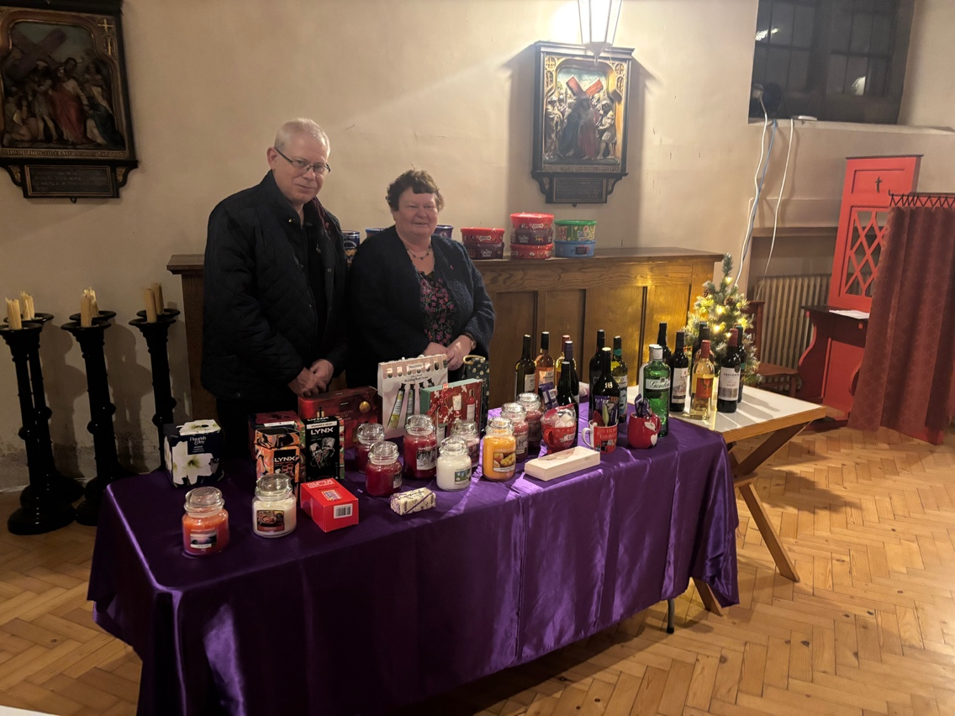
Tickets will be available after Mass each Sunday and at the last of the two Friends of St Augustine concerts for this season. The raffle will be drawn during the concert on Friday 19 December. Tickets are £1 per entry.
Please support this fundraising activity for our church.

Email:
fr.adrian.mason@gmail.com

Web:
St-augustine-church-grimsby.org
https://www.achurchnearyou.com/church/14993/

Safeguarding matters please contact:
staugustineofhipposafeguarding@gmail.com



Edition 10

