St John’s School
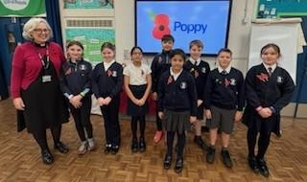
It was good to mark Armistice Day and a two minute silence at St John’s this week.

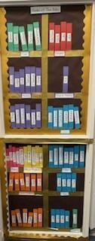
Also saw the fab display of Books of the Bible.

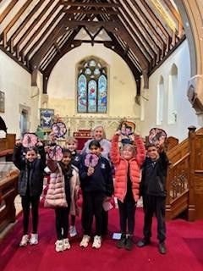
Sycamore class visited church We made ‘stained glass window
poppies’, and talked about how we find peace in our busy world today. We sang a new song ‘Pop on a Poppy’

