HOLY TRINITY CHURCH BOTTISHAM
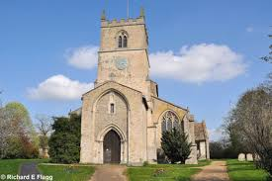
COFFEE & CAKE CONCERT
SATURDAY 6th DECEMBER 10.30am
Stuart Field, (raconteur and violin), Sarah Maxwell (Soprano), Richard Ayres (Organ)
The History of our Christmas Carols
Come along and sing your favourite Christmas Carols.
Suggested donation £5 (children free) including coffee & cake
towards church heating & building funds
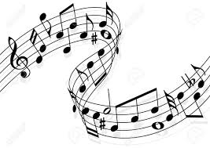 ALL ARE WELCOME 