
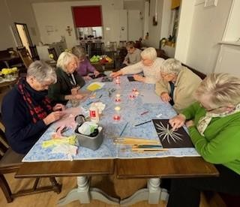
Essence– met last Wednesday 5th November 7.30pm at the Refectory
It was Bonfire Night, so we sparkled! We used sparklers and candles as a metaphor for our faith and how the spark was kindled. We got creative with mixed media! A great night enjoyed by all!
