Sunday 16th November 2025 St Paul’s, Woodhouse Eaves
WE WELCOME YOU, for we are all one in Christ Jesus

MISSION  Our Mission Statement  Our Mission is to make known the Gospel and love of Jesus Christ. We hope that you experience us as a safe, sacramental, welcoming, loving and inclusive Kingdom people who seek to make Christ present in the hearts of all.  Safeguarding  The parishes of St Paul’s, Woodhouse Eaves & St Mary’s, Woodhouse, are committed to the safeguarding of children, young people and adults. We follow the House of Bishops’ guidance and policies, and have our own Parish Safeguarding Officers. If you are concerned that a child or adult has been harmed or may be at risk of harm please contact –  ST PAUL’S - Safeguarding  Co-ordinator: Tony Lane  07977 924 677  ST MARY’S - Safeguarding  Co-ordinator: Andrea Farnsworth 07958 376 963  As a Benefice, we affirm that it is about not just a set of policies and procedures, but about all of us as the body of Christ sharing the responsibility for making God’s Church as safe as we can  A prayer for our next Archbishop of Canterbury  God our Father, Lord of the church, we thank you for calling Sarah Mullally to be our new Archbishop. Pour upon her, we pray, the strength, wisdom and vision that she needs as she leads and serves us. Bless and protect her and her family, and enable your church to walk together under her leadership in grace, unity and love. Amen  Please take this pew sheet  home and recycle it when you’ve read it. Thank you |  | PRAYER  If you would like someone to listen or to pray with you, please contact your Parish Priest:  Rev’d Lisa Temperley-Barnes - 01509 890 972  If you would like us to pray for someone by name in our Sunday services and through the week, please email Rev’d Lisa or Stephen  Let us use our time  before the service  to talk to God,  during the service  may God talk to us, and  after the service  let us talk to one another  We pray for all who are ill  for Dennis, Amelia, June Taylor,  Tom Hobbs, Joyce Lane, Di Alsop,  Sue and John Thorne, Jean Sury,  June Shilton, Joseph Breed  We remember before God  the faithful departed,  and from St Mary’s  Book of Remembrance  Olive Marjorie Poole, Alexander Cyril Taylor, Lydia Ann Kirkham, Miriam Redden, Nancy James  and from St Paul’s  Book of Remembrance  Marjorie Austin, David Barker, Anne Brown, George Francis Reeves, Gordon Alan Onion, William Maurice York, Charles Richard Grewcock, Stephen Edmund Symes-Goodman, Mary Everard, Stanley Norman Ellis Graham-Dunn, Douglas Walter Andreas, Kathryn ‘Kate’ Amanda Holmes  Rest eternal grant unto them, O Lord, and let light perpetual shine upon them. May the souls of the faithful departed through the mercy of God, rest in peace and rise in glory. Amen |  | SAVE THE DATES!      
  AfghanAid
  Yesterday was our Fundraising Event at St Mary’s, in support of AfghanAid.
  It is still possible to make a contribution – if you would like to donate, please scan the QR code below
  
  £2.50 per adult, children free!
  Tea, coffee & biscuits - £1.50
  6th - 7th December
  12.00 - 5.00pm
2nd Sunday before Advent Sung Eucharist
COLLECT  Heavenly Father, whose blessed Son was revealed to destroy the works of the devil and to make us the children of God and heirs of eternal life: grant that we, having this hope, may purify ourselves even as he is pure; that when he shall appear in power and great glory we may be made like him in his eternal and glorious kingdom;  where he is alive and reigns with you, in the unity of the Holy Spirit,  one God, now and for ever. Amen  FIRST READING  A reading from the prophet Malachi  The Lord Almighty says, “The day is coming when all proud and evil people will burn like straw. On that day they will burn up, and there will be nothing left of them. ² But for you who obey me, my saving power will rise on you like the sun and bring healing like the sun's rays.  Malachi 4:1-2a  This is the word of the Lord  Thanks be to God  PSALM 98  Refrain: The Lord has made known his salvation  - Sing to the Lord a new song, ♦  for he has done marvellous things.  - His own right hand and his holy arm ♦  have won for him the victory.  - The Lord has made known his salvation; ♦  his deliverance has he openly shown in the sight of the nations.  - He has remembered his mercy and faithfulness  towards the house of Israel, ♦  and all the ends of the earth have seen the salvation of our God R  - Sound praises to the Lord, all the earth; ♦  break into singing and make music.  - Make music to the Lord with the lyre, ♦ |  | with the lyre and the voice of melody.  - With trumpets and the sound of the horn ♦  sound praises before the Lord, the King R  - Let the sea thunder and all that fills it, ♦  the world and all that dwell upon it.  - Let the rivers clap their hands ♦  and let the hills ring out together before the Lord,  for he comes to judge the earth.  - In righteousness shall he judge the world ♦  and the peoples with equity R  Glory be to the Father, and to the Son, and to the Holy Spirit: as it was in the beginning, is now, and ever shall be, world without end. Amen  GOSPEL  Alleluia, alleluia  “Speak, Lord, your servant is listening. You have the words to eternal life.”  Alleluia  Hear the holy Gospel of our Lord Jesus Christ according to St Luke  -  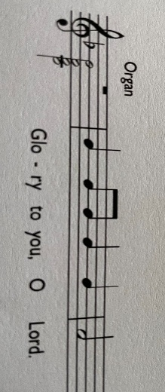  When some were speaking about the temple, how it was adorned with beautiful stones and gifts dedicated to God, Jesus said, ⁶ ‘As for these things that you see, the days will come when not one stone will be left upon another; all will be thrown down.’  ⁷ They asked him, ‘Teacher, when will this be, and what will be the sign that this is about to take place?’ ⁸ And he said, ‘Beware that you are not led astray; for many will come in my name and say, “I am he!” and, “The time is near!” Do not go after them.  ⁹ ‘When you hear of wars and insurrections, do not be terrified; for these things must take place first, but the end will not follow |  | immediately.’ ¹⁰ Then he said to them, ‘Nation will rise against nation, and kingdom against kingdom; ¹¹ there will be great earthquakes, and in various places famines and plagues; and there will be dreadful portents and great signs from heaven.  ¹² ‘But before all this occurs, they will arrest you and persecute you; they will hand you over to synagogues and prisons, and you will be brought before kings and governors because of my name. ¹³ This will give you an opportunity to testify. ¹⁴ So make up your minds not to prepare your defence in advance; ¹⁵ for I will give you words and a wisdom that none of your opponents will be able to withstand or contradict. ¹⁶ You will be betrayed even by parents and brothers, by relatives and friends; and they will put some of you to death. ¹⁷ You will be hated by all because of my name. ¹⁸ But not a hair of your head will perish. ¹⁹ By your endurance you will gain your souls.  Luke 21:5-19  This is the Gospel of the Lord  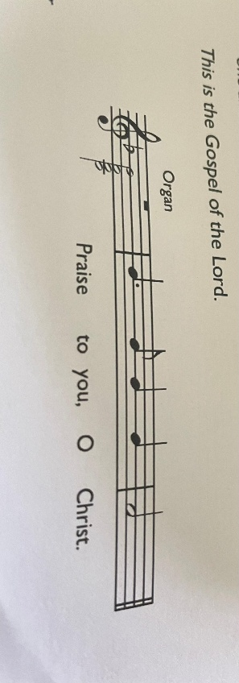  POST-COMMUNION PRAYER  Gracious Lord, in this holy sacrament you give substance to our hope: bring us at the last to that fullness of life for which we long; through Jesus Christ our Saviour. Amen

