THE BRIXHAM MISSION COMMUNITY Remembrance

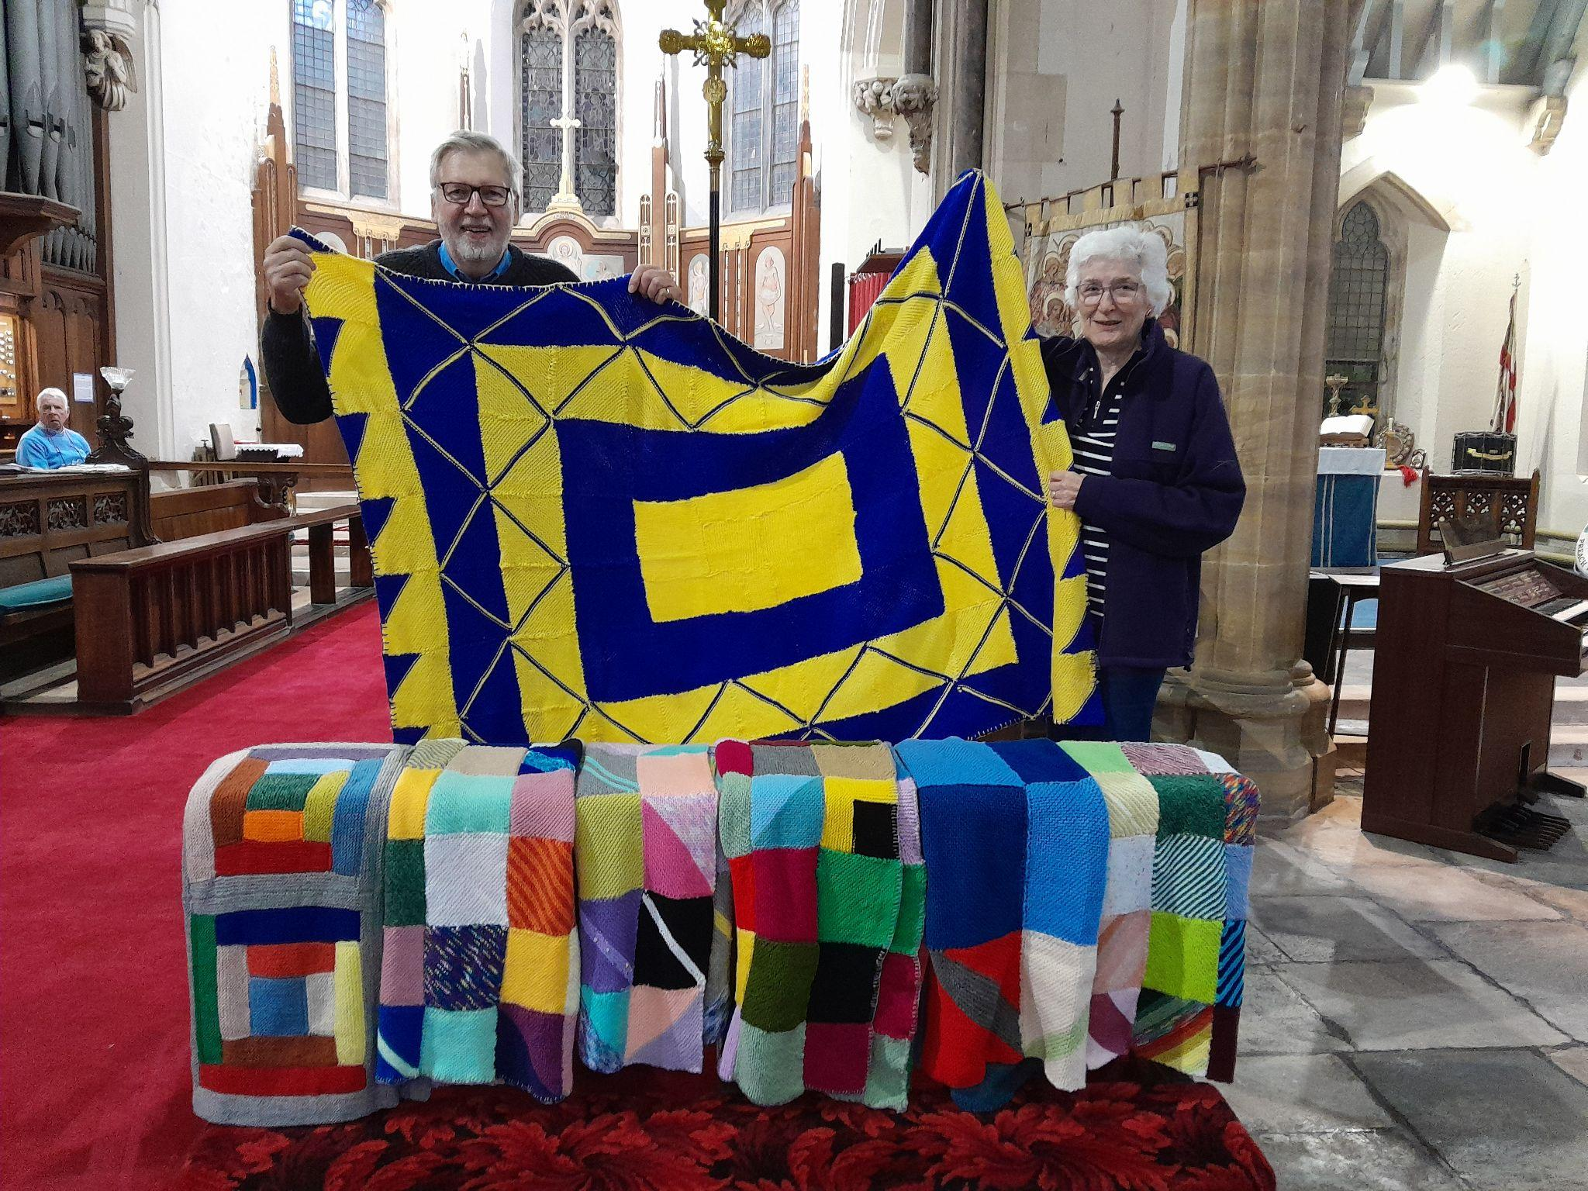

‘Peace on Earth to those whom God loves’
Picture:Nick and Rosemary, All Saints, Lower Brixham. Blanket in Ukraine colours

Moving Forward Together

Issue 27 November 2025

Brixham Mission Community Services October 2025
2025 | Week 1 | Week 2 | Week 3 | Week 4 | Week 5
Sunday | Harvest Thanksgiving | Trinity 17 | St Luke Evangelist | Last Sunday after Trinity
October | 5th | 12th | 19th | 26th
All Saints  Brixham | 09:30  Eucharist | 09:30  Eucharist | 09:30  Worship for All | 09:30  Eucharist
St Mary’s  Brixham | 08:45  No service | 08:45  Eucharist | 08:45  No service | 08:45  Eucharist
 | 11:00  Eucharist | 11:00  Morning Worship | 11:00  Eucharist | 11:00  Morning worship
SMVC  Churston | 10.00  Morning Worship | 10:00  Eucharist with Baptism | 10:00  Eucharist | 10:00  Family Worship
STCK  Kingswear | 10:30 Morning Worship | 10:30  Eucharist | 10:30  Morning worship | 10:30  Eucharist
CGSG  Galmpton | 08:45  Eucharist | 08:45  Morning worship | 08:45  Morning worship | 08:45  Eucharist
Mid-week
All Saints  Brixham |  | 7th Communion by ext. | 14th  Eucharist | Simon&Jude  21st  Eucharist | 28th  Communion by ext.
St Mary’s  Brixham | 1st  Eucharist | 8th Eucharist | 15th  Eucharist | 22nd Eucharist | 29th Eucharist

Brixham Mission Community Churches welcome you!
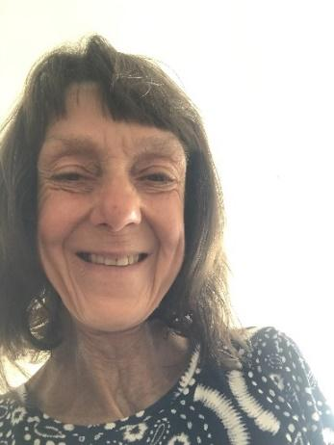
Welcome to ‘Moving Forward Together’
To all our readers
Thank you so much for your contributions to this November issue of Moving Forward.
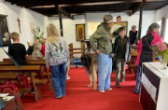
The theme this month is Remembrance :Peace on earth to those whom God loves’. We thank and praise God for our beautiful world and celebrate the huge range of creative talents that God has given us. Each of us is creative in our own special way, and this magazine is a showcase for just some of these talents. The Chapel of the Good Shepherd, Barn Chapel, was recently at the heart of the highly successful Galmpton Autumn Festival. The beautiful craft displays and tables of sumptuous produce demonstrate that creativity continues to thrive in these difficult times with so many other distractions.
We are also called to action, to look after our world, caring and sharing. Our Brixham Mission Community plans to work towards Eco church status. ‘To achieve gold status, churches demonstrate that care for creation is truly embedded and sustained in their collective life and worship for the long term. We know that more churches are deepening their engagement with caring for creation. This is an inspiring story of what God is doing in and through his churches and should give us hope. It’s easy to read news stories and feel overwhelmed at what is going on in the world and the threats to the environment, yet God has always used his church to communicate hope to a broken world and an invitation to live differently’(arocha.org.uk/100goldecochurches).
In the pages that follow there are accounts of the creativity, hard work and service undertaken by our Brixham Mission Community.
We start by looking out at the war torn and poverty- stricken parts of our world, and those who are trying to help ease the suffering.
Our Rector introduces the theme of Creation, and a Licensed Lay Minister reflects on the season of Autumn and invites us to join a Small Group.
We have our regular focus on Safeguarding, and share a photo and account of a gathering of the Exeter Company of Servers, including representatives from St Mary’s, Brixham and All Saints’.
There are photos from Galmpton Primary School following their visit to Churston church for an Agatha Christie trail, and another picture of the full house at Churston for the talk during Agatha Christie week.
We learn more about a member of the congregation at the Barn Chapel, Derek Knowles, who has demonstrated extreme creativity of ideas, culminating in establishing a charity that now supports huge numbers of people with disabilities who are unable to manage their money and affairs without this support. What a great gift from Derek, to give people with a disability equality and independence.
There are reports from all our churches, thoughts on the loss of members of St Mary’s Brixham congregation, seasonal poetry and dates for your diary.
Thank you again for reading our magazine. Debbie Perret
CONTRIBUTIONS FOR THE NOVEMBER ISSUE of MOVING FORWARD TOGETHER should please be sent to Debbie Perret, BMC Administrator, at debbie.brixhammc@gmail.com by Sunday 26 October

Rector’s Report: Remembrance
Dear Friends,
We honour Remembrance during November with
symbolic poppies reminding us how scenes of death
and destruction surrounding the trenches during World
War One gave way to scenes of restoration and new
life. But we are called to remember and honour those
who gave their lives that we may live in peace.
There are many wars. We look in November to
the many who have been killed since the World Wars of
the twentieth century. We look to those who have been
killed in current and recent wars, those who have
suffered life changing injuries and those who have lost
loved ones.
We hope and pray for peace and restoration in
Gaza, in Ukraine and all places divided by conflict. We
pray also with thanks for the work of Brixham
Humanitarian Aid Convoy and for their safety as a
convoy of essential medical supplies and first responder
equipment leaves Brixham for Ukraine this November.
During Remembrance time, we look back to honour
and learn from the past, we look to the present
to respond to it in the best way we can and we look to
the future with hope for just and sustainable political
situations in places currently divided by conflict.
We will remember them.

Rev’d Philippa

Gazing Over Rooftops
Gazing over rooftops
The sea can not be seen
It is in the air
A quality of light
It takes a constant effort
Not to imagine
Looking over Gaza
It is here
In my bones
Praying for my brothers
Not in blood
We all share one cup

February 2025 Stephen Bellows

Remembrance Services
St Mary’s, Brixham : British Legion Remembrance
Wednesday 5th November
The British Legion Festival of Remembrance will take place at St Mary’s, Brixham, 6.30 for 7pm on Wednesday 5th November.

All Saints, Lower Brixham
Sunday 9th November 9.30am
St Mary’s, Brixham: Sunday Worship
Sunday 9th November 10.45am
St Mary the Virgin, Churston
Sunday 9th November 10.45am
Chapel of the Good Shepherd, Galmpton
Sunday 9th November 8.45am
Church of St Thomas of Canterbury, Kingswear : Civic Service
Sunday 9th November 10.45am

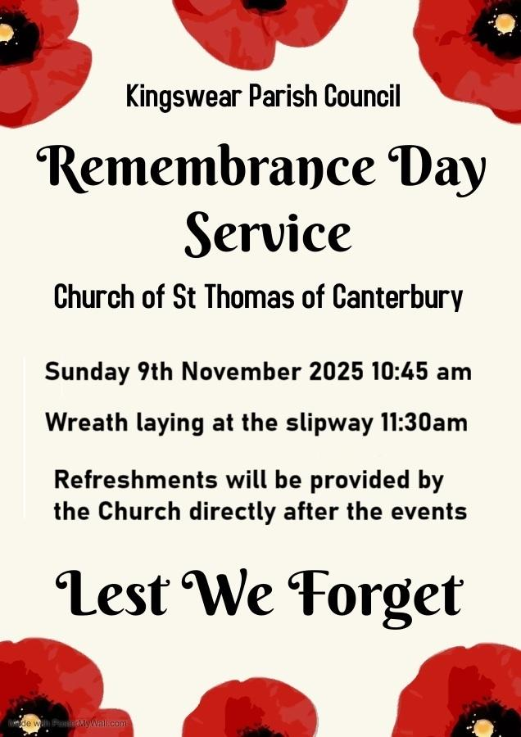

Written during a silent retreat at Lee Abbey.

God of time, yet outside time,
For whom our lifetime is but a blink -
A lifetime that, to us, seems never ending.
Be with us in each moment of this life.
Be with us in the quiet times –
The times of endless waiting
When nothing seems to happen,
The times of calm between the storms of life.
Be with us in those stormy times -
The times when peace seems far away,
The times when we feel battered beyond all hope,
The times when life seems so unfair.
Our lifetime is but a blink to You –
To You, the God outside of time.
The God to whom each second of each person's life
Is both precious and known before it happens.
Be with us, God of time, yet outside time

Wendy Emlyn LLM

Remembrance Service booklet November 9th 2025 St Mary’s Brixham

O God of truth and justice, we hold before you those whose memories we cherish and those whose names we will never know.
Help us to lift our eyes above the torment of this broken world and grant us the grace to pray for those who wish us harm.
As we honour the past, may we put our faith in the future,
for you are the source of all life and hope, now and forever. Amen.

O God of the nations, as we look to that day when you will gather people
from north and south, east and west, into the unity of your peaceable Kingdom, guide with your just and gentle wisdom all who take counsel for the nations of the world, that all your people may spend their days
in security, freedom, and peace, through Jesus Christ, our Lord. Amen

Blessing
O Lord; grant us peace in our time and a longing for the day when people of every language, race, and nation will be brought into the unity of Christ’s kingdom.
And the blessing of God almighty; Father, Son and Holy Spirit, be with us all and all those we remember, now and forever.
Amen. Margaret Pickthorne LLM
We will remember them
‘St Marys has 43 war graves.
The only one we have any knowledge of is Sidney Hellyer as there is a stained glass window dedicated to him in church.’
Roger Holtom, Churchwarden
Sidney Hellyer was a pioneer of steam trawler fishing in the early 1900s who was killed in action during the First World War.

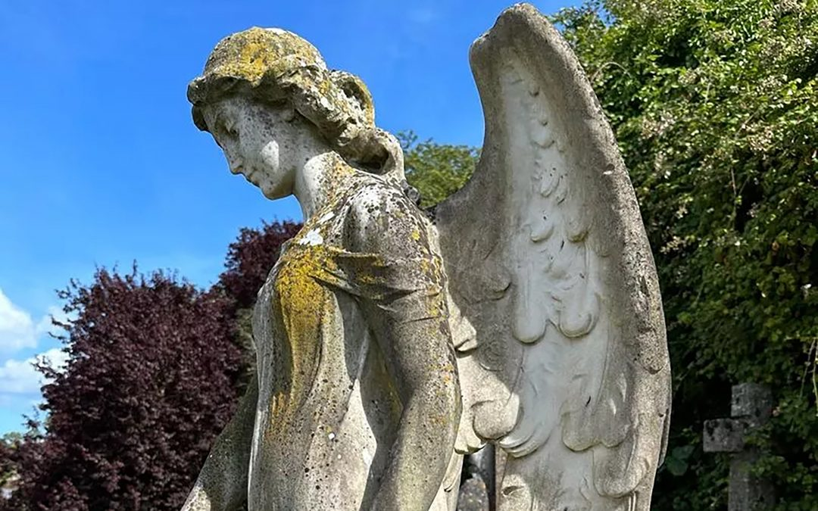
Picture: The Format Factory
The Hellyers built Walborough House in Brixham, today a beautiful guesthouse overlooking the breakwater.
Hellyer joined the Army, and on 15 April 1915 he was sent to fight in Belgium. After just 11 days of being on the Western Front Sindey Hellyer was blown up by a mortar bomb. He died of his injuries in a hospital in Bologne. He served in the East Yorkshire Regiment and of the 969 soldiers in his battalion, only six of them returned.
Original story : Jake Holden, on Devon Live, talking to Ben Field, the Format Factory.
‘IN AFFECTIONATE REMEMBRANCE Of REGINALD EARNEST WROTH
LATE OF LUPTON BARTON SEARGANT ROYAL 1ST DEVON YEOMANRY
WHO FELL IN ACTION NEAR JERUSALEM 3 DECEMBER 1917 AGED 25 YEARS’
‘Thy will be done’
Just inside the coffin door at St Mary’s Churston is a large brass memorial.
I consider that Reginald Earnest Wroth is the “Uncle I never met”.
My maternal grandfather was Jack Wroth, the youngest of seven children, born at Wonwell Farm in the South Hams. Many of his family lived in the area and I expect that Reginald was also born in the South Hams.
The Church Yards at St Ann’s Chapel, Ringmore and I think in several other Churches in that very rural area of the South Hams contain many Wroth graves. I remember as a small child visiting these Church Yards and also visiting Wroth relatives on farms at Stokenham and also Chillington.
Jane Washington, Churchwarden

Support for Ukraine
The Brixham Medical & Humanitarian Convoy to Ukraine is due to depart our town on Thursday 6 November.
In last month’s Moving Forward, John Brennan made an appeal for a collection for First Aid Responder bags. These bags are full of life-saving emergency equipment for medics to use at the site of a major incident that they are called to. Each Bag costs £500.
Your response was magnificent:
‘I am very pleased to tell you that we have raised just over £1,500.00 for the first aid responder bags for Ukraine. That will provide 3 bags! What a wonderful result and thank you all both at the Barn and at Churston and elsewhere for your great generosity. I rang John Brennan of Brixham Future CIC which is the charity that has acquired vehicles to drive out to Ukraine having done them up. They have collected plenty of blankets and many medicines etc but they would still like more of the following for the last few corners of the vehicles that have not been filled up: -Beanie hats; gloves Ibuprofen and Paracetamol; toothpaste and toothbrushes; soap; bandages.’
Jane Washington

Blankets for Ukraine
There are six blankets on the rail in the photo on the front cover of this magazine. The photo shows Nick, holding the blanket made in Ukraine colours by his friends, and Rosemary, from All Saints church Lyte Fingers group, who sewed the squares together for the other blankets. Nick also attached a label, which shows the initials of all those who contributed to making his blanket. The message is in Latin, so that any Russians reading it will not immediately think it is Ukrainian "propaganda".
Margaret Dyer

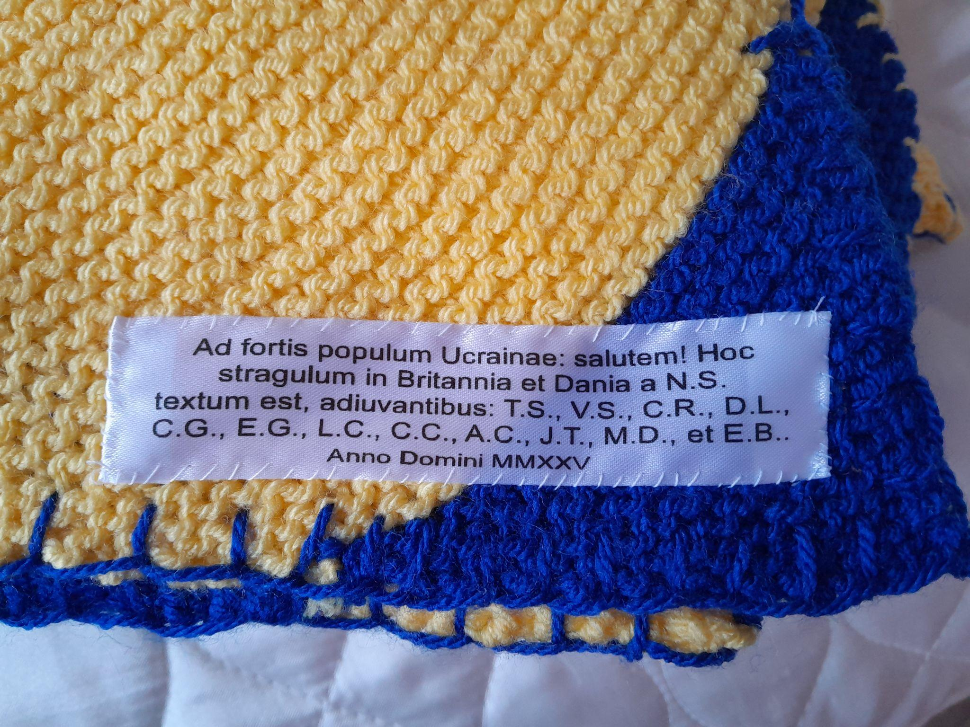

Hundreds of boxes for children in Eastern Europe
Please see the link to the article on BBC Devon news. I have created this article from the link. Copyright of BBC news. https://www.bbc.co.uk/news/articles/ckgke4kv39mo
Roger Holtom, Churchwarden
‘Five-hundred shoeboxes have been filled with Christmas presents for children in Eastern European countries. Volunteers at St Mary's Church, in Brixham, Devon, have packed and checked boxes filled with toys, toiletries, clothing and other presents. The boxes will be taken to Ukraine and Moldova by Christian Response, a charity based in Exmouth. Volunteer Lindsay Williams said: "They're going to children who otherwise wouldn't have Christmas." The boxes will be taken to the countries by lorry in November. Ms Williams said: "We've got a wonderful lady... who has a load of friends and all year they knit for the shoeboxes. "It's just amazing because you know the whole community has reached out and they just love the idea that children are going to have Christmas." She said the boxes had been in the churches that are part of Brixham Mission Community for the last three months. "People have been bringing in a couple of bars of soap, a few flannels, torches, teddy bears, anything that can go in shoeboxes... and they have just been wonderful."
Reverend Dr Philippa Bellows, team rector of Brixham Mission Community, said: "It's been mind-blowing generosity from everyone and particularly from all of our schools. It's desperately sad to think of people suffering deprivation in war-torn countries and people without anything at Christmas. The feeling that we can do something to alleviate that sadness brings us a huge amount of joy." ‘
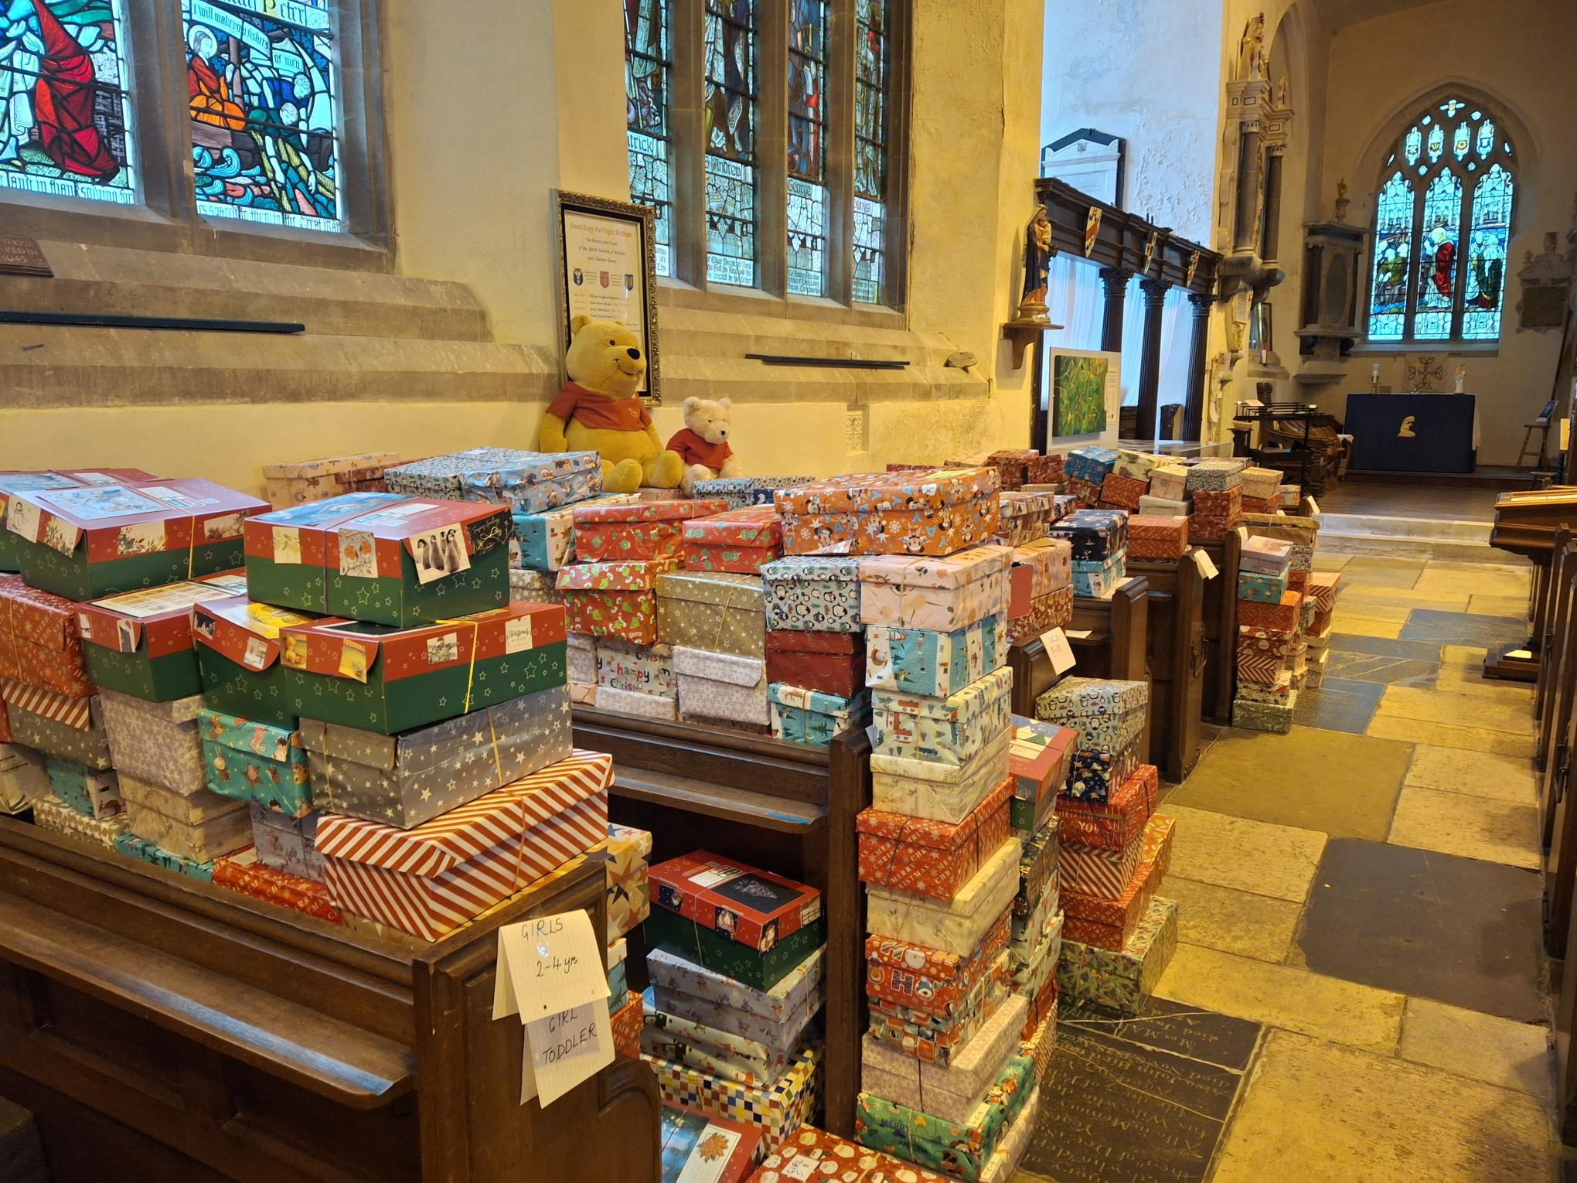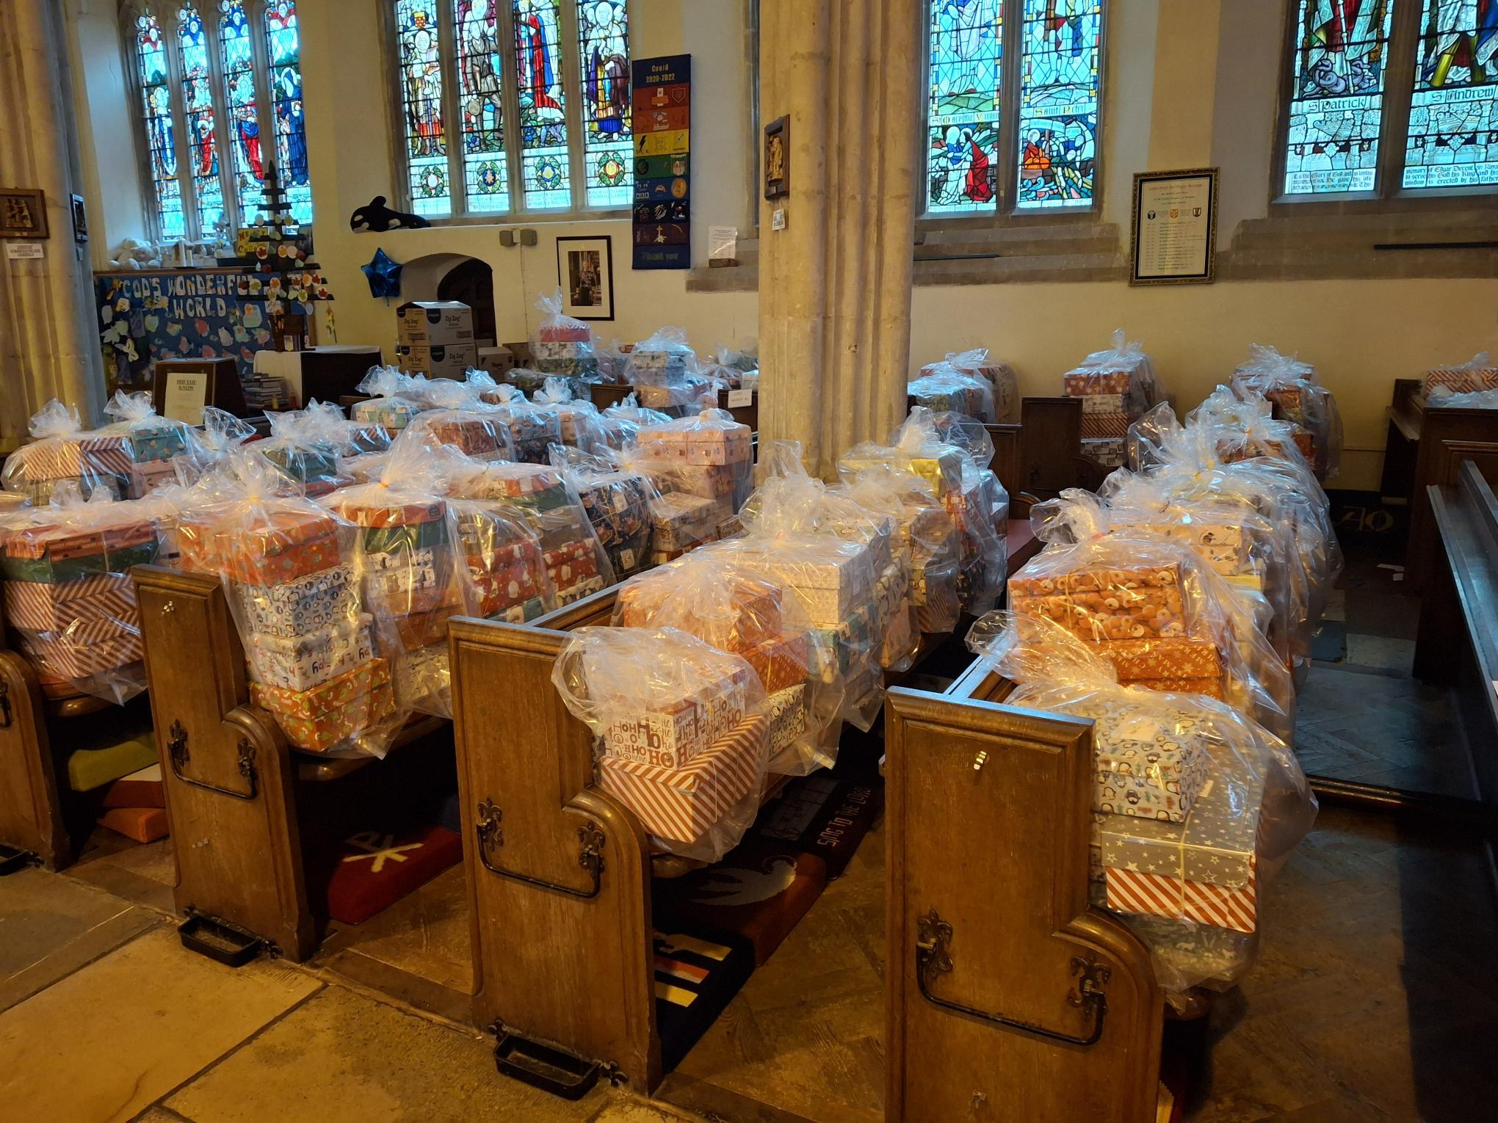
Looking forward to our New Year

Are you seeking new insight this Advent?

We believe – exploring the Nicene Creed

Come and join us for prayerful reflection on the timeless truths of the Nicene Creed.

St Mary’s Brixham 11 am on Wednesdays
26th November, 3rd, 10th and 17th December

All Saints Lower Brixham 10.30 am Tuesdays
2nd, 9th, 16th and 23rd December

The Barn Chapel, Galmpton 10 am Thursdays
27th November, 4th, 11th, 18th December

Next year's gospel in the lectionary is Matthew. I preached the piece that follows on St Matthew's Day and felt it might be an introduction in the November and December magazines, in preparation for the change of Gospel on Advent Sunday. Here is the first part.
M Pickthorne

Matthew Apostle and Evangelist - STK 21Sep25
The Gospel for next year's lectionary is the Gospel of Matthew. We start to hear Matthew's Gospel from Advent Sunday week by week. Matthew apostle and evangelist – what was he like? In a book called The St Matthew Passion the theologian John Fenton tells us that Matthew can be described by the way he lays out the mantelpiece in his living room.
In the centre is a big crucifix. Then a pair of candles each side - Matthew likes candles, they remind him of the light. Then, maybe, two wine glasses to remind him of the meals he shared with tax-collectors and sinners (Matthew was one of those himself) and one memorable supper with Jesus. Then two more candles. Then there are two vases – to remind him of the jars that contain costly anointing oils. And finally, two more candles.
Well, there is Matthew’s mantelpiece. And if his cleaner comes and moves anything, well, Matthew knows and puts it back carefully in the right place. Matthew’s mantelpiece is like his Gospel. According to Matthew there are 5 pillars to the teaching of Jesus. This is a reference to the five books of the Pentateuch – that is, the first five books of Hebrew scripture called Torah or
The Law - Genesis, Exodus, Numbers, Leviticus, Deuteronomy. In between each of the five pillars there are passages of narrative into which more teaching is woven.
At the opening end, one vase represents teaching about how to enter the kingdom of heaven. This first vase in Chapters 5 to 7 details the famous sermon on the mount. The nine beatitudes are followed by extended teaching for each one. The extended teaching is in reverse order.
At the other end of the mantlepiece, the other vase teaches about the coming of the kingdom of heaven.
This includes some pretty tough stuff about the people who do not
choose the kingdom being cast out into the eternal fire where there will be gnashing of teeth.
The first wine glass is teaching to the apostles, when Jesus gave them his authority and sent them out to teach and to heal in his name. On the other side the wine glass is teaching for the whole church. The emphasis is that those we teach and seek to evangelise are children to be treated with kindness and love.
At the centre of the gospel is a chunk of teaching given through the parables. The parables of Jesus are stories to teach us what God's Kingdom is like.
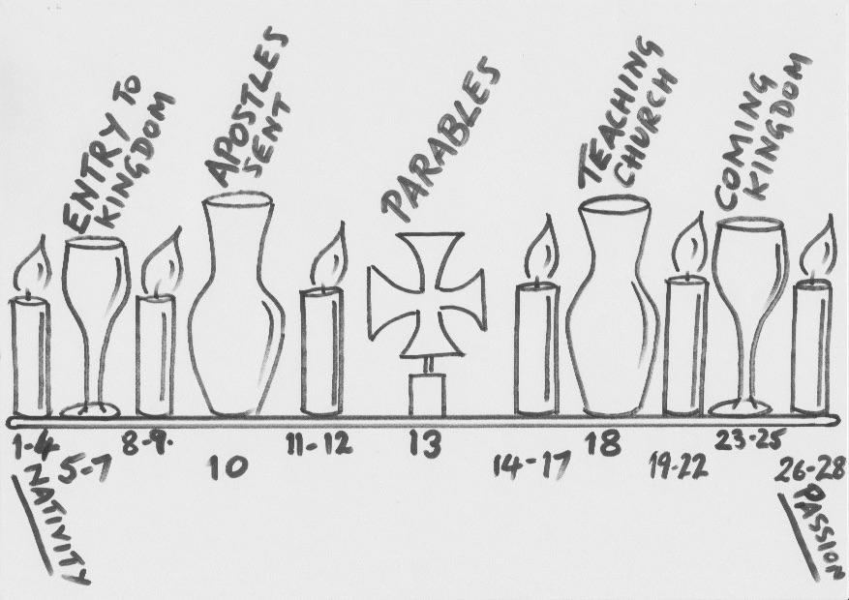

Mission Community Harvest Appeal: Mental Wellbeing in our community initiative from St Mary’s, Brixham, with support from all the Mission Community churches
A coffee morning/Bring & Buy sale for our Harvest Appeal (the work of the Lupton Trust in helping those with mental health issues) is to took place at Lupton House on Monday 13 October and we hope that many people who have never visited the house before will join us for this occasion. Our thanks go to the Lupton team and those in the BMC who have offered to oversee the sale of cakes/books/plants/bring & buy items/refreshments in beautiful surroundings.
All Saints’, Brixham and St Mary the Virgin, Churston are manning stalls. LW
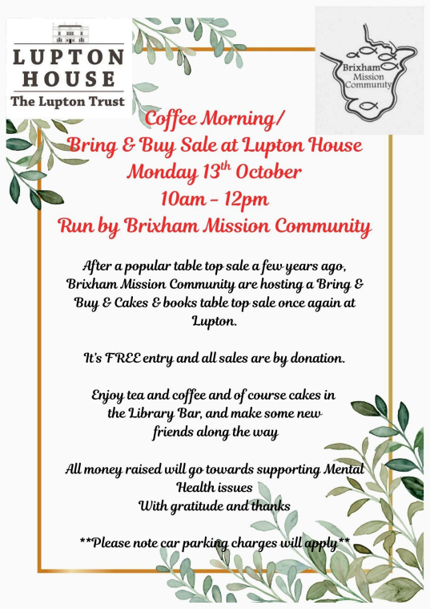
Our Harvest Appeal supported by a further event at St Thomas of Canterbury, Kingswear
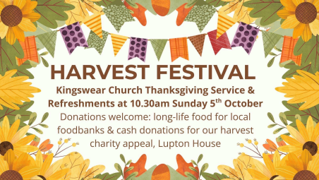

And another initiative, this time from All Saints’, Brixham All Saints’ – Toilet Twinning:
Some time ago a “potty” was placed in each of our two church toilets, together with a sign on the door stating that we are aiming to twin our toilets with ones in various parts of the underdeveloped world, places where just simple hygiene and personal safety, especially for women, cannot be guaranteed.
“If you need to go, put some pennies in the po” reads the “encouragement” to WC users. It was not long before those occasional donations added up to £60, the cost of a new hygienic sanitary toilet. The PCC decided to add a further toilet from our bank account under the Charitable Giving umbrella and so we donated one to Malawi and one to the Democratic Republic of the Congo.
The scheme was the brainchild of Tearfund and now we start our collecting all over again! Peter Thorp

All Saints’, Brixham
Fundraising:
A small number of coffee mornings, the Charity Tuesday Fish Quay Market and Margaret’s cream teas event have brought in some very much needed donations together with Lyte Fingers’ usual marvellous contributions. Also we receive regular contributions from our Sunday morning refreshments team, so thank you ALL. Peter Thorp

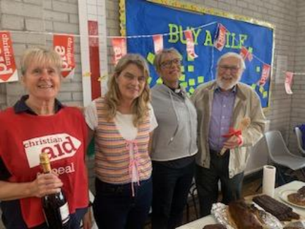
From left: Marie, Jane, Rev’d Dr Philippa and David
Harvest of Hope Coffee Morning
The climate crisis is making it harder than ever for families to grow food. Flooding and drought are destroying harvests. Crops that once fed communities are now failing.
But hope is growing. In Sierra Leone, Maryama is adapting. After floods damaged her crops and income she joined a Village Savings and Loans Association supported by Christian Aid. With a small loan, she was able to pay her children’s school fees, secure her farm and invest in their future.
Christian Aid brought Harvest of Hope to town with joy, fun and fellowship on Saturday 6 September. What a morning with both Stargazy Pie playing and our wonderful baking competition drawing in the folks. We had members from all the churches helping and attending.
Marie set up early, with bunting etc. and a load of delicious cakes. Lindsay helped with an arm in a sling, a raffle, her ever popular shortbread and some attractive bags for sale. Marge and Jim took charge of the kitchen, Judy and Barbara were cooking too and in charge of the cakes. Judy left her son, who had just arrived from Thailand, to serve coffees as well as sell cakes. Fiona was chasing everywhere! Then the Competition Cakes arrived! Rev’d Philippa and Jane judged. Mary Berry, eat your heart out! Our judges marked separately the six categories and came to the same results! Marie came second with a bakewell cake decorated with an array of fruits and David Roberts, with a Bara–Brith, was first. I knew he was a good soup maker but never knew he was such a baker as well! Philippa left us with the 64$ question - how does Mary Berry stay so slim?
Everybody thoroughly enjoyed themselves and we raised £530.00!
When lives are torn apart by disaster, we’re called to bear one another’s burdens. Through our prayers and actions, we can be a source of comfort and strength to those who are suffering. Together, we bring light into the darkest places and help rebuild lives with love and faith.
“Bear one another's burdens, and in this way you will fulfil the law of Christ” (Galatians 6:2)
Thank you all for your wonderful support and see you soon again we hope with our upcoming visit from Martin Nicholls and another coffee morning before the end of the year. Marie, Lindsay and Mary
Service in Action: Exeter gathering of Servers
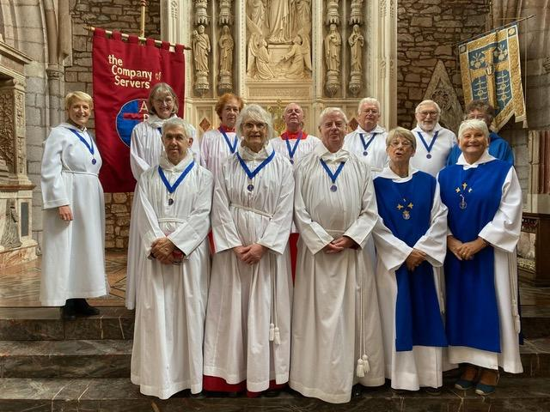
(front row right) Margaret Jaycock and Jacqui Holtom (SMB), behind David & Lesley Roberts (SMB) (slightly hidden) and Jacqui Laing and Peter Thorp (AS)
Exeter Company of Servers
Some may not know of this group but all our Servers in the Mission Community are members of the Exeter Company of Servers. Serving during the Eucharist is a very special thing to do; it is an honour to be taking part in the act that Our Lord carried out during the Last Supper.
Servers therefore are appointed by the Diocese and it is at these special services, held only twice a year, that Servers receive their authority to carry out such tasks.
Recently we were invited to the installation of two more Servers at Holy Cross Church in Crediton. The Rev’d Prebendary Matthew Tregenza performed the welcoming, assisted by the Deacon Jeremy Rawlings, following which we all enjoyed a shared lunch.
Being a Server is a very rewarding role to play within our joint churches; should you be interested in doing that in the future please discuss with Philippa. Peter
Rector’s Report
Welcome to our October edition of Moving Forward Together. It seems that this Autumn is one of abundance, with generous crops of apples, blackberries, courgettes and seasonal fruits. It’s timely that the Church throughout the world celebrates the season of creation from the beginning of September into October. This year’s theme ‘Peace with Creation’ focuses on a short biblical prophecy (Isaiah 32:14-18). Isaiah speaks of God’s Spirit being poured into desolation in the world, transforming barren deserts into fertile land and restoring security and prosperity.
The era we are living in is widely spoken of as Anthropocene as a result of dominant human activity leading to planetary change, such as we notice in global warming and pollution. For the first time in the history of the world we are aware of our own human collective capability to destroy the living environment that God has entrusted to our care.
The English translation of the creation story in Genesis reports God saying to Adam ‘fill the earth and subdue it’… ‘have dominion over’ it. This is why some lay blame for global damage at the door of the Christian faith and the bible. But we see the opposite in Isaiah’s prophecy of restoration and renewal, and when we look at the Jewish law laid out in the Christian Old Testament. Laws in the bible governing farming and food distribution show a practical awareness of environmental sustainability. Judaism and Christianity both celebrate harvest festivals to give thanks for God’s creation, and to distribute food more fairly to those who may have little.
Our Mission Community harvest festivals this October will distribute goods to the local foodbank and raise funds for local causes. As citizens of this earth we are all responsible for safeguarding creation, so tread lightly and thankfully for all the gifts of creation we enjoy in this beautiful corner of Devon.
Rev’d Philippa
Safeguarding
Safeguarding is at the centre of our faith, in our practice, in our worship, in our praying, and in our believing. In other words, safeguarding needs to become integral to the life of the Church rather than an appendage, with good safeguarding behaviours flowing naturally and intuitively. This requires recognition that safeguarding needs to move away from something that is in some respects external/imposed upon the Church, to something that flows from within the soul of the Church.
The Diocese of Exeter aims to provide comprehensive safeguarding guidance, training and support to all those who require it.
The Shadows Lengthen
After September the season starts to tip into darker times. In concert with the spinning world, we tip away from the sun. The mood of the season reminds us of things dying and of shadows that lengthen. The garden is planning to die back and go into hibernation.
The mood is punctuated by festivals that mark this change. It is no accident that, in a post-Christian country, people feel the need to revive an ancient pagan rite that is fixated on death. People like to go out on All Hallows Eve to prance about in unpleasant costumes with lanterns made from seasonal pumpkins. I call it 'The Festival of Ugliness'. Yet the name of Hallowe’en derives from a Christian festival which also taps into the mood of death and dying. As the light fades we remember those who have died. On All Saints' Day we celebrate those whose Christian life has been noteworthy and on All Souls’ Day we remember our loved ones who are no longer with us. Later, in November, we have the season of Remembrance for those fallen in war.
But Jesus is the light of the world - he said so himself (John 8:12). And those of us who live life in Christ are also light in the world. Jesus said that, too (Matthew 5:14). Even in the darker days of Winter we are the people who know that Spring, with the feast day of Easter, is just around the corner. We can endure the darkness because we know that the light is coming. The psalmist said, "Though I walk through the valley of the shadow of death I shall fear no evil" (Psalm 23), but the psalmist talks of the shadow of death, not full darkness. Where there is a shadow, there is a light causing the shadow to fall, even if we cannot see that light. In October we move towards the end of the Sundays of Ordinary Time and move into the shadow time of mourning and Remembrance. Then we start the rhythm of the church's year once more as we begin the season of Advent when the days are at their shortest. But that is when we have the most exuberant celebration of Christmas. A few days after the shortest day we declare on Christmas Day that "the light shines in the darkness and the darkness did not overcome it." (John 1:5)
Until then, let us enjoy the restfulness of the shadow time of October. Let us not dwell too much on death but on peaceful rest. The towns of Brixham and Kingswear become ours once more after the busy holiday season and we can rest from our labours of the year.
O Lord, support us all the day long,
until the shadows lengthen and the evening comes,
and the busy world lies hushed,
and the fever of life is over, and our work is done.
Then in thy mercy grant us a safe lodging,
and a holy rest, and peace at the last. John Henry Newman
M Pickthorne LLM
In Praise of Small Groups
House Group, Prayer Group, Bible Study Group - there are many names for what we can generically call a small group. Whatever we call them, small groups are vital to the thriving and growing of congregations in church life.
Here in Brixham Mission Community we hope to encourage groups of people to gather together regularly to pray and study scripture and to grow as disciples of Christ. Small groups happen in places of hospitality, preferably someone's home, and it is recommended they be no larger than around a dozen people. In an ideal world meetings would be weekly but, in a world where people have busy lives, they are often fortnightly. A monthly meeting is a little too infrequent.
WHY?
There are many ways in which the full Sunday service is not conducive to Christian discipleship. Sometimes a full church congregation can seem like a very lonely place, especially when we think everyone else knows what they are doing (which they don't!). We need a safe place with a small nucleus of supportive people to learn and to become more like the person God had in mind for us to be.
Spiritual Growth
Go therefore and make disciples of all nations, baptising them in the name of the Father and of the Son and of the Holy Spirit. Matthew 28:19
First and foremost, when we are baptised as Christians, we are called to become disciples and to learn more and more about Christian living. The word disciple is dynamic. It is not a static description. From our first understanding of what God in Christ has done for us; from the moment we make a commitment to follow him, we are called to go deeper into our relationship with him. Christians always grow better within the more intimate surroundings of a small group. In the small group we build relationships with other Christians and together we become a supportive community.
Prayer
Do not deprive one another except perhaps by agreement for a set time, to devote yourselves to prayer and then come together again. 1 Corinthians 7:5
We are called to pray. But what is prayer? How do we develop a habit of prayer if we are on our own and have never done it before? In a small group we grow a habit of praying regularly. Seeing how other people pray is a pointer to developing our own way of praying. There is no single formula for praying but it is easier to learn to pray if we have help and do not start alone and from scratch.
"[Prayer] requires only a heartfelt desire to know and love Jesus and a facility for day-dreaming. Though we may not admit it readily, most of us are well-practised at day-dreaming."
Joseph Cassidy, LIVING THE STORY (2020 Canterbury Press)
Bible Study
Set the believers an example in speech and conduct, in love, in faith, in purity. Until I arrive, give attention to the public reading of scripture, to exhorting, to teaching. 1 Timothy 4:12-13
A disciple is not someone who knows ABOUT Jesus. Any atheist can know that. The path of discipleship is the path to knowing Jesus more closely as a friend and as our saviour. In scripture we learn what Jesus was like as the teacher whom the disciples followed. Ours is the only faith to declare that God loves us. We learn to know that love through learning who Jesus was and is. We also learn the love of God when we are part of a Christian small group full of mutual understanding and care. We learn to be that community through reading scripture.
Mutual Care
Are any among you suffering? They should pray.
Are any cheerful? They should sing songs of praise.
Are any among you sick? They should call for the elders of the church and have them pray over them, anointing them with oil in the name of the Lord. James 5:13-14

It is with a group of people whom we grow to trust that we can reveal our vulnerability. We can learn to share things we are coy to reveal in a more widespread way. We all have hopes and fears and moments of shame or sadness that we hold close. In a small group where we learn to trust we can put down baggage we cling to. In this way we also learn to reveal our hidden places to God in our prayers.
Being Christian in the World
Do not be conformed to this world,
but be transformed by the renewing of your minds,
so that you may discern what is the will of God—
what is good and acceptable and perfect. Romans 12:2
The small group is an overtly Christian place. But the cultural influences all around us run counter to Christian values. The small group is the place where we go to learn how to untangle ourselves from the worldly baggage we have allowed ourselves to engage with.
All that is in the world—the desire of the flesh, the desire of the eyes, the pride in riches—comes not from the Father but from the world.1 John 2:16
HOW?
Our small group initiative needs YOU.
Consider whether you could be part of a small group (I do hope you will desire it). Could you host? Would you be happy to lead? We can provide many different study resources to guide a group leader. Would you be able to draw in a group of people across the Mission Community churches? If you are not called to be a mover or shaker, small groups also need quiet listeners and those who do not feel ready to claim a big faith but would like to learn.
Some people already have experience of small groups and will be comfortable taking part. Others might be hesitant. The ministry team will be very supportive and there will be training to build leaders and hosts so that they do not feel overwhelmed.
Whatever your hopes and fears, we need to make a start. If you think you are called to step into this world of small groups I would love to be contacted. E-mail is best: margaretpickthorne@gmail.com. M Pickthorne LLM
From our Galmpton C of E school: SIAMS Report:
Statutory Inspection of Anglican and Methodist Schools
‘Life in all its fullness’ (John 10:10)
‘
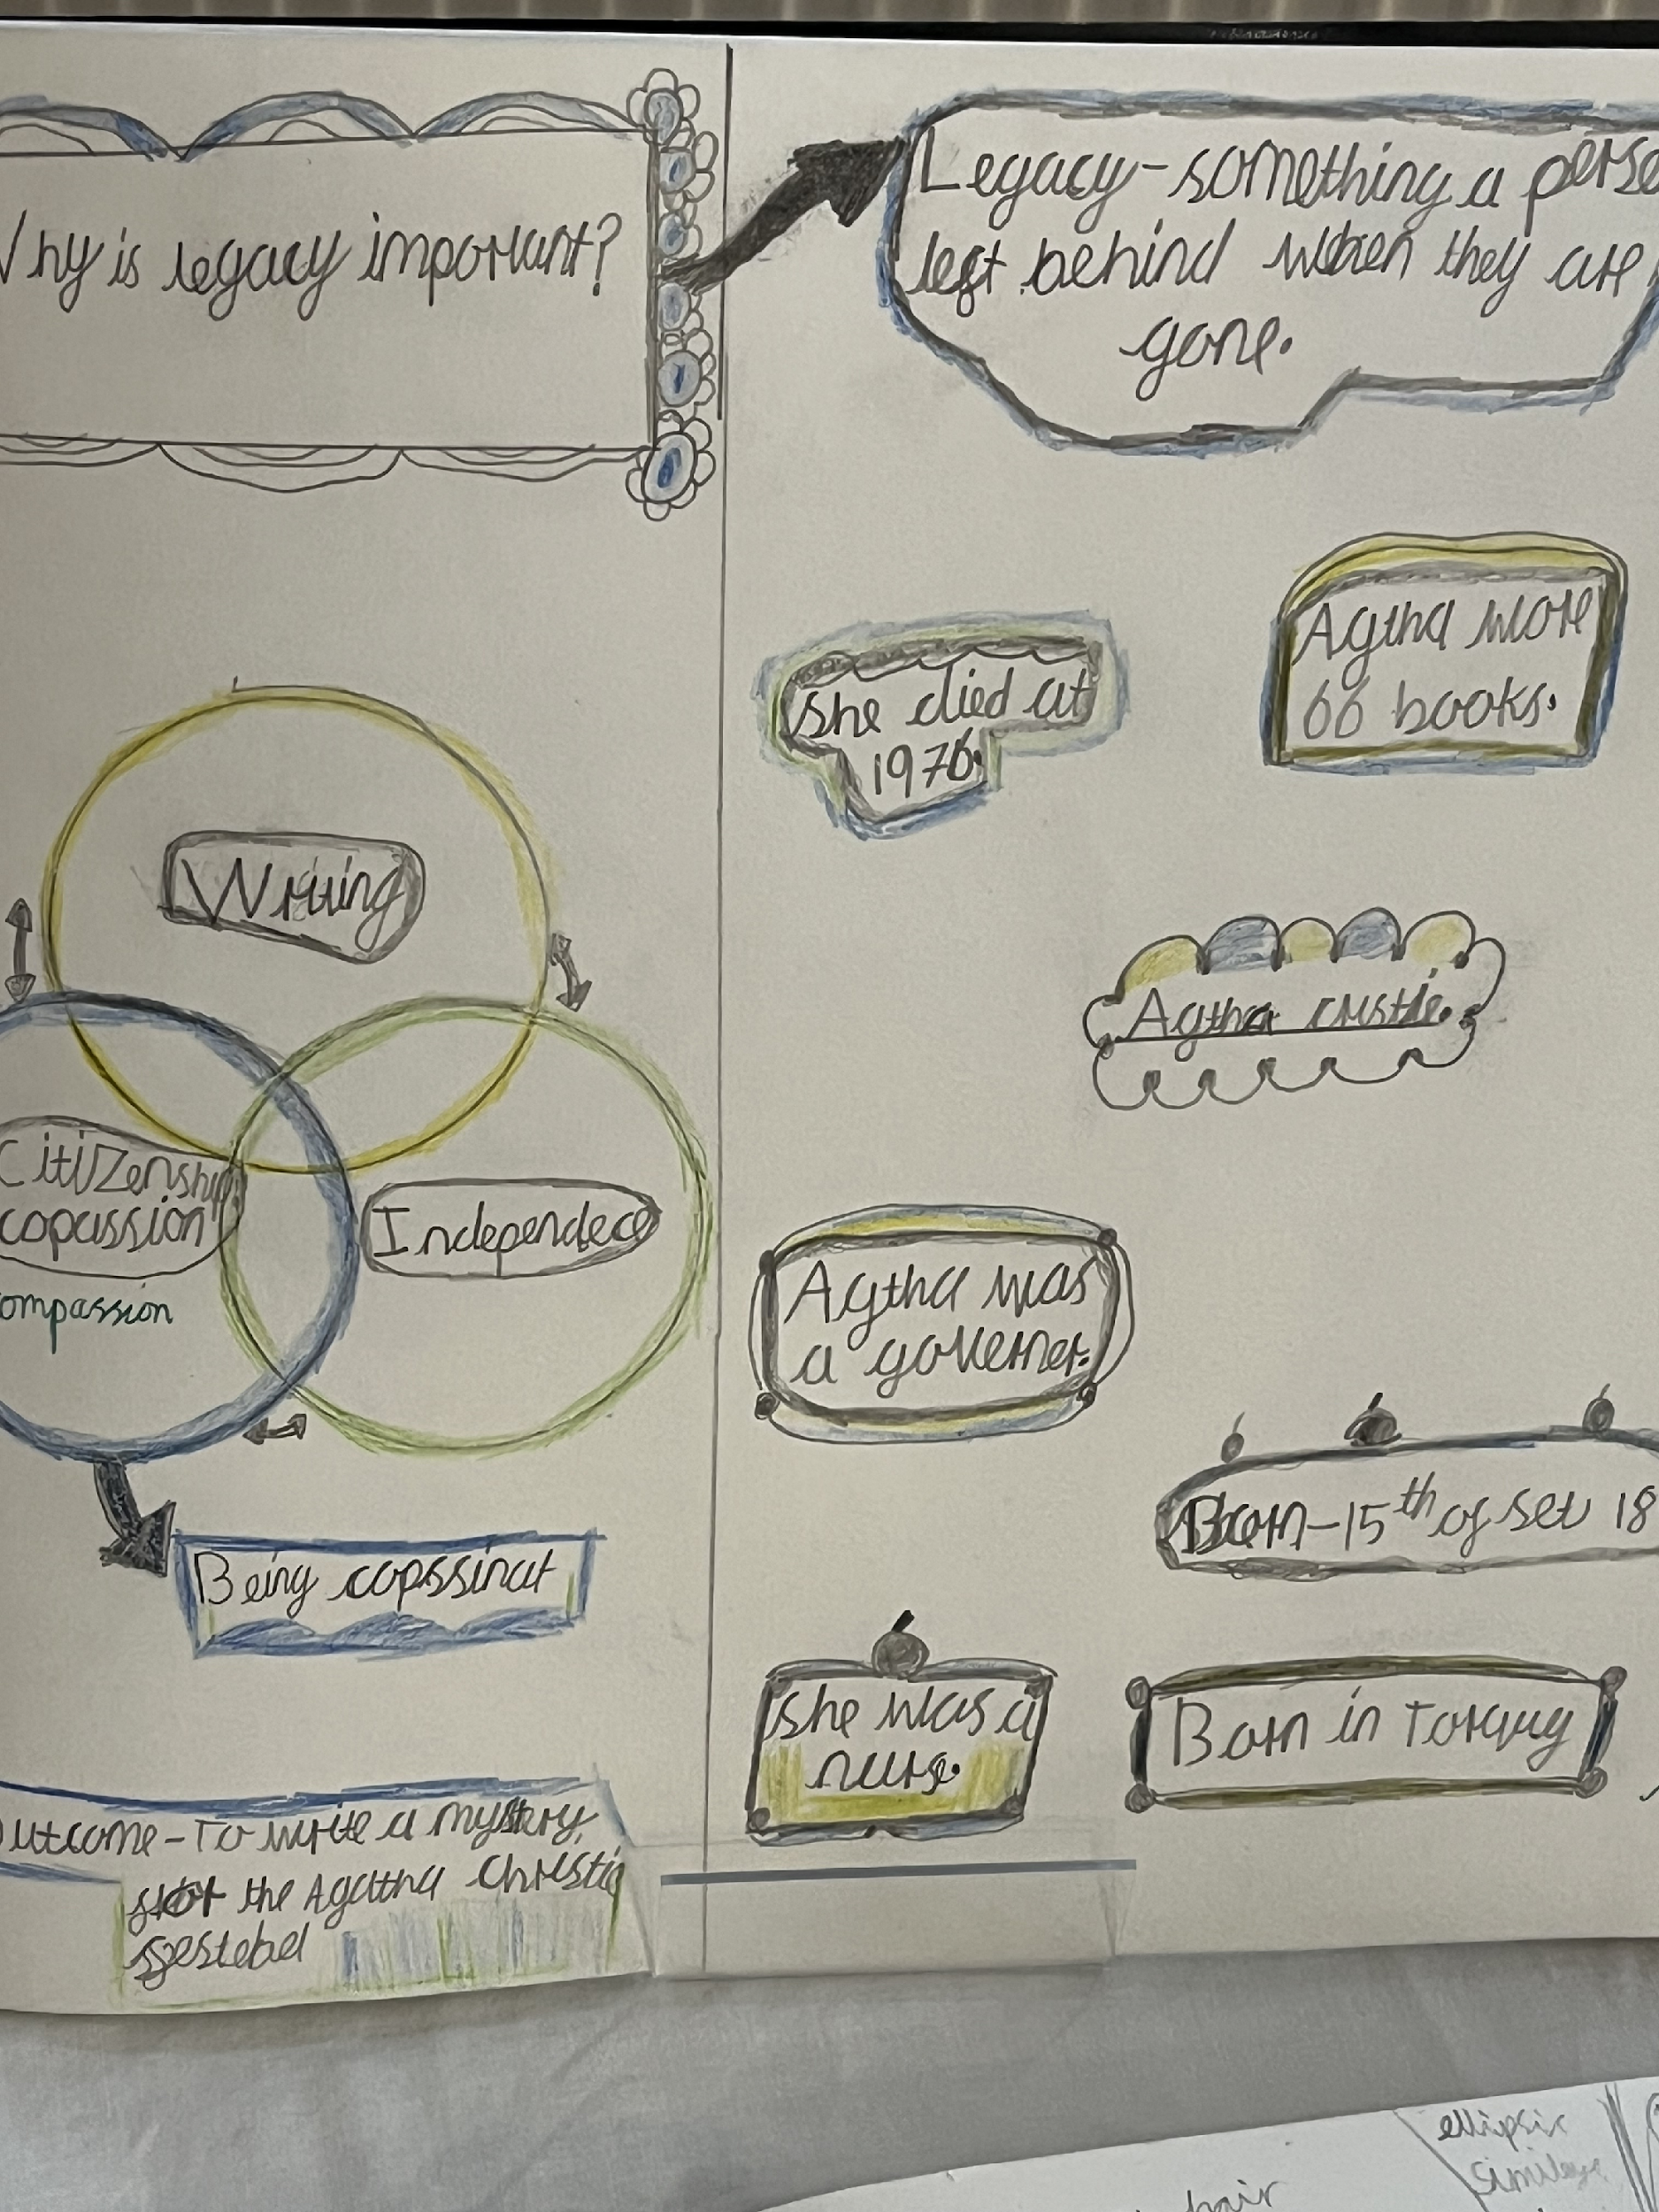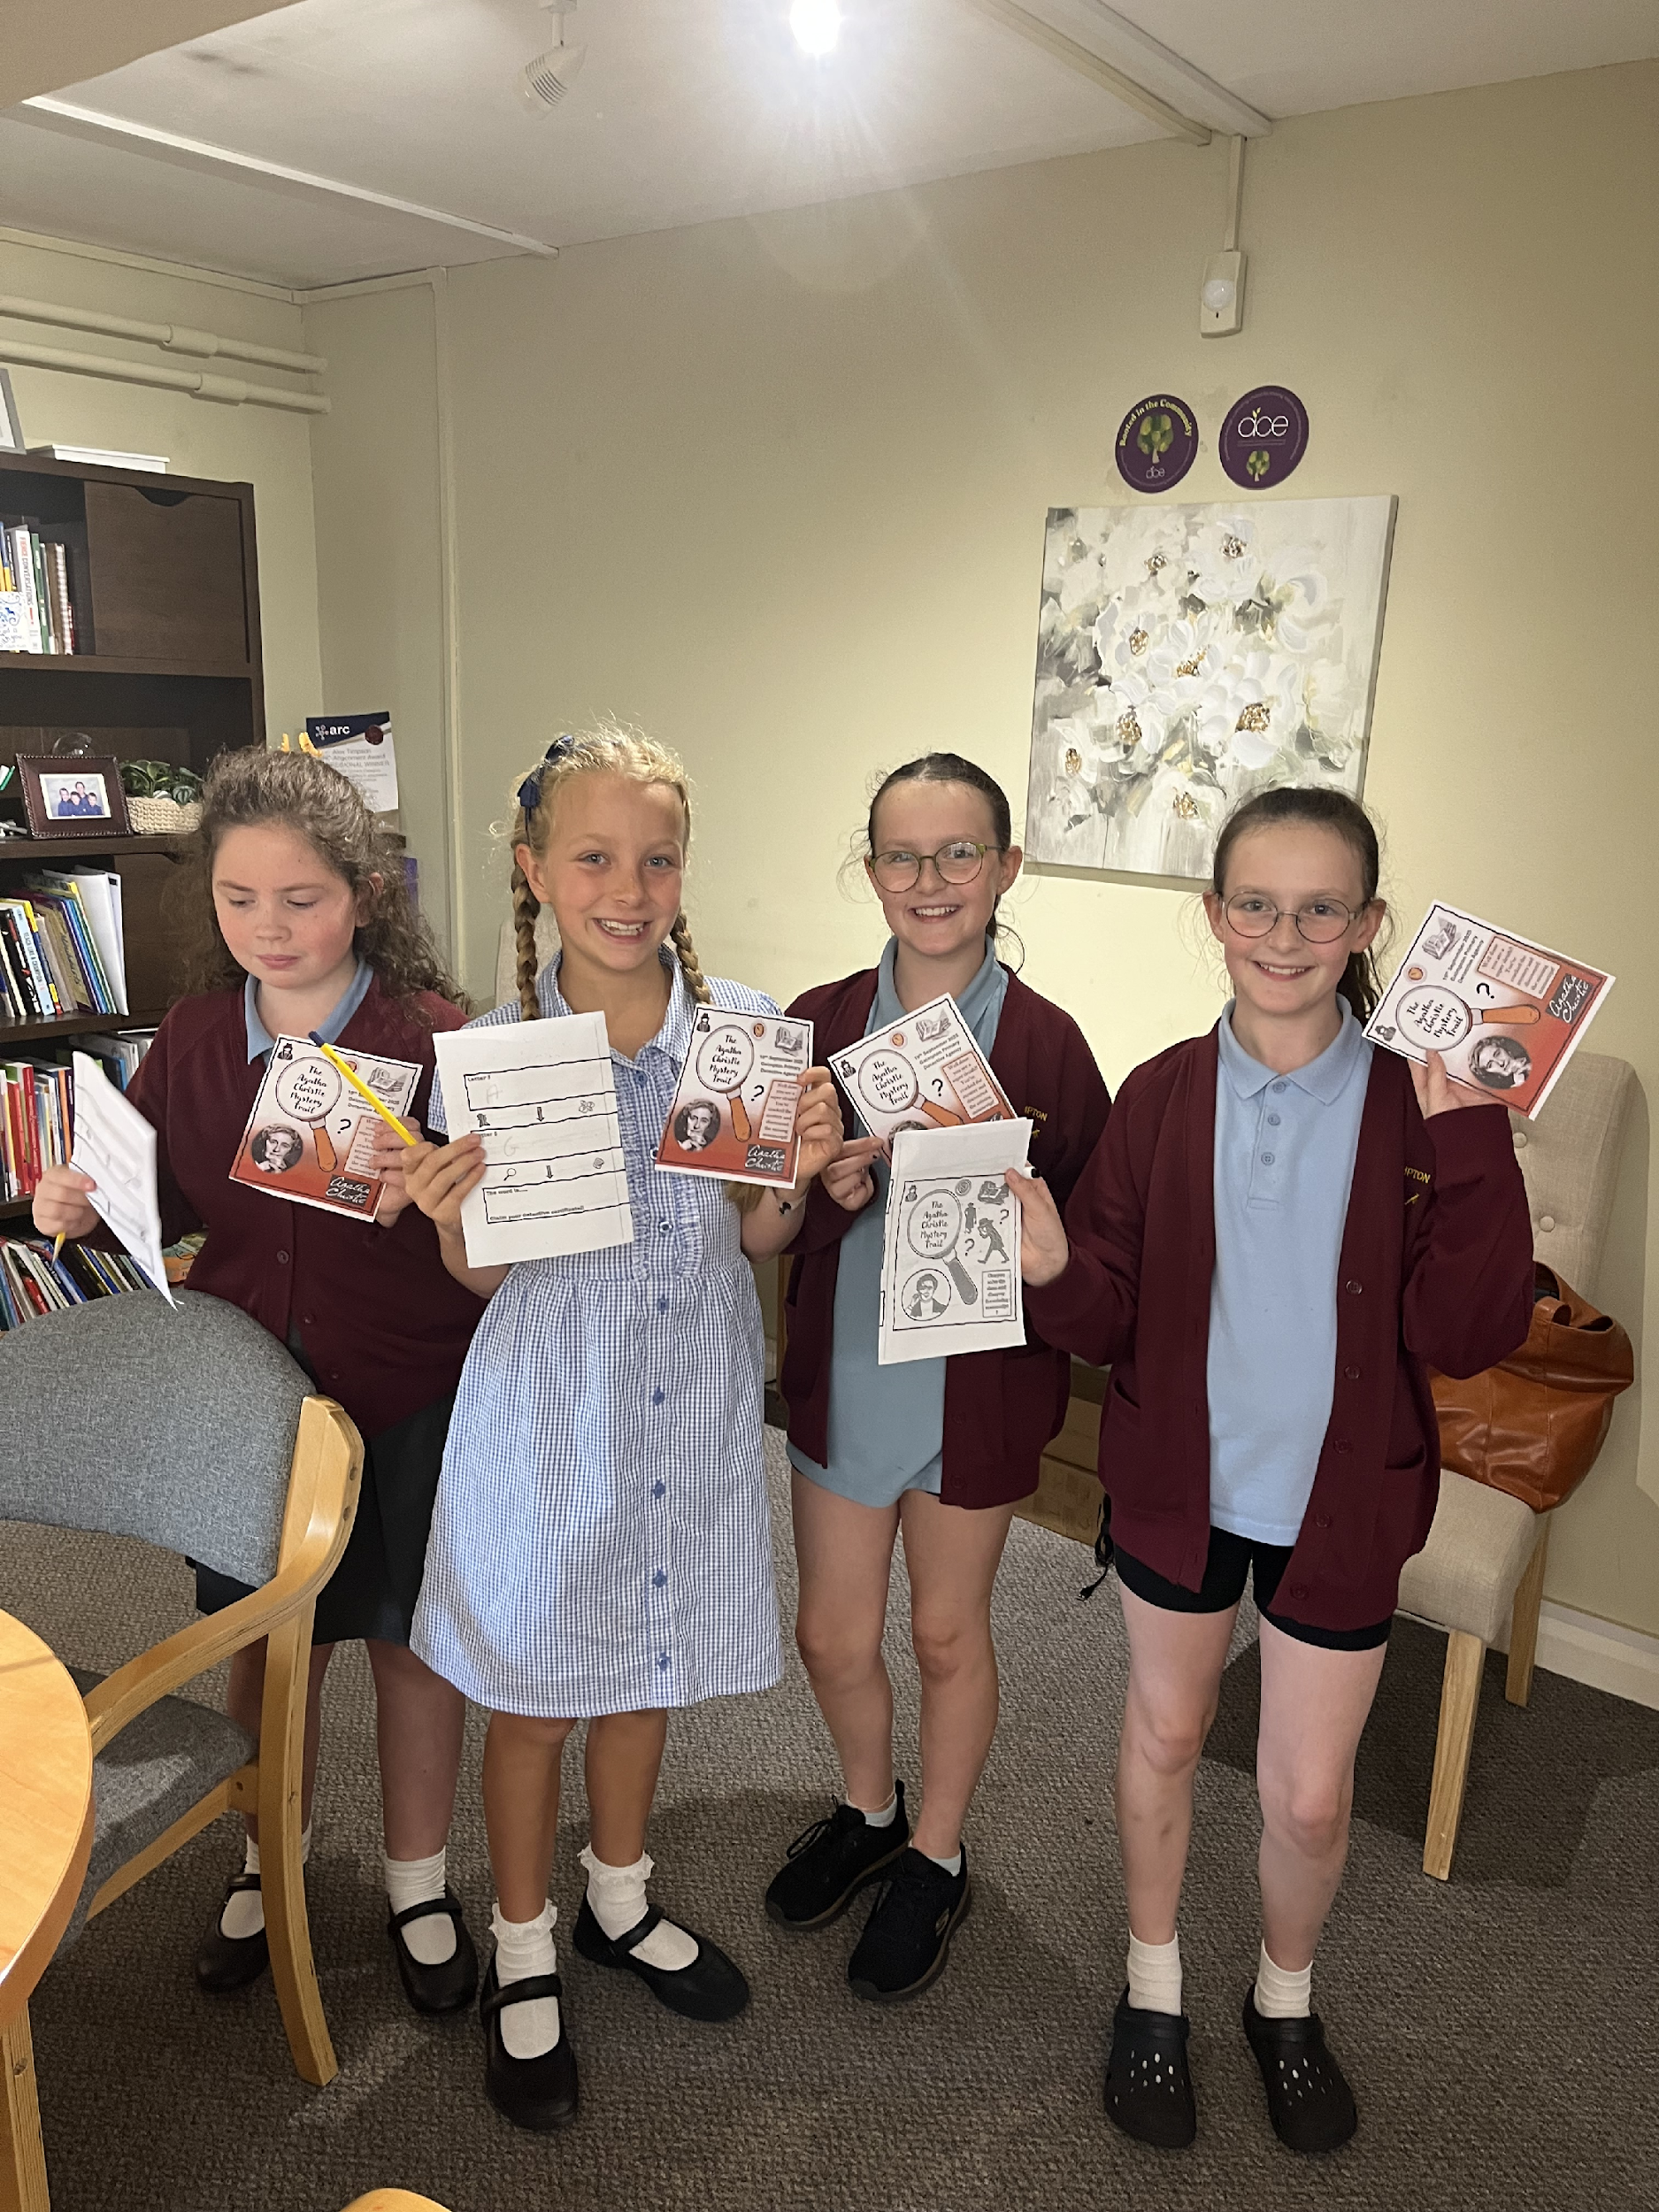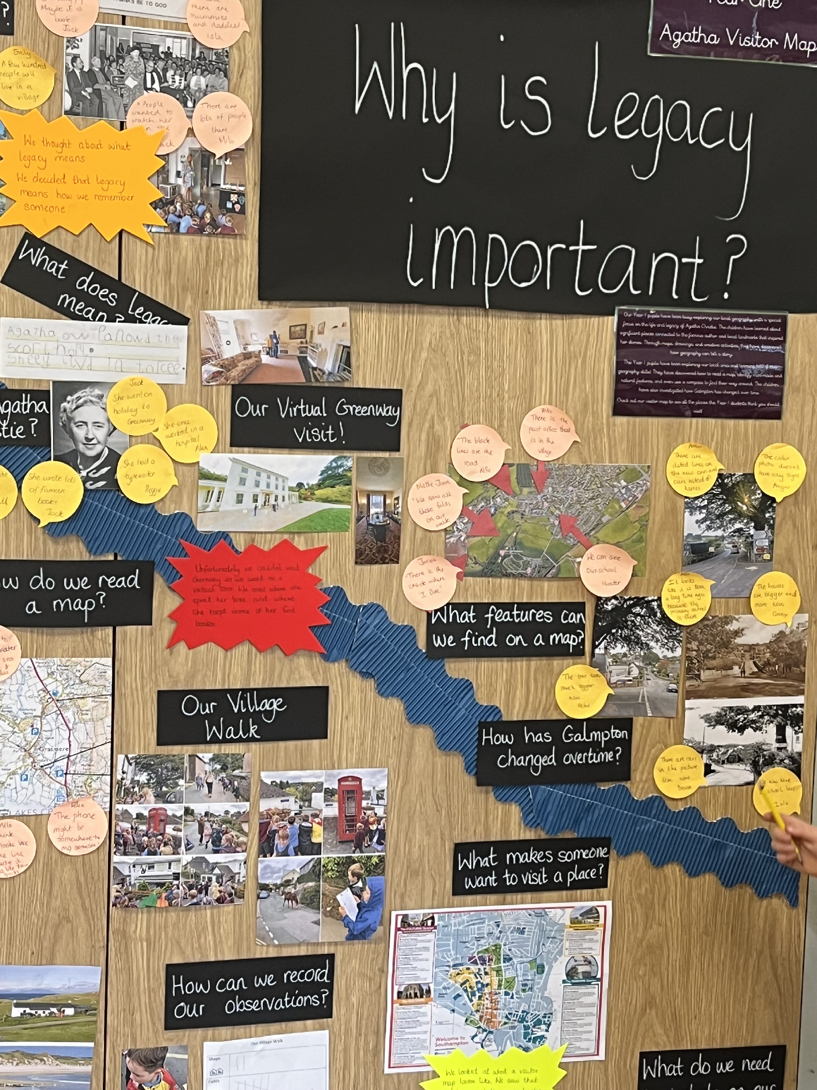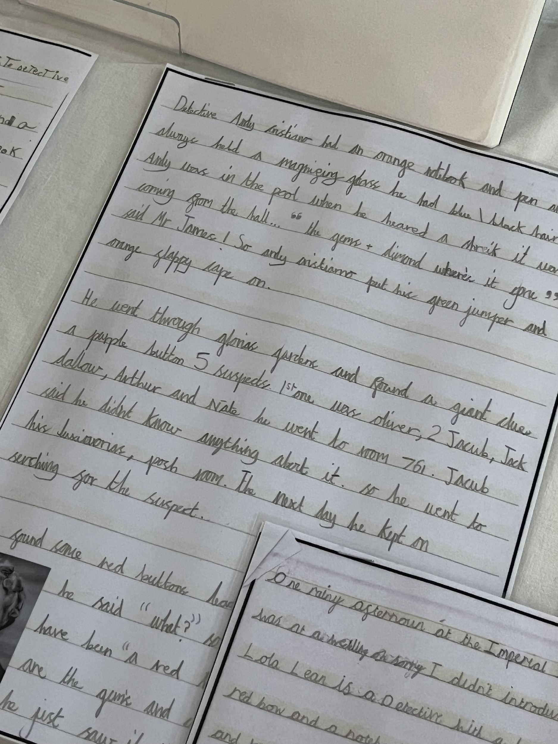

Our vision of 'Achieving and Flourishing Together in God’s loving arms’ means that we are continually striving to develop every individual in the image of God and to ensure that all those connected with Galmpton have
opportunities to develop as learners and good citizens. To ensure everyone achieves and flourishes we ensure all learning happens through the lens of our gateways: Citizenship, Leadership, Expression, Explorers and Flourishing.
We believe that through our values that are linked to these gateways, we are guided in all that we do and all that we are called to do as a Christian School.
Galmpton Church of England Primary School is living up to its foundation as a Church school and is enabling pupils and adults to flourish.

Inspection findings:
Galmpton has a deep understanding of its purpose as a Church school. It lives this out in its relationships with its pupils, their families and the broader community. It is a school constantly reflecting and improving, holding itself to account against the plumbline of its Christian vision. The vision itself has been reviewed and refined to reflect the rounded education which Galmpton seeks for pupils. The school’s vision sits closely alongside the vision of the trust, Academies for Character and Excellence (ACE). This creates a powerful partnership. The trust’s strong systems and structures root the school and support it to deliver its ambitions. As one of the first schools to join the academy trust, Galmpton has continued to help shape its work. High levels of expertise in the school, and at governance and trust level, ensure that both continue to flourish. Leaders are committed to the service of the wider community. The school is a generous presence in the village, the local authority and beyond. This echoes the Church of England’s vision of education as promoting ‘the common good’. The diocese is a strong partner, particularly valued for the pastoral care it offers alongside its practical support.

Creativity in Action: Profile of Derek Knowles, Chapel of the Good Shepherd, Galmpton. Creator of DISCASS and so much more
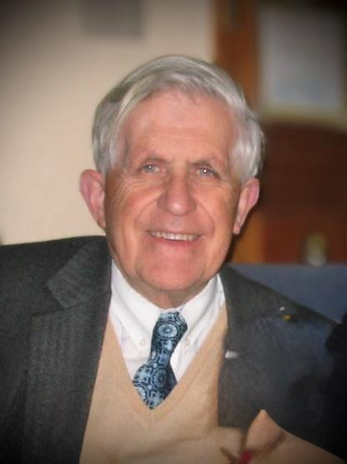
On 18 September Derek Knowles reached the ripe old age of 90! Derek and his family owned a very successful bakery in St Mary's Square, next door to the church. As a boy and as an adult Derek sang in St Mary's choir until he moved his home to Galmpton over forty years ago. Since then he has been a stalwart, and a very long-time server, at the Barn Chapel. But this is not the end of his story . . . . . NO, not by a long way!
In the 1970s Derek used to deliver bread to Douglas House, then a newly established Leonard Cheshire home for young severely physically disabled adults. He was so impressed by Douglas House, its residents and staff, that he sold his bakery business and came to work there, where he ultimately ended up as Finance Manager. Derek introduced IT to Douglas House over fifty years ago, firstly to its accounts but then into the daily lives of the residents.
An example of this is one resident who had lost the use of his arms and legs in a motorcycle accident when he was just 17 years old – he drove his electric chair with his chin! With Derek's advice and encouragement, he learned to use a computer (with his chin) and ultimately gained an unimaginable degree of independence in his daily activities, full control of his computer, his telephone, radio and TV, his room door, curtains, etc.
Another example was a Londoner who had been confined to his bed from the age of twelve and had virtually no control of his limbs. However, Derek discovered that he had a crude control of his right elbow, enough to introduce him to computing, through which he learned to read and write. And, of course, there were so many others also. This was only the beginning for Derek!
In the late 1980s he founded the Torbay Care at Home Service, a charity whose staff provided care for people with disabilities in their own homes. Up to then such care was only provided in hospitals and care homes. It was just the second such service set up in the UK, the first being in Liverpool a few months earlier. The Torbay Care at Home Service has long given way to the excellent home care agencies that we now see around us every day and which enable so many people with disabilities to continue to live at home. But Derek didn't stop there.
In the 1990s he went on to found another charity called Disability Focus. Disability Focus supports people who prefer to employ their carers directly, rather than through an agency, by providing payroll and other administrative backup services to its disabled or otherwise vulnerable clients. The charity currently serves almost 2,000 clients throughout the county of Devon.
Derek no longer enjoys good health and these days is actually a receiver of care services himself. Sadly, he lost Vivienne, his wife of over sixty years, earlier this year. But, some way or other, Derek still finds his way to the Barn Chapel every Sunday morning, which he still sees as the high point of his week.
Happy Birthday, Derek! Tom Fallon, All Saints’
Photo: Colin Knowles

St Mary’s, Higher Brixham
What a great turnout for the joint Mission Community Service at the end of August, with members of each church, a great choir, enthusiastic singing from the congregation, lovely refreshments and fellowship afterwards! An encouraging sign of the unity of the Mission Community as we ‘move forward together’.
We were delighted with our “Star Baker”, David Roberts (for his delicious bara-brith) at the Christian Aid Coffee Morning held in the Christian Community Centre in Fore Street early in September. (See Christian Aid report page 9).
As we celebrate the end of a good summer and head towards Harvest celebrations, children have returned to school, Mummy & Me, Messy Church and Youth Group have recommenced, each with new members, and with real joy shown at meeting up with ‘old’ friends. Harvest this year will be celebrated over the weekend of 3 - 5 October, when the church will be open for all to enjoy the decorations, with refreshments throughout, and a Harvest Supper on Saturday 4th (pasties, salads & puds) with musical entertainment. We invite anyone to contribute to an offering to the Foodbank by bringing non-perishable gifts at any time over the weekend.
A Coffee Morning/Bring & Buy for our Harvest Appeal (the work of the Lupton Trust in helping those with mental health issues) is to take place at Lupton House on Monday 13 October and it is hoped that many people who have never visited the house before will come and join us for this occasion. Our thanks go to the Lupton team, and those in the BMC who have offered to oversee the sale of cakes/books/plants/bring & buy items/refreshments in beautiful surroundings.
Early September has seen the funerals of two of our congregation, Thea Robson and Tony Haig. They will each be greatly missed by family and friends. As so often happens at funerals, a lot is learned about the person that many of us only knew for a short time, or in certain circumstances. We were all fortunate to know both Thea and Tony and continue to pray for their families.
At the end of October, ??? shoeboxes will be delivered to cr2ee at Exmouth for onward transportation to Moldova and Ukraine. Thanks go to everyone from all churches who has been collecting items for the boxes, persuading shoe shops to part with their boxes, wrapping boxes in Christmas paper, writing cards and volunteering to help during Shoebox Week: Tuesday 21 – Saturday 25 October, and offering to drive boxes to Exmouth.
We will probably never meet the children (and adults) who receive our boxes, but we know that they will be joyfully received and brighten Christmas for so many who are less fortunate than us.
THANK YOU! GREAT TEAMWORK!
St Mary’s Brixham, Messy Church, September
It was lovely to welcome our Messy-Churchers back after the summer holidays, bringing new friends with them. They enjoyed meeting up with each other, as different schools are represented, and welcoming new families to our growing Messy Church family.
In September and October we are looking at ‘GOD’S WONDERFUL WORLD’ and how we should be looking after it. In September we’ve looked at the sea and what part we can play in looking after it for the future.
We started with lots of painting (fish, of course, and fruit and vegetables ready for Harvest time) and then played a game before singing together, and answering ‘Ryan’ & ‘Rosie’ when they asked how we could look after the sea around our coast. We had some excellent answers from our 25 Messy-Churchers, who very obviously want to help to “KEEP THE SEA PLASTIC-FREE” and look after ‘GOD’S WONDERFUL WORLD’.
Crafts included:
- Making fish-shaped sandwiches with various fillings - yummy!
- Writing our prayer on a fish and then throwing it into the ‘sea’ and fishing it out with a rod
- Making an attractive seascape
- Constructing a fridge magnet book about looking after our world
- Creating and decorating our own scallop shell creature
- Making a boat (origami-style) with a net and sail.
Thanks as always go to our great team, who give up their time to plan and execute such great ideas for the children, who often take our simple ideas and take them a step further!
Thanks too to our regular college students who come in to work alongside the children: extra pairs of hands are always welcome.
Supper this time had to be fish fingers etc., which went down extremely well with everyone who sat down to eat in the hall afterwards. Our thanks go to the amazing kitchen team, especially for their ability to cope with an unknown number of children and adults each month!
Our next Messy Church is Friday 10 October after school.
For further information please contact Lindsay 07813 311613 or Lesley 01803 854036
Bless you all! LW
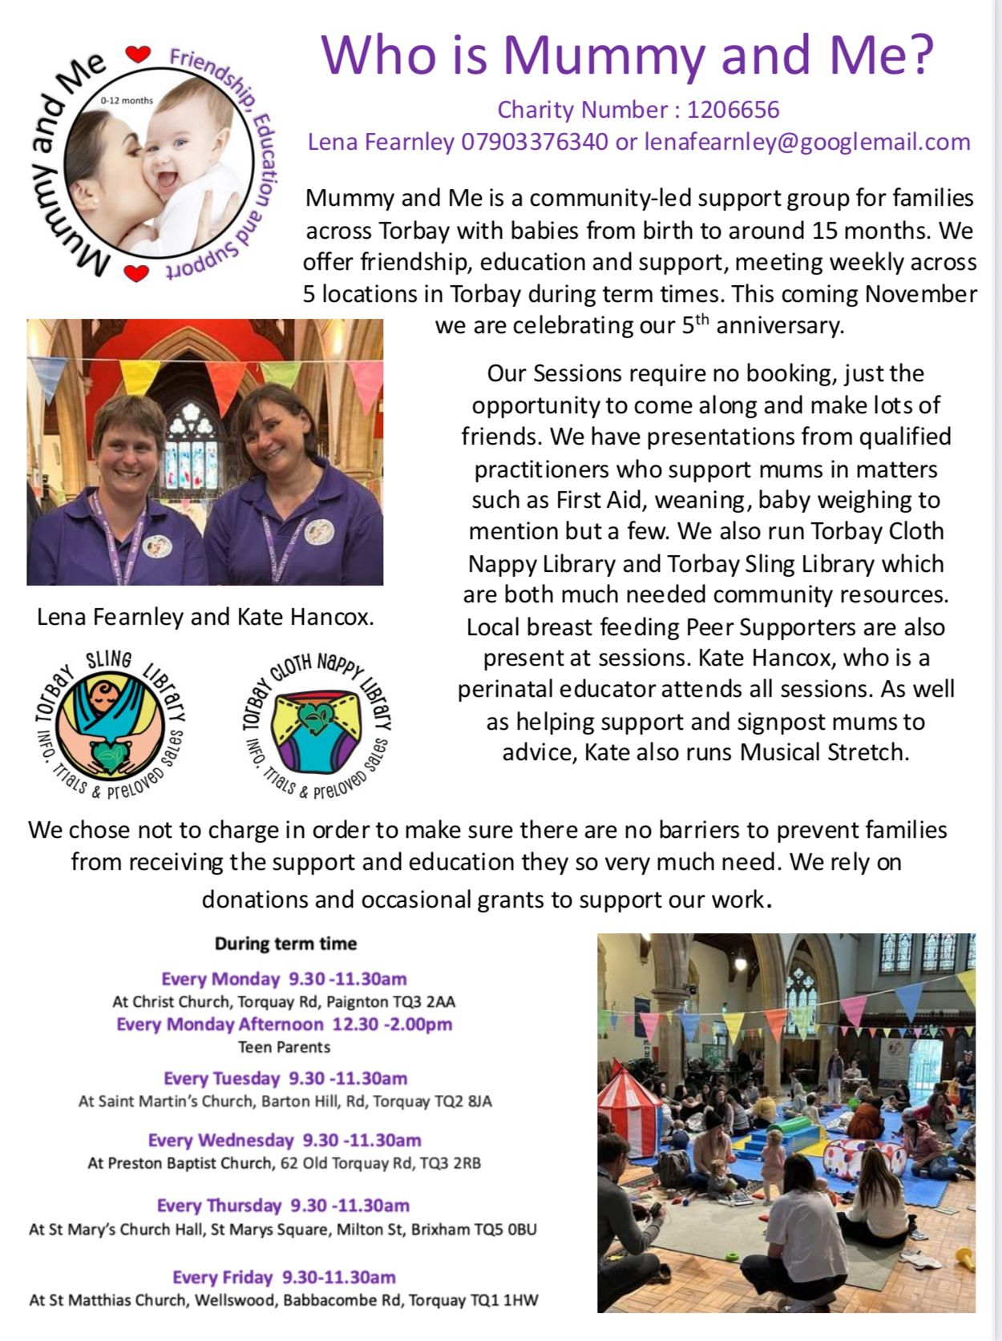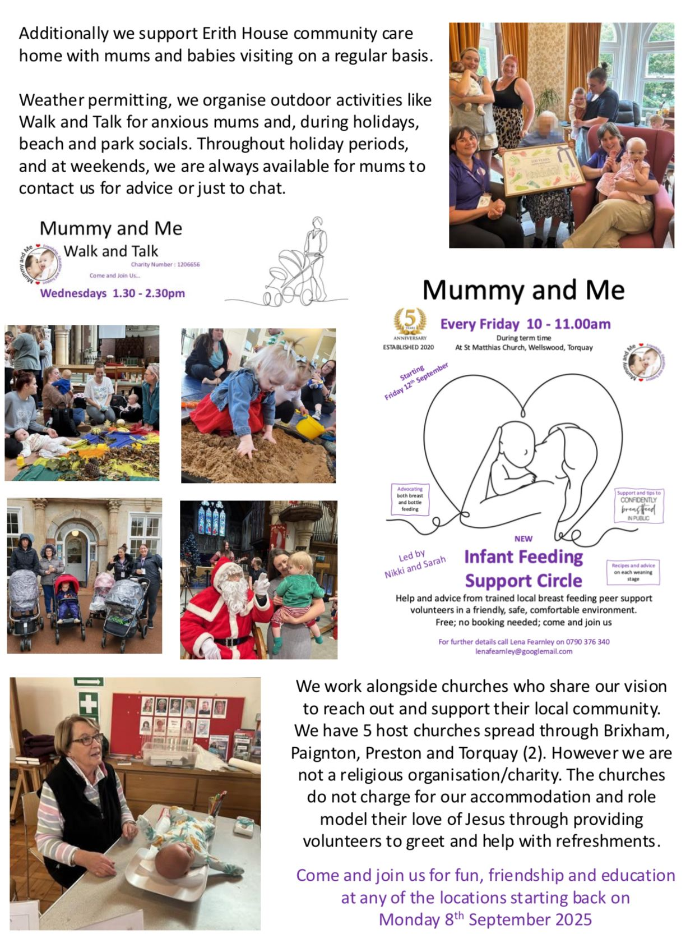
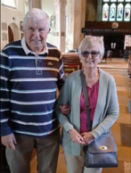
‘Our hearts are still in Brixham’: married at St Mary’s
On 13 September I was leaving church and was hailed by an elderly couple who asked if they could re-enact their wedding from 56 years before. Being in no particular hurry I let them into church and sat at the back. Bob and Margaret carried out a small re-enactment with their friends in attendance. Margaret though, when it came to her turn to say ‘I do’, said NO! It really was lovely to see and had me smiling for the rest of the day. Alison
The following message is from Bob:
We met in 1961 when we were both fifteen and courted for six years whilst saving for a mortgage. Marrying on 13 September 1969 we lived in a new build in Preston. I had joined the Fire Service in November 1971. In 1971 we had our first child Kate on Christmas Eve and, and on New Year's Eve 1973, our second child was born, a son Christopher.
We moved around over the years until finally settling in Barnstaple. Retiring from the Fire Service in November 2001, we returned to visit Brixham friends and family who still live in the area. Our hearts are still in Brixham with me being born in Overgang (Fish Town) and Margaret born in Brixham Hospital and living in Cow Town. We shouldn't have been allowed to be together according to the rules of Brixham!
It was absolutely brilliant to carry out the rerun on our 56th anniversary, thanks to you.
Best wishes Margaret and Bob Prince

News from Churston: Agatha Christie Festival
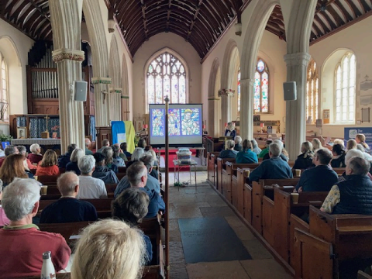A full church for the Agatha Christie talk (photo Philip Mantell)
More images from the school church visit Katy Burns
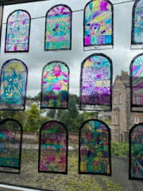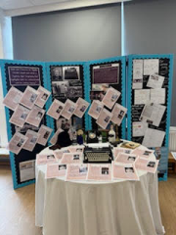

News from KIngswear
The evening of Peace and Reconciliation on VJ Day was a great success with live music and a church full of people from across the BMC as well as locals who do not normally step into church. We were extremely grateful to Chris Ryan and his colleagues from FRoST (Friends of St Thomas’) who generously supported and ran the bar, Gary Webber who assembled a display of flags and Maralyn and many others who helped Carmen and Gary with the food and hospitality. The bells were ringing out too.
Over the summer we have been lucky to have our congregations increased by a significant number of visitors. As we are fortunate enough to have a rota of volunteers to open and close the church daily, we have also benefited from donations on our card machine and some lovely comments in our visitors’ book.
The church is beautifully decorated by Lynne Cornaby who has taken over organising the flowers and has brought some new designs to brighten the church.
We do have a few new members of our congregation and are working hard to enrol more volunteers to support the church as being an important part of the village. We prepared a very detailed list of tasks, so they are broken down into bite-size chunks, and we are particularly pleased to enrol some non–churchgoers to help with some of these and hope that this will broaden the engagement with the village as a whole. There are plenty more tasks to fulfil!
We are looking forward to decorating the church for our harvest season and we are preparing for our Remembrance Service which is a highlight in KIngswear. Carolyn Williams

Thea Robson: a final word
My house is full of little gifts from Thea. Mostly they are from the charity shop, but they are all pertinent and thoughtfully chosen. Little things given by one eccentric lady to another. They are all interesting items and they were all just what I was looking for, or maybe just what I wanted at that point in time. They are all beautiful or practical or both!
Then there are the socks. Carefully and intricately knitted socks. Thea was really very good at knitting. I received a pair and I imagine there are many other people who also received a pair. I shall remember the socks with affection.
Thea was very hospitable and there were many shared meals. You can't cook a decent meal for one easily and it is too easy to slip into eating egg on toast with alarming regularity and so we had shared meals, sometimes at her flat and sometimes at mine. I had to up my game. Thea cooked well.
There are the people she took care of by giving her time and listening when needed. I count myself among those people. There are a lot of people who received her time and her support.
All of this makes me think of Dorcas who was a New Testament character. Dorcas was a disciple whose faith was expressed through practical actions. Dorcas was known for her tailoring and for making garments for the poor and those in need as a tangible way of showing her love and care for her community.
Thea was like this, she demonstrated selflessness by dedicating her time and resources to serve others, meeting their fundamental needs. Thea was able to see people. She could see them without prejudice, without bias and without being constrained by expectations or rules. She was insightful. She could see people and would touch their lives with a gift or with a meal or with her time.
Faith is not just about what you believe, it is also about what you do. Thea’s active faith of compassion and service to others speaks to me of the presence of the Holy Spirit in her life. Even simple acts of kindness can have a great impact. I will miss her. Amen Elaine Vestey LLM

And finally, more creativity, from Stephen
Procession
Autumn colours warm against a
cold October sky,
swallow song replaced by a
corvids cry. Stephen Bellows October 2012
No Wasps
The apple tree
Is looking good
Flushed with
Rose and green
Some fall
And still we have enough.
The sun is out
The wind has dropped
The air is autumn fresh
So why am I
So sad. Stephen Bellows September 2025

Coming soon…to
Brixham Does Care Café
Monday 3rd November 2025
1.15-3.15pm

Misty Autumn Singalong

Don’t sit at home.
Enjoy an afternoon of fun and entertainment.
Come along and sing along with Martyn Paddon.
Sit back and enjoy yourself with new-found friends.
You might even fancy a dance.
Donated raffle prizes would be appreciated.

Doors open 1.00pm. Limited numbers.
Tickets £5* must be pre-booked from BDC Office
situated next door in Town Hall (01803 857727).
(*includes a FREE cup of tea/coffee and
cake during interval, PLUS your raffle ticket!).

BRIXHAM DOES CARE
For your afternoon entertainment

Dates for your diary
OCTOBER
Friday 3rd 7.00pm St Mary’s Youth group
Saturday 4th 10.00am St Mary’s fun singing workshop
3.00pm St Mary’s Harvest vintage social
6.30pm St Mary’s Harvest supper
Sunday 5th HARVEST THANKSGIVING
Wednesday 8th 10.30am Churston Roger Fordham
recital
Friday 10th St Mary’s after school Messy Church
Monday 13th 10.00am Lupton House Harvest appeal
coffee morning
Friday 17th 7.00pm St Mary’s Youth group
Tuesday 21st–Saturday 25th St Mary’s Shoebox
Collection
Saturday 25th 2.00pm All Saints’ Graham Carter
celebration of life
FORTNIGHTLY
Friday 7.00-9.00pm in term time St Mary’s Youth Group 11 -18s
WEEKLY
Thursday 9.30-11.30am St Mary’s church hall Mummy & me
Friday 9.15-11.15am in term time Barn Chapel Stay & play
WHO WE ARE
Revd Dr Philippa Bellows, Team Rector rectorbrixhammc@gmail.com 01803 927797
Revd Angela Sumner, Associate Priest (SSM) 01803 853959
Debbie Perret, Administrator debbie.brixhammc@gmail.com 07790 104293
LICENSED LAY MINISTERS (LLMS)
Wendy Emlyn 07785 573145 Margaret Pickthorne 07969 474613 Martyn Hodge 01803 851302 Elaine Vestey 07930 815155 Hilary Hyde 01803 852323
-------------------------------------------------------------------------------------------------------------------------------------------- - PARISH OFFICERS
ALL SAINTS', LOWER BRIXHAM
Warden: vacant
PCC Secretary: Margaret Dyer waysider11@hotmail.co.uk 01803 852799 Organist: Mr R Thomas 01803 850125 Choir Director: Jean Aird (Mrs Jean Holman) jeanaird@aol.com 01803 858235 Treasurer: Mr I A Webb ianw@iawaccountancy.co.uk 01803 845961 Safeguarding: Martyn Hodge martynhodge47@gmail.com 01803 851302
-------------------------------------------------------------------------------------------------------------------------------------------- ST MARY'S, HIGHER BRIXHAM
Wardens: Susan Francis susanfrancis46@hotmail.co.uk 01803 411574 Roger Holtom stmaryschurchwarden1@gmail.com 01803 857357 PCC Secretary: David Roberts david@slatecottage.org.uk 01803 854036 Acting Organist/Dir. of Music: Michael Hackeson Treasurer: Alison Lodge alisonwo@yahoo.co.uk 07733 555542 Safeguarding: Margaret Jaycock margaretjaycockbxm@gmail.com 01803 883713
--------------------------------------------------------------------------------------------------------------------------------------------
ST MARY THE VIRGIN, CHURSTON
Warden: Jane Washington janewashington30@gmail.com 01803 844088 Warden/Safeguarding: Philip Mantell philip.81mantell@btinternet.com 01803 844128 PCC Secretary: Debbie Perret deb.perrethome@gmail.com 07790 104293 Treasurer: Mr I A Webb ianw@iawaccountancy.co.uk 01803 845961
--------------------------------------------------------------------------------------------------------------------------------------------
ST THOMAS OF CANTERBURY, KINGSWEAR
Warden: Gary Lewis Gary.Lewis@a1plc.co.uk 07940 734721 contact via Carmen Lewis 07957 432993 PCC Secretary: vacant Safeguarding: vacant. Diocesan Safeguarding Officer Costa Nassaris
costa.nassaris@exeter.anglican.org 01392 294969
Treasurer: Carolyn Williams carolynwilliams351@gmail.com 07801 847248
--------------------------------------------------------------------------------------------------------------------------------------------
CHURCH HALL BOOKINGS
St Mary’s Church hall Mrs M Seffert 01803 853525
Barn hall, Galmpton Lynn Miller 07305 788503
---------------------------------------------------------------------------------------------------------------------------------------------
OTHER CONTACT DETAILS
BMC Treasurer: Alison Lodge brixhambmc@gmail.com 07733 555542
Funerals: The Team Rector
Baptisms: The Team Rector/Administrator
Weddings: Rachel Fox rachelpaul2506@outlook.com 07359 143257

