Sunday Services - October 2025
5 October 11.00am Eucharist with Baptism

12 October 11.00am Choral Eucharist

19 October 9.15am Said Eucharist

3.00pm Harvest Service & Supper
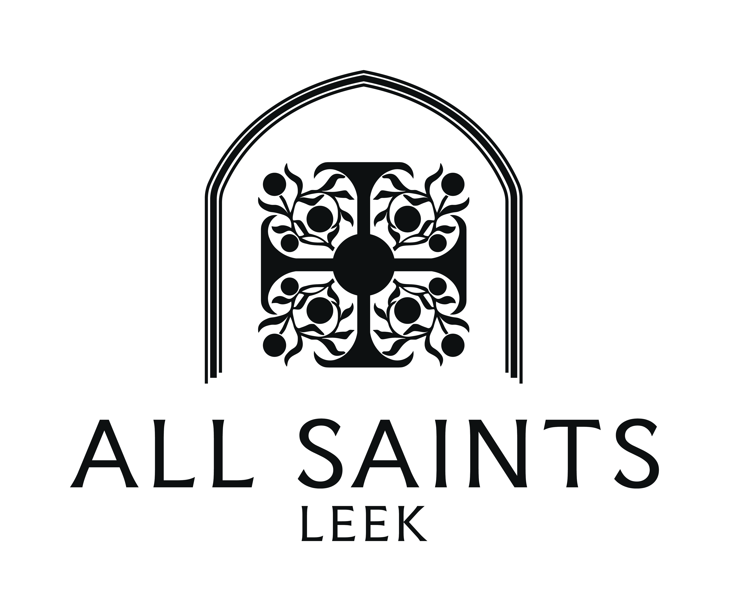
Saturday
25 October 3.00pm Come and Sing
26 October 9.15am Choral Eucharist

