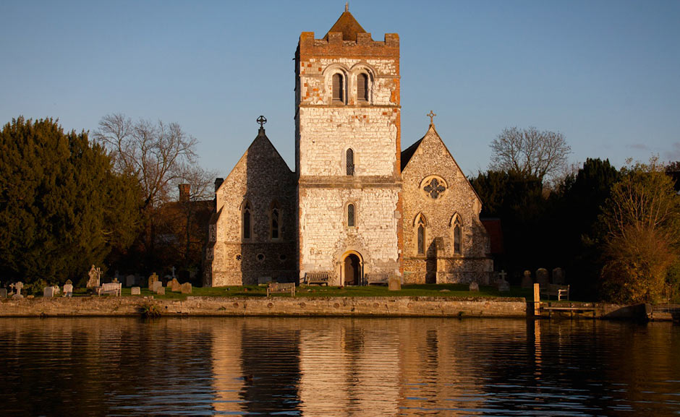**BISHAM TOGETHER**

The Monthly Newsletter

from All Saints Bisham

October 2025

**Hello everyone,**

**October is here already, and with it the turning leaves and the cosy evenings drawing in. I always enjoy watching the silver birch at the end of my garden change colour at this time of year — a gentle reminder of the beauty in each season. We’ve already shared so much together in church life, and there is plenty to reflect on as well as much to look forward to in the months ahead. My hope is that this season brings you moments of peace, joy, and a good dose of autumn comfort.**

**Carol**

**Interim Team Vicar**

**🕍 Church Life**

**Worship & Events**:

• Every Sunday: 9.30am Holy Communion at All Saints Bisham  
• First Sunday of every month: 8am Book of Common Prayer Service

*– next service: 5th October*

🌿 **Quiet Afternoon: Saturday 11th October 2-4pm**

Join us for another time of peace and reflection in our beautiful Church. There will be some resources available to help you focus or just come and “be”!

🙏**Rector Vacancy Update**

I’m very pleased to let you know that Revd Sam Follett has been appointed as our new Team Rector. He will be joining us in January, and I know we will give him a very warm welcome when he arrives. Please do keep Sam and his family in your prayers as he prepares for this new chapter, and as we look forward to all that God has in store for us together.

🌹 **Remembering Kathy Mitchell**

It is with great sadness that we share the news of the sudden passing of Kathy Mitchell on 15th September. Kathy was a much-loved member of our community, and we give thanks for her life and faith. She will be much missed by us all. Please hold her family and friends in your prayers at this difficult time.

*Kathy’s funeral will be at All Saints Bisham at 11.30am on Thursday 9th October.*

**Sundays at All Saints**

📖 **Devoted to Jesus**

***What does it really mean to follow Jesus today? Find out in our new series!***

Our next sermon series will take us on a six-week journey through the book of James, under the title *“Devoted to Jesus.”*

James is full of practical wisdom for everyday life, showing us how our faith can shape the way we work, care for others, and respond to the challenges around us. It challenges us to live out our beliefs in real and meaningful ways, not just in words, but in actions.

What does it truly mean to be devoted to Jesus in the busyness, joys, and struggles of life? Over the coming weeks, we’ll explore this together, discovering how God’s Word can guide and inspire us today.

We warmly invite you to join us and find out more!!

**…And in other news this month:**

💧 **Another Joyful Celebration of Baptism**

**We gathered together on 14th September to welcome Poppy Stretton, her parents, family and friends to All Saints as she was baptised.**

The service marked the start of her journey of faith, joining our church family who along with her Godparents and parents, promised to support and encourage her as she grows in her faith.

💍 **Sixty Years of Love and Faith**

We were delighted to also mark another important occasion: a very special milestone for Janet and Brian Slatter, as they looked forward to their Diamond Wedding Anniversary. A bottle of Champagne was presented to help them celebrate, and we prayed for them with thanks for sixty years of marriage. With several wedding couples in the congregation, Janet and Brian’s lasting love was a real inspiration.

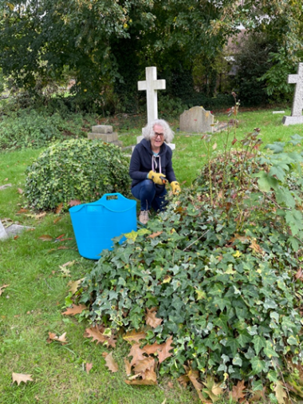

**🧹 Churchyard Tidy-Up**

The threatened rain never came, and we enjoyed a cheerful three hours tidying the churchyard.

Two very prompt newcomers arrived but, suspiciously, without tools. When they confessed to being bellringers rather than gardeners, we promptly abandoned the flowerbeds and went up the tower instead!

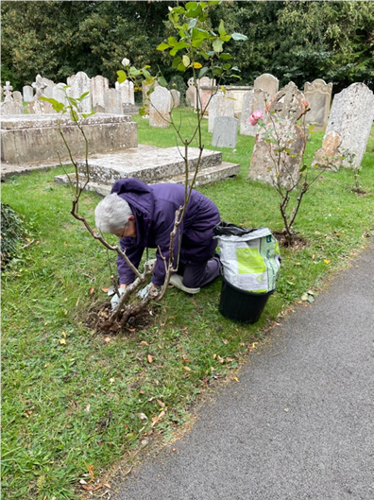Thankfully, some rose experts were on hand to give the bushes their seasonal care, while others tackled the parish path, cutting back ivy and overgrown branches. Our resident trimmer worked wonders on the Memorial Garden and paths, and we even had another go at that stubborn concrete drainage channel.

Tea, coffee and treats kept us going, but it’s the company that make these mornings special.

A big thank you to everyone who came — and do join us again in the spring or drop by with your secateurs whenever the mood takes you!

🌾 **Harvest Celebration**

Our Harvest Celebration was a real feast for the eyes and the heart. The church looked beautiful, decorated with wheatsheaves, oat sheaves, and some fantastic flower arrangements. A big thank you to Catherine and her team for all their hard work in making the church look so festive.

nourishment we find in Jesus Christ. It was a time to pause, reflect, and remember how much we have to be grateful for.

Afterwards, we carried on the celebrations with a “bring and share” lunch. And huge thanks must go to Sean, Claire and Mary for all their work in bringing this together. The table was soon filled with a wonderful variety of dishes, and there was plenty for everyone to enjoy. Sharing food together gave us the chance to chat, laugh, and spend time with one another – a real picture of community.

**🫶 Bisham Church Friends**

**🚴‍♀️🏛 Open Day & Ride+Stride**

Saturday 13th September was a busy and happy day as we welcomed both *Ride+Stride* participants and *National Heritage Open Day* visitors to the church. In total, we had 11 riders and walkers call in on their route, along with 16 people who came to explore the building as part of Heritage Open Day. Many visitors commented on how lovely the church is, and for several it was their very first visit.

We are very grateful to Roseann, Colin and Jean for giving their time to host and extend a warm welcome. The sunshine made the day even more enjoyable, and it was wonderful to see the church so well used and appreciated.

**☕📜 History & Heritage at Bisham**

September saw two wonderful opportunities to enjoy and learn more about our local history. At the History Coffee Morning, 28 people gathered to hear another of Sheila’s fascinating talks, raising £76 in the process. Warm thanks go to Sheila for her talk, and to Gina, Ali, Helen, Jean and Fred from the Friends for providing refreshments.

This is part of a regular series exploring the varied history of Bisham, the Abbey and the Church, and it’s always a pleasure to welcome both regulars and newcomers. Later in the month, a guided tour of the church gave 22 visitors another chance to discover more about our rich historical past, and to appreciate the heritage we are fortunate to share.

🏫 **Bisham CofE Academy**

**🍎 Back to School and Thankfulness**

The new school term is underway, and it has been wonderful to see children and staff settling into their new routines after the summer holiday. In Church School assemblies this term, we have been exploring the theme of thankfulness. We began by looking at Paul and Silas in prison, reflecting on how we can notice the good and give thanks even in difficult times.

In the coming weeks, we will focus on the Magnificat, Mary’s song of praise, to celebrate the blessings in our lives, and the story of Mary anointing Jesus’ feet, thinking about how giving can be an expression of gratitude. Through these assemblies, the children are learning that thankfulness can be shown in many ways—through our words, actions, and the care we show for others—whether life is easy or challenging.

🎉 **A Milestone for Our School**  
We’re delighted to celebrate with the local primary school as they reach an impressive **100 pupils**! This milestone reflects the school’s warm, nurturing community and its growing reputation as a wonderful place for children to learn and flourish. We give thanks for the staff, pupils, and families who make the school such a special part of our village.

**📌 Community Notices**

Upcoming Dates:

* **Friday October 3rd 9am**
* School Harvest Assembly with tea and coffee before the service.
* **Thursday October 9th 11.30am**
* Kathy Mitchell Funeral
* **Saturday October 11th 2-4pm**
* Quiet Afternoon at Bisham Church.
* **Sunday October 12th 3pm**
* an Afternoon of Music with Richard Brooman, Graham Barker and Bisham Academy Choir.
* **Wednesday 22nd October 10-12noon**
* Community Coffee Morning with history talk.

**Contact us:**

|  |  |  |
| --- | --- | --- |
| **Parish Office (Marlow)** | **01628 481806** | [**parish.office@4u-team.org**](mailto:parish.office@4u-team.org) |
| **Rev Carol Cooper** | **07774 061944** | [**carol.cooper@4u-team.org**](mailto:carol.cooper@4u-team.org) |
| **Mark Garrad (Churchwarden)** | **07738 029086** | [**garrad.mark@gmail.com**](mailto:garrad.mark@gmail.com) |
| **Bisham Church Friends** (Sean) | **07808 094777** | [**www.bishamchurchfriends.org**](http://www.bishamchurchfriends.org) |
| **Daphne Dru (Safeguarding)**  **And finally….** | **07717 441437** | [**Daphne.dru@4u-team.org**](mailto:Daphne.dru@4u-team.org) |

**Do you recognize this jacket or either of these pairs of glasses?**

**They have been left in All Saints Bisham Church, and we would love to give them back to you!!**

**Please get in touch before the end of October to reclaim them, as after that they will be donated to charity.**

📸 **Community Gallery**

**A few moments from the life of our church and community this month…..**

**Poppy behaving impeccably at her baptism!**

**Enjoying the Harvest Lunch**

**Churchyard Tidy Up**

