St John’s
Thank you to all who made our Harvest Celebrations such a success.
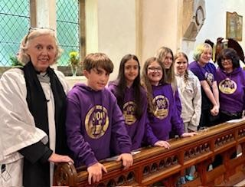
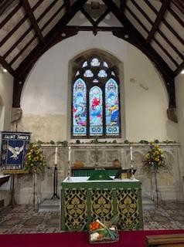
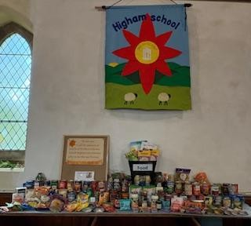

We started with our 9.30am Holy Communion and offering of gifts. All food gifts will go to our local Foodbanks and monetary gifts of £120 will go to the Bishop’s Harvest Appeal.
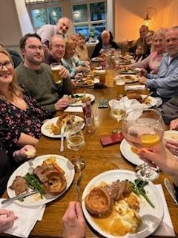
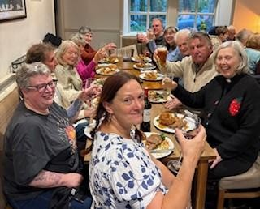
Our celebrations continued with a choral Evensong with the Pendle and Burnley Deanery choirs joining us. Thank you to Nina and ‘St Peter’s Young Choir’ for starting our service with a beautifully sung Introit.

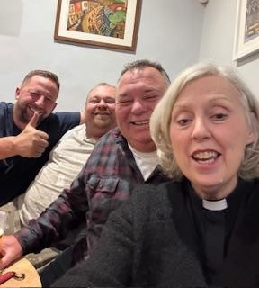
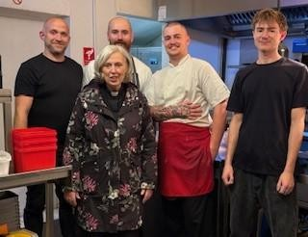
We then enjoyed a tasty Roast Beef dinner, complete with Apple Crumble and Custard at the Four Alls. Grateful thanks to Banny and his team for hosting us all.

Reverend Lesley did not miss the opportunity to visit the Tap Room and meet the locals – there were many questions about church and Jesus. Reverend Lesley will revisit I am sure but all were invited to join us next Sunday.

