Trinity Church, Leek (Methodist/URC)
Church and Community Worker

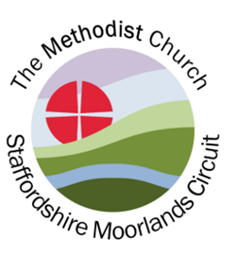
Trinity Church, Leek

We are seeking to appoint an enthusiastic and committed Church and Community Worker to join our team and to lead and support us in developing our mission to share God’s love, actively looking for opportunities for outreach within the market town community of Leek.
Key responsibilities:
- Build strong relationships with church members and wider community
- Work across different age groups including children, families and older people
- Plan, develop and lead activities and events which support the church’s mission and outreach within our local community
- Work alongside Church Minister, church leadership and volunteers
- Recognise opportunities to inspire and lead people in their faith journey
What we offer:
- An enthusiastic team to work with
- 37 hours/week post worked flexibly
- Salary £27,148 p.a.
- Length of contract - 4 years fixed-term
- Ongoing training and support, locally and across the Chester and Stoke-on-Trent District
- 6% employer’s pension
- 31 days leave inc. bank holidays + weekdays between Christmas Day and New Year’s Day
For a job information pack, please contact: admin@staffmoorlandsmethodists.org.uk
Please email completed application form to admin@staffmoorlandsmethodists.org.uk
Applications by closing date: Thursday 6 November 2025 at 12 noon
Interviews – Tuesday 25 November 2025. Post expected to begin – January 2026.
If you would like an informal chat about this post, please email our Senior Circuit Steward philip.mann@psmann.plus.com to arrange a time for a conversation.

