Notice of Church closure

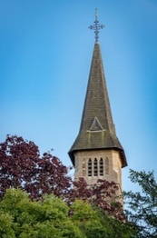

Our church will be closed from the end of October for a few months.

The reasons for this are indeed very positive - as we now have all the necessary planning permissions from the Church of England and the SDC to install a toilet and kitchenette in the church. We are so excited and so grateful for all the support we have received from the community to make this happen.

The church will be closed after the last October service on October 26th, and we are hoping that the works will start sometime in November. We will need some time to prepare for the building works and to store everything so that nothing is damaged.

We will therefore also be closed over the Christmas period, but all the Ide Hill Services will move to Sundridge until we can reopen early in the new year. So please do come and enjoy Remembrance Sunday and Christmas services in the beautiful 12th century St Mary's church in Sundridge.

We will be back in 2026, and we are planning a few concerts and events in the new year to celebrate the modernisation of our church facilities and the role that our dear Anne Beasley played in making this happen.

The Trustees of The Friends of Ide Hill Church and
The PCC for The Parish of Sundridge Ide Hill and Toys Hill

