

W/B 2 November 2025
All Saints Day
All Saints’, Lower Brixham
9.30am Holy Communion
Tues 4 Nov 10am Communion by Ext.
St Mary’s, Higher Brixham
11am Holy Communion
5pm All Souls Day service
Mon 3 November 9am Morning Prayer
Wed 5 Nov 10.30am Holy Communion
St Mary the Virgin, Churston
10am Holy Communion
St Thomas of Canterbury, Kingswear
10.30am Morning Worship
Chapel of Good Shepherd, Galmpton
8.45am Holy Communion
PRAYERS FOR THE SICK
All Saints’, Lower Brixham
Mary Eveleigh, Clarice Westlake, Chris Chinnery, Christine Watt, Phyllis Jordain
St Mary the Virgin, Churston
Eric Smith,Jo & David Lambert, Vikki Sheen, Derek Brown, Wendy Tonkin, Gay Brooke, Jamie, Diane Lord-Lear, Sandra Marley,Geoff Gadsby, Philip Mantell, Eve Coombes
St Mary’s, Higher Brixham
Gordon Smith, Graham Ward, Helen Kelly and her daughter Sarah, Ivor John, Steve Clutterbuck, Robin Hale, Paul Stamp, Paul Oxenbury, Joshua Jackson, Judy Jolly, Paul Upchurch, Val Dixon, James Campbell and family, Jean Buttersworth, Hannah Hockings, Rita White
St Thomas of Canterbury, Kingswear
Tessa Gibson, Marcia Abdilla
THE DECEASED: Celia Warne (Kingswear)

THE GRAPEVINE
26 October 2025
Last Sunday after Trinity

Collect
Blessed Lord,who caused all holy Scriptures to be written for our learning:help us so to hear them; to read, mark, learn and inwardly digest them; that, through patience, and the comfort of your holy word, we may embrace and for ever hold fast the hope of everlasting life, which you have given us in our Saviour Jesus Christ, who is alive and reigns with you, in the unity of the Holy Spirit, one God, now and for ever.
First reading: Ecclesiasticus 35.12-17
Second reading: 2 Timothy 4.6-8,16-18
Gospel: Luke 18 9-14
He also told this parable to some who trusted in themselves that they were righteous and despised others: “Two men went up into the temple to pray, one a Pharisee and the other a tax collector. The Pharisee stood and prayed thus with himself, ‘God, I thank thee that I am not like other men, extortioners, unjust, adulterers, or even like this tax collector. I fast twice a week, I give tithes of all that I get.’ But the tax collector, standing far off, would not even lift up his eyes to heaven, but beat his breast, saying, ‘God, be merciful to me, a sinner!’ I tell you, this man went down to his house justified rather than the other; for every one who exalts himself will be humbled, but he who humbles himself will be exalted.
Post Communion God of all grace, your Son Jesus Christ fed the hungry with the bread of his life and the word of his kingdom: renew your people with your heavenly grace, and in all our weakness sustain us by your true and living bread; who is alive and reigns, now and for ever.

Readings for Sunday 2 November
All Saints
First reading: Daniel 7 1-3; 15-18
Second reading: Ephesians 1 11-23

All Souls Day Sunday 2 Nov 5 pm St Marys Brixham
A short service to remember those we love and have lost. Please sign the sheet at the back of your church with the names of those people you would like to be remembered by name.

British Legion Wednesday 5 Nov 6.30 for 7pm St Mary’s Higher Brixham
The British Legion festival of Remembrance is at 7pm on Wednesday 5th November at St Mary’s, Higher Brixham.

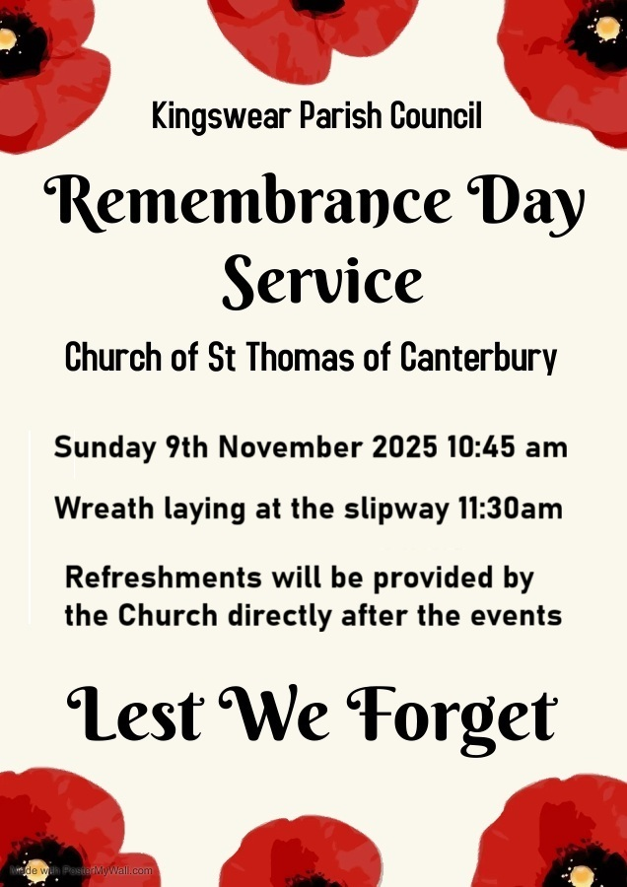

Brixham Does Care Cafe Monday 10th November 2025 1.15-3.15pm.
Misty Autumn Singalong, with Martyn Paddon.
Donated raffle prizes would be appreciated.
Doors open 1.00pm. Limited numbers.
Tickets £5* must be pre-booked from BDC Office
situated next door in Town Hall (01803 857727)

(*includes a FREE cup of Tea/Coffee and cake during interval, PLUS your raffle ticket!).

TEAM RECTOR
Rev’d Dr Philippa Bellows
rectorbrixhammc@gmail.com 01803 927797
ASSOCIATE PRIEST (SSM)
Rev’d Angela Sumner01803 853959

BMC ADMINISTRATOR
Debbie Perret debbie.brixhammc@gmail.com 07790 104293

CHURCHWARDENS
ALL SAINTS' LOWER BRIXHAM Vacant
ST MARY'S, HIGHER BRIXHAM
Susan Francis 01803 411574 susanfrancis46@hotmail.co.uk
Roger Holtom 01803 857357
stmaryschurchwarden1@gmail.com
ST MARY THE VIRGIN, CHURSTON
Jane Washington 01803 844088
janewashington30@gmail.com
Philip Mantell 01803 844128
philip.81mantell@btinternet.com
ST THOMAS OF CANTERBURY
Gary Lewis Gary.Lewis@a1plc.co.uk
Contact via Carmen Lewis 07957 432993

