A New Team Vicar for Berinsfield

Many of you will know that we have been working and praying hard to appoint a new Team Vicar for Berinsfield, the Baldons and Drayton St Leonard. At last we have good news to share! The Revd Vicky Burton has been offered and accepted the post. Vicky has a very deep sense of God’s call to her to come and minister among us here. Her gifts and experience wonderfully match what we have been seeking – I’m delighted, and can’t wait for her to arrive and begin ministry with us.
Vicky has sent us a photo and some introductory words.
Vicky’s licencing will be held on Monday 20th October at 7:30pm at the Abbey. All are welcome to attend. Please do pray for Vicky and her family as they prepare to move.

Every blessing
Jane
Revd Jane Willis, Team Rector
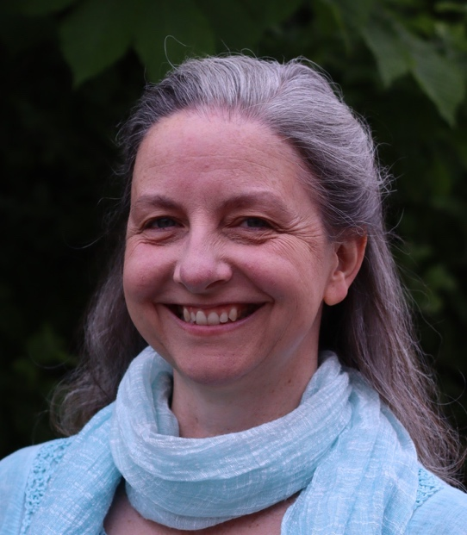
About Revd Vicky Burton
As a child growing up in Hemel Hempstead, one of my favourite weekend activities was visiting my grandpa’s farms, and I dreamt of one day living in one of the neglected houses in the village. At the time, we didn’t attend church, and I could never have imagined that I would one day become a vicar. And yet, as I’ve read the Parish Profile, visited the villages of the Dorchester Team, and applied for this role, I can hardly contain my joy and excitement at what lies ahead.
I am delighted to be joining the Dorchester Team as Team Vicar for the BBD Cluster, which includes Berinsfield, Marsh Baldon, Toot Baldon, Drayton St Leonard, and Nuneham Courtenay. Even in my short visits—including the interview day—Martyn (my husband) and I have felt a strong sense of warmth and vibrancy in these communities, and we are very much looking forward to hearing your stories and getting to know you.
My journey here has been shaped by a variety of experiences: I first trained as a classical musician in Birmingham, then served as a missionary to university students before becoming a music tutor and working with isolated adults to help them connect through music. When our two children were in primary school, I took on the role of children’s minister, then became assistant pastor in Chesham Bois, later training for ordination at St Mellitus College. I am currently serving my curacy at St Peter’s Aylesbury.
Martyn and I will be moving to Berinsfield along with our 21-year-old, while our other child is married and living abroad. When I’m not working, I enjoy worship, music, walking, birdwatching, book groups, and time with friends.
Please pray for us as we prepare to leave Aylesbury and settle into this new season. We’re praying for a good ending here and a joyful beginning with you, and for Christ’s light to shine in you and your communities.

