**The Churches of the Thurton Benefice**

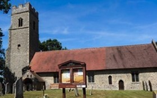 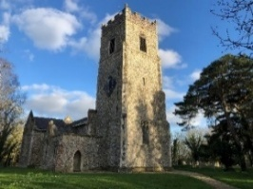 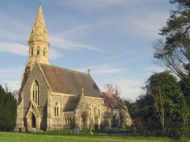

Ashby St Mary, NR14 7BJ Bergh Apton, NR15 1BJ Framingham Pigot, NR14 7QH

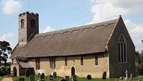 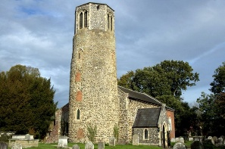 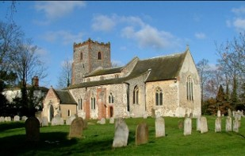

Thurton, NR14 6AG Surlingham, NR14 7DF Yelverton. NR14 7NY

**If we have no service in Bergh Apton, or if ours is a service of Morning Prayer/Morning Worship, the list shows where in the Benefice there will be a service of Holy Communion**

**OCTOBER MIDWEEK COMMUNION SERVICES - -** 10.30 am, 30-minute ‘Said’ Holy Communion (BCP)

**Wednesday 1st** **October - Ashby St Mary**

**Thursday 2nd** **October – Yelverton**

**Wednesday 8th October - No Service**

**Wednesday 15th October - Framingham Pigot**

**Wednesday 22ndOctober – Thurton**

**Sunday 5th October**

10.00 am, Harvest Festival Morning Worship (Parish Team), **Bergh Apton Church,** followed by refreshments

**Sunday 12th October** – No service in Bergh Apton

10.00 am Benefice Holy Communion, **Framingham Pigot Church**, The Street, Framingham Pigot, NR14 7QH

**Sunday 19th October**

9.30 am Morning Prayer (Parish Team), **Bergh Apton Church**, Followed by refreshments

9.30 am Holy Communion, **Yelverton Church**, Church Road, Yelverton, NR14 7NY

**Sunday 26th October**

9.30 am Holy Communion, **Bergh Apton Church** followed by refreshments

**NOVEMBER MIDWEEK COMMUNION SERVICES - -** 10.30 am, 30-minute ‘Said’ Holy Communion (BCP)

**Wednesday 5th** **November –** **No Service**

**Thursday 6th November – No Service**

**Wednesday 12th November – Bergh Apton**

**Wednesday 19th November - Framingham Pigot**

**Wednesday 26th November – Thurton**

**Sunday 2nd November**

10.00 am Holy Communion & Confirmation service with Bishop of Thetford.

**Sunday 9th November**

10.30 am Service of Remembrance, **Bergh Apton Church**

10.50 am Remembrance Holy Communion, **Framingham Pigot Church**, The Street, Framingham Pigot, NR14 7QH

**Sunday 16th November**

10.00 am Benefice Holy Communion, **Thurton Church**, Hall Road, Thurton, NR14 6AG

11.00 am Special Family Service in support of the Salvation Army Christmas Present Appeal, **Bergh Apton Church**

Refreshments will be shared after the service

4 pm All Souls, **Yelverton Church**, Church Road, Yelverton, NR14 7NY

**Sunday 23rd November**

9.30 am Holy Communion (BCP), **Bergh Apton Church** followed by refreshments

**Sunday 30th November**

10.00 am Group Holy Communion, **Surlingham Church,** Church Lane Surlingham, NR14 7DF

**Sunday 7th December**

9.30 am Morning Worship, **Bergh Apton Church,** followed by refreshments

9.30 am Holy Communion, **Yelverton Church**, Church Road, Yelverton, NR14 7NY