Into his Courts

with Praise...



A Service of the Word

Sunday 5 October 2025

Sixteenth Sunday after Trinity.

**A Service of the Word for Sunday morning**

This service is taken from A Service of the Word,

Morning and Evening Prayer, Night Prayer,

which is copyright (c) The Archbishops' Council, 2000,

with permitted variations.

**INTRODUCTION**

***““If you had faith the size of a mustard seed, you could say to this mulberry tree, “Be uprooted and planted in the sea”, and it would obey you.”***

*Luke 17:6*



**THE CONFESSION**

The grace of God has dawned upon the world with healing for all. Though we have grieved him, yet he will heal us if we confess our sins in penitence and faith.

**Almighty God,**

**I confess that I have sinned against you**

**in thought, word and deed;**

**I have not loved you with all my heart;**

**I have not loved my neighbours as myself.**

**Have mercy upon me,**

**cleanse me from my sins,**

**and help me to overcome my faults,**

**through Jesus Christ our Lord. Amen.**

*Receive God’s forgiveness*

May the Father forgive us

By the death of His Son

And strengthen us

To live in the power of the Spirit

All our days. **Amen.**

**PRAISE**

O Lord, open my lips...

**and my mouth shall proclaim your praise.**

Give me the joy of your saving help...

**and sustain me with your life-giving Spirit.**

**THE COLLECT**

Lord of creation, whose glory is around and within us:

open our eyes to your wonders, that we may serve you with reverence

and know your peace at our lives’ end, through Jesus Christ our Lord.

**Amen.**

*Suggested hymn to sing or* *read*  ***All my hope on God is founded.***

**THE WORD OF GOD.**

**Psalm 37:1-9.**

Fret not because of evildoers; ♦︎

be not jealous of those who do wrong.

For they shall soon wither like grass ♦︎

and like the green herb fade away.

Trust in the Lord and be doing good; ♦︎

dwell in the land and be nourished with truth.

Let your delight be in the Lord ♦︎

and he will give you your heart’s desire.

Commit your way to the Lord and put your trust in him, ♦︎

and he will bring it to pass.

He will make your righteousness as clear as the light ♦︎

and your just dealing as the noonday.

Be still before the Lord and wait for him; ♦︎

do not fret over those that prosper

as they follow their evil schemes.

Refrain from anger and abandon wrath; ♦︎

do not fret, lest you be moved to do evil.

For evildoers shall be cut off, ♦︎

but those who wait upon the Lord shall possess the land.

**Habakkuk 1:1–4; 2:1–4**

The oracle that the prophet Habakkuk saw.

O Lord, how long shall I cry for help,

and you will not listen?

Or cry to you ‘Violence!’

and you will not save?

Why do you make me see wrongdoing

and look at trouble?

Destruction and violence are before me;

strife and contention arise.

So the law becomes slack

and justice never prevails.

The wicked surround the righteous—

therefore judgement comes forth perverted.

I will stand at my watch-post,

and station myself on the rampart;

I will keep watch to see what he will say to me,

and what he will answer concerning my complaint.

Then the Lord answered me and said:

Write the vision;

make it plain on tablets,

so that a runner may read it.

For there is still a vision for the appointed time;

it speaks of the end, and does not lie.

If it seems to tarry, wait for it;

it will surely come, it will not delay.

Look at the proud!

Their spirit is not right in them,

but the righteous live by their faith.

**2 Timothy 1 : 1-14**

Paul, an apostle of Christ Jesus by the will of God, for the sake of the promise of life that is in Christ Jesus,

To Timothy, my beloved child:

Grace, mercy, and peace from God the Father and Christ Jesus our Lord.

I am grateful to God—whom I worship with a clear conscience, as my ancestors did—when I remember you constantly in my prayers night and day. Recalling your tears, I long to see you so that I may be filled with joy. I am reminded of your sincere faith, a faith that lived first in your grandmother Lois and your mother Eunice and now, I am sure, lives in you. For this reason I remind you to rekindle the gift of God that is within you through the laying on of my hands; for God did not give us a spirit of cowardice, but rather a spirit of power and of love and of self-discipline.

Do not be ashamed, then, of the testimony about our Lord or of me his prisoner, but join with me in suffering for the gospel, relying on the power of God, who saved us and called us with a holy calling, not according to our works but according to his own purpose and grace.

This grace was given to us in Christ Jesus before the ages began, but it has now been revealed through the appearing of our Saviour Christ Jesus, who abolished death and brought life and immortality to light through the gospel.

For this gospel I was appointed a herald and an apostle and a teacher, and for this reason I suffer as I do. But I am not ashamed, for I know the one in whom I have put my trust, and I am sure that he is able to guard until that day what I have entrusted to him.

Hold to the standard of sound teaching that you have heard from me, in the faith and love that are in Christ Jesus. Guard the good treasure entrusted to you, with the help of the Holy Spirit living in us.

*Suggested hymn to sing or* *read*  ***Firmly I believe and truly.***

**GOSPEL**

**Luke 17: 5-10**

The apostles said to the Lord, ‘Increase our faith!’

The Lord replied, ‘If you had faith the size of a mustard seed, you could say to this mulberry tree, “Be uprooted and planted in the sea”, and it would obey you.

‘Who among you would say to your slave who has just come in from ploughing or tending sheep in the field, “Come here at once and take your place at the table”?

Would you not rather say to him, “Prepare supper for me, put on your apron and serve me while I eat and drink; later you may eat and drink”?

Do you thank the slave for doing what was commanded? So you also, when you have done all that you were ordered to do, say, “We are worthless slaves; we have done only what we ought to have done!” ’

**REFLECTION – God can do great things with the little faith we have.**

Faith, the size of a tiny seed, can enable you to command a bush with deep roots to uproot itself, and plant itself in the sea – and it would obey you.

I have always been struck by this saying of Jesus, and was struck even more a while ago when I was digging out a bush in our overgrown garden, with strongly established intertwining roots. I wish I could have commanded it to uproot itself!

So does that mean that my faith is so tiny as to be non-existent? Not even **this** big? Sometimes it feels like that! Perhaps Jesus is pointing out to us that if we do things in our own human strength, we’re limited by our own bounds. But if we believe in God, have faith in him and rely on him, **he** can do things through us and with us in **his** power, love and strength.

It's a humbling thing, coming to God, accepting that we’re flawed beings, and can never come near to being acceptable to God’s standards of goodness, love and mercy. Even the best person would be way below the required level.

The Bible is full of great, but flawed, characters. But by God’s grace, by Jesus’ death and rising again, we are forgiven, and receive mercy and love. That is when our seeds of faith grow: when we acknowledge before God who and what we are, and ask him in.

Then we receive from God a special gift – the gift of becoming his child. So we know who we are in Christ – special, loved children. Now we are God’s own, so must look to him to see where we fit into his plan, his will.

This sounds simple, I know, and it is – but we are still also human beings living in the world, and used to thinking about things in human terms, and with a lot going on sub-consciously. We’re used to protecting ourselves, our families. It’s difficult to change our ways of thinking. But we now have God on our side – or should that be we are now on God’s side?

In Paul’s second letter to Timothy, Paul tells Timothy to keep the faith – to keep the pattern of sound teaching that he has passed on to him, to guard that precious deposit of faith – with the help of the Holy Spirit.

Paul and Timothy were teaching in the emergent church, in the first century. Paul is in prison, suffering because he has been teaching about Jesus, upsetting the established order, causing trouble. Yet he is still convinced – his faith holds strong – he was appointed a herald and an apostle and a teacher. It is important for him and for Timothy to hold to the truth of the gospel, and to spread it. They are not thinking about church buildings, or what to wear for services, or what language to use: they are talking about the heart of the gospel. About who God is – Father, Son and Holy Spirit – about Jesus, the Son, coming down to live as a human being, dying for us, to bring us back to God. And about accepting what he did for us and becoming part of his family.

That is so exciting they want to share it with others, and help them to know God through Jesus too; and they look to him all the time for purpose, strength, love – and yes, for faith too. Even though it may cost them dearly, perhaps even cost them their lives.

That feels a far cry from where we are today, doesn’t it? Today, we often meet indifference, and feel side-lined by society.

‘I suppose you can believe all that if you want to!’

Church congregations are small, we’re getting short of money and struggling with buildings.

Things are changing, and the different traditions we have in the church seem to be challenging one another, and clinging on to the ‘right way’ to worship.

We have the right to hold opinions on these things – but before God we are not entitled to insist on being totally right – only he can do that. If our faith is right – if God is there, Father, Son and Holy Spirit – then the church will **not** disappear and we don’t have to fear for the future. God will keep it going, he will start new springs of faith bubbling up, who knows in what ways? Are we willing to come to him and be used by him? Or will we cling to what **we** want to happen, what **we** think is right?

It certainly isn’t wrong to meet together and worship God in our time-honoured churches, and in our particular way. It is right and good to give God honour and glory, and to praise his name. But faith is a living and growing thing, and we must be careful not to get too set in our ways; to keep listening for ways in which God is talking to us and calling us.

And be of good cheer in these difficult times: God has not, and will not, abandon us. Draw near to him and he will draw near to you. Remember he is always with you, whatever your situation, and will use you to draw others to himself.

*Keep the faith!*

**Sheila Falkner**

*Suggested hymn to sing or read*  ***The Servant King.***

**THE CREED**

**All I believe in God the Father,**

**whose loving care is the pattern for family life.**

**I believe in Jesus, the Son of God,**

**who lives in my heart through faith,**

**and fills me with his love.**

**I believe in God the Holy Spirit,**

**who strengthens me with power from on high.**

**I believe in one God;**

**Father, Son and Holy Spirit. Amen.**

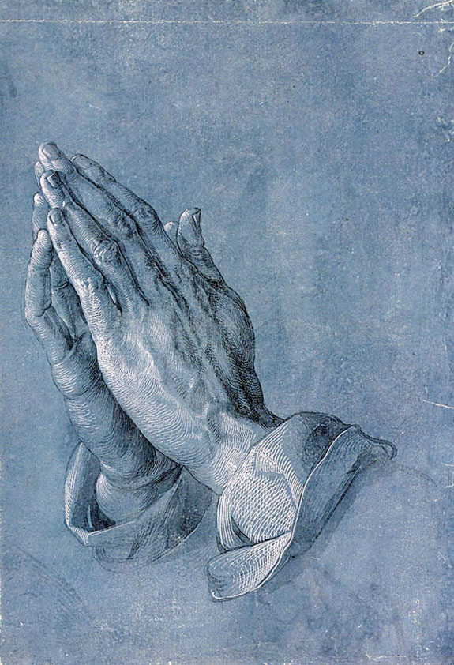

*A time of quiet prayer for*

*• The universal Church - Bishops, synods and all leaders church*

*• The leaders of the nations*

*• The natural world and the resources of the earth*

**Loving God I see the news and I am afraid. Violence is spiralling out of control. I don’t know what to think or feel. The temptation to fall into hatred, or despair feels very close at hand.**

**Help me to remember that nothing in all creation can separate me from your love that I know in Jesus. May your perfect love for me cast out my fear and free me to discern what is mine to do amidst the chaos of this suffering world.**

**Amen.**

*Finishing with the South Calder Mission Community prayer...*

**Heavenly Father we thank you for the life of your Church**

**in this place, and in all the villages of the South Calder Mission Community;**

**for all who have served and worshipped you in years gone by,**

**for all who make up your family in our churches today, for the faith we have in common, and for the people and traditions which make each church unique.**

**By your Spirit, guide and equip us, that together we might find new ways to reach out to our local community, to show your love to our neighbours, and to encourage them to follow the Lord Jesus in their lives. Father, we offer ourselves to your service. In the unity of the Holy Spirit, And in the name of Jesus Christ our Lord. Amen.**

*and the Lord’s prayer...*

**Our Father, who art in heaven,**

**hallowed be thy name; thy kingdom come;**

**thy will be done; on earth as it is in heaven.**

**Give us this day our daily bread.**

**And forgive us our trespasses,**

**as we forgive those who trespass against us.**

**And lead us not into temptation;**

**but deliver us from evil.**

**For thine is the kingdom,**

**the power and the glory,**

**for ever and ever. Amen.**

**THE CONCLUSION**

*Suggested hymn to sing or read* ***Jesus, be the centre.***

*The following prayer is said*

**Be with me, Lord, as I finish my prayer today.**

**May my lips always speak the truth;**

**may my eyes which have read your word**

**see only what is good;**

**and may my life as well as my worship**

**be always pleasing in your sight,**

**for the glory of your name. Amen.**

And nowmay the Lord who brought us to birth by his Spirit,  
 strengthen us for the Christian life.   
 May the Lord who provides for all our needs  
 sustain us day by day.  
 May the Lord whose steadfast love is constant as a mother's care,  
 send us out to live and work for others.   
 And the blessing of God Almighty.  
 the Father, the Son, and the Holy Spirit,  
 be with us and remain with us always.

**Amen.**

So now may I go in peace to love and serve the Lord.

**In the name of Christ. Amen.**

**Links for the hymns**

All my hope on God is founded.

<https://youtu.be/DohxO6ytsaU>

Firmly I believe and truly.

<https://youtu.be/9kPzfqy4RIo>

The Servant King.

<https://youtu.be/SuDTVNbdPrQ>

Jesus, be the centre.

<https://youtu.be/884tPls01e0>