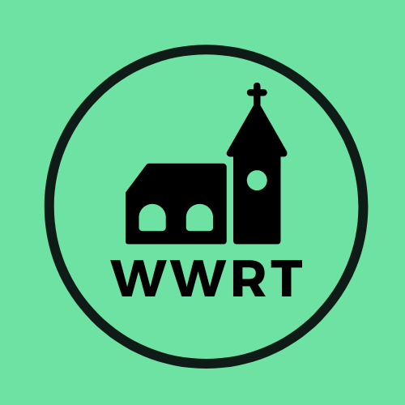

CHURCH SERVICES IN THE LOWER TEME VALLEY NOVEMBER 2025

Sunday 2nd November
4th Sunday before Advent
9.00 am BCP Holy Communion, St Leonard, Cotheridge
10.30am Worship for All, St Mary Magdalene, Broadwas
3.00pm All Souls Memorial, St Peter, Martley

Sunday 9th November
3rd Sunday before Advent/Remembrance Sunday
10.45am Remembrance Service, St Mary Madgalene, Broadwas

Sunday 16th November
2nd Sunday before Advent
10.30am CW Holy Communion, St Mary Magdalene, Broadwas

Sunday 23rd November
1st Sunday before Advent
10.30am Morning Worship, St Mary Magdalene, Broadwas

Sunday 30th November
Advent Sunday
10.30am Benefice Advent Service (tbc)

In November there will be Holy Communion at Heaton House, Martley on Wednesday 12th and 26th at 10.15am and on the 1st and 3rd Wednesday via our YouTube channel -wwrtlive1.
All services and timings are subject to review and amendment – please check the website for updates: www.achurchnearyou.com

All services and timings are subject to review and amendment in accordance with Covid lockdown easing – please contact the Rectory or check the website for updates.
01886 888664
www.achurchnearyou.com

