Next Sunday

19th October 2025

18th Sunday after Trinity

11.00am

Sung Eucharist
With
Revd Chris McQuillen-Wright

1st reading Shelley
2nd reading
Intercessions Shelley
Preist’s assistant Jim

Dates for your diary;

Sorry, but we need to talk about Christmas. This year we shall be holding a Festival of Christmas Trees on Saturday & Sunday 6th & 7th December. The Traditional Hamper competition winner will be drawn on the Sunday. Please hand suitable long-life items for the hamper to Arlene or Jim.

Eden Marathon Sunday 19th October is scheduled to pass Luxulyan Church at 10.00am and 11.20am.

Bishop Hugh Nelson will be leaving us to take up his new position as Bishop of Worcester. See letter at the back of church.

Please pray for;-
Holly Pat Weston
Elizabeth Cleare Magi & Vern
Gill Moore Jenny Filer Toni Olsson Sadie Rawlings
Sandra George Robin Burley
Vanessa Jeffries Helen Peacock
Liz Edwards

Please note that Revd Chris is ceasing his landline and can only be contacted on his mobile 07478 732212

Food Bank; Thank you for your continued support.
This week’s wish list;-
Long life fruit juice
Chocolate/treats
Tinned fruit
Biscuits
Tinned potatoes
Tinned custard
Jam
and Instant coffee

If you have items suitable for inclusion in next Sunday’s leaflet please ring Jim on 01726 850553 or email jim.cleare@btinternet.com
by 9.00pm on Saturday

Welcome to

Luxulyan Church

SS Cyriacus & Julitta
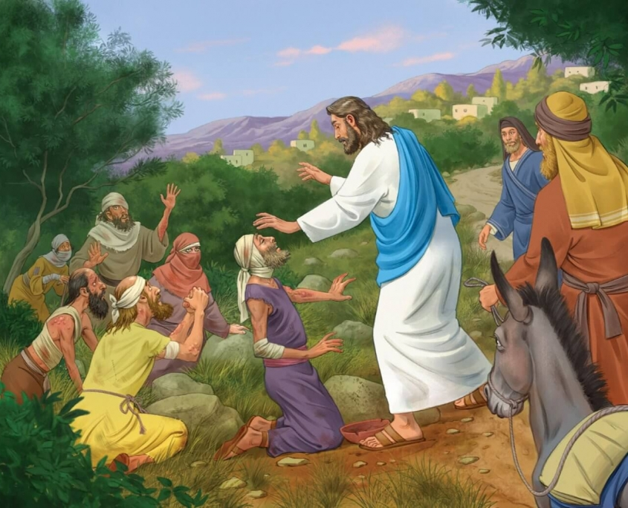
12th October 2025

17th Sunday after Trinity

11.00am

Sung Eucharist
with
Revd Barry Browning

1st reading Ros
2nd reading Jim
Intercessions Ros
Preist’s assistant Jim

Please stay for Tea or Coffee and a chat

Please take this leaflet home
The Seventeenth Sunday after Trinity Green

Collect
Almighty God,
you have made us for yourself,
and our hearts are restless till they find their rest in you:
pour your love into our hearts and draw us to yourself,
and so bring us at last to your heavenly city
where we shall see you face to face;
through Jesus Christ your Son our Lord,
who is alive and reigns with you,
in the unity of the Holy Spirit,
one God, now and for ever.

FIRST READING 2 Kings 5.1–3, 7–15b
A reading from the second book of Kings.
1 Naaman, commander of the army of the king of Aram, was a great man and in high favour with his master, because by him the LORD had given victory to Aram. The man, though a mighty warrior, suffered from leprosy. 2 Now the Arameans on one of their raids had taken a young girl captive from the land of Israel, and she served Naaman’s wife. 3 She said to her mistress, ‘If only my lord were with the prophet who is in Samaria! He would cure him of his leprosy.’ 7 When the king of Israel read the letter, he tore his clothes and said, ‘Am I God, to give death or life, that this man sends word to me to cure a man of his leprosy? Just look and see how he is trying to pick a quarrel with me.’ 8 But when Elisha the man of God heard that the king of Israel had torn his clothes, he sent a message to the king, ‘Why have you torn your clothes? Let him come to me, that he may learn that there is a prophet in Israel.’ 9 So Naaman came with his horses and chariots, and halted at the entrance of Elisha’s house. 10 Elisha sent a messenger to him, saying, ‘Go, wash in the Jordan seven times, and your flesh shall be restored and you shall be clean.’ 11 But Naaman became angry and went away, saying, ‘I thought that for me he would surely come out, and stand and call on the name of the LORD his God, and would wave his hand over the spot, and cure the leprosy! 12 Are not Abana and Pharpar, the rivers of Damascus, better than all the waters of Israel? Could I not wash in them, and be clean?’ He turned and went away in a rage. 13 But his servants approached and said to him, ‘Father, if the prophet had commanded you to do something difficult, would you not have done it? How much more, when all he said to you was, “Wash, and be clean”?’ 14 So he went down and immersed himself seven times in the Jordan, according to the word of the man of God; his flesh was restored like the flesh of a young boy, and he was clean. 15 Then he returned to the man of God, he and all his company; Naaman came and stood before him and said, ‘Now I know that there is no God in all the earth except in Israel.’

SECOND READING 2 Timothy 2.8–15
A reading from the second letter of Paul to Timothy.
8 Remember Jesus Christ, raised from the dead, a descendant of David – that is my gospel, 9 for which I suffer hardship, even to the point of being chained like a criminal. But the word of God is not chained. 10 Therefore I endure everything for the sake of the elect, so that they may also obtain the salvation that is in Christ Jesus, with eternal glory. 11 The saying is sure: If we have died with him, we will also live with him; 12 if we endure, we will also reign with him; if we deny him, he will also deny us; 13 if we are faithless, he remains faithful – for he cannot deny himself. 14 Remind them of this, and warn them before God that they are to avoid wrangling over words, which does no good but only ruins those who are listening. 15 Do your best to present yourself to God as one approved by him, a worker who has no need to be ashamed, rightly explaining the word of truth.

GOSPEL Luke 17.11–19
Hear the gospel of our Lord Jesus Christ according to Luke.
11 On the way to Jerusalem Jesus was going through the region between Samaria and Galilee. 12 As he entered a village, ten lepers approached him. Keeping their distance, 13 they called out, saying, ‘Jesus, Master, have mercy on us!’ 14 When he saw them, he said to them, ‘Go and show yourselves to the priests.’ And as they went, they were made clean. 15 Then one of them, when he saw that he was healed, turned back, praising God with a loud voice. 16 He prostrated himself at Jesus’ feet and thanked him. And he was a Samaritan. 17 Then Jesus asked, ‘Were not ten made clean? But the other nine, where are they? 18 Was none of them found to return and give praise to God except this foreigner?’ 19 Then he said to Samaritan, ‘Get up and go on your way; your faith has made you well.’

Post Communion
Lord, we pray that your grace
may always precede and follow us,
and make us continually to be given to all good works; through Jesus Christ our Lord.

Copyright acknowledgement (where not already indicated above):
Scripture quotations are from New Revised Standard Version Bible: Anglicized Edition, copyright © 1989, 1995 National Council of the Churches of Christ in the United States of America. Used by permission. All rights reserved. Collect and Post-Communion Prayer from Common Worship: Services and Prayers for the Church of England, copyright © The

