CHENIES BENEFICE PROFILE 2025
HOUSE-FOR-DUTY POST FOR LATIMER AND FLAUNDEN

St Mary Magdalene, Latimer  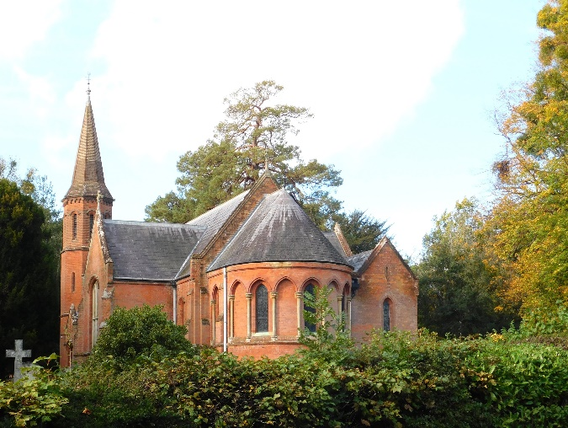 | St Mary Magdalene, Flaunden  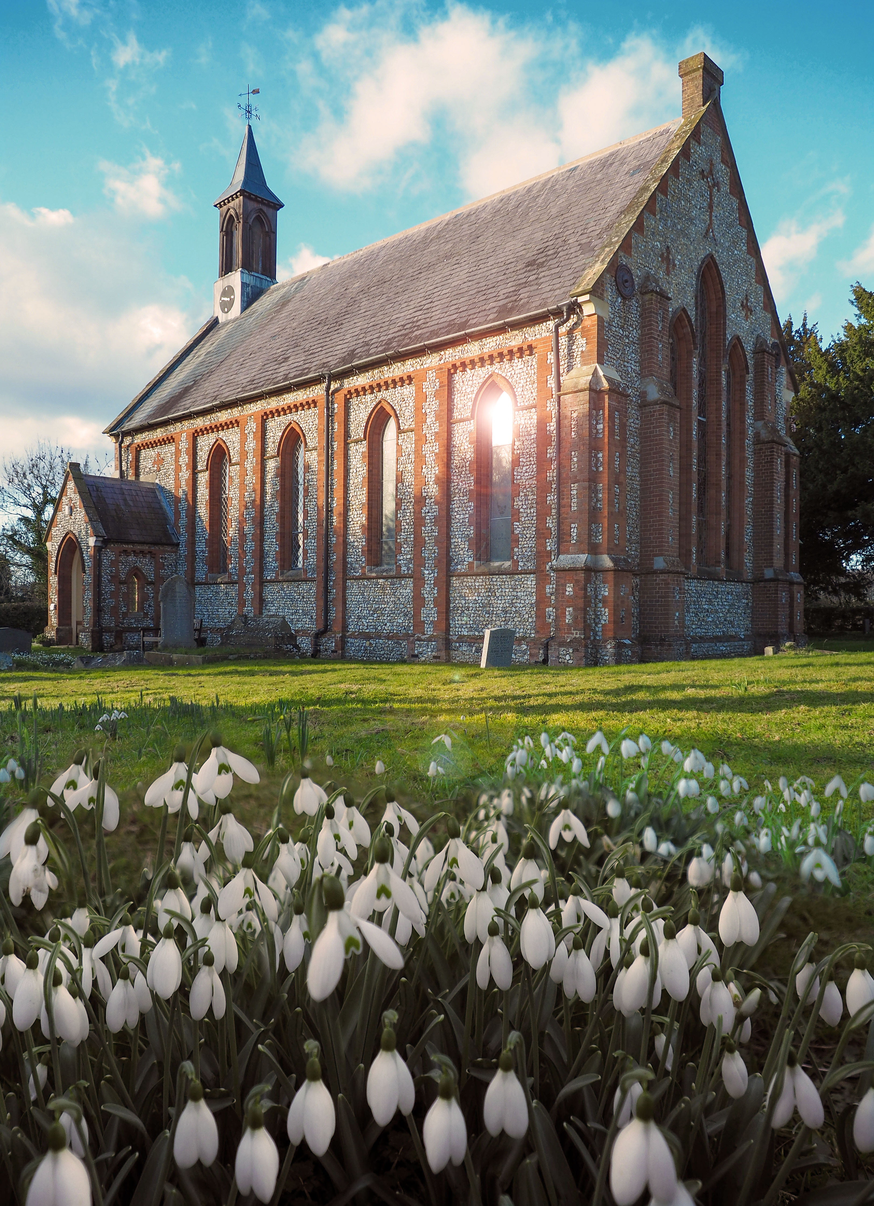 |  | St Mary Magdalene, Flaunden
St George’s, Little Chalfont  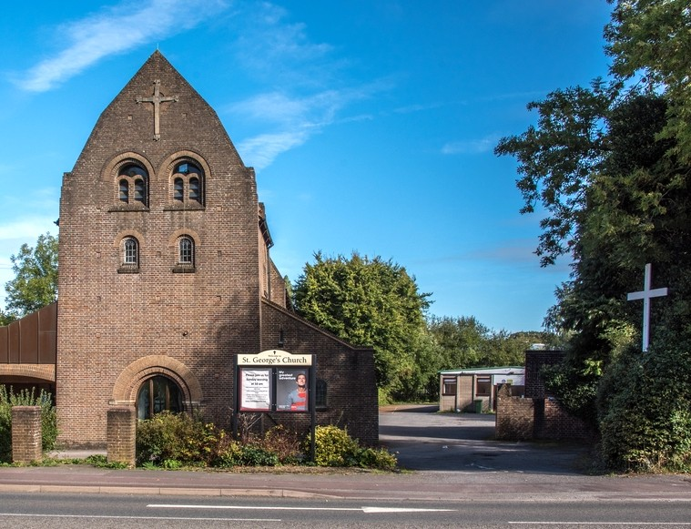 | St Michael’s, Chenies  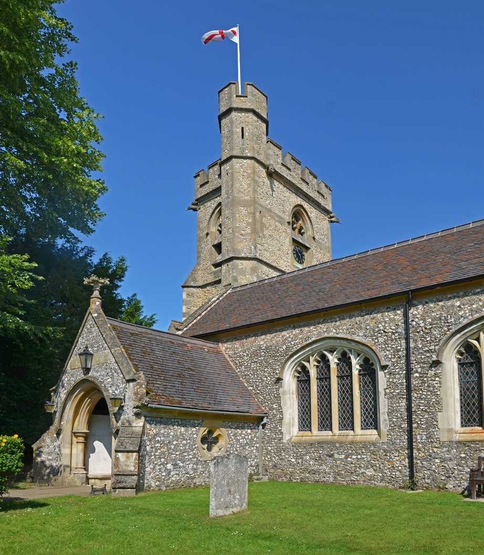

CONTENTS

Foreword from our Associate Archdeacon
Welcome from the Rector
Chenies Benefice
The Benefice Team
Our Vision
Benefice Services
What we are looking for
What we can offer
Location
Associate Minister’s House – Latimer Rectory
St Mary Magdalene, Latimer
St Mary Magdalene, Flaunden
St Michael’s, Chenies
St George’s, Little Chalfont
The Diocese and Deanery
Appendix 1. Person Specification
Appendix 2. Role Description

FOREWORD FROM OUR ASSOCIATE ARCHDEACON

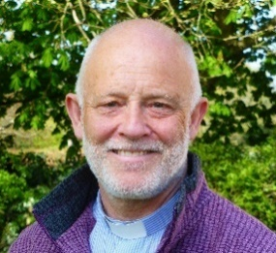
Any conversation about the most beautiful places to live in Southern England will include Latimer and Flaunden. The setting of the Chess valley, the historic parkland and perfectly proportioned villages, along with their attractive sense of community, are complemented perfectly by two George Gilbert Scott churches.
The care and attention paid to these church buildings are also complemented perfectly by the congregations. Their rhythm of worship and abiding traditions shape their place in parish life and act as a wellspring for their calling, echoing the Prophet Isaiah.

It is often commented that churches in this corner of our Diocese are especially well served by diligent, gifted and generous laity – Latimer and Flaunden provide ample support for that view.
Serving here as a House for Duty, Associate Minister, comes with considerable freedom within the wider team, in no small part due to this volunteer base. The opportunities the setting provides for a ministry in weddings is considerable and well advanced already.
And yet, there is something very special afoot here, alongside all these good things. To have a comment like this, ‘God is the greatest we love him so much I hope you do too. So don’t be shy come here to play and you’ll have a happy day,’ from a 7-year-old worshipper at Messy Church, sets this post apart from comparable advertised roles. This conveys something of the hopeful tone of welcome that awaits applicants.
With substantial support from the Diocese and the Deanery, as ever, the new Priest will be committed to the diocesan vision of becoming a more Christ-like Church for the sake of God’s World – contemplative, compassionate and courageous – and to model and enable a flourishing ministry, for all, in line with the diocesan work in this area.
I commend this profile to you and I would welcome conversations about the role with interested candidates. The place of greatest blessing is ever where God calls.

Reverend Canon Christopher Bull


This profile is compiled in preparation for the appointment in 2026 of an Associate Minister (House-for-Duty post) with special responsibility for the village parishes of Latimer and Flaunden. The House-for-Duty post is currently shared by the husband-and-wife team of Revds Brian and Peggy Ludlow who will retire in early 2026.
We hope and pray for God’s guidance in appointing their successor.

From the Rector, Revd David Whale:
Each church in the Benefice has its own individual identity and we need someone able to build upon the generations of love and care that have gone before us. We will have the opportunity to share the gospel, to show that the local church is the beating heart of our community and the hope of the world and so much more than just another social group. Latimer and Flaunden need a minister who is interested in and has an aptitude for rural ministry.
CHENIES BENEFICE
There are three parishes with four churches: St Mary Magdalene, Latimer and St Mary Magdalene, Flaunden are separate parishes with their own PCCs; St Michael’s, Chenies and St George’s, Little Chalfont form one parish with a single PCC.
The Benefice is in the Amersham Deanery (which has its office at St Mary’s in old Amersham), in the Archdeaconry of Buckingham and in the Diocese of Oxford. Revd Peggy Ludlow (currently Associate Minister with special responsibility for Flaunden) has been Area Dean since April 2021 and will retire in the near future.
There is a benefice office at St George’s in which the Benefice Administrator works. A very capable and efficient administrator, she has been in post since April 2024.
There are no proposals for any pastoral reorganisation.
The Benefice Team 2025
Revd David Whale, Rector
Revds Brian and Peggy Ludlow (with special responsibility for Latimer and Flaunden respectively)
Revd Vic Jones, Children’s and Families Minister
Mrs Pat Ansell, Licensed Lay Reader
Mrs Becca Newman, Benefice Administrator
Our Vision
To know Jesus and to make Jesus known, through:
- Personal discipleship
- Action within the community and our schools
- Deepening our faith by attending prayer and home groups

Services
Flaunden and Latimer Churches both offer a combination of Common Worship services and one BCP Communion each month on Sunday mornings. Their style of worship tends more to the traditional. St Michael’s, Chenies favours BCP services and St George’s, Little Chalfont is more contemporary.
 | Latimer | Flaunden
1st Sunday | BCP Holy Communion | Family Service
2nd Sunday | CW Morning Prayer | BCP Holy Communion
3rd Sunday | CW Holy Communion | CW Morning Prayer
4th Sunday | CW Morning Prayer | CW Holy Communion
5th Sunday | Something different! | CW Morning Prayer

What we are looking for
- A person with a deep faith in Jesus Christ and a strong sense of calling, who enjoys rural ministry and village community life. The House-for-Duty post is for two days a week including evenings, plus Sundays, with almost all that time spent in Flaunden and Latimer; only a small proportion of time is spent at St George’s and St Michael’s.
- Someone sociable and approachable to help us develop and strengthen local links within the community.
- Someone who values the church buildings as gathering places for the community.
- Someone who values tradition and has imagination for the future.
What we can offer
• Welcoming and relaxed congregations open to new initiatives (although we do like traditional hymns!)
- Three committed and encouraging PCCs
- Collaborative Benefice team
• An opportunity to live in a community surrounded by beautiful countryside with excellent local schools and good transport links to London
- A home in a well-built, four-bedroom house with superb views
• Support in professional and self-development, such as providing costs of clergy cover for conferences
• Administrative support from the Benefice Administrator, particularly for weddings and funerals
- Full reimbursement of standard clergy expenses (mileage and subsistence on duty, and percentage of telephone costs)

Location
Latimer, Flaunden and Chenies churches are at the heart of three separate villages within easy range of each other and set on either side of the Buckinghamshire/Hertfordshire border. St George’s is located within the more suburban area of Little Chalfont.
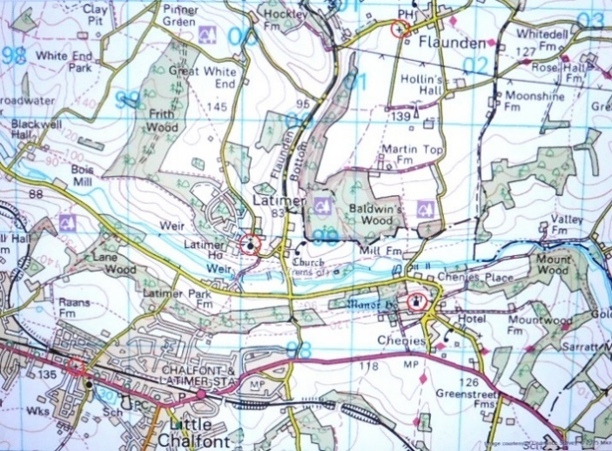
Map of the four churches in the Benefice
All four churches enjoy excellent connectivity to London, Heathrow, etc. and are within easy driving distance of Chalfont & Latimer and Chorleywood stations on the Metropolitan Line, and on Chiltern Line to Marylebone, as well as 10 mins from the M25.
Associate Minister’s House - Latimer Rectory
Latimer Rectory was built in 1953/4 on land donated by Lord Chesham. It is a fine house with four bedrooms and is situated about 100m from Latimer Church in a stunning location overlooking both the Chess Valley and Flaunden Bottom. It is reckoned to have the best views of any rectory in the whole of the Oxford Diocese! It stands at the end of a 60m drive, surrounded by fields on two sides and on the third side by an orchard belonging to the Old Rectory next door. The garden is mainly grass with a few shrubs and plants around the house. Electricity costs are £50-60 p.c.m. and oil costs £1,200-1,800 p.a. The Rector lives in the Rectory in Chenies.
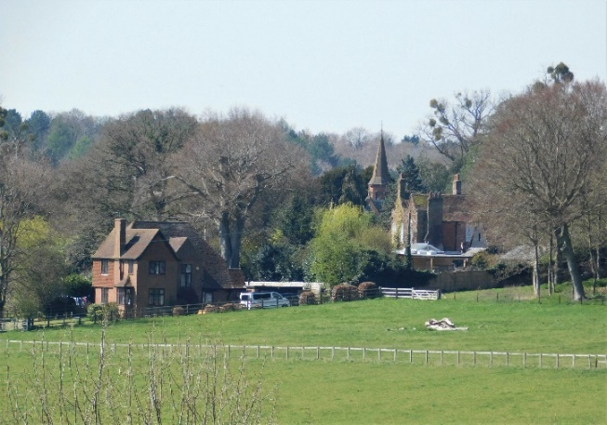 |  | 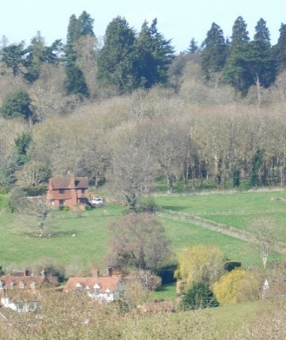
Latimer Rectory with the Church behind  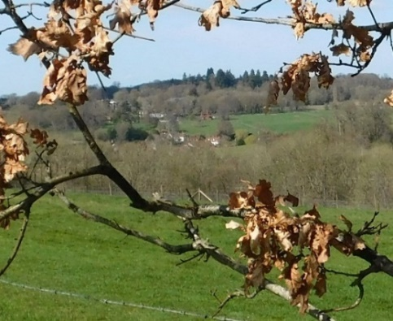 |  | The Rectory with the Village below  Looking across the Chess Valley to the Village and Rectory
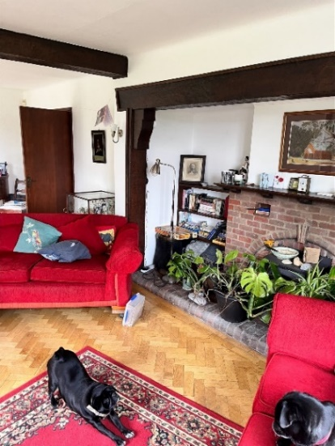 | 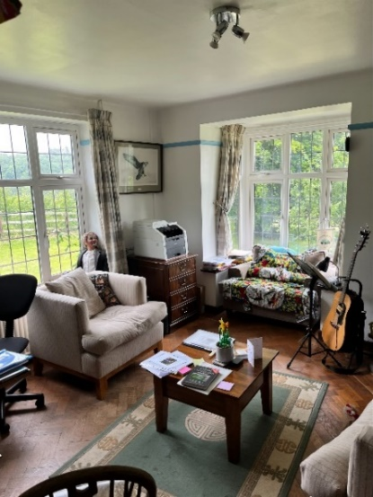 |  | 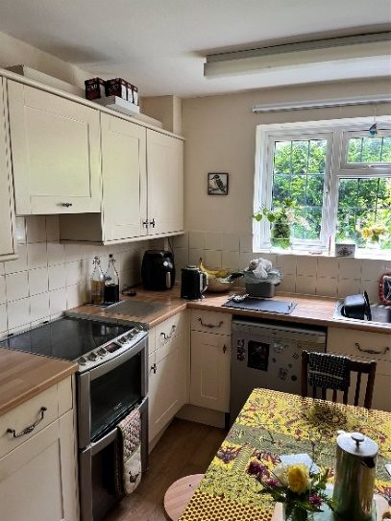
Latimer Rectory: Sitting Room, Study, Kitchen
ST MARY MAGDALENE, LATIMER
Our Church and Community
The church is set above the beautiful Chess Valley in the Latimer Conservation Area (part of the Chilterns Conservation Area) and is 3-4 miles SE of Chesham. It is adjacent to Latimer House, formerly the home of the Lords Chesham, subsequently the National Defence College and now a hotel and conference centre (https://www.devere.co.uk/latimer-estate/latimer-house). The church is a mid-19th century building largely designed by George Gilbert Scott, and is Grade II listed. The structure has remained essentially unchanged since Scott’s work.
Latimer village has a long and rich history from Roman times and including Latimer House’s involvement in secret activity during the Second World War, about which more is being uncovered and released. There are approximately 150 houses in Latimer, of which 84 are within the private estate of Parkfield (formerly service accommodation when Latimer House was the National Defence College).
There has been a place of worship at Latimer since the early 13th Century. The medieval chapel of St James was demolished and replaced in 1841 by the current red brick church, to a design by Edward Blore. It was substantially enlarged and re-designed by George Gilbert Scott in 1867. (The church in Flaunden, over the border in Hertfordshire, is the first church designed by Scott.)
The church is situated beside the popular Chess Valley Walk, which attracts local walkers and many from further afield. It is open every day and visitors’ appreciation of this is shown by these recent comments in the Visitors’ Book, e.g.
‘Lovely to reflect in this beautiful building’
‘Amazing.’
‘Einfach nur wow!’
‘Utterly enchanting’
‘Very peaceful’
‘Thank you for the lovely church. Always keep open’

The church seats 100+ people in traditional pews and its capacity can be increased by using the transepts. It is situated within a discreetly screened open churchyard next to the grounds of Latimer House and enjoys a peaceful outlook across the Chess Valley. There is a small, free-standing Parish Hall, right next to the Church, for church gatherings, and other community activities. The church is especially popular for weddings because the adjacent Latimer House Hotel is a popular wedding reception venue. We enjoy a collaborative relationship with the management. This has undoubtedly led to many couples choosing St Mary Magdalene from outside the area for their weddings. The Church is the venue for the excellent Latimer Music Festival which runs over an August weekend each year and features musicians of international standing.
The Parish Hall has a kitchen and toilet, and is used for coffee after Sunday services and is a vital adjunct to activities in the Church.
Over the last five years the PCC and congregation have put considerable effort into repairing and conserving the fabric and artefacts in the church. With local support a Fabric Fund was established and has raised thousands of pounds from grant-giving bodies, private donors locally and further afield, and from the profits of the Music Festivals. (There are no category 1 items outstanding from the Quinquennial Report of 2023.)
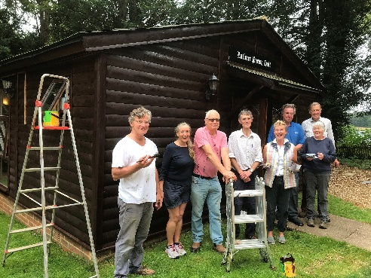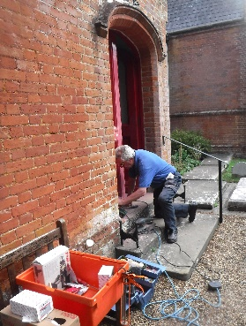
Latimer’s Fabric Team painting the Parish Hall and the Church’s outer doors
Our Long-term Vision
• To welcome all members of our community and beyond and demonstrate the unconditional love of Jesus, wherever they may be on their own personal journey with Christ.
• To maintain our weekly services and increase our regular congregation (on average 17-18). Attendance is increased, especially in the winter and spring by wedding couples as they come to fulfil their attendance requirements before their summer weddings.
• To build upon our higher numbers of attendance at major festivals and special services

• To continue to support, care for and respect the needs of all of our regular worshippers
• To develop further opportunities to work with other churches and groups to build and encourage the body of Christ.
Worship
There is one service at Latimer every Sunday at 9:30. Members of the congregation are involved in reading lessons. Service times may change when the new Associate Minister takes post to allow one minister to lead worship at two different churches on Sunday mornings.
In recent years Latimer has held Benefice services on Ash Wednesday and the Agape Meal and Service on Maundy Thursday. Our biggest service of the year is the Service of Lessons and Carols just before Christmas.
Outreach and Mission
We are involved with our community in many ways:
• Visiting the sick, frail, lonely or anyone in need of someone to listen and care
• Providing warm and welcoming hospitality to our visitors
• Keeping the church open every day for visitors to find quiet, beauty and spiritual peace
- Holding coffee mornings in people’s homes
• Joining in fundraising events
• Arranging a Harvest Lunch following the Harvest Service
• Arranging services to mark special days and encouraging the local community to attend, such as Mothering Sunday, Remembrance Sunday, and Lessons and Carols before Christmas
- Continuing to develop our thriving wedding ministry, particularly in partnership with Latimer House. We usually have around 12 weddings a year.
• Looking for opportunities for other special services to reach out into our community and to celebrate with our neighbouring parish of Flaunden.

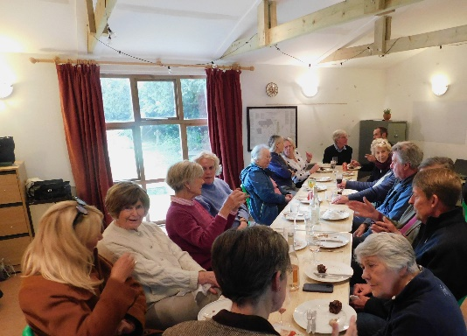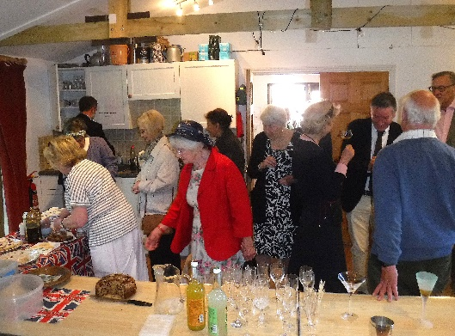
Harvest Lunch 2024 and Cocktails for the 80th Anniversary of VE Day
The churchyard is still open.
The Electoral Roll stands at 26. Latimer has one churchwarden and a deputy churchwarden. There are 5 elected PCC members, plus the Treasurer. The PCC is independent from the Benefice in its governance and finances. The Parish Share (which is the lowest in the Amersham Deanery) is fully paid. The church is signed up to the Parish Giving Scheme and has a contactless device available for collections at services. Our Fabric Fund is in surplus, as is our General Fund, although regular giving has declined and further fundraising for the General Fund would be desirable.
A history of the church – A Church by the Chess - by Tim Leary (the churchwarden’s husband) was published in 2023 (www.hawkesdesign.co.uk-church-by-the-chess).
ST MARY MAGDALENE, FLAUNDEN
Our Church and Community
The Parish of St Mary Magdalene is a rural community situated in the Chiltern Hills above the Chess Valley and is a favourite walking area with many footpaths including the Chiltern Way. We are a vibrant, welcoming and close-knit community of 147 homes. Unique in the Diocese of Oxfordshire, St Mary Magdalene is in the County of Hertfordshire.
The population covers all ages of people from young families to retirees and includes a small residential park. Once a farming community, most people, many of them professionals, now leave the village for work in the local area and London. The village has a fine-dining pub restaurant (www.bricklayersarms.com) and also another, a traditional village pub (www.greendragonflaunden.co.uk/). There is a good selection of small local shops, primary schools, doctors and dentists in the nearby villages of Bovingdon and Chipperfield.
A thriving Village Hall provides a Mother and Toddler group, various sports activities and entertainments many of which involve villagers. It has a large playing field used regularly for football and also a very popular, brand new children’s playground. The church has its own smaller, freestanding and well-equipped Church Room, which is used for Church events, occasionally hired out and where Sunday Afternoon Teas are served throughout the summer months.
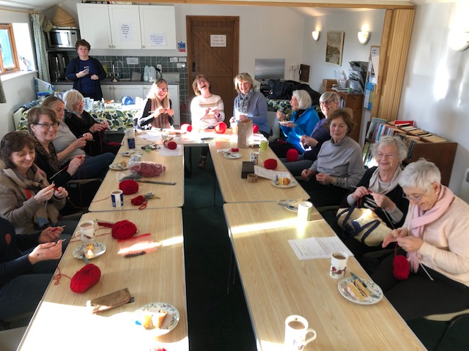  Flaunden Villagers knit poppies in the Church Room for Remembrance Sunday | 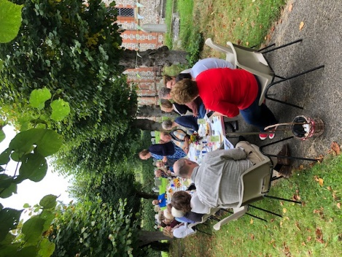  Sunday tea in the Churchyard

Flaunden’s Church was built in 1838, and was also designed by George Gilbert Scott. We are proud of our well-kept welcoming village church with its spectacular John Hayward window. The church and well-cared for churchyard are open 7 days a week and used and enjoyed by locals and visitors. The churchyard is very nearly full for burials but there is plenty of room for ashes. We also have a large car park. We have a constant nucleus of villagers, averaging 15 and about 5% of the village’s population, attending regular services.
In September each year members of the congregation, with their friends from Latimer down the hill, take part in Ride+Stride to raise funds for the Buckinghamshire Historic Churches Trust.
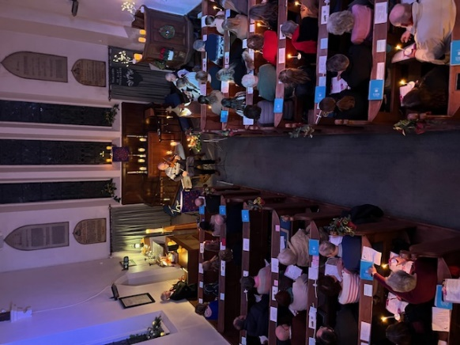 | 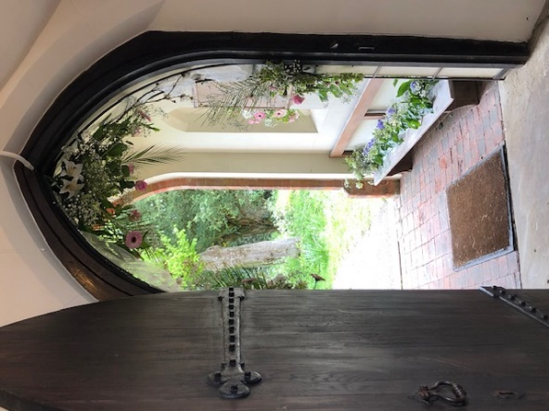 | 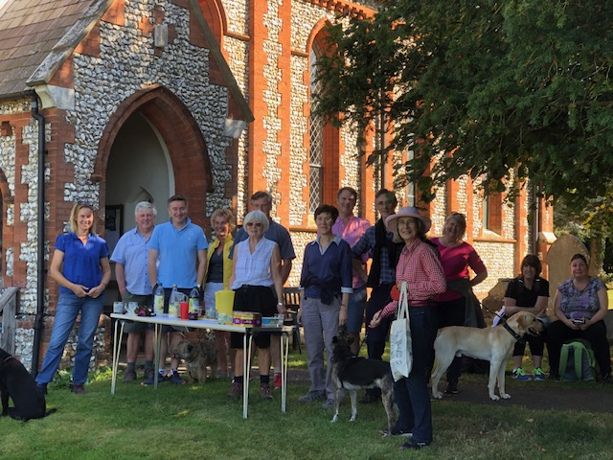
L to R: The Church from the Gallery at the Service of Lessons and Carols
The Porch decorated with spring flowers
Walkers from Flaunden and Latimer about to set off on Ride+Stride

Our special services such as Carols, Children’s Nativity and Christingle, Easter, Songs of Praise, Harvest, Remembrance Sunday, Pet Service and In Loving Memory are very well supported by many more of our residents and neighbours. There is also an annual Christmas Fayre with craft stalls, Father Christmas, carol singing, mulled wine and mince pies. The annual nativity play is one of the most popular church events in the village, where both adults and children dress up as nativity figures and the play ‘evolves’ depending on which characters are involved.
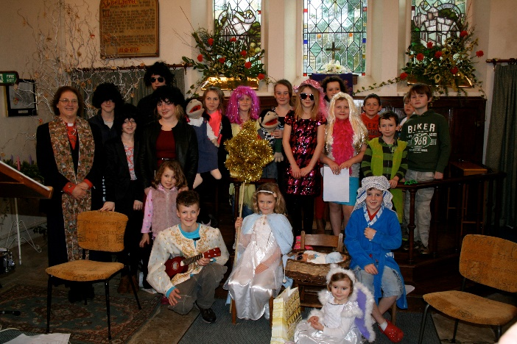
Nativity Service
Our Electoral Roll is 35.
A history of Flaunden Old Church – A Church in the Valley - by Tim Leary was published in 2024. It also covers the early history of Flaunden ‘new’ church (www.hawkesdesign.co.uk-the-church-in-the-valley).
Outreach and Mission
We are a welcoming church aware of the needs of the whole village, including everyone in our events and activities and offering mid-weekly opportunities for prayer. There is a different format for each of the weekly services, which include Family Service, BCP, Morning Worship and family communion. (The PCC is aware that current service times may change when the new Associate Minister takes post to allow one minister to lead worship at two different churches on Sunday mornings.) Church activities are provided for children where appropriate. Our services are for all ages and are both fun and thought provoking. Pastoral care reaches out to the whole village.
Messy Church is run on three occasions each year and attracts young people from surrounding villages, as well as from Flaunden, who clearly enjoy it:
I like the people that go to church because they are kind and loving, I also like the things we say about God. It makes me feel so very happy to see everyone there and the things we do there. It’s so very fun. God is the greatest we love him so much I hope you do too. So don’t be shy come here to play and you’ll have a happy day. Finlay, age 7
I like decorating a Biscuit so much and it’s at Messy church. I like the people there. I like doing stuff a lot it’s quite good. On your first day I hope you feel FINE. It should be great there. Callum, age 5

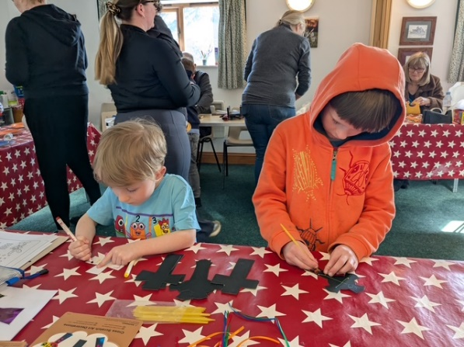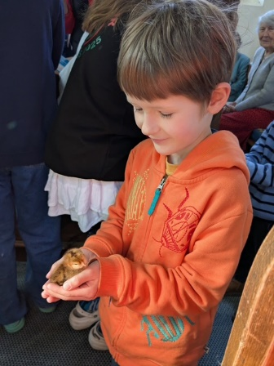
Callum and Finlay having fun at Messy Church
(photographs included with parents’ permission)

We are enthusiastic and active users of Instagram and Facebook, which is helping to grow our congregation and spread our message more effectively. We have created an online space for people to engage with our church and each other, building stronger connections within our village and wider community. Social media allows us to keep our congregation informed about upcoming events, share inspirational messages, and post updates on church activities. By sharing images, videos, and stories on social media we aim to grow a digital presence that reflects our church's values and mission. Please take a look! https://www.facebook.com/share/1HFvnxwSFu/?mibextid=wwXIfr;
https://www.instagram.com/stmarymagdalenechurch_flaunden?utm_source=ig_web_button_share_sheet&igsh=ZDNlZDc0MzIxNw==

Pastoral Outreach
We continue regular clergy visits, monthly coffee mornings, Sunday afternoon teas and many seasonal events.

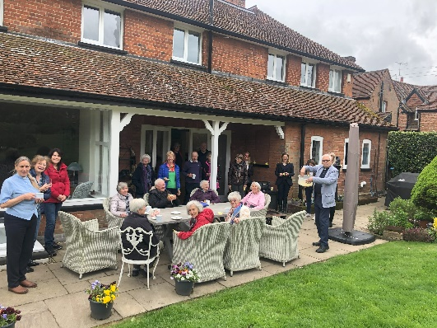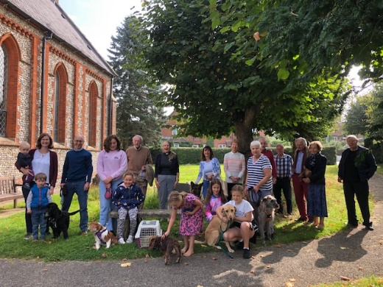
Coffee Morning and Pet Service
Organisation
The PCC is well organised with two churchwardens, a Treasurer, Deanery Synod representative and six elected members. The PCC works together with the clergy for the running of good services and events. Funding is also very well organised with many fundraising events arranged jointly with the village hall committee.
We pay the parish share in full and cover all our overheads. In 2023 we repaired the church roof, and in 2025 we have replaced half of our Church Room roof, both of which works have been partly funded by grants from the Benefact Trust, the Francis Coales Charitable Foundation, the National Churches Trust and the Buckinghamshire Historic Churches Trust.
Our top 3 challenges
• Support and Growth. To maintain and grow the church we need to encourage and resource new leaders and plan for succession in some roles.
• Congregation. We hope to grow our decreasing and older congregation with families and newcomers to the village.
• Communication: supporting each other within the parish and Benefice, and using social media to communicate well within the wider community.
Our Long-term Vision
• To address our challenges above whilst having a secure place within the Deanery/Diocesan network.
• To encourage more people to commit time and energy to the future of the church.

ST MICHAEL’S, CHENIES
Our church and community
St Michael’s is a beautiful 15th-century church, largely rebuilt by the Victorians, which is popular for weddings (approx. 12 a year because of its delightful setting next to the gates to Chenies Manor.
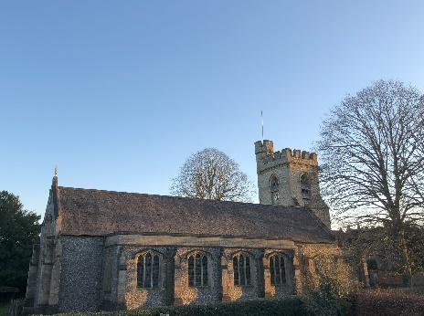 | 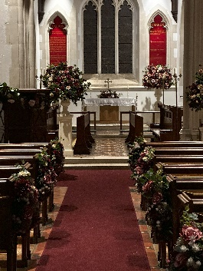

The church is set in a walled churchyard and there is an additional graveyard on the other side of the Manor Drive. The church is open all day and is extremely popular with walkers and visitors to Chenies Manor who want to see the Bedford memorials.
Chenies was an estate village built by the Dukes of Bedford when they owned the manor and local farms. Now it is a very desirable dormitory village, set in an Area of Outstanding Natural Beauty. The church was built to service the village and estate, but our congregation is now gathered from the surrounding area.
Worship
There are two services every Sunday: BCP Holy Communion has welcomed new members over the last two years; our BCP Evening Prayer is always sung. The tower bells are pealed for weddings and occasional services. We also have an excellent set of 56 handbells, just awaiting the right ringing master to re-form a ringing band.
Our long-term vision
• To reconnect the local community with its parish church.
• To maintain and develop our Sunday services, increasing our congregations and particularly growing our numbers of young people and families.
• To grow and develop our ministry to the many visitors that come to St Michael’s and to those who marry in our church.

ST GEORGE’S, LITTLE CHALFONT
Our Church, Community and School
St George’s Church was built in the 1930s as a mission church and is situated in the residential area of Little Chalfont and Amersham Common. We have strong links with the local Infant and primary schools. The current congregation reflects the diversity of the population of Little Chalfont. Following the appointment of a Children’s and Families minister our Sunday school numbers have begun to rise.
St George’s is a friendly, welcoming church with a loyal congregation. Regular volunteers help with the running of the church. We are right next door to one of the many social housing estates in our area.
St George’s currently has a 10.15am Sunday Morning Worship service with Holy Communion monthly. A traditional Communion Service, followed by a shared lunch, is held at 12.30pm every Thursday.
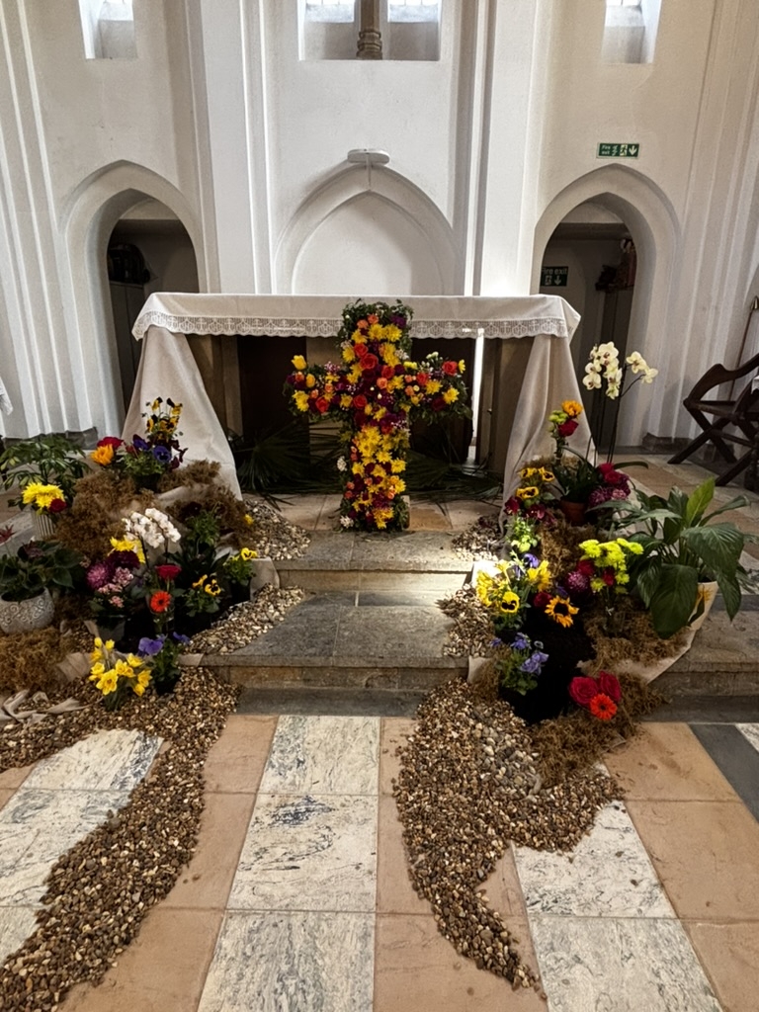 | 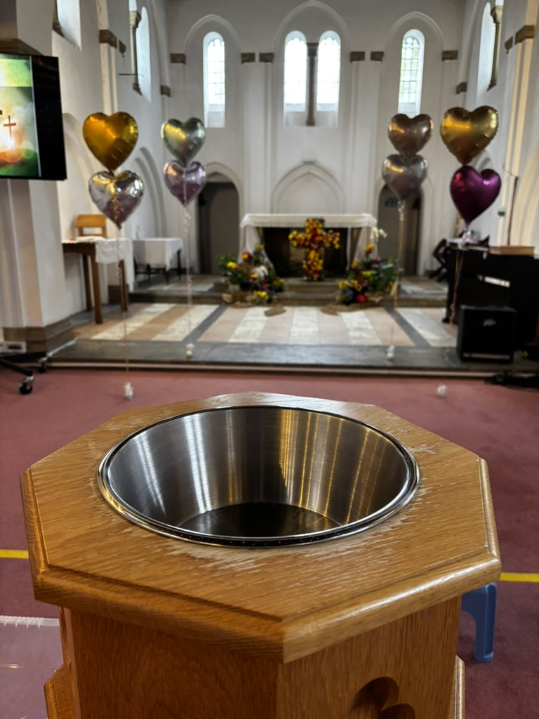 | 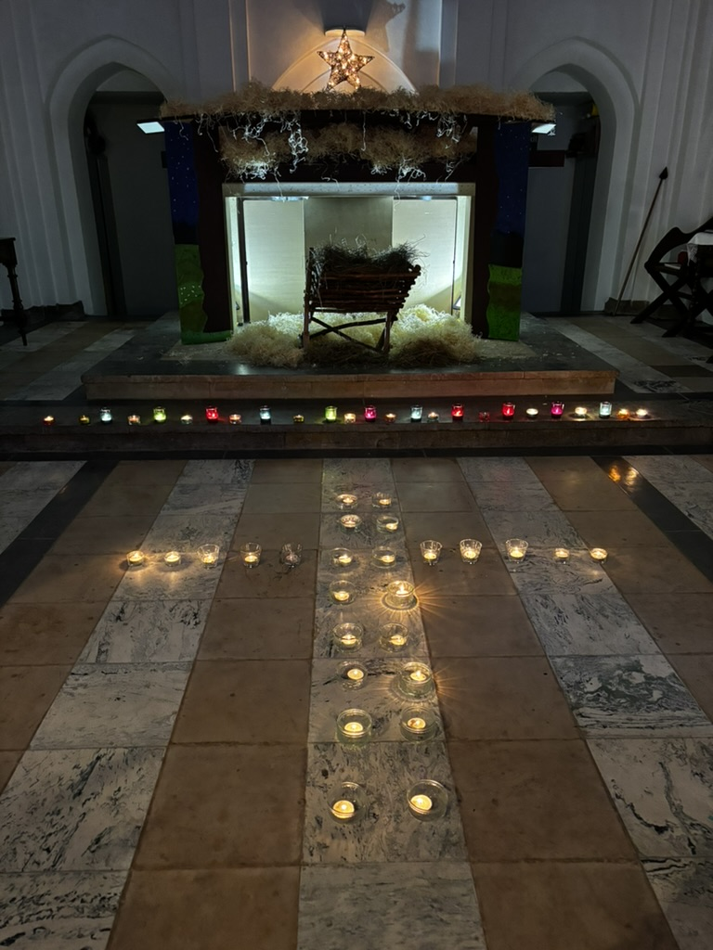 | 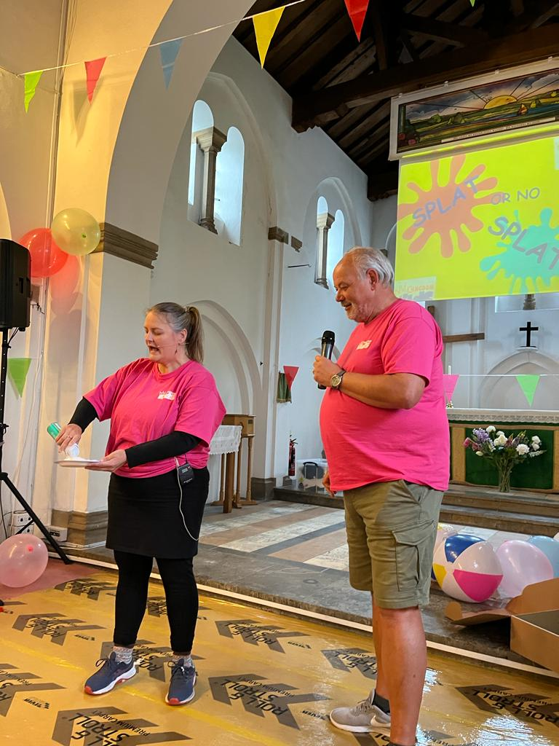
Last March we appointed a Children and Families Minister to help us reach out to those in our community. Since Revd Victoria’s appointment she has launched 2 mid-week groups on a Tuesday. Kingdom Tots is an outreach to toddlers and their parents and carers. Kingdom Kids is an after-school church for children ages 5-11yrs. Last September we launched a Sunday afternoon service for families of all ages named Kingdom Builders.
We are delighted to have an active relationship with the excellent voluntary controlled St George's C of E Infant and Preschool. A holiday club happens at the end of August and family park meet ups happen every Tuesday. We also open up the church at least once in the school holidays, when parents can come and chat over a cup of tea while their children play.
Outreach and Mission
Mission takes many forms, expressed within both the church building and the wider community:
- Oasis café. Mainly for young mums to relax in a safe place, this has built into a time where Christian conversation and worldview are encouraged and prayer offered.
- School Assemblies. We seek to engage with all our local primary schools and offer to go in and do assemblies.
- Food Hub. We hold a stock of food and open weekly to dispense emergency food supplies.

Redevelopment
St George’s stands on a plot of about ¾ acre, which includes the church, a church house, a scout hall and extensive parking. The church and all surrounding buildings are in desperate need of updating. We have been working on plans to redevelop the site over many years. Currently we are working with our Architects to achieve our goal to transform the church into a more modern facility for the community.

Useful websites
Benefice: www.cheniesbenefice.org/
Flaunden Village and Church: www.flaunden.com
www.achurchnearyou.com/church/5862/
www.nationalchurchestrust.org/church/st-mary-magdalene-flaunden
Latimer Church: www.achurchnearyou.com/church/5917/
www.nationalchurchestrust.org/church/st-mary-magdalene-latimer
Chenies Village: www.cheniesvillage.co.uk/
Chenies School: www.chenies.bucks.sch.uk/web/
Little Chalfont: littlechalfont.org.uk/
St. George’s School: www.stgeorgesamersham.org.uk/
Restore Hope: restorehopelatimer.org/

The Diocese and Deanery
The Diocese of Oxford serves the mission of the Church in Buckinghamshire, Berkshire and Oxfordshire. It comprises more than 600 parishes, with over 800 churches, serving a diverse population of more than 2 million people located in all types of settings. The Bishop of Oxford is the Right Revd Stephen Croft, who, due to the size and complexity of the Diocese, is assisted by three Area Bishops – for Buckingham, Dorchester and Reading. Each exercises considerable strategic and pastoral oversight for their areas. The Bishop of Buckingham is the Rt Revd Dave Bull, who has been the Area Bishop since February 2025. The current Archdeacon of Buckingham, the Ven Guy Elsmore will retire retired in September 2025.
The Diocesan vision is based on the qualities described in The Beatitudes and addresses what kind of church we are called to be: a more Christ-like Church for the sake of God’s world: contemplative, compassionate, courageous. The vision and priorities are set out here: https://www.oxford.anglican.org/who-we-are/our-vision-and-values/. They are supported centrally by resources, training, conferences, workshops and much more. The Diocese invites benefices and their priests to share a vision rather than demanding a response. It wants all its priests to flourish in ministry and to deepen their enjoyment of God.
Amersham Deanery
The Benefice of Chenies, Little Chalfont, Latimer and Flaunden is an important part of the Amersham Deanery touching on several smaller parishes. The Deanery is one of the largest and almost certainly the wealthiest in the Diocese. However, while many households could be described as ‘comfortable’, there are patches of significantly less prosperous housing, notably in Chesham. There is an excellent spirit of co-operation between all the parishes in the deanery, and the clergy chapter is strong.
The Area Dean aims to provide pastoral care and supervision for incumbents, and can be relied on to provide a listening ear, help and advice, whenever needed.
Lord Chesham is the patron of St Mary Magdalene, Latimer and the Trustees of the Bedford Estates patron of St Michael’s, Chenies.
The Deanery website can be found at http://www.amershamdeanery.org.uk/index.html.
Appendix 1. Person Specification
Essential | Desirable
Qualifications and Training
- Ordained priest within the Church of England
- Satisfactory completion of Initial Ministerial Education and willingness to engage in further training when appropriate
Experience
- Priestly ministry involving effective leadership, vision setting and team development, including developing lay leaders  - Active pastoral engagement with and support for people of all ages, within and beyond the church  - Good personal relationships, while maintaining confidentiality and being an active presence in our communities. | Experience of creative, engaging and imaginative ways of working with children and families to increase our congregations
Knowledge/Skills and Competencies
- Ability to preach well to a broad range of listeners and lead mature and thoughtful worship in a variety of traditions and styles.  - Ability to identify and respond to opportunities for mission, especially with individuals and community organisations whose involvement with the Church is limited | - Interest in supporting and encouraging general fundraising  - Aptitude for planning and leading ‘set piece’ services on special occasions.
General
- Seeks the guidance of the Holy Spirit through prayer and Bible reading and will encourage us to do the same  - Able to work in sympathy with varied service styles of the Benefice, accepting and celebrating the differences between our churches. | An appreciation and willingness to engage with all forms of music worship and an understanding of how this can draw people to God
Other
- The ability to work to a Safeguarding Policy  - Experience in working as part of a team | - Interest in 19th-century church buildings  - Willingness to support and encourage the local teams in Latimer and Flaunden who work on the fabric of their churches and in their churchyards.

Appendix 2. Role Description
1. Details of post
Associate Minister for two days a week, including evenings, plus Sundays. The post is an appointment to the Benefice of Chenies and Little Chalfont, Latimer and Flaunden but most of the appointee’s time is spent at Flaunden and Latimer.
Type of Role: House for Duty
Conditions: Please refer to Statements of Particulars document issued in conjunction with this role description
Key contact: Assistant Archdeacon of Buckingham
Clergy Terms: This role falls within the Clergy Terms of Service, formally known as Service: Common Tenure. The Archdeacon of Buckingham is the person designated by the Bishop of Oxford to issue the Statement of Particulars for the post holder.
Accountability: Priests share with the Bishop oversight of the Church. Whilst, as an office holder, the individual is expected to lead and prioritise work in line with the purpose of the role, they are encouraged to inform the Archdeacon and Churchwardens about any issues exceptional or otherwise that have the potential to affect ongoing delivery of ministry
2. Context
Work aligned to the vision of the Diocese of Oxford: a Christ-like Church; to be the Church of the Beatitudes. Contemplative; Compassionate; Courageous
3. Purpose of role and key responsibilities
A. To share in the cure of souls, following the leadership of Bishop Dave and the Rector of the Benefice, in collaboration with colleagues, including praying the Daily Office, the administration of the sacraments and preaching.
B. To have regard to the calling and responsibilities of the clergy (as described in the Canons, the Ordinal, the Code of Professional Conduct for the Clergy) and other relevant legislation.
C. To share in the wider work of the Deanery and Diocese as appropriate.
D. Key local responsibilities:
• Work collaboratively with ordained and lay colleagues
• Develop the life and worship of our congregations with specific focus upon Latimer and Flaunden
• Support the wedding ministry in Latimer
4. Other responsibilities
• Participate in the Bishop’s Ministerial Development Review scheme and engage in Continuing Ministerial Development
• Carry out any other duties and responsibilities, as required by the Benefice’s needs and agreed between the post holder and the Rector.
• Take care of their own wellbeing, including health and safety, and building a good repertoire of spiritual and psychological strategies
KEY CONTACTS
Groups and committees
• The three PCCs
• Deanery Chapter
• Deanery Synod
• Deanery Mission and Pastoral Committee
In the Benefice
• Churchwardens
• Ministerial colleagues
• Head teacher(s) of local school(s)
Support structures
• Area Dean of Amersham Deanery
- Archdeacon of Buckingham
• Area Bishop
• Staff at the Diocesan Office with key responsibilities for various aspects of supporting clergy

6. Other
This role description is issued alongside and should be read in conjunction with the following documents:
The Ordinal
The Canons of the Church of England
Guidance for the Professional Conduct of Clergy
Bishop’s Licence Statement of Particulars issued to the office‐holder on successful appointment
Diocesan Clergy Handbook
Benefice Profile
Ministry Action Plans (MAPs)
Any objectives discussed and agreed between the post holder and the supervising minister

If you would like to discuss this post further, please contact the Benefice Office on parishoffice@cheniesbenefice.org or 01494 762233, or Revd Canon Chris Bull, Associate Archdeacon of Buckingham at christopher.bull@oxford.anglican.org.

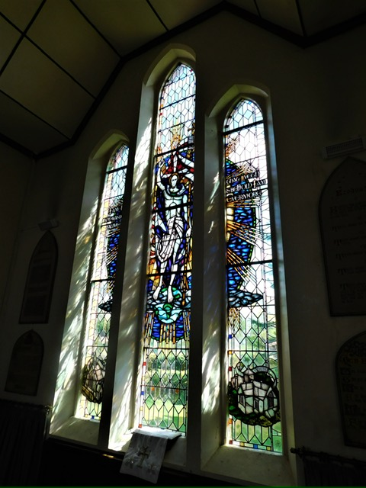

The East Window of Flaunden Church by John Hayward

