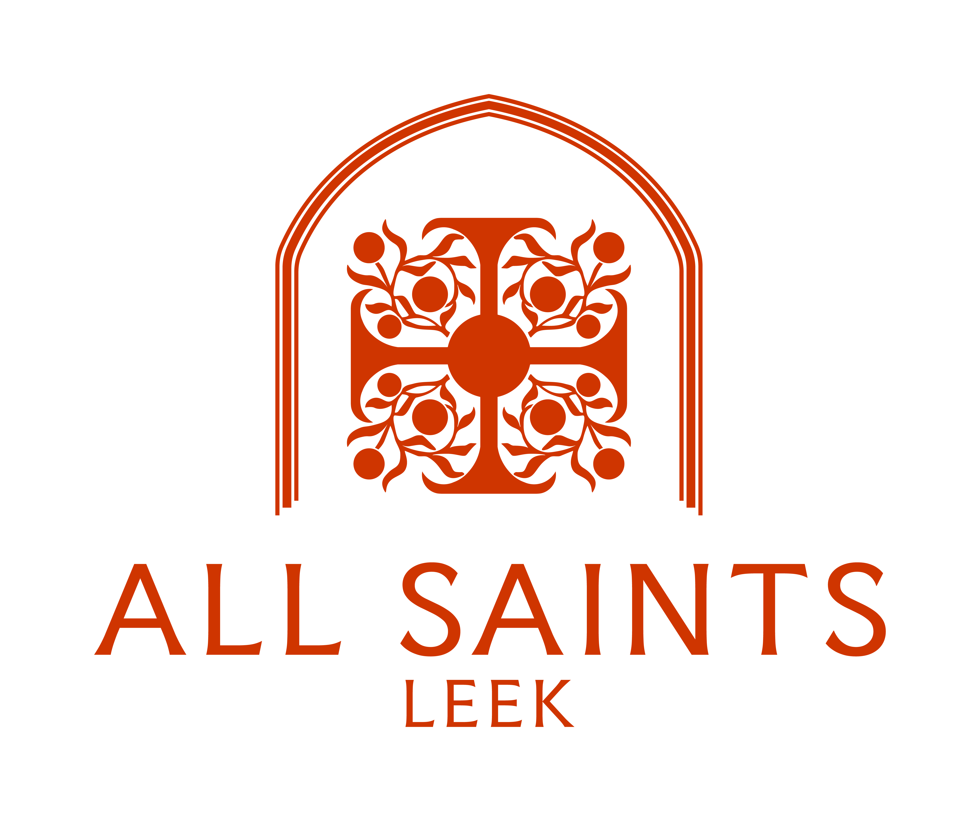

### **Mid-Week**

### **&**

### **All Services**

October 2025

Mondays 5.00pm Evening Prayer

Tuesdays 5.00pm Evening Prayer

Wednesdays 12.30pm Holy Communion

Fridays 8.30am Morning Prayer

Please join us - Everyone welcome

### **Services taking place in October**

Friday 3rd October 10.30am Prayers & Pastries

Sunday 5th October 11.00am Choral Eucharist

with Baptism

*Followed by refreshments in the Parish Hall*

Monday 6th October 5.00pm Evening Prayer

Tuesday 7th October 5.00pm Evening Prayer

Sunday 12th October 11.00am Choral Eucharist

Monday 13th October 5.00pm Evening Prayer

Tuesday 14th October 5.00pm Evening Prayer

Wednesday 15th October 12.30pm Holy Communion

Sunday 19th October 9.15am Said Eucharist

3.00pm Harvest Service

*followed by Harvest Supper*

Saturday 25th October 3.00pm – 5.00pm Come and Sing!

Sunday 26th October 9.15am Choral Eucharist

Monday 27th October 5.00pm Evening Prayer

Tuesday 28th October 5.00pm Evening Prayer

Wednesday 29th October 12.30pm Holy Communion

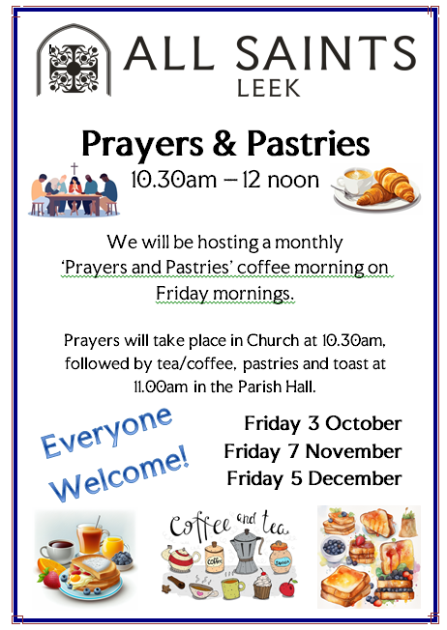

For more information about these and other Services and

to check dates and times, please do not hesitate to contact Revd. Henry and the Parish Office.

Revd. Dr. Henry Hope

Telephone: 07421 462 595

E-mail: [revdhenry.hope@posteo.uk](mailto:revdhenry.hope@posteo.uk)

Parish Office

Telephone: 01538 528545

E-mail: [allsaints.leek@outlook.com](mailto:allsaints.leek@outlook.com)