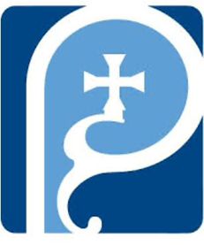
St Augustine of Hippo
Grimsby

A Forward in Faith Parish

Parish Magazine



November 2025

Our Giving

Bank details for standing orders or donations are:
TSB Bank
St Augustine of Hippo PCC
Sort Code: 30-93-72 Account Number: 00159954

You may have seen that many charity bank accounts have started
charging fees for everyday transactions. It costs us money to bank cheques and cash, which devalues the amount of the donation/payment. We are therefore asking that, wherever possible, people donate money using online banking, even for small amounts. This doesn't cost us a penny. Please indicate in the reference field who it's from, and what for, then we can Gift Aid your donation wherever possible. Gift aid forms should be completed for regular giving by standing order if applicable. Thank you.


Donating by card or phone

We have a card machine positioned at the back of church near the south door as an alternative way of giving. Please bear in mind that a percentage of all giving using this method (between 1% and 2%) is taken by the provider.

Regular Sunday giving by oﬀertory collection plate

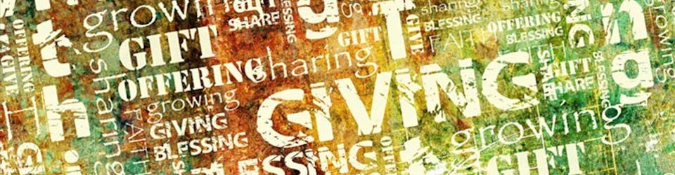
It is no longer necessary to use gift aid envelopes for cash donations of £30 or less. This again keeps administration down. However, should you wish to make a higher donation, please use gift aid envelopes as usual.
Anniversary of Deaths / Year’s Mind Parish Records for November
15 | 1987 | Peter | Phillipson | 52

If you have any additional information to complete any gaps for those
listed, or information relating to anyone you know of who should be
included please let me know on: mrs.maria.mason@gmail.com

Thank you

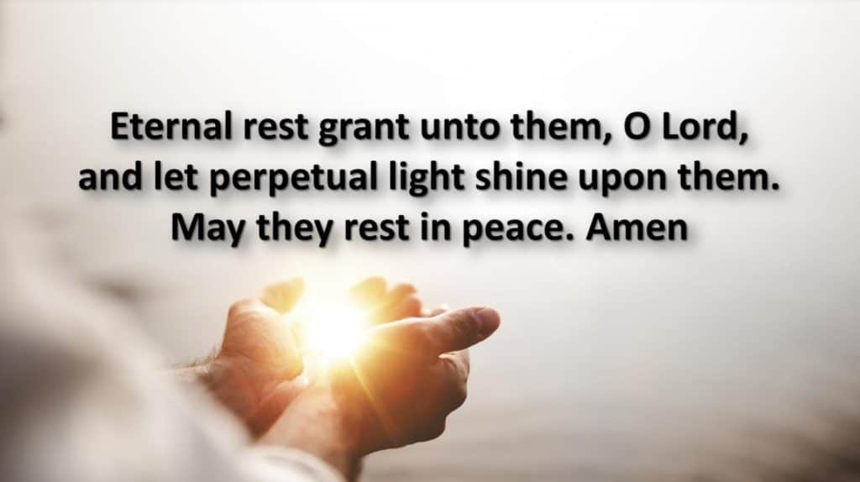
Maria

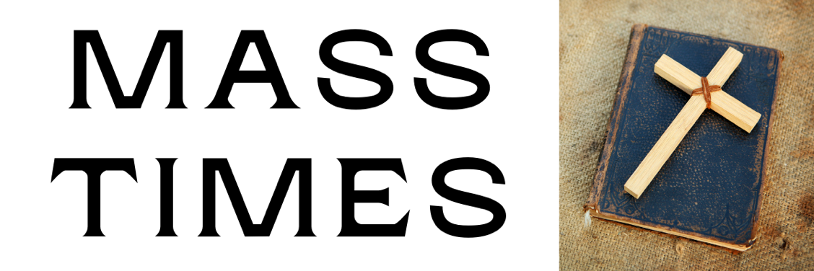

November Worship Times

Thirty-first Week in Ordinary Time
Sunday 2 November 10am Sung Parish. Mass
Wednesday 5 November 10am Said Mass followed by Coffee Morning

Thirty-second Week in Ordinary Time
Sunday 9 November 10am Sung Parish Mass
Wednesday 12 November 10am Said Mass followed by Coffee Morning

Thirty-third Week in Ordinary Time
Sunday 16 November 10am Sung Parish Mass
3.30pm Evensong and Benediction
Wednesday 19 November 10am Said Mass followed by Coffee Morning

Thirty-fourth Week in Ordinary Time
Sunday 23 November 10am Sung Parish Mass
Wednesday 26 November 10am Said Mass followed by Coffee Morning

First Week in Advent
Sunday 30 November 10am Sung Parish Mass
6pm Advent Procession

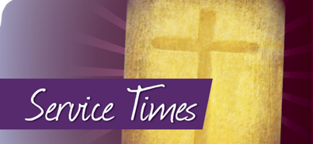

November 2025 Calendar
Dates, Observances and Prayer Intentions

Date Feast Intentions
1 Feria Parents
2 All Saints The Parish
3 All Souls The Departed
4 St Charles Boromeo Reformers
5 Feria Parliament
6 Feria Irish Christians
7 Feria Bishop Luke
8 Feria USPG
9 Remembrance Those who died in war in our Parish
10 Pope St Leo the Great Church Unity
11 St Martin Tours Schools of Theology
12 St Josaphat Bishop Stephen
13 Feria Teacher
14 Feria King Charles III
15 Feria Philosophers
16 33rd Sunday in Ordinary Time The Parish
17 Feria Franciscans
18 Feria Missionaries
19 Feria Lisle Marsden Academy
20 Feria St Edmundsbury Cathedral
21 Presentation of the BVM Those preparing for Baptism
22 St Ceilia Our Organist and Choir
23 Christ the King The Parish
24 St Andrew Dung-Lac and Comps Eastern Christians
25 Feria Additional Curates’ Society
26 Feria USPG
27 Feria The Medical Profession
28 Feria Penitents
29 Feria St Bueno’s Spirituality Centre
30 First Sunday of Advent The Parish

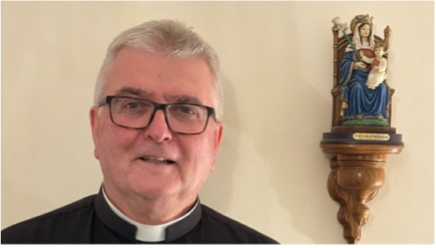

Fr Adrain Writes . . . . . . . . .

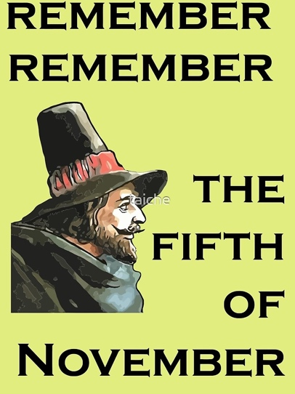
Remember, remember the fifth of November;

Gunpowder, treason and plot…………

These first two lines of a little poem, often recited on Guy Fawkes Day, open up all sorts of avenues for a Christian to explore in November.
I believe that the plot had a religious basis, more specifically a Christian denominational basis. Thank heavens we have all moved on and have greater tolerance for each other, rather than attempting to see each other off!

November is of course a season of remembrance and is also deemed by parts of the Christian Church as the Kingdom season. This is more the Heavenly Kingdom that any earthly kingdom.

At the beginning of the month, we have All Saints’ and All Souls’ Days. We remember and give thanks for all the holy people who have gone before. That’s quite a lot, some of whom were saints and some who were possibly less saintly but stilled loved. On All Souls’ Day we especially remember those we have known and loved who have left this life. We have the chance especially to pray that they may reach heaven, should their journey have been delayed (especially by a visit to purgatory).

On the Sunday closest to November 11th and indeed on November 11th itself, we remember those who have died in war. We think especially of those from our parish, not just those from the World Wars, but those who have died in other military conflicts since. It is good for us to remember also and pray for all involved in our military and other organisations where they risk life and limb for us.

These events point us to the Heavenly Kingdom of course. Towards the end of the month, as a Church, we celebrate the Feast of Christ the King. We think of Our Lord’s conquest against evil through His redeeming work on the cross. We give great thanks for all of this and, because of His redeeming work, we too can look forward to being part of His Heavenly Kingdom when our time in the earthly realms comes to a close.

Let us remember, remember, but look forwards as well.

With every blessing
Fr. Adrian

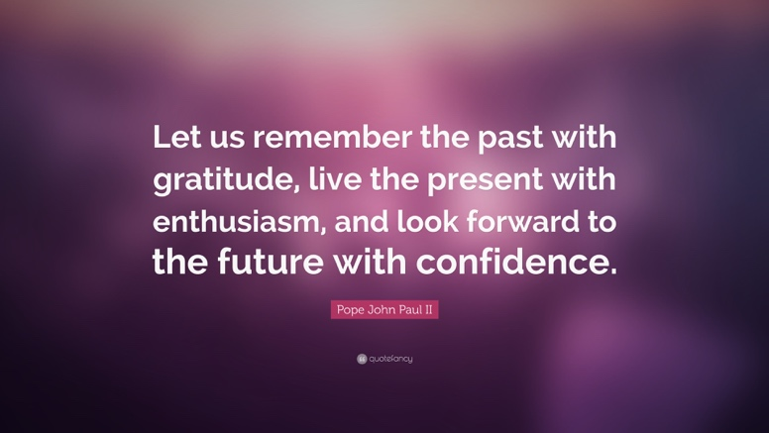

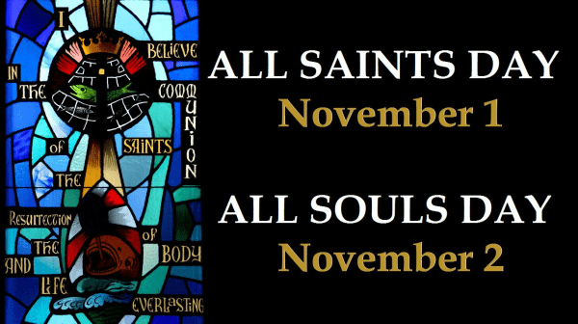
It seems unusual that our Church liturgical calendar schedules two major celebrations on days that are back to back.
But that is precisely the situation with the solemnity of All Saints, a liturgical feast, and the Commemoration of the Faithful Departed (All Souls), a liturgical observance. All Saints is a churchwide holy day of obligation and normally celebrated on November 1. If the first day of November falls on a Saturday or Monday, at least in the United States, the obligation to attend Mass is abrogated. All Souls’ Day takes place on November 2, unless it falls on a Sunday, then the celebration is held November 3.
During these early November celebrations, those of us still living (the Church militant) unite our hearts with, and in a special way remember, the faithful departed, whether they be in heaven (Church triumphant) or in purgatory (Church suffering).
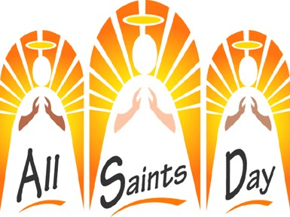
All Saints’ Day
All Saints’ Day, which began most likely as All Martyrs’ Day, can be traced to the earliest Christians. By the third century, the followers of Christ were annually honouring their brothers and sisters who had given their lives (been martyred) while witnessing for and defending Jesus Christ. Typically, on the anniversary of a martyr’s death, those living would gather to remember and offer prayers at the tomb or place where the deceased had died. Tombs were sometimes decorated and altars built over the tomb. “From the third century the anniversary of a martyr’s death, called his ‘birthday,’ was commemorated at his grave by a celebration” (Henry Chadwick, “The Early Church,” p. 271; Penguin Books, 1993). The belief among the first Christians, which continues today, is that believers who died defending Christ were borne by angels to heaven and are face to face with the living God, in the presence of the beatific vision.
In those first centuries, especially during the savage reign of the Roman Emperor Diocletian (r. 284-305), there were more and more Christians who accepted death at the hands of the Romans rather than deny Christ, rather than worship false gods or the personage of the emperor. Additionally, others who had publicly confessed their Christian faith (confessors) and somehow survived the Romans were also honoured. Thus, the number of martyrs and confessors became greater than the opportunities to give each one an anniversary celebration, and the need for a common feast day was recognised. By the fifth century there is evidence of locations, such as in Antioch, where the fledgling Church had set aside the first Sunday following Pentecost to collectively honour these holy and courageous people.
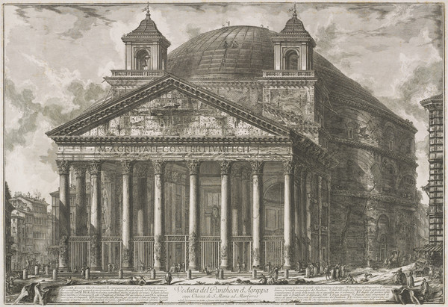
The Pantheon
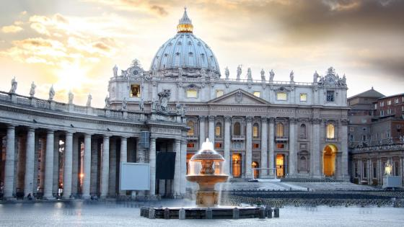
In 609, during the reign of Pope Boniface IV (608-615), the Eastern Emperor Phocas (r. 602-610) gifted a temple in Rome to the Holy See. The temple, still standing today and still known as the Pantheon, was originally built in the first century. Destroyed by fire and rebuilt between 118 and 128, it was a public place to worship and honour all the Roman gods and goddesses — a spectacular monument to pagan Rome. Pope Boniface accepted this temple, removed all the pagan embellishments, all the statues of false gods and, according to legend, relocated and buried the remains of hundreds of Christian martyrs beneath the Pantheon. The pope then consecrated the Pantheon as a Christian church to the Blessed Mother and all the Holy Martyrs (Sanctae Mariae and Martyrs). The consecration took place on May 13, and that was the annual date of the feast of All Martyrs for the next 125 years.
On November 1, 735, Pope Gregory III (731-741) dedicated an oratory in St. Peter’s Basilica to house the relics of the apostles, martyrs, saints and confessors. Thereafter, November 1 became, at least for the churches in Rome, the feast of All Saints, and the May 13 date was suppressed. Other countries and cities began to celebrate the feast on the same day as the Rome churches, and soon a vigil of All Saints was added. Eventually, Pope Gregory IV (827-844) assigned November 1 as the date of the feast of All Saints throughout the Latin Church and proclaimed it a holy day of obligation. In the 15th century, octave days were added by Pope Sixtus IV (1471-1484) and the octaves of All Saints were part of the Church calendar until suppressed in 1954. In sum, there is ample historical evidence that Christians have annually, on some date or another, been acknowledging the collective lives of all martyrs and saints for over 1,200 years.
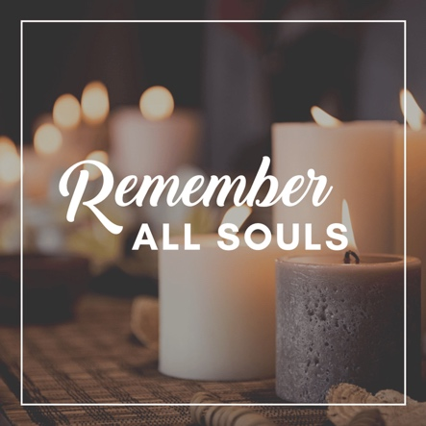
Today, All Saints’ Day is a solemnity and holy day of obligation on which the universal Church honours the martyrs, the saints and the confessors, including all known and unknown, all who have gained the reward of heaven.
All Souls’ Day
Offering prayers for those who have died is ancient in origin. In the Old Testament’s Second Book of Maccabees, written around 100 B.C., Judas Maccabeus orders his army to pray and offer sacrifices on behalf of their fallen comrades. Tombs found in the Roman catacombs are inscribed with prayer requests for the deceased. The second-century writer Tertullian wrote in an essay, “Monogamy,” about a woman praying for her deceased spouse: “Indeed she prays for his soul and asks that he may, while waiting, find rest; and that he may share in the first resurrection. And each year, on the anniversary of his death, she offers the sacrifice.”
The Commemoration of the Faithful Departed, or All Souls’ Day, evolved onto the Church calendar long after All Saints’ Day. Sometime between 998 and 1030, St. Odilo, the abbot at the Benedictine Monastery in Cluny, France, encouraged all the monks to pray for the souls of those who had died, those waiting the joys of heaven. He instituted this commemoration on the day after All Saints’ Day, and soon other religious orders and churches began, on that same date, to annually remember all who had died. Remembering and praying for the faithful departed is tied directly to our belief in purgatory.
On All Souls’ Day the universal Church prays for all those in purgatory, people who were much like us, whose offense may have been less than ours. By pleading for them, we are inspired to lead purer lives. On that day, and during the entire month of November, we remember our departed brethren as we go to the cemetery where they are buried, attain indulgences for them, give alms, do some good work, ask for Masses to be said in remembrance, all on behalf of those close to us and to others we may have neglected during the year.
We also light candles, and in some parishes the faithful display pictures of their deceased loved ones in the church. Church bells are sometimes rung to remind everyone to pray for the poor souls in purgatory. Priests are authorized to say three Masses on this holy, sombre day.
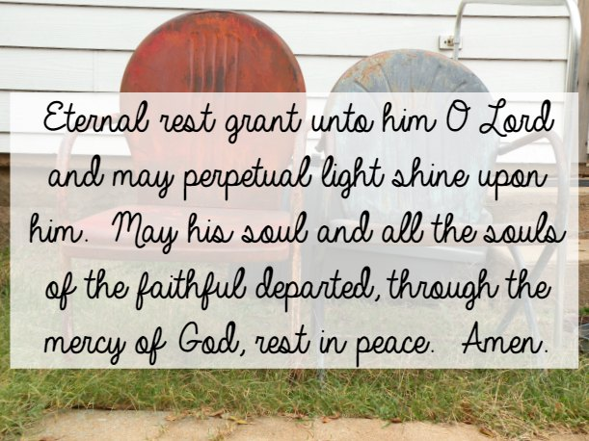

Saint Charles Borromeo’s Story

The name of Charles Borromeo is associated with reform. He lived during the time of the Protestant Reformation and had a hand in the reform of the whole Church during the final years of the Council of Trent.
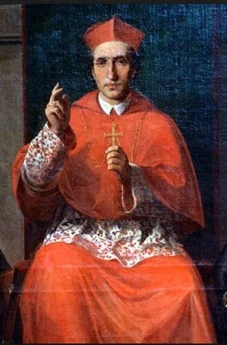
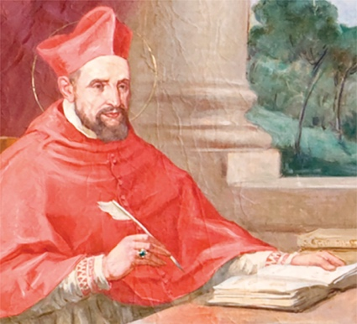
Although he belonged to the Milanese nobility and was related to the powerful Medici family, Charles Borromeo desired to devote himself to the Church. In 1559, when his uncle, Cardinal de Medici was elected Pope Pius IV, he made Charles cardinal-deacon and administrator of the Archdiocese of Milan. At the time Charles was still a layman and a young student. Because of his intellectual qualities Charles was entrusted with several important offices connected with the Vatican, and later appointed secretary of state with responsibility for the papal states.
The untimely death of his elder brother brought Charles to a definite decision to be ordained a priest, despite his relatives’ insistence that he marry. Soon after being ordained a priest at age 25, Borromeo was consecrated bishop of Milan.
Working behind the scenes, Saint Charles deserves the credit for keeping the Council of Trent in session when at several points it was on the verge of breaking up. Borromeo encouraged the pope to renew the Council in 1562, after it had been suspended for 10 years. He took upon himself the task of the entire correspondence during the final phase. Because of his work at the Council, Borromeo was unable to take up residence in Milan until the Council concluded.
Eventually, Borromeo was allowed to devote his time to the Archdiocese of Milan, where the religious and moral picture was far from bright. The reform needed in every phase of Catholic life among both clergy and laity was initiated at a provincial council of all the bishops under him. Specific regulations were drawn up for bishops and other clergy: If the people were to be converted to a better life, Borromeo had to be the first to give a good example and renew their apostolic spirit.
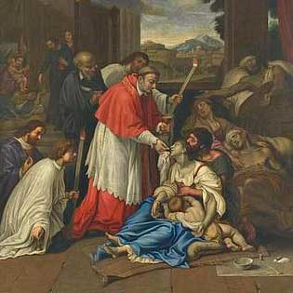
Charles Borromeo took the initiative in giving a good example. He allotted most of his income to charity, forbade himself all luxury, and imposed severe penances upon himself. He sacrificed wealth, high honours, esteem, and influence to become poor. During the plague and famine of 1576, Borromeo tried to feed 60,000 to 70,000 people daily. To do this he borrowed large sums of money that required years to repay. Whereas the civil authorities fled at the height of the plague, he stayed in the city, where he ministered to the sick and the dying, helping those in want.
Work and the heavy burdens of his high office began to affect Archbishop Borromeo’s health, leading to his death at the age of 46.
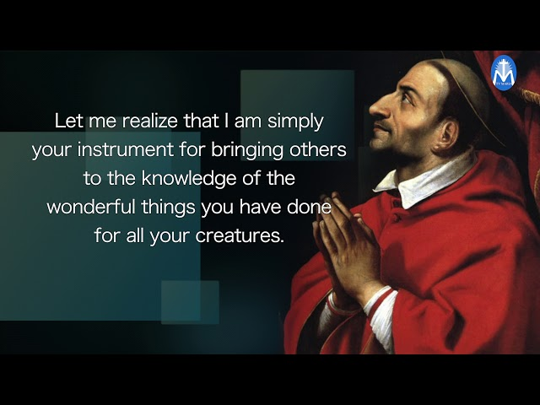

Pope St Leo I

Saint Leo the Great, also known as Pope Saint Leo I, was born into a Roman aristocratic family. His response to the call of the Lord transformed him into one of the greatest popes of Christian history. In fact, he was the first pope to be given the title "the Great." Details pertaining to Leo's place of birth are not known, but it is believed his ancestors come from Tuscany.

St Leo the Great became a very well-known deacon of the Church by 431, serving the church under the pontificate of Pope Celestine I. Leo was widely respected for his love for the Lord, intelligence and persuasive nature. He was also gifted in bringing reconciliation between disputing groups of Christians.

That is why he was often sent out to settle disputes, both secular and theological. Following the pontificate of Pope Celestine, the next Pope was Pope Sixtus III.

Pope Sixtus III passed away while Leo was visiting Gaul at the request of Emperor Valentinian III. His task was to bring peace between one of Gaul's chief military commanders and the chief magistrate. Leo was then unanimously elected as the next pope to succeed Pope Sixtus III in 440. His swift election reflected the respect he had garnered among the people from his service to the Lord and the affection the faithful had this pastoral and wise servant of the Lord.

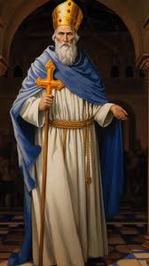
Pope Leo was deeply dedicated to his service as pope. He saw himself as privileged to sit in the Chair of St Peter, as the servant of the servants of God. He worked diligently as "Peter's successor." Over time, Leo became known as one of the best administrative popes of the ancient Church. But, he was so much more.

During his reign, he tirelessly fought to preserve the unity of the Church and its faith; and to ensure the safety of his people against invasions from armies which sought to destroy the Church and the Christian influence on culture which she brought to bear.

Pope Leo I focused his pontificate on four main areas. He continuously worked to oppose and root out numerous heresies which were threatening the Western Church. Among them were Pelagianism, which involved denying Original Sin and failing to understand the necessity of God's grace for salvation.

At the foundation of the Pelagian error was the mistaken notion that we can perfect ourselves without God's grace and assistance.

The other major heresy threatening the Church was Manichaeism.

This heresy denied the goodness of the human body, creation, and even matter itself. It failed to understand the full implications of the Incarnation of Jesus Christ. In fact, it denigrated the human body. In short, it viewed everything material as evil. That denies the very teaching of the Hebrew Scriptures and the New Testament. It also rejects the very heart of the Gospel message.

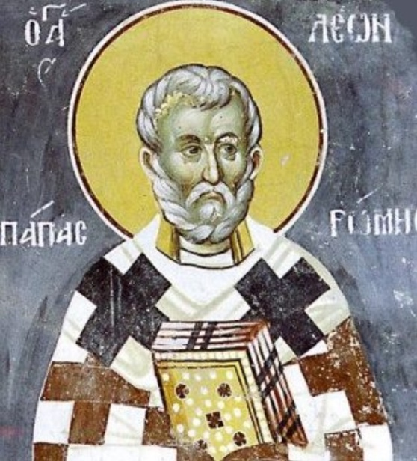
Pope Leo I was a great defender of the orthodox teaching of the Catholic Christian Church and protected the full deposit of faith. The whole Church is still indebted to him for this.

During this same period, some Eastern Christians began questioning the teaching of the Church concerning the relationship between Jesus' humanity and his divinity, and how to articulate this mystery of the Christian faith.

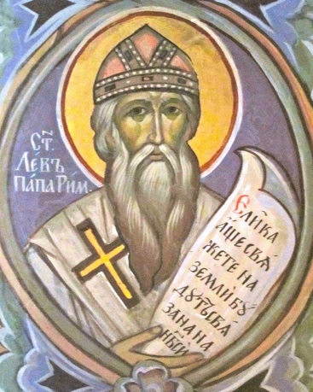
In response, Leo resolved the doctrinal controversy with a letter setting down the Church's official teaching on Jesus Christ as One Person with a human and a divine nature which could not be separated. This profound and theologically astute letter reconciled the disputing parties. It preserved the core teaching concerning Jesus Christ. Finally, it affirmed the fullness of what occurred in the Incarnation, as well as its implications for all men and women who are baptized into Jesus Christ.

To this day, Leo's letter is heralded and praised, not only for bringing peace, but for preserving the fullness of Christian truth and doctrine. It helped the whole Church enter more fully into the heart of the Gospel message of who Jesus is - and who we can become in Him, as we cooperate with grace.

Along with his dynamic faith and outstanding theological wisdom, Pope Leo I was also courageous. He led Rome's defence against Attila the Hun's barbarian invasion on Italy in 452, by taking on the role of peacemaker.

Pope St Leo focused heavily on the pastoral care of his people. He inspired and helped to foster charitable work in areas of Rome affected heavily by famine, refugees and poverty. To him, being a Christian was not only about embracing the fullness of the Gospel theologically but living it out in a world filled with hurt, suffering and needs.

Pope Leo I was renowned for his profoundly spiritual sermons. With his words, Leo could reach the everyday needs and interests of his people. It was his reputation as an "instrument of the call to holiness, well-versed in Scripture and ecclesiastical awareness" that helped him become one of the greatest popes in the history of the Church.

Leo died on November 10, 461. He wished to be buried as close as possible to St. Peter's tomb. His body was first laid in the entrance of St. Peter's basilica but was later moved inside the basilica in 688.

Pope Leo I's papacy has been described as one of the most important in the Church's history. Nearly 100 sermons and 150 letters of Leo I have been preserved; one of them is still, to this day, used in the Office of Readings on Christmas.

In 1754, Pope Benedict XIV proclaimed Leo I a Doctor of the Church. Pope Leo I faithfully and unequivocally held to the belief that everything he did and said as pope represented Jesus Christ, and St. Peter. He discharged his office, and vocation, with dynamic faith, great pastoral care and excellence. His feast day is celebrated on November 10.

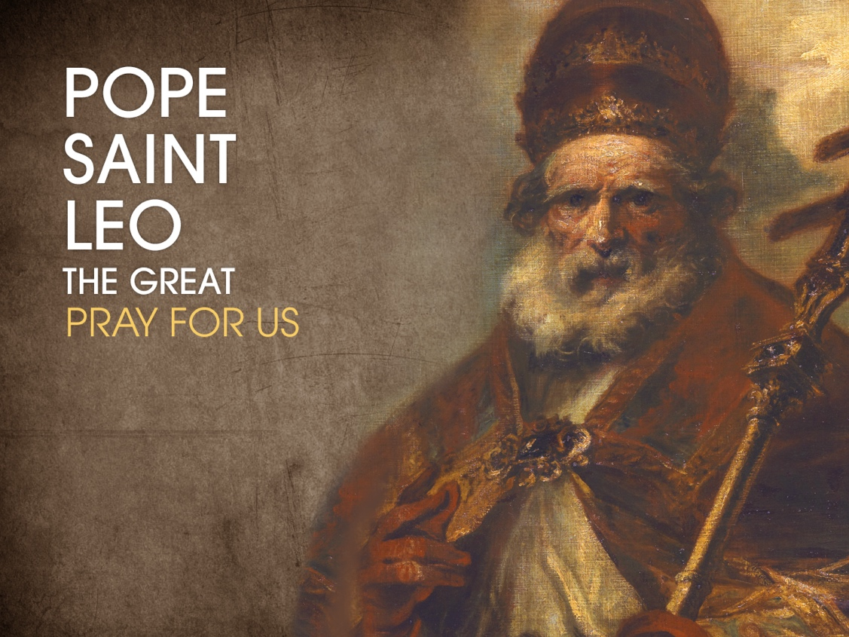

Presentation of the Blessed Virgin Mary

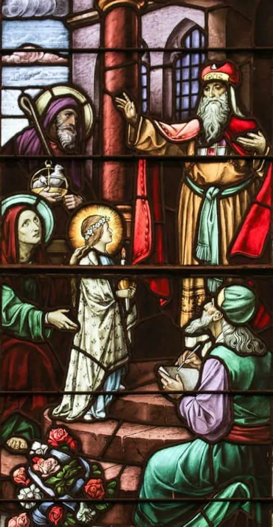
At the time of the birth of the Blessed Virgin Mary, it was not uncommon for some children to be presented in the Temple at a young age, to be raised there, and to enter into service at the Temple. They assisted the priests and acted as servants of charity. Though every firstborn boy was ritually presented to the priest in the Temple eight days after birth so as to be consecrated to God, sometimes girls were also presented, but for the purpose of entering into the Temple’s service. Saint Alphonsus Liguori, an eighteenth-century Doctor of the Church who wrote extensively on the Blessed Virgin Mary, offers this description of her presentation in the Temple, which mirrors the aforementioned apocryphal gospel accounts:

‘Having barely reached the age of three years, the holy child Mary entreated her parents that she might be placed in the temple according to the promise they had made. The appointed day having arrived, the immaculate young Virgin left Nazareth with St. Joachim and St. Anne, accompanied by a host of angels attending that holy child destined to become the mother of their Creator…Upon their arrival at the temple in Jerusalem, the holy child turned to her parents. Kneeling, she kissed their hands, asked for their blessing, and then, without looking back, ascended the steps of the temple. There, renouncing the world and all it could offer her, she wholly offered and consecrated herself to God. From then on, Mary’s life in the temple was a continuous exercise of love, offering her entire being to her Lord…As a young virgin in the temple, Mary did nothing but pray, desiring to be the servant of the blessed Virgin chosen to be the mother of God’ (Glories of Mary, On the Feast of the Presentation of Mary).
It is believed that this feast originated in the Eastern Byzantine liturgy around the sixth century at the time that Byzantine Roman Emperor Justinian I built a church in Jerusalem near the ruins of the Temple called the Basilica of Saint Mary the New. By the ninth century, several monasteries in the Latin Church began to observe this feast, and it was added to the Universal Church calendar in the fifteenth century.

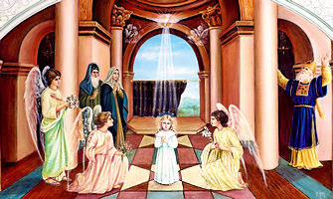
In 1953, Pope Pius XII tied this memorial of the Presentation of Mary to an annual commemoration of the World Day of Cloistered Life. He did so because of the belief that the Blessed Virgin Mary was not only presented in the Temple as a child, she then lived out her childhood in constant prayer and solitude, becoming the most excellent model for those in the cloister.

In 1974, Pope Saint Paul VI wrote a beautiful apostolic exhortation, Marialis Cultus (For the Right Ordering and Development of Devotion to the Blessed Virgin Mary), in which he speaks of the development of Marian devotion in the life of the Church. Regarding feasts like today’s, which come to us in part from apocryphal sources, he says, “There are still others [feasts] which, apart from their apocryphal content, present lofty and exemplary values and carry on venerable traditions having their origin especially in the East.”

As we celebrate the liturgical memorial of the Presentation of Mary in the Temple, we especially honour the fact that, regardless of the lack of certainty of the historical details, the Blessed Virgin Mary lived a life of profound prayer and contemplation from her earliest years and continued to do so throughout her life. She always has been, and continues to be, the Immaculate One, the sinless Spouse of the Holy Spirit, the first contemplative, and one who dedicated her whole life to the service of the will of God. Even if the account of her presentation and childhood service in the Temple is not accurately represented in these early sources, the spiritual reality of her total dedication to the will of God throughout her life is an indisputable dogma of our faith.

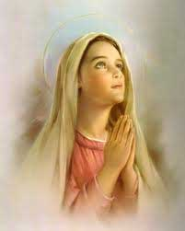
As we ponder the early life and dedication of the Blessed Virgin Mary to God’s will today, reflect upon the fact that every child is capable of a profound faith and commitment to God’s will. For those who are entrusted with the guardianship and raising of children, allow your prayerful reflection on the holy life of Blessed Mary as a child to inspire you to help all young people imitate her profound faith and holiness.
Prayer:

Most Holy and Immaculate Virgin Mary, you were conceived without sin and remained sinless throughout your life. With the perfection of every virtue and grace, you loved and served God even as a young child. Please pray for me, as I help to inspire young people in the ways of holiness, that I will never shy away from pointing them to you as a model and mediator of God’s grace. Most Holy Blessed Virgin Mary, pray for me. Jesus, I trust in You.
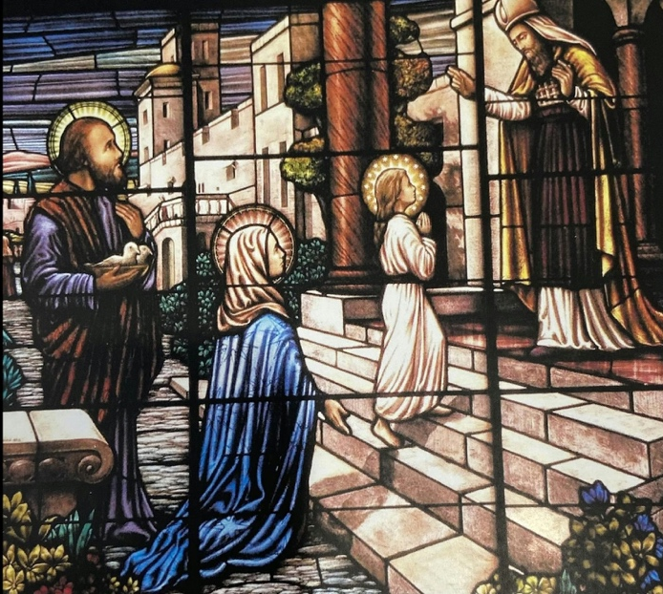

Magazine Sponsorship for November
The printing of this November edition of our Parish Magazine has been sponsored by Fr Adrian and Maria, in memory of their parents:
Brian Mason born 14 November 1924, died 2 October 1973. Joyce Mason born 10 August 1925, died 17 December 1992.

Joyce and Brian were both born in Lincolnshire, Brian in Horncastle and Joyce in Boston. They met through work at Boots. They moved to Bourne when they married and lived there for the rest of their lives. Adrian is their only child.

Bill McCarthy born 25 February 1929, married Maureen 5 June 1954 and died 20 November 2022. Maureen McCarthy born 17 October 1932, married Bill 5 June 1954 and died 23 December 2016.
Bill and Maureen came over from Ireland, Co Tipperary, to find work and married very soon after in Willesden Green, London. Maria is one of five children born in London but now, along with her siblings, live is various places across the country. Maureen and Bill had a very happy retirement in Leverington, near Wisbech.

This sponsorship enables us to offer our monthly magazine free of charge. Thank you!

Moving forward as a way of covering some of the ongoing costs of the
the church and wider ministry I would like to trial the introduction of
sponsorship.


The easiest example of what I am thinking is the sponsorship of the
printing costs of our new magazine. Another example is covering the cost
of the sanctuary light which is always alight (except following the
Good Friday Liturgy until it is lit again to celebrate the risen Lord at the Easter Vigil) and the candles in the Lady Chapel and St Monica’s Chapel.
Sponsorship would be on a weekly or monthly basis, although monthly sponsorship would make administering the process an easier task, and could be in memory of a loved one who has died or something else such as a birthday that is close to your heart. Sponsors and their special intention will be published in this magazine each month.

Sponsorship money should be paid at the beginning of the month
preferably by bank transfer using the reference box to indicate that it is
sponsorship money or you could give your sponsorship money in cash
to our treasurer, Tracy Poole.

If you would like to participate in this new venture, please email Maria
the month, what you are sponsoring and your intention to:

mrs.maria.mason@gmail.com

It is of course possible to have more than one sponsor for any category in
any month and all sponsors with their intention will be published.

Item | Duration | Suggested Donation
Parish Magazine | Monthly | £50
Sanctury Lamp | Monthly | £15
St Monica’s Chapel Lamp | Weekly | £10
Sunday Service Heating | Weekly | £50
Weekly Notice Sheet | Weekly | £2.50



Could you sponsor the magazine, or any of the above items, for a month moving forward?

It would be helpful moving forward into 2026 to have the year’s sponsorships laid down. Payment wouldn’t be asked for until the beginning of the month sponsored. Please email Maria to let her know which month you would like to sponsor and she will then be in contact with you nearer the time to ask you why you are sponsoring that particular month’s magazine or sanctuary lamp etc . . . . . .

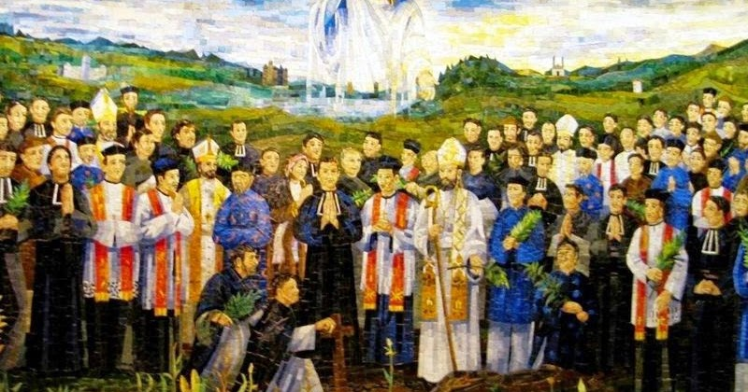
St Andrew Dung-Lac and Companions
There are 117 martyrs in this group and although they died at different times, they were all canonized by Pope John Paul II on June 19, 1988. Of the group, 96 were Vietnamese, 11 were Spaniards, and 10 were French. There were 8 bishops, 50 priests and 59 lay Catholics in the group. Of the priests, 11 were Dominicans, 10 belonged to the Paris Mission Society, and the rest were diocesan priests plus one seminarian. Certain individual martyrs were mentioned by name in the process of canonization: Andrew Dung-Lac, a diocesan priest; Thomas Tran-Van-Thien, a seminarian; Emmanuel Le-Van-Pung, father of a family; the Dominican bishops Jerome Hermosilla and Valentine Berrio-Ochoa; and John Theophane Venard.
—Excerpted from Saints of the Roman Calendar by Enzo Lodi
St. Andrew Dung-Lac's name was originally Dung An Trân, and he was born about 1795 in a poor and pagan family in Bac-Ninh in North Vietnam. When he was twelve the family had to move to Hà-Nôi (Hanoi) where his parents could find work. There he met a catechist and got food and shelter from him. He also got education in the Christian faith for three years, and was baptized in Vinh-Tri with the Christian name Andrew (Andrew Dung). After learning Chinese and Latin he became a catechist, and thereafter taught catechism in the country. He was chosen to study theology, and on March 15, 1823 he was ordained a priest. As parish priest in Ke-Dâm he was tireless in his preaching. He often fasted and lived a simple and moral life, he was a good example for the people, and many were baptized. In 1835 he was imprisoned under emperor Minh-Mang's persecutions (he was called Vietnam's emperor Nero), but his freedom was purchased by donations from members of the congregation he served. To avoid persecutions he changed his name to Lac (Andrew Lac) and moved to another prefecture to continue his work. But on November 10, 1839 he was again arrested, this time with Peter Thi, another Vietnamese priest whom he was visiting so that he might go to confession.
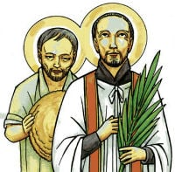
Once again Andrew was liberated, along with Peter Thi, in exchange for money. Their freedom was brief. They were soon re-arrested and taken to Hanoi, where both suffered dreadful torture. Finally they both were beheaded December 21, 1839.

Your Favourite Hymn

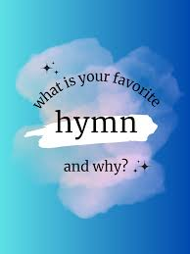
Would you like to share with us details of your favourite Hymn? We will be introducing a new feature each month encouraging you all to share your favourite hymn and why it is so special to you. We will feature one each month beginning in the January 2026 magazine.

An example will be featured in the December edition.

Please email details of your favourite hymn to the usual email address:
mrs.maria.mason@gmail.com .

If you would rather just talk about your favourite hymn with Maria, she will do her best to do it justice when writing it up. If this is your preferred way of sharing details about your favourite hymn, please arrange a time to sit down with Maria. A quick conversation after Mass on a Sunday won’t work.
You can contact Maria on 07463 303112.

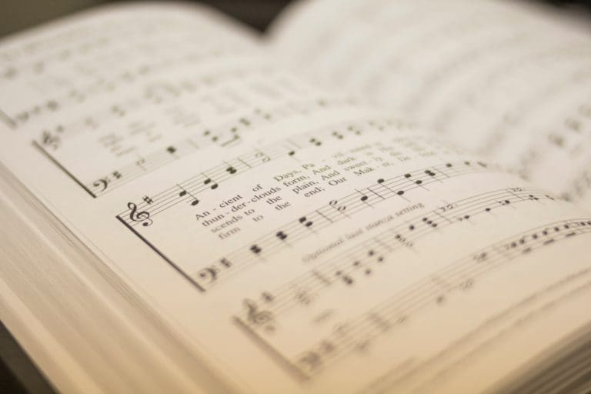


Rock Food Bank, Grimsby

Rock Food Bank was actually founded by the Rock Foundation UK back in 2014, after identifying an increase in demand for food provision. Back then the Food Bank was based at the Old Wellington Steet premises. Over a period of time and experience in facilitating this service, they became more aware that there was a need to expand the facility in order to address some of the underlying causes of food poverty in Grimsby.

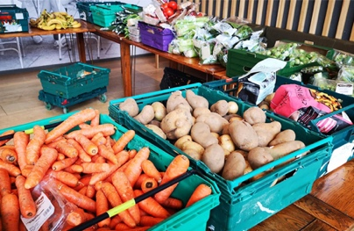
In June 2023 the Rock Foundation Uk handed the baton over to the charity Rock Community Hub, who now own and facilitate the food bank and associated services. They provide nutritionally balanced food parcels which include fresh food and vegetables, tinned goods, bread and dairy as well as frozen foods. These items are donated by local supermarkets as well as local businesses and generous individuals.

At St Augustine’s we have a box positioned at the church entrance as a collection point for the Food Bank. In the past we have been very generous, however a little reminder is obviously needed. The box has remained empty for some weeks. Over 280 people are needing to access the Food Bank each week, with access limited to two or three visits, this indicates that the real need is much higher than this.

If we could fill our box with a range of tins, packets, baby products and toiletry goods (food must be in date) it would again demonstrate St Augustine’s commitment support those less fortunate than ourselves. Bill and Pauline Murdoch have been dedicated to taking our donations to the distribution point in Garibaldi Street, Grimsby for sorting and packaging.

One item per person, per week would make a huge difference.
A Gentle Prod from Bill Murdock

“The Burning Bush”

In August MAGAZINE was a plea for help around handling 'Vocation' among our Sisters. The Context being our Denomination having ladies ordained since the first one by our Bishop in Hong Kong, 1938; plus the present with SIX lady bishops across the African Continent.

No comments received so far.

This is a “P.S.” …. a postscript in our new situation regarding the announcement that The Rt Revd and Rt Hon Dame Sarah Mulally DBE is to be the 106th Archbishop of Canterbury.

As we are Anglicans too, how should we go “FORWARD”?

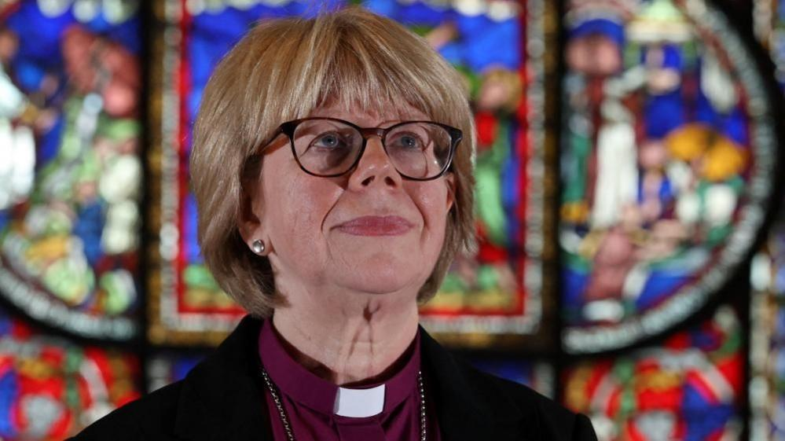
I wonder if this can provoke a correspondence column??

I don't believe our Editor would mind . . . . . . .
mrs.maria.mason@gmail.com
Feast of Christ the King

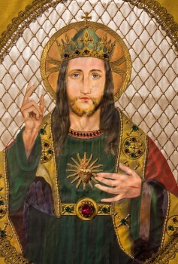
On the last Sunday of each liturgical year, the Church celebrates the Solemnity of Our Lord Jesus Christ, King of the Universe, or Christ the King.

Pope Pius XI instituted this feast in 1925 with his encyclical Quas primas (“In the first”) to respond to growing secularism and atheism. He recognized that attempting to “thrust Jesus Christ and his holy law” out of public life would result in continuing discord among people and nations. This solemnity reminds us that while governments come and go, Christ reigns as King forever.

During the early twentieth century, in Mexico, Russia, and some parts of Europe, militantly secularistic regimes threatened not just the Catholic Church and its faithful but civilization itself. Pope Pius XI’s encyclical gave Catholics hope and—while governments around them crumbled—the assurance that Christ the King shall reign forever. Jesus Christ “is very truth, and it is from him that truth must be obediently received by all mankind” (Quas primas, 7).

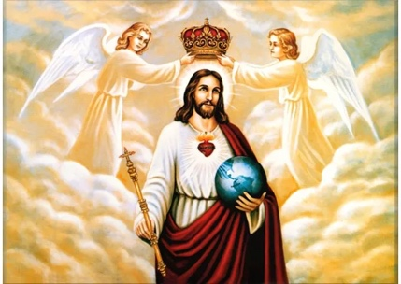
Christ’s kingship is rooted in the Church’s teaching on the Incarnation. Jesus is fully God and fully man. He is both the divine Lord and the man who suffered and died on the Cross. One person of the Trinity unites himself to human nature and reigns over all creation as the In carnate Son of God. “From this it follows not only that Christ is to be adored by angels and men, but that to him as man angels and men are subject and must recognize his empire; by reason of the hypostatic union Christ has power over all creatures” (Quas primas, 13).

The Church calls us to acknowledge Christ’s kingship with our whole lives:
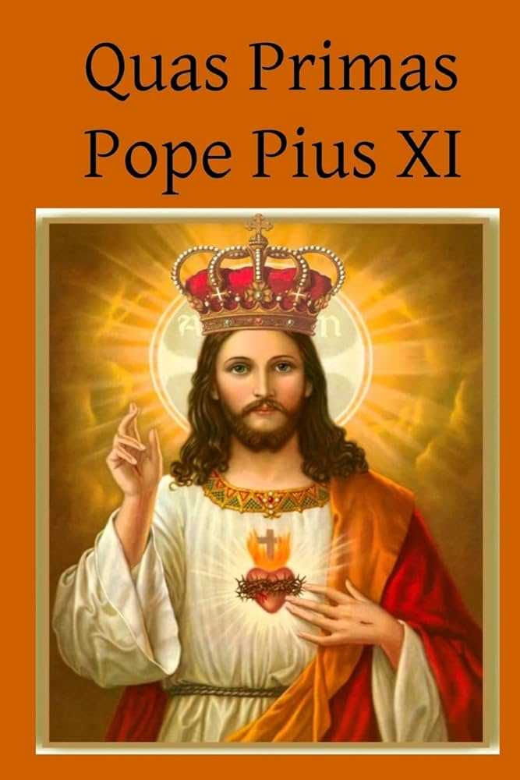
He must reign in our minds, which should assent with perfect submission and firm belief to revealed truths and to the doctrines of Christ. He must reign in our wills, which should obey the laws and precepts of God. He must reign in our hearts, which should spurn natural desires and love God above all things, and cleave to him alone. He must reign in our bodies and in our members, which should serve as instruments for the interior sanctification of our souls, or to use the words of the Apostle Paul, ‘as instruments of justice unto God.’ -Quas primas, 33
Today, religious freedom for many people means that we can believe whatever we want in private, but when we enter the public square or the marketplace, we may not speak of anything that relates to our faith. However, the Church acknowledges the reign of Christ, not only privately, but publicly. This solemnity encourages us the celebrate and live out our faith in public. “Thus by sermons preached at meetings and in churches, by public adoration of the Blessed Sacrament exposed and by solemn processions, men unite in paying homage to Christ, whom God has given them for their King” (Quas primas, 26).

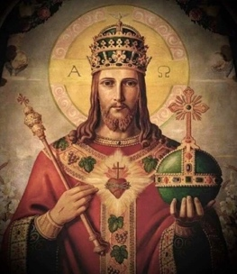
For Christians, when our faith is repeatedly marginalized in public life, we can fall into the habit of compartmentalizing our lives. We love Jesus in our private lives, but we shrink from acknowledging the kingship of Christ in social life. When we celebrate the Solemnity of Christ the King, we declare to the world and remind ourselves that Jesus is the Lord of the Church and of the entire universe.
What is Advent?

The season of Advent is a time of expectation, when we prepare our home and our hearts to celebrate the birth of Jesus on Christmas Day. The word Advent is derived from the Latin word adventus, which means “coming”.

Advent is a season of hope, a time to nurture peace and experience joy in anticipation for the love that is made incarnate with the birth of Jesus.

Keep this purpose ever in mind as you make your plans to prepare for Christmas. Everything will make sense or become senseless in relation to this purpose. If baking cookies helps you achieve this purpose, bake away. Sitting quietly on a park bench, taking long walks in quiet places, visiting your church each day, reading, singing, serving others...whatever it is that helps you achieve the purpose of Advent, give yourself to those activities.

Wake up each day with this purpose in your heart and on your mind. Purpose has a way of transforming the way we live our lives. Allow the purpose of Advent to transform you.

This year, Advent begins on Sunday, November 30, 2025. The first day of Advent marks the beginning of the Catholic Church’s liturgical calendar year.

Advent Traditions
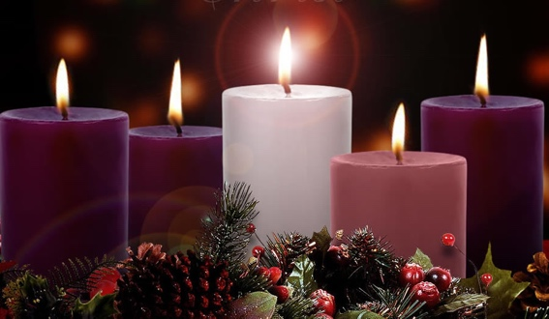
God created you to flourish. Are you flourishing this year? As you look to Christmas are you confident that what you have planned is going to help you and those you love to flourish? If not, it is time to adjust the plan. It is time for some fun, healthy, serious, light-hearted, profound, and bold routines, rituals, and traditions. Routines, rituals, and traditions play a powerful role in human flourishing. They can be as silly as Christmas pyjamas and profound as Sunday Mass.
The season of Advent is a wonderful time to establish or reestablish some routines, rituals, and traditions. A few examples of Advent traditions many Catholics implement are Advent calendars or wreaths.

There are amazing Advent traditions all around the world—maybe you’ll be inspired to bring them into your family’s celebrations, too! Here are just a few examples:

In Germany and Austria, Catholics celebrate St. Barbara’s feast day in a special way. On December 4th a small cherry branch is cut and put into a vase in a warm room. The branch typically blooms right around Christmas—and if the blossoms arrive on December 25, it’s considered good luck! This tradition aligns perfectly with Advent, the season of anticipation for the birth of Jesus. It serves as a symbolic reminder of the hopeful expectation and joyous blooming that accompanies his arrival.

A common tradition in Mexico and some other Latin American countries is the celebration of Las Posadas, which means “The Inns.” This is a nine-day event where the community forms a parade procession to symbolize Mary and Joseph’s search for an inn in Bethlehem. The parade is made mostly of children dressed up as different characters like an angel. Each night, participants dressed up as Mary and Joseph travel through the neighbourhood or town and ask for lodging. They are denied, but the host provides refreshments! Christmas carols are sung. On the final night Mary and Joseph are welcomed and a feast is held. Children break open pinatas filled with candy and small toys.

In the Philippines, a unique tradition called Simbang Gabi is observed during Advent. It is a series of nine early morning Masses held from December 16th to 24th, often starting at 4am! These Masses serve as a preparation for Christmas and are often followed by festive meals and gatherings.

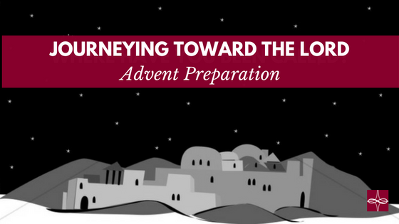
If you want to have a powerful Advent experience, followed by an amazing Christmas, begin by deciding what matters most, and then honour, celebrate, prioritise, and bask in those few things.
November Awareness Days

November blends charity and community with Movember, Black Friday and Small Business Saturday. Flyers, loyalty cards and event banners help businesses and organisations connect their audiences while promoting values that matter. Keep a look out for these in the coming weeks.

1st November: World Vegan Day
2nd to 6th November: Trustees Week
5th November: World Tsunami Awareness Day and Bonfire Night
8th November: Remembrance Sunday and Diwali
9th November: World Adoption Day
11th November: Armistice Day
13th November: World Kindness Day
14th November: World Diabetes Day
15th November: National Philanthropy Day
16th November: International Day for Tolerance
20th November: World Children’s Day and Transgender Day of
Remembrance
25th November: International Day for the Elimination of Violence Against Women
27th November: Black Friday
28th November: Small Business Saturday
30th November: Cyber Monday

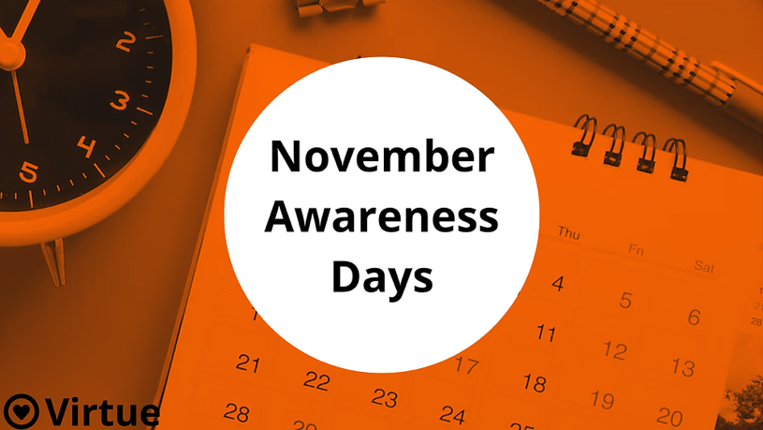


Have you thought about becoming a Friend of St Augustine’s Church?
Membership per annum is single £15 Joint £25. When you see and hear the wealth of musical talent that rings out in our building during a musical season it is quite mind blowing.

The ‘Friends of St. Augustine’ was established to promote concerts to raise funds to assist with the maintenance of the church. Regular concerts and recitals are held in the church. The building itself possesses an outstanding acoustic and is regularly used for rehearsals and recordings. A variety of musical events feature every year featuring artists from near and far. Coming up . . . . . . .

Fri 14 Nov 7.30pm Dolce Brass
Fri 28 Nov 7.30pm Christmas Tree Festival Opening Concert
Music for Advent
Fri 19 Dec 7.30pm Adele Dixon and Barry Whitfield
Christmas Tree Finale Concert with Octangle ` (octet from Louth Male Voice Choir)
Ticket prices . . . . . . .

Adults: £12 Friends: £10 Students: £5 Under 12: Free

Evening concerts are café style. A complimentary glass of wine or fruit juice is available with each ticket. You can bring your own drinks and nibbles for further refreshment. Further details email:

staugustinesfriends@gmail.com or phone 07398 567677


Christmas Parish Lunch

Sunday 14 December at 12.30pm

Cheryl has kindly offered to arrange a Parish Christmas Lunch at the Pear Tree in Cleethorpes. The date she is suggesting is Sunday 14 December meeting at the Pear Tree at 12.30pm.

A list is available at the back of church. Please sign up and join in if you are able to make this parish event a success.

Details of prices and menus can be found at:

www.peartreepub.co.uk/menus

The Life and Times of Thomas Augustus, The Vicarage Cat
I have been a well behaved cat during October, well reasonably. I did hear my Mum saying that she really needed to get on with the November magazine or it wouldn’t be done for them to be able to go away on their holiday. As you may already know, I don’t like it when they go away, and I heard that they were going away for three weeks. Three weeks!! I don’t understand it, why would they want to be away from me and my little girlfriend Kitty for three weeks.
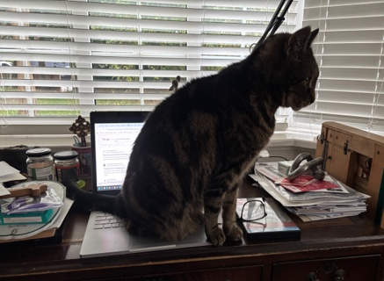
Well, I saw an opportunity to scupper their plans, and I took it. If access to the laptop was denied, then the job would never be completed in time. I sat on the computer for quite some time only to discover that my Mum was working away on her laptop upstairs. She even had the cheek to take a photo of me sitting on the wrong laptop. How embarrassing!!
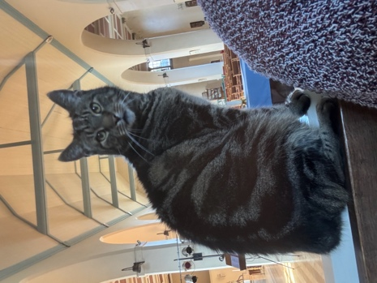
I redeemed myself a little by making sure that I was ready to accompany my Dad into church each day when he went in to say his prayers. I confess to enjoying this quiet time sometimes just sitting by his shoulder and listening to the prayers he is saying.
I do like to go for a wander as well but if I do I have to be very careful that I don’t get myself locked in. This has happened more than once I can tell you!
It would seem that the November magazine has been completed in time so I hope my Mum and Dad have a great holiday and I look forward to my good friend Adele looking after me and Kitty until my Mum and Dad return.
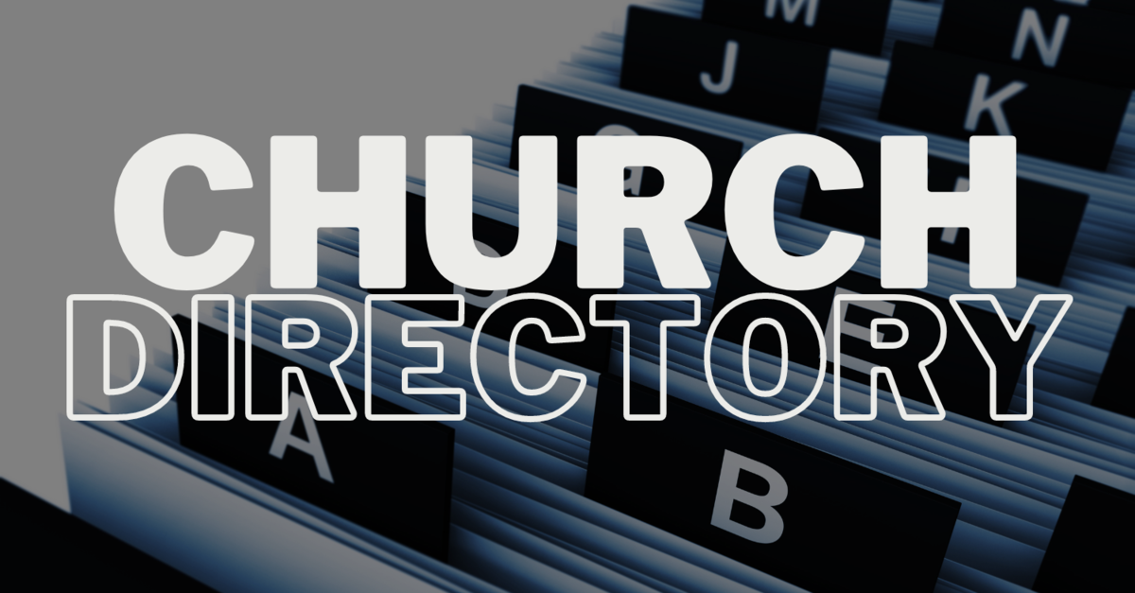
Priest-in-Charge | Fr Adrian Mason | fr.adrian.mason@gmail.com 07824 467333
Church Wardens | Adele Dixon Janet Nixon | adele.dixon90@gmail.com  janet.nixon59@gmail.com
Lay Chair of PCC | Adele Dixon | adele.dixon90@gmail.com
PCC Secretary | Barry Whitfield | barrywwhitfield@gmail.com
PCC Treasurer | Tracy Poole
Safeguarding Officer | Adele Dixon | staugustineofhippo safeguarding@gmail.com
Electoral Roll Officer | Cheryl James | cheryljames1@live.co.uk
Director of Music | Barry Whitfield | barrywwhitfield@gmail.com
Magazine Editor | Maria Mason | mrs.maria.mason@gmail.com


Items for inclusion in the December edition of this magazine should be sent to the editor via email by Sunday 23 November. version. There is no guarantee of inclusion after this date.

(mrs.maria.mason@gmail.com).

Could you write an article for our Parish Magazine? The editor would be pleased to receive articles of a religious nature or otherwise that would be of interest to our readers.
Again, the email address to send articles to is: mrs.maria.mason@gmail.com

Cheryl’s Name Cards
As many of you are aware, Cheryl always has some name cards on the go. There are always great prizes with boxes costing 20p - £1.
To quote Cheryl,
“you have to be in it to win it!”
Prizes are given out as soon as the name card is complete.

Email:
fr.adrian.mason@gmail.com

Web:
St-augustine-church-grimsby.org
https://www.achurchnearyou.com/church/14993/

Safeguarding matters please contact:
staugustineofhipposafeguarding@gmail.com



Edition 9

