CHURCH CALENDAR AND SERVICES

NOVEMBER

2nd Trinity XX Holy Communion
9th REMEMBRANCE SUNDAY Service of Remembrance
16th Trinity XXII Holy Communion
23rd Sunday Next Before Advent Matins
30th Advent Sunday Benefice Service, Milton-on- Stour 10.30

DECEMBER

7th Advent II Holy Communion
14th Advent III Matins
21st CAROL SERVICE
24th CHRISTMAS EVE 6.00 P.M. Holy Communion
25th CHRISTMAS DAY Holy Communion
28th Christmas I Matins

JANUARY

4th Christmas II Holy Communion
11th Epiphany I Matins

All services are from the Book of Common Prayer and are at 10.30 a.m. unless otherwise stated.

All services will be publicised on the website and may be subject to alteration.

Next PCC Meeting: Monday 26th January at 2.30p.m. in the Village Hall

Date for the diary - 29th January 2026 -7.30pm at St. Mary’s, Gillingham - the new Rector, Becca McDonnell, is to be licensed.
RIDE AND STRIDE
A very big thank you to all who sponsored Peter and/or Diana, Mike and Michela; their efforts raised a total of £1,830 for the Dorset Historic Churches Trust, half of which comes back to our PCC - and much gratitude goes to the DHCT for their help with finance on our recent repairs to the church’s (internal) roof timbers.

PCC CHARITY GIVING
The weekend the clocks changed was the last weekend the Stall was out this season. Much gratitude to all those who have kept it going especially with cooking, baking, flowers, plants, etc.
Together with the Stall money and the takings from the summer Coffee Morning money has been steadily given away. Recently donations have been made of £200 to the Air Ambulance, £200 to Alabare, £200 to the Hope for Tomorrow Chemo Van and £100 to the Gillingham Silver Band to help with their rent of practicing facilities. For ‘World Homeless Day’ Alabare asked if a special fund-raising event could be done for them, so it was decided to donate all the previous weekend’s Stall takings to them and, rounding it up, we were able to send them £150.
Please support the Christmas Coffee Morning on 15th November. After that Christmas donations will be made – and it is hoped to make lots more money next year!

CHRISTMAS COFFEE MORNING
AT SILTON VILLAGE HALL
SATURDAY 15TH NOVEMBER
10.00 am – 12.00 noon
COFFEE AND MINCE PIES
Baking, Books, Bric a Brac, Plants, Preserves, and Christmas items

SILTON PARISH MEETING
The next Silton Parish Meeting is being held in Silton Village Hall at 6pm on Tuesday 4th November.
SOCIETY OF FRIENDS OF SILTON
Quiz Night: Friday 15th November - Doors open at 6.0pm for 6.30pm start.
For all SOFOS enquiries contact: Jackie Dyer on 01747 840087 or email friendsofsilton@gmail.com
SILTON VILLAGE HALL
Castle Hill Quilters: Every Thursday 1.30pm - 4.30pm
Creative Stitch: Every 3rd Monday in the month 10am - 4pm
Hannah Monksummers Wellness & Healing Classes: Friday evenings Contact: 07824510186 or hannah@whitefeatherhealing.net
Friday Markets: 10am - 12.00 in the Village Hall. Note: Nikki and the team will be taking a well deserved break in January, the last Friday market will be on Friday 19th December, they will be back and look forward to seeing you all on Friday 6th February.
Evergreen: Education and Therapy - Tuesday and Wednesday during term times
Sunday 7th December: Silton Village and Friends Christmas Drinks Party 6pm - 8pm
Come and join us for a glass of Mulled Wine, savoury nibbles and mince pies to start the Festive Spirit. £5 a ticket payable on the evening.
Please let Sue know by 1st December if you would like to come: Sue@siltonmanor.co.uk Tel: 07970 865790
Saturday 13th December: Silton Yuletide Gift Fayre: 10am - 4pm - Come for a coffee or a glass of Mulled Wine. Seasonal food, Stocking Fillers, local Crafts, Christmas Wreaths and Flowers will all be on sale.
The Village Hall Calendar: This can be viewed online - you can also now make an enquiry though the website www.siltonvillage.co.uk.

CHURCH AND PARISH OF
ST. NICHOLAS, SILTON, SP8 5PR
www.siltonchurch.org

NOVEMBER - DECEMBER 2025
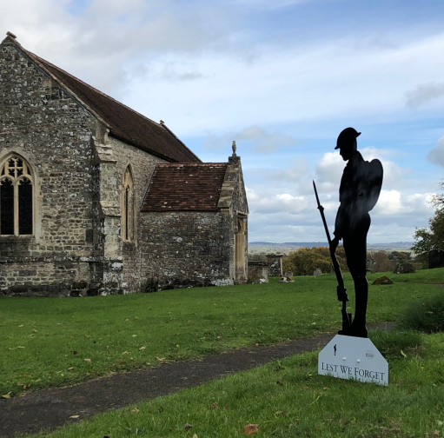
Church Wardens:
Anne Bridge (01963 31983) bridgetoofar42@gmail.com
Peter Williams (01747 840275) peterwilliams53@gmail.com

Society of Friends of Silton:

Chairman: Charles Peel: (01747 840303)
Secretary: Jackie Dyer (01747 840087) jack27.dyer@gmail.com

Parish Meeting:

Chairman: Diana Masters (01747 840288) mastersbagmore@btinternet.com
Acting Parish Clerk: Chris Woodhouse (01747 841243) cardsfarmhouse@btinternet.com

Village Hall:

Chairman: Keith Harris (07966166905) keith@siltonmanor.co.uk
Secretary: Sue Harris (07970865790) sue@siltonmanor.co.uk

Silton Village Website: www.siltonvillage.co.uk

Parish Office:

Miriam Light 01747 821598 gillinghamanglican@gmail.com

