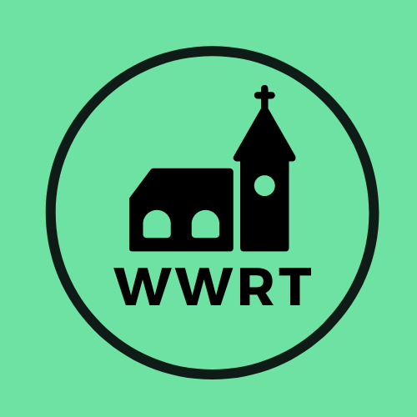
CHURCH SERVICES IN MARTLEY AND WICHENFORD
NOVEMBER 2025

Sunday 2nd November
4th Sunday before Advent
10.30am Worship for All, St Mary Magdalene, Broadwas
10.30am CW Holy Communion, St Peter, Martley
3.00pm All Souls Memorial, Martley

Sunday 9th November
3rd Sunday before Advent/Remembrance Sunday
10.45am Remembrance Service, St Peter, Martley
10.45am Remembrance Service, St Laurence, Wichenford

Sunday 16th November
2nd Sunday before Advent
10.00am Café Church, St Peter, Martley

Sunday 23rd November
1st Sunday before Advent/Christ the King
10.30am CW Holy Communion, St Peter, Martley

Sunday 30th November
Advent Sunday
10.30am Benefice Advent Service, (tbc)

In November there will be Holy Communion at Heaton House, Martley on Wednesday the 12th and 26that 10.15am and on the 1st and 3rd Wednesday via our YouTube channel -wwrtlive1.
All services and timings are subject to review and amendment – please check the website for updates: www.achurchnearyou.com

