THE UPDATE #286 (12 October 2025) for the Forest of Galtres Benefice.
The Seventeenth Sunday after Trinity 2025
Welcome to this week’s update. The video reflections from the diocese are on hold for the time being. There is an alternative challenging and inspiring video from Beverly Minster on the appointment of the new Archbishop of Canterbury. There is a written reflection from Canon Robert Law. We continue to pray for the Holy Land as well as Ukraine, prayers below. The monthly What’s On for Benefice Services in September is attached as a separate page.
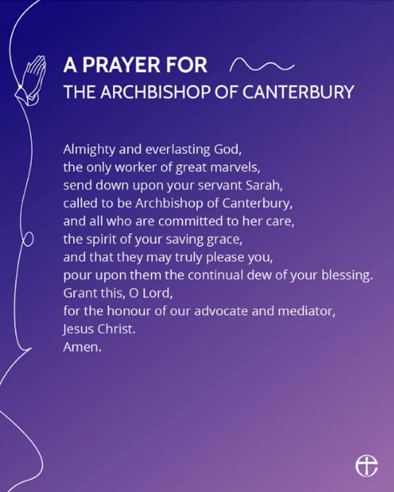
From me: We have been praying for the Holy Land for over two years now and it seems that we have at lone last a move towards peace, if anything it doesn’t mean we stop praying it means we pray harder for and end to that war and for lasting peace!

New Archbishop of Canterbury
Last week's update came out before the announcement of the new Archbishop of Canterbury. If you would like to click on this link Archbishop of Canterbury-designate, Sarah Mullally | The Church of England You will be able to read more about our new Archbishop Designate. The prayer opposite is for us to hold the Rt Revd and Rt Hon Dame Sarah Mullally in our prayers.
Blessings
Steve

A video sermon from Beverley Minster, mid-week communion centering on Thomas Becket, martyr, and linking to the appointment of the new Archbishop of Canterbury. Ctrl & click here à https://www.youtube.com/watch?v=OhxR1ld-3IU

Coming to church this week 8.00am BCP Holy Communion at Sutton
12 October 10.00am Harvest Festival at Sheriff
10.00am Morning Worship at Stillington
10.30am Shortened Matins at Farlington
11.00am Harvest Festival at Sutton (in church)

Coming to church this week 10.00am Holy Communion at Stillington
19 October 10.00am Morning Worship at Sutton
6.00pm Celtic Worship at Marton
Reflection for 12th October – Luke 17:11 - 19
Now on his way to Jerusalem, Jesus travelled along the border between Samaria and Galilee. As he was going into a village, ten men who had leprosy met him. They stood at a distance and called out in a loud voice, “Jesus, Master, have pity on us!”
When he saw them, he said, “Go, show yourselves to the priests.” And as they went, they were cleansed.
One of them, when he saw he was healed, came back, praising God in a loud voice. He threw himself at Jesus’ feet and thanked him—and he was a Samaritan.
Jesus asked, “Were not all ten cleansed? Where are the other nine? Has no one returned to give praise to God except this foreigner?” Then he said to him, “Rise and go; your faith has made you well.”
Reflection
The story is told of a princess who lost her precious golden ball in a pond. A frog found it and brought it to the surface. And because this is a fairy story, the frog could talk. He would return the ball, he said, if the princess would take him in. She had to let him live with her, eat her food, sleep in her bed, be with her constantly. The princess really wanted her ball, so she agreed. But she soon came to regret it. The frog was pretty disgusting, and always there. At meals he put her off her food as he ate from her plate. She could not sleep at night because he was there on her bed. She wished she had never seen a golden ball.

But time passed and the princess began to realise that the frog was quite interesting. He talked to her, and she talked back. He made her laugh. They sang and croaked together. They became less alien to each other. She liked him, even perhaps loved him.

Well, this being a fairy story, of course eventually the princess kissed the frog, and he turned back into the prince he had been before the curse of a witch. The connection made across a seemingly impassable divide had broken the spell. Fear and disgust had turned to love.

A man finds himself in a group of Jewish people with leprosy. His disease means that he can’t live in his own community for fear of infecting them. No one will come close to him except fellow sufferers. But even they keep clear of him, because he is not only a leper, he is also a Samaritan. He belongs to a racial group regarded by Jews with the deepest suspicion. They are the product of a mixture of races brought about when Assyria conquered part of Israel many centuries before. They worship the God of Israel, but not properly, or so the Jews claim. So the Samaritan leper lives as an alien with people who despise him.

Does he want to go with this group to seek help from a Jewish rabbi? It is said that this Jesus has miraculous healing powers and can even cure leprosy. But if he’s as clever as they say he is, won’t he know that this sufferer is a Samaritan and refuse to heal him? The disappointment would be worse than not asking at all.
He has heard a story, though, an old story told by his own people, of an army commander called Naaman. He was cured of leprosy by following the instructions of a prophet, even though the process was humiliating. Perhaps this prophet Jesus will give similar instructions. Perhaps it’s worth the risk.

In the event, nothing so dramatic happens. Jesus sends the lepers on their way. It is only when they turn to go that they look at their skin and find it whole again. They rush off to begin the process of reintegrating into society – all except the Samaritan. He has no need of a Jewish priest. He knows where to find God – in the young rabbi who only has to say a word for a miracle to happen. “Your faith has made you well,” says Jesus; his Samaritan faith, his willingness to take a risk, his humble expression of his need. It is not only his body that is now whole. The Jewish rabbi has accepted him into faith in the one God of Jews and Samaritans alike. He is no longer alien and disgusting; he is whole, and he is loved.

Life-saving faith can be found in unexpected places and it is there at the heart of each one of us, if we allow it some room. Frogs can turn into princes in our imagination, and Samaritans can be healed, and we can move mountains. Life can seem such an effort, but the Christian message says faith and love lie at the heart of the universe and have been implanted in our hearts too. And the healing of all the world’s ills is there waiting for us, for the time when God says to us, “Your faith has made you well.”

I saw this with a nurse whose leg was infected. She asked early one morning before receiving Holy Communion in hospital, “Can I have the same relationship with Jesus described in the New Testament I found in my hospital locker?”
I assured her that she could, but I was curious as to why. She answered, “I couldn’t sleep last night so I read it from cover to cover.” I expressed my admiration, and she replied, “I’ve asked him to heal my infection, and I’m going to refuse any sedation when they come to dress my wound. And you mustn’t breath a word of this to anyone.”
Cut a long story short, her leg had begun to heal, she had stopped drinking sherry. The final “healing” was a white wedding bible which we blessed, and she gave to her husband. Her family were healed too.

A Prayer for the Holy Land:

O God of all justice and peace
we cry out to you in the midst of the pain and trauma
of violence and fear which prevails in the Holy Land.
Be with those who need you in these days of suffering;
we pray for people of all faiths – Jews, Muslims and Christians and for all people of the land.
While we pray to you, O Lord, for an end to violence and the establishment of peace,
we also call for you to bring justice and equity to the peoples.
Guide us into your kingdom
where all people are treated with dignity and honour as your children
for, to all of us, you are our Heavenly Father.
In Jesus’ name we pray. Amen.

A Prayer for Ukraine:
God of all peoples and nations,
Who created all things alive and breathing,
United and whole,
Show us the way of peace that is your overwhelming presence.
We hold before you the peoples of Ukraine and Russia,
Every child and every adult.
We long for the time
When weapons of war are beaten into ploughshares
When nations no longer lift up sword against nation.
We cry out to you for peace;
Protect those who only desire and deserve to live in security and safety
Comfort those who fear for their lives and the lives of their loved ones
Be with those who are bereaved.
Change the hearts of those set on violence and aggression
And fill leaders with the wisdom that leads to peace.
Kindle again in us a love of our neighbour,
And a passion for justice to prevail
and a renewed recognition that we all play a part in peace.
Creator of all hear our prayer
And bring us peace. Make us whole. Amen.

