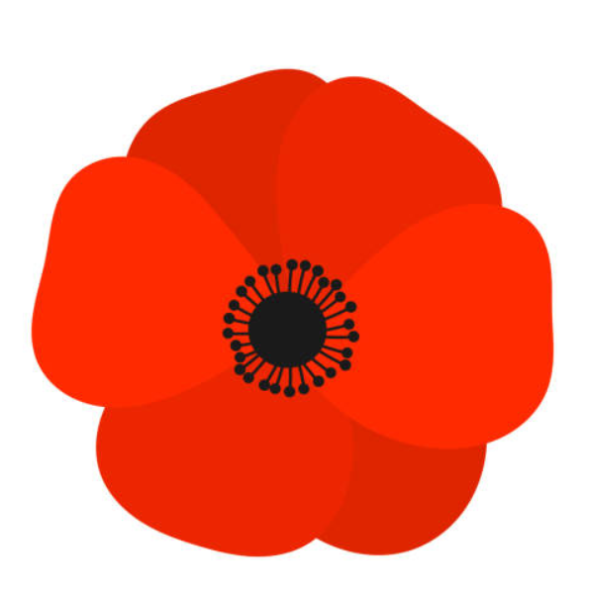
Commemorating 80 years since the end of WWII
An Open Day at Astley Church
Saturday November 8th 2025
11am-3.30pm
Poppy displays by local school children
Weeping window poppy display by the local community
Information about local soldiers from WWI and WWII
Tower Tours
Make your own poppy to wear
Information about the history of the church
Birds of Prey
Teas and Cake
Find us at: St Peter’s Church, Church Lane, Astley, DY13 0RJ
All proceeds to Astley Church

