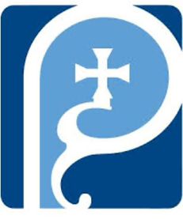
St Augustine of Hippo
Grimsby

A Forward in Faith Parish

Parish Magazine



October 2025
Our Giving

Bank details for standing orders or donations are:
TSB Bank
St Augustine of Hippo PCC
Sort Code: 30-93-72 Account Number: 00159954

You may have seen that many charity bank accounts have started
charging fees for every day transactions. It costs us money to bank cheques and cash, which devalues the amount of the donation/payment. We are therefore asking that, wherever possible, people donate money using online banking, even for small amounts. This doesn't cost us a penny. Please indicate in the reference field who it's from, and what for, then we can Gift Aid your donation wherever possible. Gift aid forms should be completed for regular giving by standing order if applicable. Thank you.


Donating by card or phone

We have a card machine positioned at the back of church near the south door as an alternative way of giving. Please bear in mind that a percentage of all giving using this method (between 1% and 2%) is taken by the provider.

Regular Sunday giving by oﬀertory collection plate


It is no longer necessary to use gift aid envelopes for cash donations of £30 or less. This again keeps administration down. However, should you wish to make a higher donation, please use gift aid envelopes as usual.
Anniversary of Deaths / Year’s Mind Parish Records for October
1 | 2000 | Byron | Smith | 64
2 | 1982 | Millicent Helen | Ensor | 88
10 | 2004 | Rev Mother Lilian CSW |  | 107
14 | 2019 | John | Poole
17 | 1980 | William Leonard | Roberts | 75
25 | 1993 | Edmund Aylmer | Coates | 78
29 | 2023 | Ian | Wright (Priest) | 58

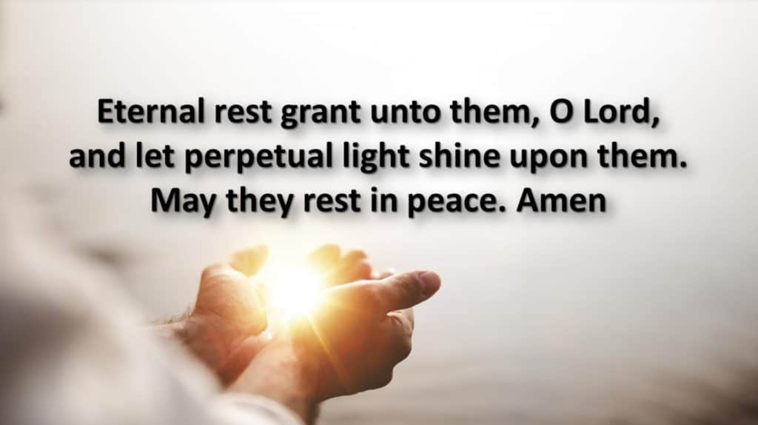
If you have any additional information to complete any gaps for those
listed, or information relating to anyone you know of who should be
included please let me know on: mrs.maria.mason@gmail.com

Thank you

Maria
Shirley Randall, who sadly passed away on 28th May 2025 just one week before her 95th birthday, was a beloved member of the parish community.

She first met her husband, Peter Randall, at the church and they were married there in 1952 making the church a special place throughout her life. Shirley regularly attended services and was actively involved in parish life as a member of the PCC and the Women’s Fellowship.

Shirley’s ashes were buried in our Garden of Remembrance on Saturday 27 September.

She will be fondly remembered by those who knew her.

October Worship Times

Wednesday I October 10am Said Mass followed by Coffee Morning

Twenty-seventh Sunday in Ordinary Time
Sunday 5 October 10am Sung Parish Mass
Wednesday 8 October 10am Said Mass followed by Coffee Morning

Twenty-eighth Sunday in Ordinary Time
Sunday 12 October 10am Sung Parish Mass
Wednesday 15 October 10am Said Mass followed by Coffee Morning

Twenty-nineth Sunday in Ordinary Time
Sunday 19 October 10am Sung Parish Mass
Wednesday 22 October 10am Said Mass followed by Coffee Morning

Thirtieth Sunday in Ordinary Time
Sunday 26 October 10am Sung Parish Mass
Wednesday 29 October 10am Said Mass followed by Coffee Morning

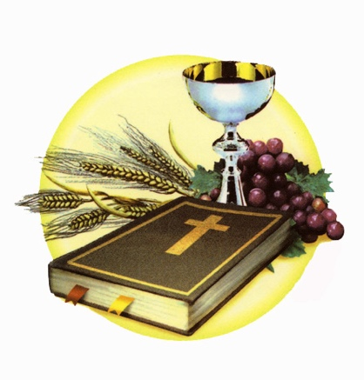

October 2025 Calendar
Dates, Observances and Prayer Intentions
Date Feast Intentions
1 St Thérèse of the Child Jesus Those with Disabilities
2 The Holy Guardian Angels The Emergency Services
3 Feria Bishop Luke
4 St Francis of Assisi Animal Charities
5 27th Sunday in Ordinary Time The Parish
6 Feria Bishop Stephen
7 Our Lady of the Rosary The Ukraine
8 Feria USPG
9 St John Henry Newman Theologians
10 Feria Church Musicians
11 Feria Church Wardens
12 28th Sunday in Ordinary Time The Parish
13 Feria Our PCC
14 Feria Our Servers
15 St Teresa of Ávila The Poor
16 Feria King Charles
17 St Ignatius of Antioch Spiritual Directors
18 St Luke The Parish
19 29th Sunday in Ordinary Time The Parish
20 Feria The Royal Family
21 Feria Diana Princess of Wales Hospital
22 Feria St Andrew’s Hospice
23 Feria General Practitioners
24 Feria Universities
25 Feria Lisle Marsden School
26 30th Sunday in Ordinary Time The Parish
27 Feria Monks
28 Sts Simon and Jude The Parish
29 Feria Nuns
30 Feria Persecuted Christians
31 Feria Parliament

October Month of Devotion to The Holy Rosary
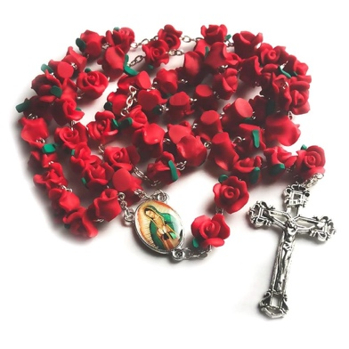
Rosary comes from the Latin word for “rose garden,” an image used for the Blessed Virgin Mary in Latin hymns. Using the rosary, we pray traditional prayers while contemplating sacred Mysteries of our faith. Each time we pray a Hail Mary as part of the rosary, we add a beautiful flower to a crown of roses for Mary.

by Fr. Hugh Thwaites, SJ
It seems to me that the principle cause of the loss of faith today, is the neglect of the practice of the family rosary.

In Austria, after World War II, there was a complete collapse of vocations. One year, apparently, no one at all entered the seminaries. So, the Bishops held a synod to find out how it could be that this had happened. The conclusion they reached was that the war had so disrupted family life that the centuries-old practice of the Rosary in the home had stopped, and had never started up again. When the rosary goes, the faith soon collapses.

I remember someone telling me of a friend of his, a great Catholic, the pillar of the parish, whose children had all lapsed, one after the other. They had all fallen away from the sacraments and from attending Mass. So I said to him, “I would not mind betting that your friend had been brought up to recite the family rosary when he was a boy, and that his children have not.” The next time I saw him, he said that this was indeed true. His friend had recited the family rosary at home when he was a boy and when he married and started his own family, they all said the rosary. But then, one evening when they were about to start the rosary, one of the children switched on the television, and that was that. The custom of the family rosary was dropped, and in due course they gave up the practice of the faith.

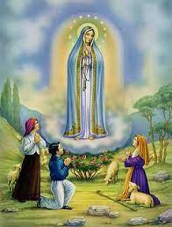
After this life, that one unrebuked action will be seen to have affected the eternity of many people. God sent His Mother to Fatima to tell us that we had to say the rosary every day. There were no other prayers She asked us to say. Accordingly, we should do what She asked.

A layman I met once who did not say his rosary told me that he read the breviary every day. That is fine. It is what priests have to do. It is the prayer of the Church. So in a way it is better than the rosary. But it is not what Our Lady asked for. She asked for the rosary. If a mother sends her child to the shop for a bottle of milk, and he comes back instead with ice cream, is she pleased? In a way, ice cream is better than milk, but it is not what she asked for.

In that most holy home at Nazareth, do you think that Our Lady had to ask for anything twice? If we want in any way to be like Jesus, we must do what His Mother asks. If we do not, can we expect things to go right? We cannot with impunity disobey the Mother of God. She knows better than we the dangers of this spiritual warfare. She sees more clearly than we do the dangers that beset us. She warns us: You must say your rosary every day.

If the garage mechanic warns you that your car needs repairing or else it will break down, surely you would heed that warning. If the gas gauge warns you that you need more gas, do you do nothing about it? And if Our Lady comes to Fatima and tells us, not just once but six times, that we must say the rosary every day, do we disregard that warning? If we do, we have only ourselves to blame when we find that our children have lapsed from the faith.

I know that Fatima is only a private revelation, but nevertheless the Church has endorsed it, and that makes it rash for us to disregard it. If the Church informs us that Our Lady really did come to Fatima and tell us these things, then we must harken to her words. It really seems to me that those Catholics who do not take Fatima seriously and say the rosary every day in their homes, are very akin to the Jews who laughed at Jeremiah. If God sends us His prophets and we do not take them seriously – well, we have the whole of the Old Testament to tell us what happens as a result. But at Fatima, God sent us, not His prophets, but His Immaculate Mother.

So I think that the abandonment of the family rosary is a main reason why so many Catholics have lost the faith. It seems to me that the Church of the future is going to consist solely of those families who have been faithful to the rosary. But there will be vast numbers of people whose families used to be Catholic.

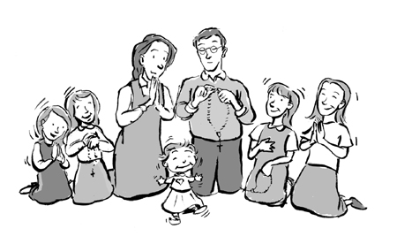
In my work of going round visiting homes I have seen this conclusion borne out time and again. Homes can be transformed by starting the recitation of the daily rosary. I remember a woman telling me that she could not thank me enough for having nagged her into starting it; it had united her family as never before. And I remember another home where I called. There was a strange tension there: the children were silent and the wife seemed withdrawn, but the husband was willing to start the family rosary. When I called back again a couple of months later, the atmosphere was quite different. The children were chatty and the wife was friendly, and the husband walked down the road with me afterwards and said how amazing it was that the home was so much happier.

One reason, I think, why the daily rosary makes for a happy home, is this. From what some possessed people have said, and from what some of the saints have said, it seems certain that demons fear the rosary. It makes their hair stand on end, so to speak. Holy water certainly drives them out, but they come back again. The daily rosary drives them out and keeps them out. It is rather like living in an old house where there are mice everywhere. The only way to get rid of them is to bring cats. If you get a couple of cats, after a week or two there simply will not be any more mice. Mice fear the very smell of cats. And in a home where the rosary is said every day, after a time the demons realize they are impotent in front of Our Lady, and go elsewhere.

This must be one reason why, as they say, “the family that prays together stays together.” In that home, utterly free of evil spirits, there is an atmosphere one does not find outside. In a demon-infested city like London, where I live, such a home is an oasis of God’s grace, and people find a comfort and peace there which they enjoy greatly. We human beings are not meant to live in the company of demons, but with God and with the angels and saints in heaven.

So, as I see it, in this effort we are making to keep the faith and pass it on, the practice of the rosary is absolutely indispensable. Whatever else a person may do, even though they go to Mass every day, they still need to say the rosary in their home. It is the medicine our Mother has told us to take, to keep our faith strong and healthy.

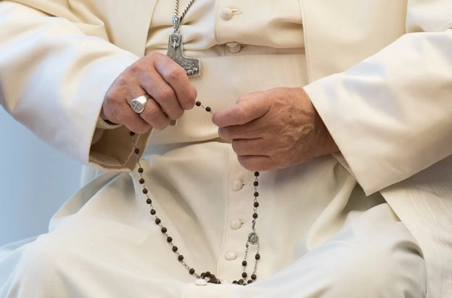
Pope Leo XIV asked Catholics to pray the rosary each day in October for peace. The Pope made his request at the end of his weekly general audience 24 September.

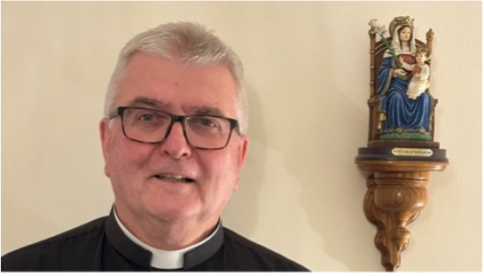

Fr Adrain Writes . . . . . .

As many of you know, one of the things I become increasingly annoyed about is the way our society becomes increasingly secular and materialistic. This is especially the case where Christian festivals have been taken over by commerce. This seems to have happened almost completely to Christmas and Easter, so much so, that the true meaning of both festivals is more or less completely obscured by frippery; a large portion of our population don’t know the true meaning of either festival. Mothering Sunday has become Mothers’ Day and any Christian meaning for the day is lost.

This month we Christians DON’T celebrate Halloween. 31 October is not, of course, a Christian Festival. All Hallows’ Eve, the day before All Hallows’, or All Saints, Day has slipped in almost under the radar. It has always been a “dodgy” occasion and it has become yet another time of year when unscrupulous entrepreneurs have seized the opportunity to make money. Where did “Trick or Treat” come from? I know the immediate answer is that it was imported from another country, but how did it come about there?

This will be our first Halloween living in Grimsby. We are curious to see how it will be kept by local people. There was an unwritten rule in a previous parish that if you didn’t display pumpkins at your house, you would be left alone by trick or treaters. We will see if that holds true here.
In some areas, the trick or treat is taken seriously by those participating. If a treat is not forthcoming, then a trick the other way is. The common minor trick is to throw eggs at the house where treats have been withheld. Much worse things are also known to happen. I believe evil is at play in this!

Why, why, why? I think it all comes down to selfishness, greed and materialism, and possibly hype.

What can we as Christians do about this? We can try to reclaim the Christian Festival and celebrate All Saints Day. We can pray for those who misunderstand the season that they may see the light of Christ. Perhaps, as a Church locally, we can offer a “Light and Bright” party in the future. We could buy a stash of prayer cards and hand them out as treats instead of the usual sweets and toys.

Oh dear! Father is beginning his annual tradition of “BAH! HUMBUG!” in preparation for Christmas.

Let’s focus on the Christian. Let’s fight against sin, the world and the devil.
Let’s pray that more will see the true meaning of Christian festivals, may see the light and turn to Christ.

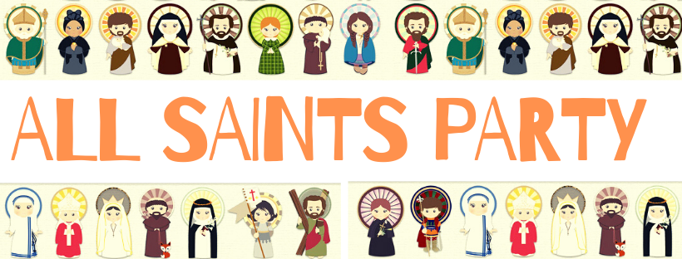

With every blessing

Fr. Adrian

The Holy Guardian Angels
Angels are servants and messengers from God. "Angel" in Greek means messenger. In unseen ways the angels help us on our earthly pilgrimage by assisting us in work and study, helping us in temptation and protecting us from physical danger.
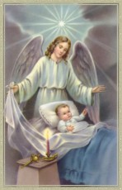
The idea that each soul has assigned to it a personal guardian angel has been long accepted by the Church and is a truth of our faith. From the Gospel of today's liturgy we read: "See that you do not despise one of these little ones, for I say to you that their angels in heaven always look upon the face of my heavenly Father" (Matthew 18:10). The Catechism of the Catholic Church states that "the existence of the spiritual, non-corporeal beings that Sacred Scripture usually calls 'angels' is a truth of faith (328)." From our birth until our death, man is surrounded by the protection and intercession of angels, particularly our guardian angel: "Beside each believer stands an angel as protector and shepherd leading him to life (336)." The Church thanks God for our helpers, the angels, particularly on this feast day and September 29 which is the feast of Saint Michael, Saint Gabriel, and Saint Raphael, archangels. This feast appeared in Spain during the sixteenth century. It was extended to the universal Church and made obligatory in 1670.
Be alert in your every action as one should be who is accompanied by angels in all your ways, for that mission has been enjoined upon them. In whatever lodging, in whatever nook or corner you may find yourself, cherish a reverence for your guardian angel. In his presence do not dare to do anything you would not do in mine. Or do you doubt his presence because you do not see him? Would it really help if you did hear him, or touch him, or smell him? Remember, there are realities whose existence has not been proven by mere sight.
Brethren, we will love God's angels with a most affectionate love; for they will be our heavenly co-heirs some day, these spirits who now are sent by the Father to be our protectors and our guides. With such bodyguards, what are we to fear? They can neither be subdued nor deceived; nor is there any possibility at all that they should go astray who are to guard us in all our ways. They are trustworthy, they are intelligent, they are strong — why, then, do we tremble? We need only to follow them, remain close to them, and we will dwell in the protection of the Most High God. So as often as you sense the approach of any grave temptation or some crushing sorrow hangs over you, invoke your protector, your leader, your helper in every situation. Call out to him and say: Lord, save us, we are perishing.
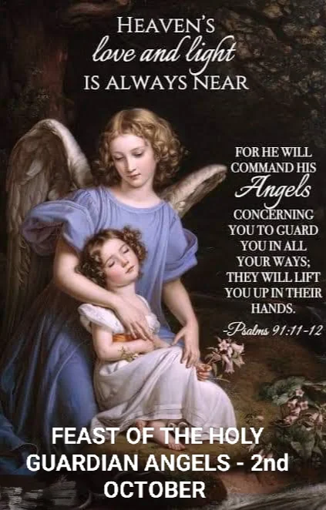
St Bernard

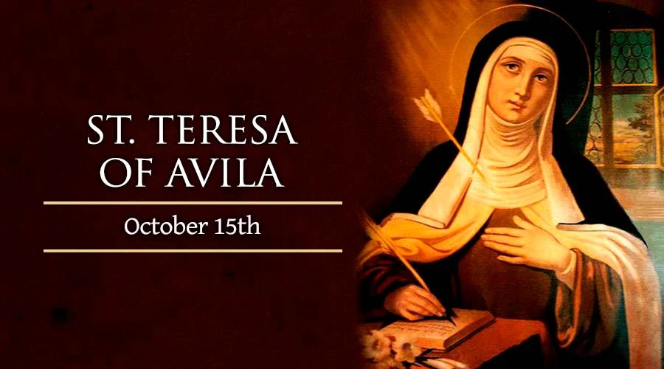
On 15 October, Catholics celebrate the Spanish Carmelite reformer and mystic St. Teresa of Avila, whose life of prayer enriched the Church during the 16th century counter-reformation.
Teresa Sanchez Cepeda Davila y Ahumada was born in the Castilian city of Avila during the year 1515, the third child in a family descended from Jewish merchants who had converted to Christianity during the reign of King Ferdinand and Queen Isabella. Her father Alphonsus had become an ardent Catholic, with a collection of spiritual books of the type his daughter would later compose herself.
As a child, Teresa felt captivated by the thought of eternity and the vision of God granted to the saints in heaven. She and her younger brother Rodrigo once attempted to run away from home for the sake of dying as martyrs in a Muslim country, though they soon ran into a relative who sent them back to their mother Beatrice.
When Teresa was 14, her mother died, causing the girl a profound grief that prompted her to embrace a deeper devotion to the Virgin Mary as her spiritual mother. Along with this good resolution, however, she also developed immoderate interests in reading popular fiction (consisting, at that time, mostly of medieval tales of knighthood) and caring for her own appearance.
Though Teresa's spiritual directors in later life would judge these faults to be relatively minor, they still represented a noticeable loss of her childhood zeal for God. Alphonsus decided his teenage daughter needed a change of environment and sent her to be educated in a convent of Augustinian nuns. Teresa found their life dull at first but soon came to some understanding of its spiritual advantages.
Illness forced her to leave the convent during her second year. But the influence of her devout uncle Peter, along with her reading of the letters of the monk and Church Father St. Jerome, convinced Teresa that the surest road to salvation lay in forsaking marriage, property, and worldly pleasures completely. Against the will of her father, who wanted her to postpone the decision, she joined the Carmelite Order.
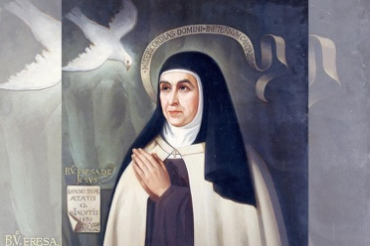
Teresa became a professed member of the order at age 20 but soon developed a serious illness that forced her to return home. She experienced severe pain and physical paralysis for two years and was expected to die when she went into a coma for four days. But she insisted on returning to the Carmelite monastery as soon as she was able, even though she remained in a painful and debilitated state.
For the next three years the young nun made remarkable progress in her spiritual life, developing the practice of recalling herself into the presence of God through quiet contemplation. As her health returned, however, Teresa lapsed into a more routine prayer life. While she remained an obedient Carmelite, she would not re-establish this close personal connection to God for almost twenty years.
When she was nearly 40, however, Teresa found herself dramatically called back to the practice of contemplative mental prayer. She experienced profound changes within her own soul, and remarkable visions that seemed to come from God. Under the direction of her confessors, Teresa wrote about some of these experiences in an autobiography that she completed in 1565.
Teresa had always been accustomed to contemplate Christ's presence within her after receiving him in the sacrament of Holy Communion. Now, however, she understood that the presence she received did not simply fade: God was, in fact, with her always, and had been all along. It was simply a matter of putting herself in his presence, with love and attention – as one could do at any moment.
This revolution in her spiritual life enabled Teresa to play a significant role in the renewal of the Church that followed the Council of Trent. She proposed a return of the Carmelites to their original rule of life, a simple and austere form of monasticism – founded on silence and solitude – that had received papal approval in the 12th century and was believed to date back to the Old Testament prophet Elijah.
Together with her close collaborator, the priest and writer later canonized as Saint John of the Cross, she founded what is known today as the Order of Discalced Carmelites – “discalced,” meaning barefoot, symbolizing the simplicity to which they chose to return the order after a period of corruption. The reform met with fierce opposition, but resulted in the founding of 30 monasteries during her life.
Teresa's health failed her for the last time while she was traveling through Salamanca in 1582. She accepted her dramatic final illness as God's chosen means of calling her into his presence forever.
“O my Lord, and my spouse, the desired hour is now come,” she stated. “The hour is at last come, wherein I shall pass out of this exile, and my soul shall enjoy in thy company what it hath so earnestly longed for.”
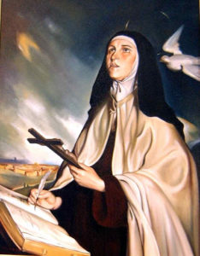
St. Teresa of Avila died on Oct. 15, 1582. She was canonized on March 22, 1622, along with three of her greatest contemporaries: St. Ignatius Loyola, St. Francis Xavier, and St. Philip Neri.
In 1970, Pope St. Paul VI proclaimed St. Teresa as one of the first two woman Doctors of the Church, along with 14th century Dominican St. Catherine of Siena.
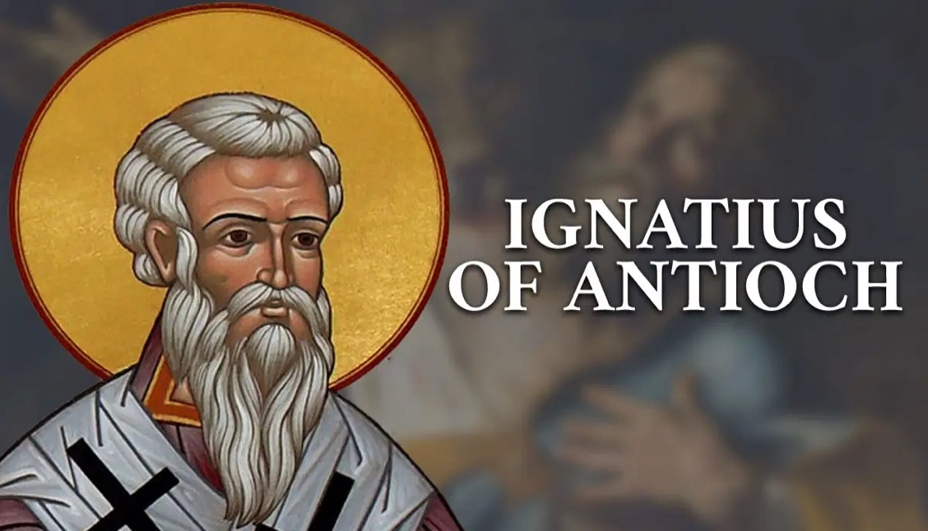St. Ignatius was the Bishop of Antioch after St. Peter and then St. Evodius who died around 67 AD. Eusebius records that St. Ignatius succeeded St. Evodius, and it is reported that St. Peter himself appointed Ignatius to the see of Antioch. Ignatius is a Greek name, and he also called himself Theophorus, “God Bearer”. Tradition says he was one of the children that Jesus took in His arms and blessed. St. Ignatius is one the Apostolic Fathers, the earliest authoritative group of the Church Fathers. His authority is based on being a Bishop of the Church, and living his life in the imitation of Christ. It is believed that St. Ignatius along with his friend Polycarp were disciples of the Apostle St. John.
Feast Day 17 October
St. Ignatius wrote a series of letters that have been preserved as an example of very early Christian Theology. Important topics addressed in these letters include ecclesiology, the sacraments, and the role of Bishops. Epistles attributed to St. Ignatius report that he was arrested in Syria and taken back to Rome. He writes, “From Syria to even Rome, I fight with wild beasts, by land and sea, by night and by day, being bound amidst ten leopards, even a company of soldiers, who only grow worse when they are kindly treated”. Along this route he wrote six letters to the Churches in the region, and one to a fellow Bishop. He was sentenced to die at the Colosseum. The year of his death was 108.
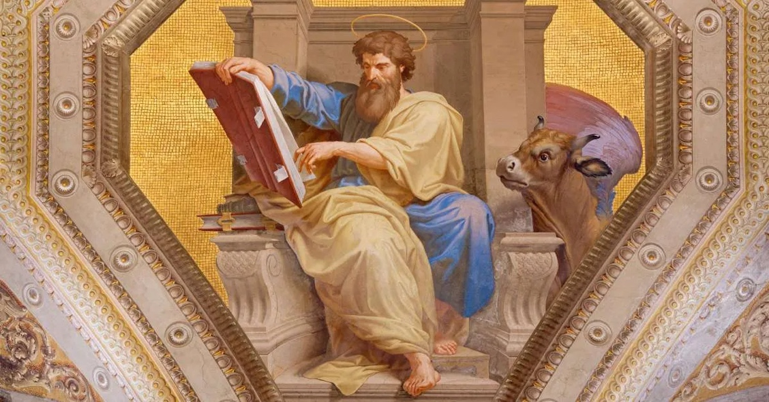
St Luke The Evangelist

Feast Day 18 October

In the first century, the city of Antioch was the capital of the Roman province of Syria and one of the most important cities in the eastern Mediterranean. For centuries, its ancient remains could be found in Antakya, Turkey, until a February 2023 earthquake obliterated many treasured religious sites. In the first century, Antioch was a central trade route in the Roman Empire, a culturally diverse city, mostly Greek-speaking, and an intellectual hub with a massive library. Antioch was also one of the earliest Christian communities, initially evangelized by Saints Paul and Barnabas, and whose first bishop was Saint Peter, “and it was in Antioch that the disciples were first called Christians” (Acts 11:26). Today’s exceptionally important saint, Saint Luke the Evangelist, was most likely born, raised, and discovered the faith in this city.

Luke is credited with writing the Gospel of Saint Luke and the Acts of the Apostles. According to the fourth-century historian, Eusebius, Luke “was of Antiochian parentage and a physician by profession, and…was especially intimate with Paul and well acquainted with the rest of the apostles” (3.4). Saint Paul identifies Luke in several of his epistles as being his close companion and as a physician (see Colossians 4:14; Philemon 1:24; 2 Timothy 4:11).
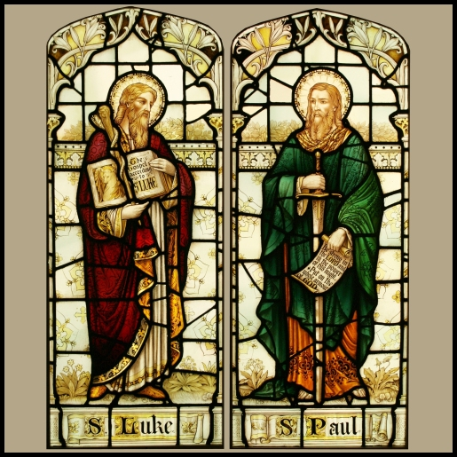
The fact that Luke was a faithful companion of Saint Paul is also revealed in the Acts of the Apostles when the narrative of Saint Paul’s journeys moves to the first-person plural, to “we,” implying Luke is part of the missionary activity he describes. The “we” passages begin in Acts 16:10–17 when Saint Paul receives a vision to go to Macedonia while in Troas. It appears that from this trip onward, Luke accompanied Saint Paul. The travels included Macedonia and Greece, Antioch, Galatia, Phrygia, Ephesus, back through Macedonia and Greece, and to Jerusalem, where Saint Paul was arrested and sent to Rome, spending two years there before being executed. It appears from Saint Paul’s writings that Saint Luke remained with him until the end—“Try to join me soon, for Demas, enamoured of the present world, deserted me and went to Thessalonica, Crescens to Galatia, and Titus to Dalmatia. Luke is the only one with me. Get Mark and bring him with you, for he is helpful to me in the ministry” (2 Timothy 4:9–11). The second letter to Timothy was most likely written just before Saint Paul was executed.
Based on the prologue of his own Gospel, Luke was not an eyewitness to Jesus’ ministry from the beginning; rather, he accurately investigated everything anew and wrote down his findings in an orderly sequence (see Luke 1:1–4). Saint Paul mentions Mark, the author of the first Gospel, next to Luke in his epistles, clearly indicating that Mark and Luke knew each other well. Luke’s Gospel was written after Mark’s, suggesting that Luke used Mark’s Gospel as a source.

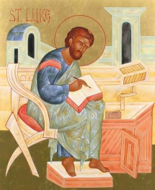
Most scholars believe that Luke was a Gentile convert. This conviction is largely based on Colossians 4:10–14, in which Saint Paul does not include Luke in his greetings by those “​​who are of the circumcision,” meaning those who are Jews. He includes Luke after that in the grouping of the Gentiles. Furthermore, Luke’s Gospel and the Acts give special attention to the Gentile converts, holding them in an important position. Thus, Luke was most likely the only one of the four Gospel writers who was not of Jewish origin. This is further evidenced by the fact that Luke’s Gospel appears to have been written in Greek. His Greek grammar and structure are excellent, suggesting he is well educated in Greek language, literature, and culture.

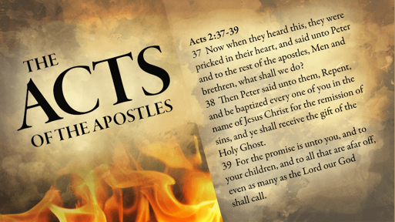
Luke’s Gospel and the Acts of the Apostles make up a two-volume single work. Both are written for a man named “Theophilus.” In the prologue to the Gospel we read, “I too have decided, after investigating everything accurately anew, to write it down in an orderly sequence for you, most excellent Theophilus…” (Luke 1:4). In the prologue to Acts we read, “In the first book, Theophilus, I dealt with all that Jesus did and taught until the day he was taken up…” (Acts 1:1–2). Scholars have varying opinions about who Theophilus is. He might be Saint Paul’s lawyer, and Luke’s writings might have been created for Saint Paul’s defence before the Roman authorities. Theophilus might also be a wealthy benefactor who commissioned and paid for Luke’s written accounts. However, many have suggested a spiritual interpretation rather than a literal one. The name “Theophilus” can mean “Friend of God.” Thus, Luke could be writing broadly to everyone who is a friend of God.

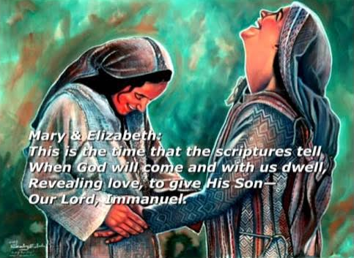
The Gospel according to Luke, the longest of the four gospels, is sophisticated in its literary form and offers a depth of moral teaching. Luke includes a number of parables and events that are not included in the other Gospels. The events include: Annunciation to Zechariah (Luke 1:5–25); Annunciation to the Blessed Virgin Mary (Luke 1:26–38); Visitation of Mary to Elizabeth and the Magnificat (Luke 1:39–56); Birth of John the Baptist with Zechariah’s Canticle (Luke 1:57–80); Presentation of Jesus in the Temple (Luke 2:22–38); Jesus at the age of Twelve in the Temple (Luke 2:41–52); Jesus’ Rejection at Nazareth (Luke 4:16–30); The Widow at Nain (Luke 7:11–17); A Sinful Woman Forgiven (Luke 7:36–50); Jesus Sends Out Seventy-two Disciples (Luke 10:1–24); Jesus visits the home of Martha and Mary (Luke 10:38–42); and Zacchaeus the Tax Collector Climbs a Tree (Luke 19:1–10).
Additionally, there are several parables only found in Luke: Good Samaritan (Luke 10:25–37); Friend at Midnight (Luke 11:5–13); Rich Fool (Luke 12:13–21); Barren Fig Tree (Luke 13:6–9); Lost Sheep (Luke 15:3–7); Lost Coin (Luke 15:8–10); Prodigal Son (Luke 15:11–32); Unjust Steward (Luke 16:1–13); Rich Man and Lazarus (Luke 16:19–31); Unjust Judge (Luke 18:1–8); Pharisee and Tax Collector (Luke 18:9–14); and Ten Coins and Servants (Luke 19:11–27).

It should be noted that only Luke includes details from the life of our Blessed Mother. Her Magnificat, experience at the Annunciation, and Presentation in the Temple suggest he either had an intimate knowledge of these events directly from the Blessed Mother or was privileged to receive a reliable and detailed account of them from another source. There is also an ancient tradition that Saint Luke was an artist who painted the first icon of the Blessed Virgin Mary with the Child Jesus.

Early tradition states that Saint Luke died at the age of eighty-four in Boeotia, Greece. It is also an ancient belief that he died a martyr, though records are unreliable. His writings, however, are reliable. Together, the Gospel of Saint Luke and the Acts of the Apostles make up a significant portion of the New Testament. God clearly used this intelligent and well-educated man when the Holy Spirit inspired Luke to write a thorough, definitive, and orderly account of God’s life-saving actions in the Person of Jesus Christ and the early Church. Saint Luke did the writing, but the Holy Spirit guided the pen, using Saint Luke’s human experience and talent as the instrument.
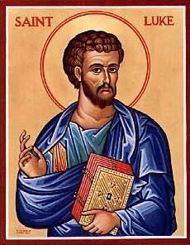
As we honour this great evangelist, ponder the fact that while he wrote down this orderly account of the life of Christ and the early Church, little did Luke know that his writings would be among the most widely distributed writings in the history of the world and would be one of the primary instruments of the salvation of countless souls.


Prayer: Saint Luke, you were a faithful servant of Saint Paul and a devout worshiper of Jesus, your Lord. You placed before God all your natural gifts, your education, time, and energy so that He could use you for the fulfilment of His holy will and the proclamation of the Gospel. Please pray for me, that I will always devote myself without hesitation to the fulfilment of God’s will, so that God can use me as He will to draw many to Christ. Saint Luke, pray for me. Jesus, I trust in You.
My Catholic Life

Magazine Sponsorship for October.


The printing of this October edition of our Parish Magazine has been sponsored by Adele Dixon, in memory of her husband, Stuart, who died on 10th April 2024 following a brave battle against cancer. Stuart would have celebrated his 65th birthday on the 7th of this month.
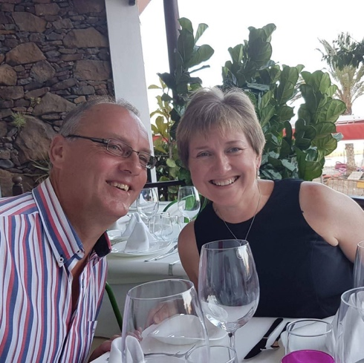
Stuart was a brilliant engineer and an innovator. He loved engines, particularly if they were steam, and he built his first 5” gauge steam locomotive when he was 15. He had a wonderful witty sense of humour, and he made Adele laugh practically every day since they met in 1988. He was a charismatic man and highly respected by his family, friends and business colleagues. He is greatly and sadly missed.

This sponsorship enables us to offer our monthly magazine free of charge. Thank you!
Moving forward as a way of covering some of the ongoing costs of the
the church and wider ministry I would like to trial the introduction of
sponsorship.


The easiest example of what I am thinking is the sponsorship of the
printing costs of our new magazine. Another example is covering the cost
of the sanctuary light which is always alight (except following the
Good Friday Liturgy until it is lit again to celebrate the risen Lord at the Easter Vigil) and the candles in the Lady Chapel and St Monica’s Chapel.
Sponsorship would be on a weekly or monthly basis, although monthly sponsorship would make administering the process an easier task, and could be in memory of a loved one who has died or something else such as a birthday that is close to your heart. Sponsors and their special intention will be published in this magazine each month.

Sponsorship money should be paid at the beginning of the month
preferably by bank transfer using the reference box to indicate that it is
sponsorship money or you could give your sponsorship money in cash
to our treasurer, Tracy Poole.

If you would like to participate in this new venture, please email Maria
the month, what you are sponsoring and your intention to:

mrs.maria.mason@gmail.com

It is of course possible to have more than one sponsor for any category in
any month and all sponsors with their intention will be published.

Item | Duration | Suggested Donation
Parish Magazine | Monthly | £50
Sanctury Lamp | Monthly | £15
St Monica’s Chapel Lamp | Weekly | £10
Sunday Service Heating | Weekly | £50
Weekly Notice Sheet | Weekly | £2.50


Sanctury Lamps for October are sponsored by Fr Adrian in memory of the death of his father.

Could you sponsor the magazine, or any of the above items, for a month moving forward?

It would be helpful moving forward into 2026 to have the year’s sponsorships laid down. Payment wouldn’t be asked for until the beginning of the month sponsored. Please email Maria to let her know which month you would like to sponsor and she will then be in contact with you nearer the time to ask you why you are sponsoring that particular month’s magazine or sanctuary lamp etc . . . . . .

Rock Food Bank, Grimsby

Rock Food Bank was actually founded by the Rock Foundation UK back in 2014, after identifying an increase in demand for food provision. Back then the Food Bank was based at the Old Wellington Steet premises. Over a period of time and experience in facilitating this service, they became more aware that there was a need to expand the facility in order to address some of the underlying causes of food poverty in Grimsby.


In June 2023 the Rock Foundation Uk handed the baton over to the charity Rock Community Hub, who now own and facilitate the food bank and associated services. They provide nutritionally balanced food parcels which include fresh food and vegetables, tinned goods, bread and dairy as well as frozen foods. These items are donated by local supermarkets as well as local businesses and generous individuals.

At St Augustine’s we have a box positioned at the church entrance as a collection point for the Food Bank. In the past we have been very generous, however a little reminder is obviously needed. The box has remained empty for some weeks. Over 280 people are needing to access the Food Bank each week, with access limited to two or three visits, this indicates that the real need is much higher than this.

If we could fill our box with a range of tins, packets, baby products and toiletry goods (food must be in date) it would again demonstrate St Augustine’s commitment support those less fortunate than ourselves. Bill and Pauline Murdoch have been dedicated to taking our donations to the distribution point in Garibaldi Street, Grimsby for sorting and packaging.

One item per person, per week would make a huge difference.

Have you thought about becoming a Friend of St Augustine’s Church?
Membership per annum is single £15 Joint £25. When you see and hear the wealth of musical talent that rings out in our building during a musical season it is quite mind blowing.

The ‘Friends of St. Augustine’ was established to promote concerts to raise funds to assist with the maintenance of the church. Regular concerts and recitals are held in the church. The building itself possesses an outstanding acoustic and is regularly used for rehearsals and recordings. A variety of musical events feature every year featuring artists from near and far. Coming up . . . . . . .

Fri 17 Oct 7.30pm Louth Male Voice Choir
Fri 14 Nov 7.30pm Dolce Brass
Fri 28 Nov 7.30pm Christmas Tree Festival Opening Concert
Music for Advent
Fri 19 Dec 7.30pm Adele Dixon and Barry Whitfield
Christmas Tree Finale Concert with Octangle ` (octet from Louth Male Voice Choir)
Ticket prices . . . . . . .

Adults: £12 Friends: £10 Students: £5 Under 12: Free

Evening concerts are café style. A complimentary glass of wine or fruit juice is available with each ticket. You can bring your own drinks and nibbles for further refreshment. Further details email:

staugustinesfriends@gmail.com or phone 07398 567677

'Doctors – Oversight – Overwork – Overkill...

Case-study: Pete, 49 year old male [incidentally with Down's Syndrome]

1st - 5th April Midge bites, mainly lower legs to abdomen on Scottish Holiday.
Scratching produced multiple locally septic lesions, mainly on legs and feet.
11th April seen by Nurse @ G.P.'s surgery.
Nurse asked a doctor to prescribe, and Fluoxacillin 500mg qds x 7 days resulted. --
by 13th April no sign of sepsis remained, and no itching. Course religiously completed on 18th April.
On 21st April Patient revealed a mass mid left upper arm. Not itching but painful if touched.
A red hard mass at least 3 inches across; very tender. There is a small hole with yellow pus.
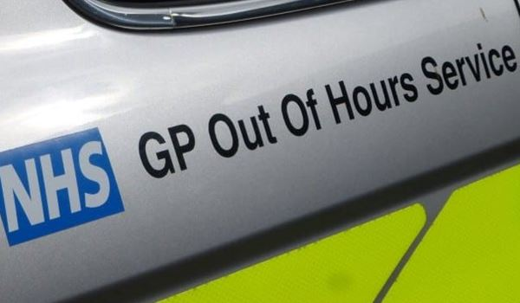
A Sunday; no walk-in, and out-of-hours GP in Hospital has gone. So 1pm, Carer dialled '111'
Offered a 'call back within 4 hours'.
4hrs 30mins a Nurse[?] said a doctor would respond. 1/2hr later @ 5.30pm another Nurse rang. Had noticed still outstanding and recommended to 'attend GP out-of-hours' (which has a new address in another GP Practice's suite). Clerked-in at 6pm;- at 7.30pm saw Doctor Number 1. {duty GP}
Advised had to refer to A & E. Form said '? Abscess.'
A&E busy; [we sat under a diagram showing a long wait, then a Nurse, then a wait to see a doctor.]
In fact 2 hours to see Nurse, and 1 hour to see Doctor 2.
[Casualty Officer], he squeezed out a stream of pus, but said he could not treat.
We must see the Orthopaedic Team.
Half hour later we met another young doctor: Doctor 3. Patient will have to 'see my Consultant', but a pus sample was taken, and X-ray arranged [to exclude bony involvement]...
Including walks down corridors, the X-ray was done in 10 minutes.
But it was 1am before the Consultant arrived, - Doctor 4. He had to take in the whole story, [and no doubt we were bad at key details of a history repeated to so many professionals during the 12 hours thus far]. He drew a line round the inflamed area, and prescribed a doubled dose of Fluoxacillin for 7 days. Review 8th day in Fracture Clinic.
At the Fracture Clinic patient met Doctor 5. Now reduced area of induration, and not tender; leaking pus; but pus sample had not grown any live bacteria.
Told Okay, but if it flares up - 'and it may' – call us (in Orthopaedic Department- fracture clinic)
3rd May - Unfortunately, deteriorated, tender and red again.
As instructed – rang orthopaedics. Even so, cannot attend clinic direct:- “You have to go to A & E First'. {they left out the compulsory Nurse} Doctor 6 Casualty Officer referred us to Orthopaedics “not the clinic, they will come to you here.”
3 hour later, told to go to room next door. One and a half hours more for Doctor 7. By now pus and blood again, so less tender. “Wait for my Boss.”

20 minutes: Doctor 8 (who has brought Doctor 3 with him} Doctor 8 took history in brief, and said Pus culture grew no organism. -No need to take off dressing, just wait for treatment [doubled dose of same antibiotic]. “Ten minutes”
After 2 hours wait for treatment and a letter by Doctor 3 allowed to go home.
13th May reviewed in fracture clinic Doctor 9 [slow progress]
20th May Dressing clinic
24th fracture clinic Doctor 10 {continued slow progress]
June 3rd dressing/clinic; Doctor 11
7th – dressing.
June 10th clinic review Doctor 9 again. [tho' continuing slow progress, never worse,] patient discharged (safe for a doctor who had seen him before.)

COMMENT
Once upon a time one Doctor saw the problem and got the story.....- treated – reviewed – (if) third time going in the right direction,- discharged. - Welcome back if stuck or relapsed, of course. Note, Doc' was only told the story once, with least chance of error or omission; and augmented by perceptive questions from the doctor who knows you.

I aim to highlight the ELEVEN DOCTORS who had to try and get to grips with one patient. If seeing once only every patient that day, that is an enormous amount of stressful work, presumably every working day, whilst this case is a light job for one doctor!

The unnecessary workload here for 11 [plus one on April 11th] doctors with stress compounded for each unattached patient that the doctor must see, assess, - and treat, - [with no reassuring feedback either] - is mind boggling.

Politicians say we need more doctors; and they may be right. But if
mis-used, on this massive scale, we shall never ever have enough.
Moreover they will leave or be invalided out in droves.


Bill Murdoch MB BS (Lond)[1958]

P E A C E
by Andy Murdoch

People don't say anything,
just walk away,
Some things are silent,
lovely, peaceful.
Then you walk in the park,
No people at all. No sound.
And down the beach.
No sound there are no people
No buses nor cars
No cats, no dogs
No kids, no trains
No aeroplanes, no birds
Nothing, nothing
It's really peace
by peace
Wandering
on my own; Just me.



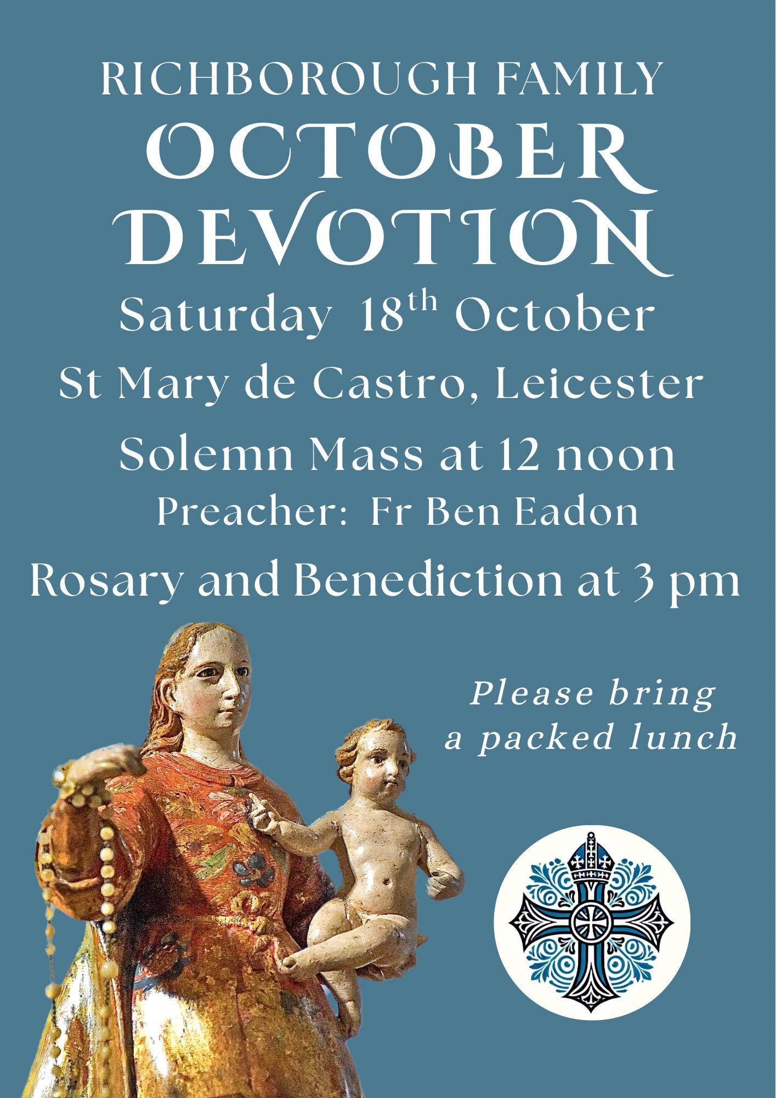


1 Oct 1207 Birth of England’s King Henry III.

2 Oct 1452 England’s last Plantagenet King Richard III is born.

3 Oct 1283 Dafydd ap Gruffydd, Prince of Wales, became the first nobleman in Britain to be hanged, drawn and quartered.

4 Oct 1911 Britain’s first escalator opens at London’s Earls Court.

5 Oct 1930 The British airship R101 crashes near Beauvais, France killing 48 people.

6 Oct 1892 Death of the English Poet Laureate Alfred, Lord Tennyson, who immortalised ‘The Six Hundred’ in his poem, ‘The Charge of the Light Brigade’.

7 Oct 1920 Women become eligible for admission as full members of Oxford University and are given the right to take degrees.

8 Oct 1967 Clement (Richard) Atlee dies. British Labour politician. As Prime Minister 1945-51 introduced radical reform of the social welfare system and introduced the N.H.S.

9 Oct 1967 Transport Minister, Barbara Castle, introduces the breathalyser. The breathalyser offered a way of testing a person’s BAC (blood alcohol concentration) level at the roadside.


10 Oct 1903 Founded today by the English suffragette Mrs Emmeline Pankhurst at her home in Manchester… The Women’s Social and Political Union, campaigning for women’s suffrage in Great Britain.

11 Oct 1899 Start of the Anglo-Boer War.

12 Oct 1984 An IRA terrorist bomb kills 4 people at the Grand Hotel, Brighton, Sussex.

13 Oct 1852 Birth of Lillie Langtry, actress and mistress of King Edward VII.

14 Oct 1066 Harold II, England’s last Anglo-Saxon King was killed at the Battle of Hastings in Sussex – possibly by an arrow in the eye as shown in the Bayeux Tapestry.

15 Oct 1666 Samuel Pepys, diarist, records the wearing of the first waistcoat by King Charles II.

16 Oct. 1902 England’s first prison for Young Offenders is opened at Borstal in Kent.

17 Oct 1860 The first professional Golf Tournament is played at Prestwick, in Western Scotland. Mr. Willie Park heads the leader board.

18 Oct 1865 British Tory politician Lord (Pumice-stone) Palmerston dies in office. His abrasive and arrogant style earned him his nickname.

19 Oct 1781 British general Lord Charles Cornwallis surrenders to George Washington at Yorktown, Virginia, ending the American War of Independence (Revolution).

20 Oct 1632 Birth of English architect Christopher Wren. Responsible for the rebuilding of St. Paul’s Cathedral following the Great Fire of London.

21 Oct 1805 Admiral Nelson is mortally wounded at the Battle of Trafalgar, near Gibraltar.


22 Oct 1957 The children’s cartoon hero Captain Pugwash makes his television debut.

23 Oct 1642 The first major battle of the English Civil War takes place at Edgehill in south Warwickshire. Charles I and Prince Rupert lead the Royalists and the Earl of Essex leads the Parliamentarians.

24 Oct 1537 Henry VIII‘s third wife, Jane Seymour dies following the birth of the future king Edward VI.

25 Oct 1854 Lord Lucan leads The Charge of the Light Brigade at Balaclava during the Crimean War – famously recorded in Tennyson’s poem.

26 Oct 1863 Formation of the English Football Association who documents the first rules of soccer.

27 Oct 1914 Birth of Welsh poet Dylan Thomas.

28 Oct 1831 English physicist Michael Faraday demonstrates the dynamo founding the science of electro-magneticism.

29 Oct 1618 English courtier, writer and explorer Sir Walter Raleigh is beheaded on the orders of King James I.

30 Oct 1925 The first television transmission of a moving image is made by Scottish inventor John Logie Baird.

31 Oct 1517 Martin Luther nails his ’95 Theses’ to the church door at Wittenberg, Germany triggering the Protestant Reformation.

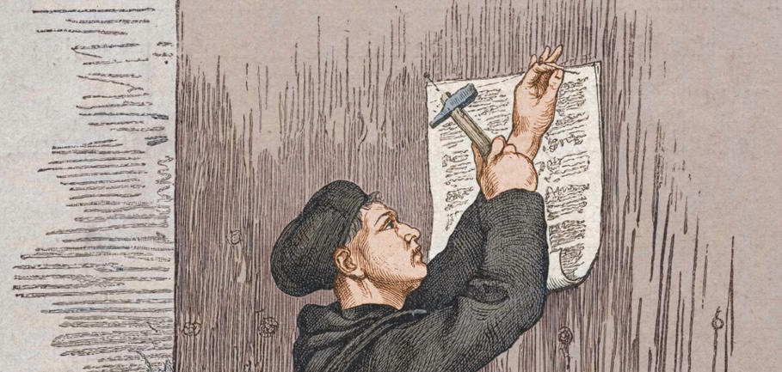

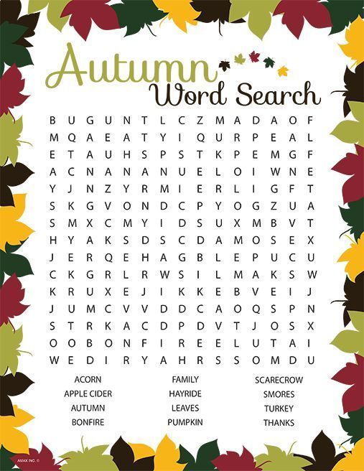

The Life and Times of Thomas Augustus, The Vicarage Cat
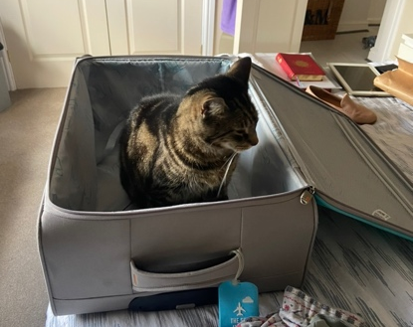
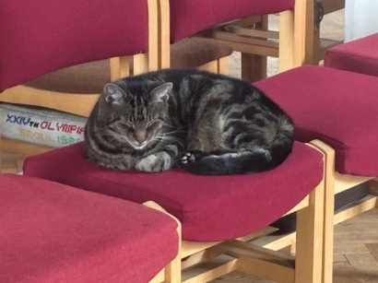
Well, I must admit to having disgraced myself recently. I had been having a lovely peaceful time in the south isle, reflecting and snoozing. Unfortunately, as can happen in the feline world, I got the dreadful urge to bring up a furball. I must confess to having made quite a mess. After this I just made my way back into the vicarage without making anyone aware. It wasn’t until Cheryl came into church the following Saturday to do some cleaning that my mess was found. Fortunately, Cheryl had a very effective machine for cleaning the chairs. My mummy was absolutely mortified that someone else had to clean up after me but was very grateful to Cheryl and her amazing machine.
Enough of church for now. It has come to my attention that suitcases are being taken out of storage and this can only mean one thing – my mummy and daddy are going away and leaving me. Well, I’m not having it this time. Wherever they go I am going as well. Do you think I will get away with it?
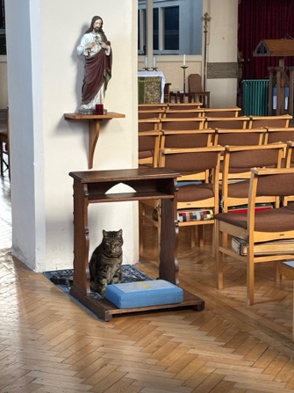
In the meantime I will continue to spend time in church exploring, sleeping and reflecting on my life here in Grimsby and particularly at St Augustine’s Vicarage and Church. I am thankful to be here among so many people who look out for my welfare. It was only a few days ago that I was ‘rescued’ by both church wardens who thought I had gone astray. I was delivered safely back home. I probably could have made my own way back through my cat flap but this demonstrates how lucky I am to be here.


Priest-in-Charge | Fr Adrian Mason | fr.adrian.mason@gmail.com 07824 467333
Church Wardens | Adele Dixon Janet Nixon | adele.dixon90@gmail.com  janet.nixon59@gmail.com
Lay Chair of PCC | Adele Dixon | adele.dixon90@gmail.com
PCC Secretary | Barry Whitfield | barrywwhitfield@gmail.com
PCC Treasurer | Tracy Poole
Safeguarding Officer | Adele Dixon | staugustineofhippo safeguarding@gmail.com
Electoral Roll Officer | Cheryl James | cheryljames1@live.co.uk
Director of Music | Barry Whitfield | barrywwhitfield@gmail.com
Magazine Editor | Maria Mason | mrs.maria.mason@gmail.com




Items for inclusion in the November edition of this magazine should be sent to the editor via email by Sunday 10 October. There will be limited time available to compile a magazine for November, due to the editor taking a few weeks to spend in sunny climes, it will be a slimmed down version.

(mrs.maria.mason@gmail.com). There is no guarantee of inclusion after this date.

Could you write an article for our Parish Magazine? The editor would be pleased to receive articles of a religious nature or otherwise that would be of interest to our readers.
Again, the email address to send articles to is: mrs.maria.mason@gmail.com

Cheryl’s Name Cards
As many of you are aware, Cheryl always has some name cards on the go. At the moment, 20p could win you a box of chocolates or £1 a bottle of gin.
Prizes are given out as soon as the name card is complete.
To quote Cheryl,
“you have to be in it to win it!”

Email:
fr.adrian.mason@gmail.com

Web:
St-augustine-church-grimsby.org
https://www.achurchnearyou.com/church/14993/

Safeguarding matters please contact:
staugustineofhipposafeguarding@gmail.com



Edition 8

