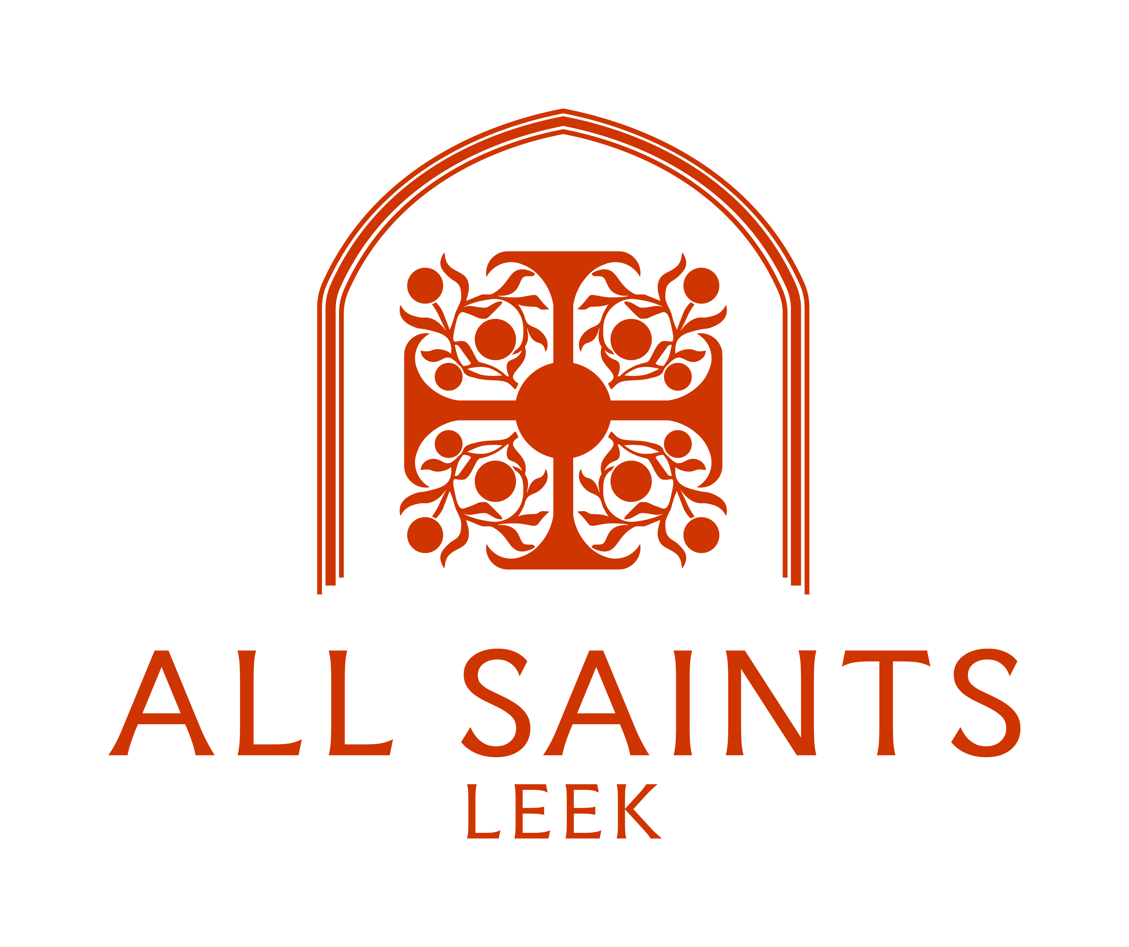

Mid-Week

&

All Services

November 2025

Mondays 5.00pm Evening Prayer

Tuesdays 5.00pm Evening Prayer

Wednesdays 12.30pm Holy Communion

Please join us - Everyone welcome

Services taking place in November

Saturday 1st November 4.00pm All Souls Day – Memorial Service

Sunday 2nd November 11.00am All Saints Day - Choral Eucharist
Followed by Festal Lunch

Monday 3rd November 5.00pm Evening Prayer

Tuesday 4th November 5.00pm Evening Prayer

Wednesday 5th November 12.30pm Holy Communion

Friday 7th November 10.30am Morning Prayer – Prayers and Pastries
Followed by refreshments

Sunday 9th November Remembrance Sunday
10.00am St. Edward’s Church (Cheddleton)
9.30am St. Edward’s Church (Leek)
(Including parade and Service in the town centre)

Monday 10th November 5.00pm Evening Prayer

Tuesday 11th November 5.00pm Evening Prayer

Wednesday 12th November 12.30pm Holy Communion

Sunday 16th November 10.30am Team Confirmation Service

Sunday 23rd November 9.15am Choral Eucharist

Monday 24th November 5.00pm Evening Prayer

Tuesday 25th November 5.00pm Evening Prayer

Wednesday 26th November 12.30pm Holy Communion

Sunday 30th November 11.00am Joint Choral Eucharist
at St. Edward’s Church, Cheddleton
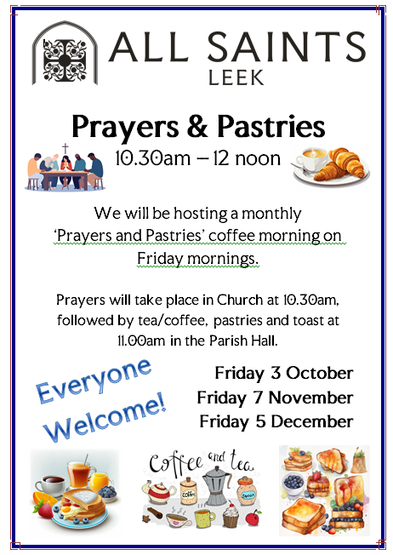

For more information about these and other Services and
to check dates and times, please do not hesitate to contact Revd. Henry and the Parish Office.

Revd. Dr. Henry Hope
Telephone: 07421 462 595
E-mail: revdhenry.hope@posteo.uk

Parish Office
Telephone: 01538 528545
E-mail: allsaints.leek@outlook.com

