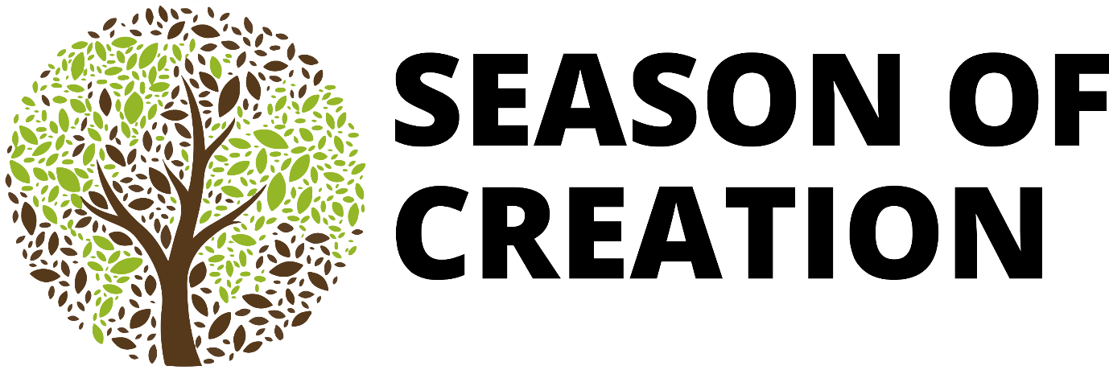

What is the Season of Creation?

The Season of Creation, sometimes also called Creationtide, is a period in the annual church calendar dedicated to God as Creator and Sustainer of all life.

It starts on September 1st, when the Orthodox church celebrates the Feast of Creation and the beginning of the new Church year, and runs until October 4th, the day when many Western Christian denominations celebrate St Francis of Assisi. This period coincides with harvest time in the Northern Hemisphere and the beginning of Spring in the Southern Hemisphere.

Many churches choose to use this time of year to hold special services and events to give thanks for God's gift of creation, and to renew their commitment to caring for our planet and the good stewardship of all life. This connects with the 5th Anglican Mark of Misson, which is “To safeguard the integrity of creation and sustain the earth's life.”

The Season of Creation traces its history back to 1989, when the Ecumenical Patriarch Dimitrios I proposed a day of prayer for creation. From 2001 other major Christian European churches began to observe the day, and then in 2007 the European Christian Environmental Network (ECEN) and the Third European Ecumenical Assembly in Sibiu further promoted a "Time for Creation" to be observed as a month-long period.

In 2008 the World Council of Churches called on the faithful to observe this longer, month-long season, which Churches Together in Britain and Ireland adopted the same year. It has become increasingly observed by many denominations world-wide, including the Anglican Communion.

In recent years, the Ecumenical Season of Creation Steering Committee have identified a theme, key bible verse, and produced resources each year (see https://seasonofcreation.org). The Church of England also collates resources (https://www.churchofengland.org/about/environment-and-climate-change/season-creation).

The theme for the Season of Creation 2025 is peace with creation, based on Isaiah 32:14-18. The prophet Isaiah pictured the desolated Creation without peace because of the lack of justice and the broken relationship between God and humankind. This description of devastated cities and wastelands eloquently stresses the fact that human destructive behaviours have a negative impact on the Earth.

Our hope: Creation will find peace when justice is restored.
There is still hope and the expectation for a peaceful Earth.
To hope in a biblical context does not mean to stand still and quiet, but to act, pray, change, and reconcile with Creation and the Creator in unity, metanoia (repentance), and solidarity.

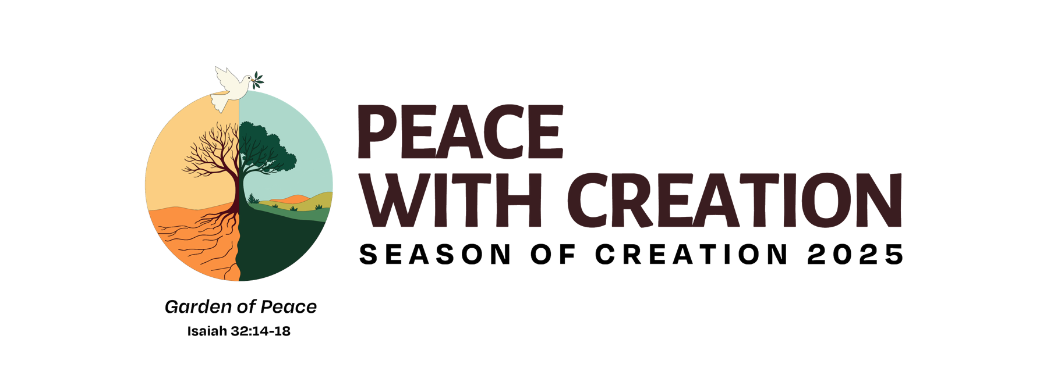

The symbol for the Season of Creation 2025 is a tree in a world of two halves. On one side, the tree is barren and the landscape exploited. On the other side, the tree is lush and green, in a flourishing landscape. Above is a dove, carrying an olive branch in its beak.

Through this year’s Season of Creation, churches are being encouraged to reflect on the connection between caring for creation and fostering peace.

For more information, please contact Rev. Joe Mottram via email: revjoemottram@gmail.com or phone: 07746211093.

