Sunday Services - September 2025

7 September 11.00am Choral Eucharist

Saturday 13 Sept 5.00pm Choral Evensong

14 September 9.15am Choral Eucharist

21 September 11.00am Joint Choral Eucharist
at St Edwards Church, Cheddleton

28 September 9.15am Choral Eucharist

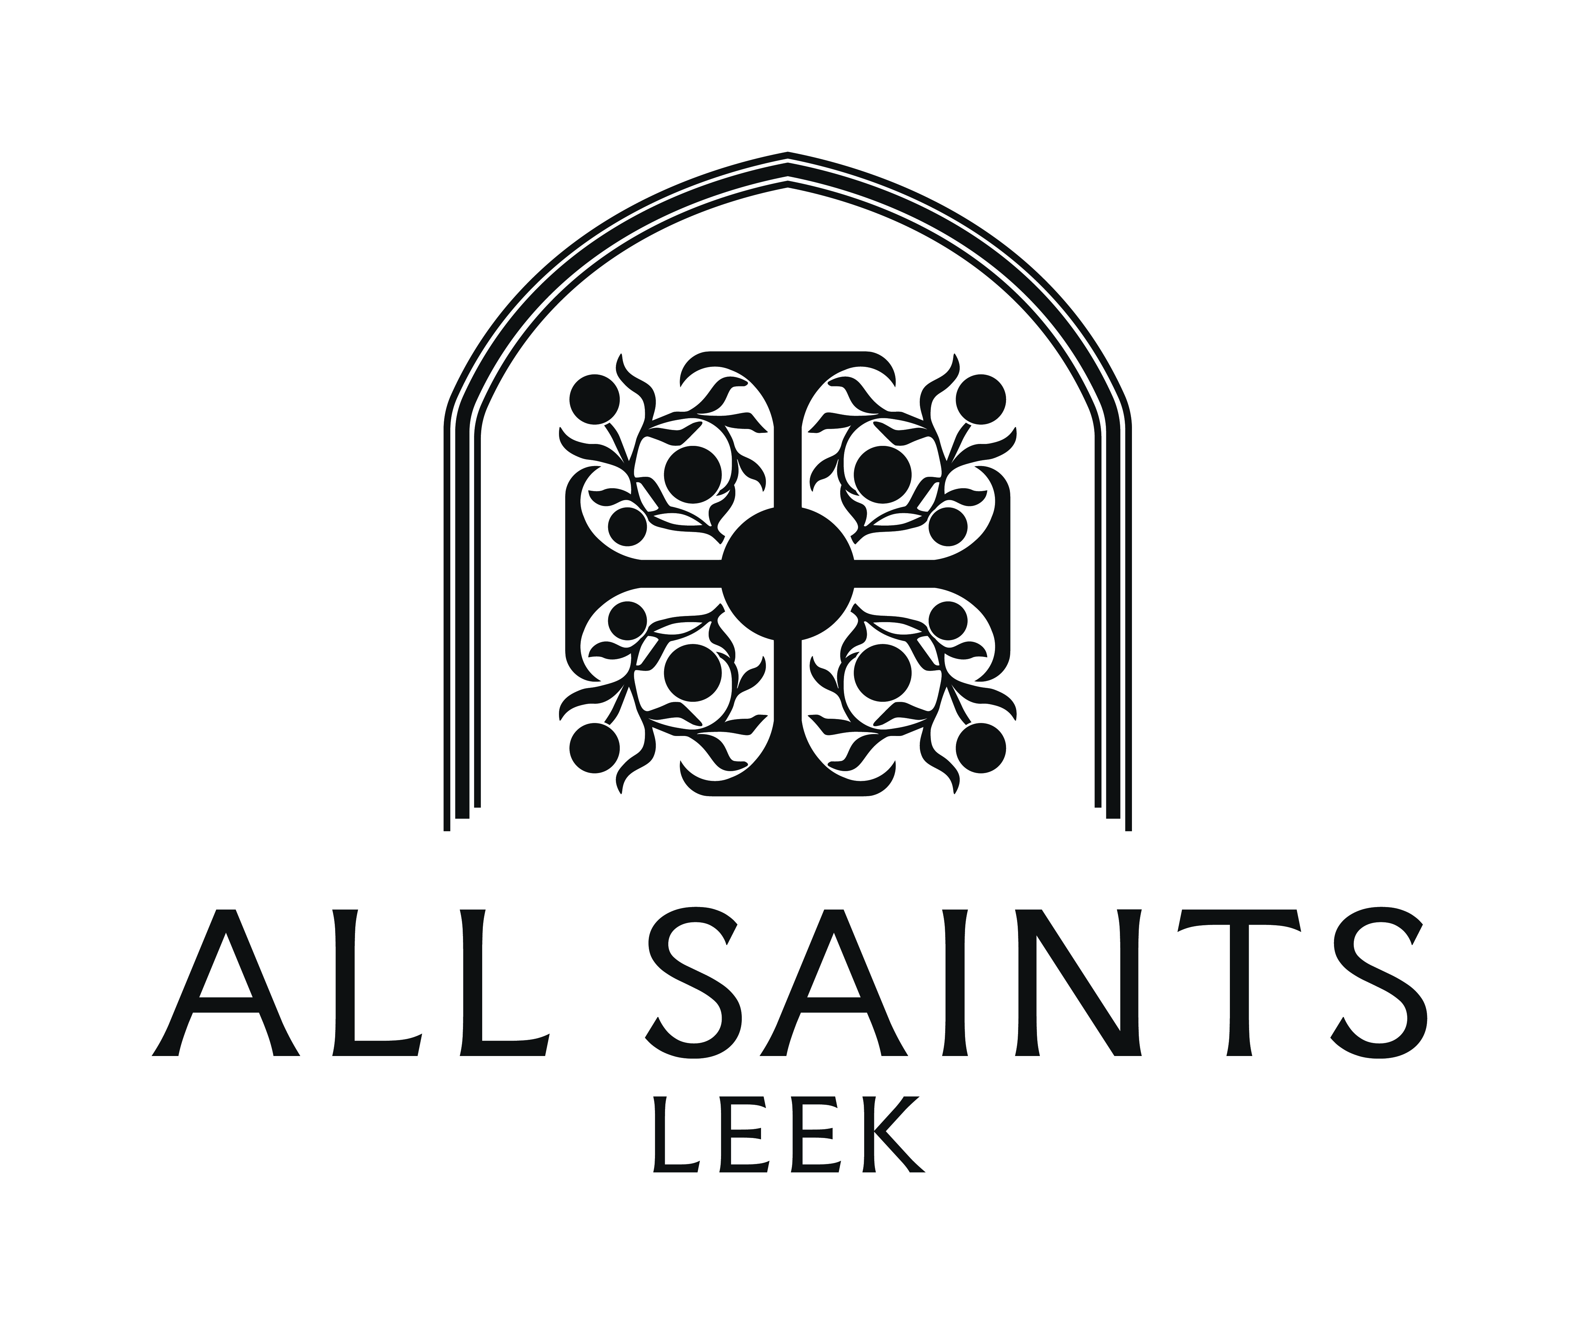

Everyone welcome! Please join us!

