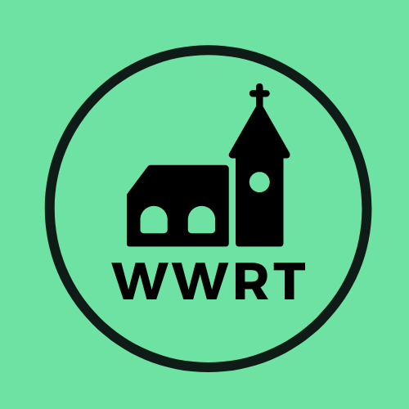
CHURCH SERVICES IN MARTLEY AND WICHENFORD
OCTOBER 2025

Sunday 5th October
Trinity 16
10.30am Worship for All, St Mary Magdalene, Broadwas
10.30am CW Holy Communion, St Peter, Martley

Sunday 12th October
Trinity 17
10.30am Harvest, St Laurence, Wichenford

Sunday 19th October
Trinity 18
10.30am Café Church, St Peter, Martley

Sunday 26th October
Trinity 19
10.30am CW Holy Communion, St Peter, Martley

In August there will be Holy Communion at Heaton House, Martley on the 8th and 22nd Wednesday at 10.15am and on the 1st and 3rd Wednesday via our YouTube channel -wwrtlive1.
All services and timings are subject to review and amendment – please check the website for updates: www.achurchnearyou.com

