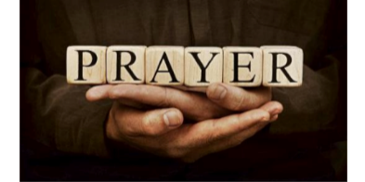

Welcome to the Pendle Deanery
‘Week of Prayer’ Sunday 14th to Sunday 21st September 2025
As we approach the centenary year of our Diocese (2026) the Bishop of Blackburn is inviting parishes to make 2025 a Year of Prayer for Growth and Renewal across the Diocese. The intention for this year is for parishes to pray for new and deeper disciples for Jesus Christ.
‘Be joyful always, pray continually, give thanks in all circumstances.’
1 Thessalonians 5:16-18

Each of the churches in the Pendle Deanery is involved and are offering a selection of related events and activities that are taking place across the Deanery.
We hope you will be able to visit one or more of these events. Locations are colour coded with the map below.

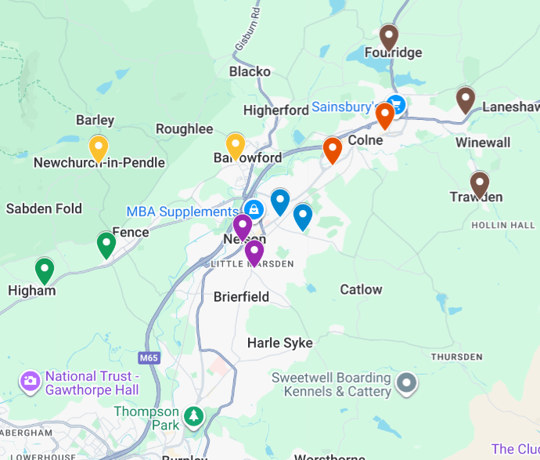
St Anne’s Church Fence BB12 9EE
St John’s Church Higham BB12 9EU
St Thomas Church Barrowford BB9 6QS
St Mary’s Church Newchurch BB12 9JR
 St Paul’s Church Nelson BB9 0EE
St Mary’s Church Beacon Centre BB9 7HD
St Bartholomew’s Church Colne BB8 0LQ
Holy Trinity Church Colne BB8 9PL
St Michael’s & All Angels Foulridge BB8 7NP
St Mary’s Church Trawden BB8 8PF
Christ Church Colne BB8 7HF
St John’s Church Nelson BB9 9JS
St Philip’s Centre Nelson BB9 9XB

 | SUNDAY 14th | MONDAY 15th | TUESDAY 16th | WEDNESDAY 17th | THURSDAY 18th | FRIDAY 19th | SATURDAY 20th | SUNDAY 21st
Pendle Deanery  Week  Of  Prayer | Regular services take place across all churches in the Deanery, where prayers will be said for the week of prayer  10.45am Hope Explored 1 – ‘Hope’ at St Michaels and All Angels Foulridge BB8 7NP |   8am-9pm ‘Prayer Space’ at St Thomas Barrowford BB9 6QS  9.30am-4.30pm ‘Prayer Space’ at St Mary’s Newchurch-In-Pendle BB12 9JR  9.15-9.45am Morning Prayer, you are welcome to join Revd. Alex in church for this said service of prayer & reflection at St Bartholomew’s Colne BB8 0LQ  2pm The Prayer Course Session 1 - "What is prayer?" Trawden area (ring 0778 653 4050 for exact location) | 8am-9pm ‘Prayer Space’ at St Thomas Barrowford BB9 6QS with ‘Morning Prayer’ at 9.15am  9.30am-4.30pm ‘Prayer Space’ at St Mary’s Newchurch-In-Pendle BB12 9JR  9.30-10am Morning Prayer, you are welcome to join Revd. Alex in church for this said service of prayer & reflection at Holy Trinity Colne BB8 9PL  10.30am Coffee and Conversation discuss prayer today. Does it work? With Revd. Lesley at The Refectory St Anne’s Fence (opposite Fence Gate Lodge) BB12 9EE  1.30pm ‘Reminisce at the Refectory’ with Revd. Lesley. Looking back at the celebrations in our lives and offering thanks in prayer together. The Refectory St Anne’s Fence (opposite Fence Gate Lodge) BB12 9EE | 8am-9pm Prayer Space at St Thomas Barrowford BB9 6QS with Holy Communion 10.30am  9.30am-4.30pm ‘Prayer Space’ at St Mary’s Newchurch-In-Pendle BB12 9JR  9.15-9.45am Morning Prayer, you are welcome to join Revd. Alex in church for this said service of prayer & reflection at St Bartholomew’s Colne BB8 0LQ  10.30am Prayer Group with Revd. Lesley at The Refectory St Anne’s Fence (opposite Fence Gate Lodge) BB12 9EE  7pm ‘A Service of Prayer for Wholeness & Healing with Revd. Lesley at St Anne’s Fence BB12 9EE | 8am-9pm ‘Prayer Space’ at St Thomas Barrowford BB9 6QS  9.30am-4.30pm ‘Prayer Space’ at St Mary’s Newchurch-In-Pendle BB12 9JR  9.15-9.45am Morning Prayer, you are welcome to join Revd. Alex in church for this said service of prayer & reflection at St Bartholomew’s Colne BB8 0LQ  2pm ‘Bring a prayer – share a coffee’ an opportunity to bring to God things that are on our minds (ring Gil 07427113522 for exact location)  7.30pm ‘Let Your Light Shine’ - P.R.A.Y. With interactive prayer stations to help focus our prayers,  With Pastor Pete Baker from Life Church Burnley at The Refectory St Anne’s Fence (opposite Fence Gate Lodge) BB12 9EE  7pm The Prayer Course Session 1 - "What is prayer?" Foulridge area (ring 0778 653 4050 for exact location) | 8am-9pm ‘Prayer Space’ at St Thomas Barrowford BB9 6QS  9.30am-4.30pm ‘Prayer Space’ at St Mary’s Newchurch-In-Pendle BB12 9JR |   As we approach the end of our week of prayer, be encouraged to take time today to reflect on your past week, to ‘be’ and find space to rest with Jesus. | Regular services take place across all churches in the Deanery, where prayers will be said for the week of prayer    10.15am Bishop Philip visits St Paul's for Confirmations. The confirmations will be followed by a celebration marking the completion of a Year of Prayer young families project. During this the 'young@heart' group will lead the Bishop through a time of prayer as well as show him an exhibition of the Church's foundations of daily prayer at St Paul’s church Nelson BB9 0EE  10.45am Hope Explored 2 – ‘Peace’ at St Michaels and All Angels Foulridge BB8 7NP  6pm ‘Contemplative Prayer Taster’ - an hour of prayer and meditation on scripture, drawing on the practices of Ignatian Spirituality with Rev Lorelli. Note:- this is a session with a learner not an expert! St John’s Church, Barkerhouse Road, Nelson, BB9 9EY.

