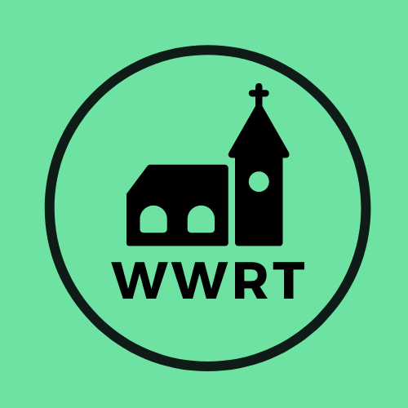

CHURCH SERVICES IN THE LOWER TEME VALLEY SEPTEMBER 2025

Sunday 7th September
Trinity 12
9.00 am BCP Holy Communion, St Leonard, Cotheridge
10.30am Worship for All, St Mary Magdalene, Broadwas

Sunday 14th September
Trinity 13
3.00pm Evening Worship, Knightwick Chapel

Sunday 21st September
Trinity 14
10.30am CW Holy Communion, St Mary Magdalene, Broadwas

Sunday 28th September
Trinity 15
10.30am Morning Worship, St Mary Magdalene, Broadwas

In September there will be Holy Communion at Heaton House, Martley on Wednesday 10th and 24th at 10.15am and on the 1st and 3rd Wednesday via our YouTube channel -wwrtlive1.
All services and timings are subject to review and amendment – please check the website for updates: www.achurchnearyou.com

All services and timings are subject to review and amendment in accordance with Covid lockdown easing – please contact the Rectory or check the website for updates.
01886 888664
www.achurchnearyou.com

