St Faith and St Laurence
HARBORNE, BIRMINGHAM B17 8RD

This Photo by Unknown Author is licensed under CC BY
MESSY CLUB
In THE CHURCH HALL

SATURDAY 4th October 2025

Children’s Free Fun Craft Activities From 11am to 12.30pm – Everyone Welcome!

SUITABLE FOR NURSERY AND INFANT AGED CHILDREN ACCOMPANIED BY A PARENT, CARER or OTHER RELATIVE.

JOIN US FOR SOME FREE CHILDREN’S FUN AUTUMN AND HARVEST FELLOWSHIP with baking, painting, colouring, songs, snacks, and other crafting tasks. ADULT REFRESHMENTS (Tea / Coffee and Cake) AVAILABLE.

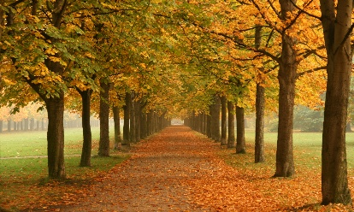
This Photo by Unknown Author is licensed under CC BY-SA

WE LOOK FORWARD TO WELCOMING YOU, especially Stay and Play families, TO OUR MESSY CLUB COMMUNITY - SEE YOU THERE!
www.saintfaithandsaintlaurence.co.uk

