CHURCH SERVICES IN CLIFTON, THE SHELSLEYS AND LOWER SAPEY (HARPLEY)
September 2025
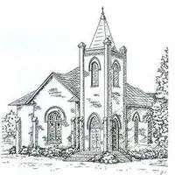

Sunday 7th September
10.30am: Holy Communion, St Kenelm’s, Clifton
10.30am: Morning Prayer, St Bartholomew, Harpley

Sunday 14th September
10.30am: Family Communion, All Saints, Shelsley Beauchamp

Wednesday 17th September
10.30am: Holy Communion, St Andrews, Shelsley Walsh
Sunday 21st September
10.00am: Praise 4 All, St Kenelm’s, Clifton
6.30pm: Choral Evensong, Led by Severn Voices Choir and Friends of St Kenelm’s, Light Refreshments at 6.00pm, St Kenelm’s, Clifton

Thursday 25th September
12.45am: Soul Space, Clifton Village Hall, Rowberry Room
Meeting after lunch at Warm Welcome.

Saturday 27th September
4.00pm: Welly Church, St Kenelm’s Clifton

Sunday 28th September
10.30am: Circle Service and Communion, St Bartholomew, Harpley
3pm: Pet Service, St Kenelm’s, Clifton

