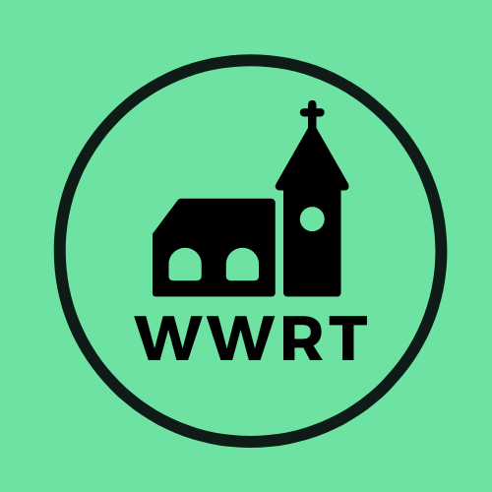
CHURCH SERVICES IN MARTLEY AND WICHENFORD
SEPTEMBER 2025

Sunday 7th September
Trinity 12
10.30am Worship for All, St Mary Magdalene, Broadwas
10.30am CW Holy Communion, St Peter, Martley

Sunday 14th September
Trinity 13
10.30am CW Holy Communion, St Laurence, Wichenford

Sunday 21st September
Trinity 14
10.00am Café Church, St Peter, Martley

Sunday 28th September
Trinity 15
10.30am CW Holy Communion, St Peter, Martley

In September there will be Holy Communion at Heaton House, Martley on Wednesday the 10th and 24that 10.15am and on the 1st and 3rd Wednesday via our YouTube channel -wwrtlive1.
All services and timings are subject to review and amendment – please check the website for updates: www.achurchnearyou.com

