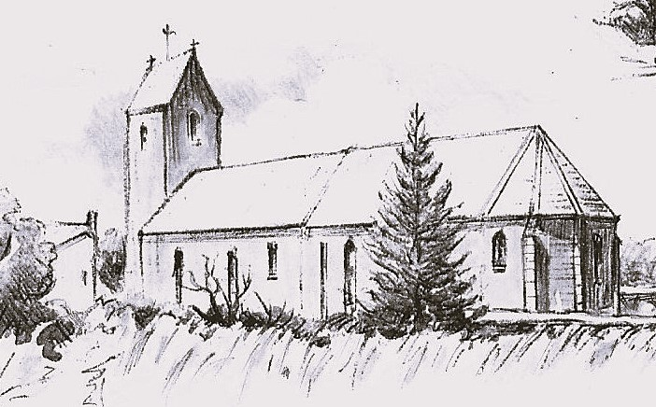
A brief guide to the
Church of Notre Dame
du Hommëel

By Fr Chris Probert
Chaplain, Anglican Church of la Manche
Drawing by Penny Feather

The Church of Notre Dame du Hommëel is simple, and probably typical of many village churches across France. The architecture is humble, historical records are patchy, and behind the seemingly harmonious appearance of the structure lies a complex heritage of flourishing followed by neglect, decay followed by recon-struction, threatened abandonment followed by an unexpected new page being turned.

To learn more about that history please read the booklet by Agnès Crompton-Roberts. This brief guide draws on her research, with thanks.

A walk round the exterior

Walking round the outside of the church will help you to grasp the history of the structure. The building, of local stone, was once more elaborate than now: the ground plan was in the shape of a cross, with north and south transepts containing chapels, and a central tower over the crossing.

The oldest part of the building is the nave, which still shows areas of herringbone stonework (Opus spicatum) dating from the presumed foundation of the church in the 11th-12th century. The building was enlarged in the 14th-15th century, and the enlarged chancel from that time is finished with a polygonal apse renewed in 1846.

The central tower fell in 1807, destroying the transepts in the process. A new tower was built in 1833, but it too collapsed within months. Finally in 1834 the present simple tower was built at the west end, enclosing the fine original arch. Stone benches in the porch provided a not-too-comfortable place for Church Council meetings. We now enter the church through that porch (or via the south side door).

A walk round the interior

The inside of the church as we see it now owes much to the revival of church life in the 19th century after a time of spoliation and neglect. The tower contains the only surviving bell, baptised 'Marie' in 1776, and saved by a local family who hid it in a pond! This saved it first from being melted down and used for secular purposes during the Revolution, then again from being destroyed when the tower fell. This bell still rings the Angelus each day.

The 16th century font stands in the traditional place by the entrance, symbolising the entry of the new Christian into the Church community. On the north wall we see a fine 18th century wooden pulpit.

Now we pass under the poutre de gloire (where a rood screen would have stood until liturgical fashions changed in the 16th century): notice the 15th - 16th century statue of Our Lady, originally outside but brought in to prevent further deterior-ation. The choir or chancel is much brighter than the nave, the larger windows typical of the rebuilding of the 14th-15th century. Most of the fittings, together with the statues, date from the beautification of the church from 1846 onwards.

The earliest surviving feature, the glory of the interior, is the 18th century altar, restored in 1846, and again in 2023. Standing on wooden steps in the chord of the apse (with a sacristy behind), the altar is backed by a contemporary reredos or screen, in which is set the tabernacle surmounted by a throne for the mon-strance during Exposition of the Blessed Sacrament. It is noble but not over-elaborate, a fitting highlight to the Church of Notre Dame du Hommëel.

Postscript

Many village churches have the slightly sad feel of places dutifully preserved but no longer in use for their original purpose, the week by week worship of the local Christian community. Spiritually sensitive visitors soon realise that Notre Dame du Hommëel is different: this much loved place is in regular use, thanks to a creative if not unique partnership.

Concerned to keep and beautify their church (where regular worship ceased in 1950), in partnership with the commune of Gratot a heritage association was formed to raise funds and carry out conservation work. Over the years this has included replacing floors, adding stained glass, and recently the conservation of the altar.

The remaining element of this partnership was put in place in 2011: the Diocese of Coutances granted use of Notre Dame du Hommëel to Eglise anglicane de la Manche as our place of weekly worship, linking with our base in the neighbour-ing presbytery and hall. The Anglican community now loves to worship here, and each Sunday Notre Dame du Hommëel rings once more with the praises of God.

https://www.achurchnearyou.com/christ-church-manche-normandy

